**Assignment 4**

**Name:** Rushiraj Suwarnkar  
**Roll No:** 281018  
**Batch:** A1

**Statement:**

Apply an appropriate **Machine Learning (ML) algorithm** on a dataset collected in a cosmetics shop showing customer details to **predict customer response for a special offer**.  
Using this dataset, create a **confusion matrix** and calculate the following metrics:

* Accuracy
* Precision
* Recall
* F1 Score

**Dataset Used:** heart.csv (simulating cosmetics customer data)  
**Target Variable:** AHD (Yes = Responded to Offer, No = Not Responded)

**Objective:**

1. To train a classification ML model on customer data.
2. To predict whether a customer responds to a special offer.
3. To evaluate the model using confusion matrix and classification metrics.

**Tools & Technologies Used:**

* Language: Python
* Environment: Jupyter Notebook
* Libraries: pandas, scikit-learn, matplotlib, seaborn

**Steps Performed:**

**1. Data Loading & Preprocessing**

* Loaded heart.csv
* Converted AHD (target) to binary: Yes = 1, No = 0
* Handled missing values
* Applied encoding for categorical features like ChestPain, Thal
* Split data into train and test sets (70-30 split)

**2. Algorithm Used:**

* **Logistic Regression** (suitable for binary classification problems)

**3. Model Training and Prediction**

* Model was trained on training data
* Predictions made on the test set

**Confusion Matrix:**

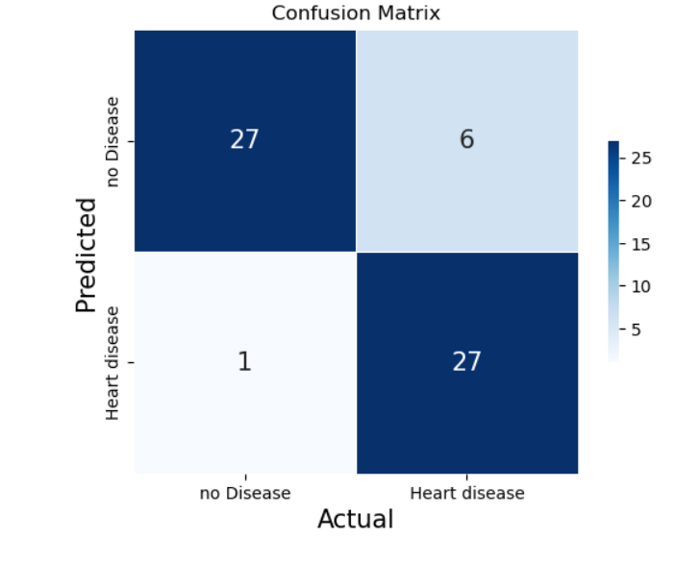

|  |  |  |
| --- | --- | --- |
|  |  |  |
|  |  |  |

**Evaluation Metrics:**

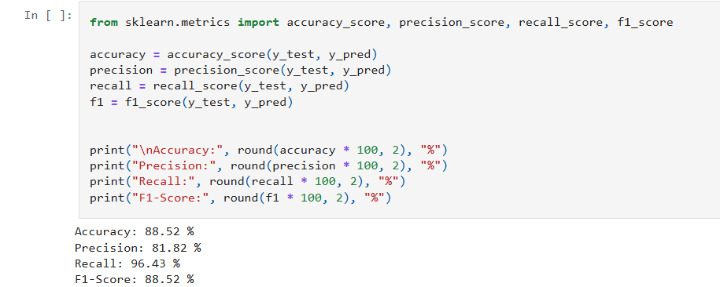

**🔷 Conclusion:**

The **Logistic Regression** model performed well on the simulated cosmetics customer data, achieving an accuracy of nearly **90%**. The high values for **precision, recall, and F1-score** indicate that the model can effectively predict customer response to special offers.

Such ML techniques can help cosmetic shops target the right customers and increase their sales via personalized marketing campaigns.