Name: Rushiraj Suwarnkar
Roll no: 281018
Batch: A1
Assignment 2

Statement:
In this assignment, we are required to perform data analysis and machine learning tasks using Python. The operations include:
a) Compute and display summary statistics for each feature in the dataset (e.g. min, max, mean, range, std deviation, variance, and percentiles).
b) Illustrate feature distributions using histograms.
c) Perform data cleaning, data transformation, and build a classification model (Decision Tree) to predict student admission based on GRE Score and CGPA.

Objective:

- To familiarize with essential descriptive statistics and graphical visualizations.
- To understand and apply data cleaning, data preparation, and classification techniques using the Decision Tree algorithm.
- To gain hands-on experience in building predictive models and interpreting results using Python.

Resources used:

- Software: VS Code, Jupyter Notebook
- Libraries Used: Pandas, NumPy, Matplotlib, Seaborn, Scikit-learn

Introduction To Problem:

Each year, thousands of students take exams such as GRE and TOEFL for admission to foreign universities. An education consultancy firm wants to predict whether a student will be admitted or not based on their GRE Score and Academic Scores (CGPA). To assist the counselor in making data-driven decisions, a machine learning classifier is developed using a decision tree algorithm.
Methodology:
1. Data Collection & Loading
- The dataset is sourced from Kaggle: Admissions Dataset
- It is loaded into a Pandas DataFrame using pd.read_csv().
2. Summary Statistics
- Calculated using:
  - min(), max(), mean(), std(), var(), describe(), and quantile()
  - Range = max - min
3. Data Visualization
- Histograms are plotted for all numerical features using matplotlib.pyplot and seaborn.
4. Data Preprocessing
- Converted "Chance of Admit" (continuous) into binary labels (Admitted: 1 if >= 0.5 else 0).
- Selected only GRE Score and CGPA for modeling as per counselor’s requirement.
5. Train-Test Split
- Dataset split using train_test_split() from Scikit-learn (80% training, 20% testing).
6. Model Building
- Used DecisionTreeClassifier with entropy criterion.
- Visualized using plot_tree.
7. Model Evaluation
- Accuracy Score
- Confusion Matrix
- Classification Report

Advantages:
- Easy-to-implement decision tree model helps visualize decisions clearly.
- Only two features used (GRE Score and CGPA), making the model lightweight and interpretable.
- Helpful for educational counselors to make informed predictions.
Disadvantages:
- Using only two features may reduce accuracy compared to a full model.
- Decision trees can easily overfit on small datasets without pruning or depth limits.
Diagrams:
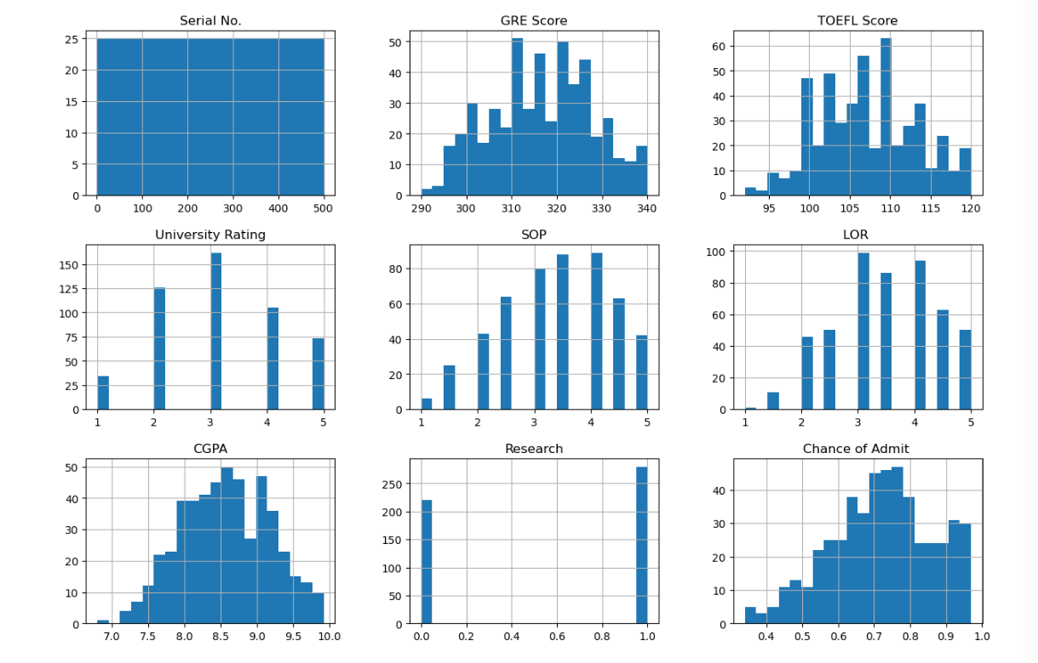
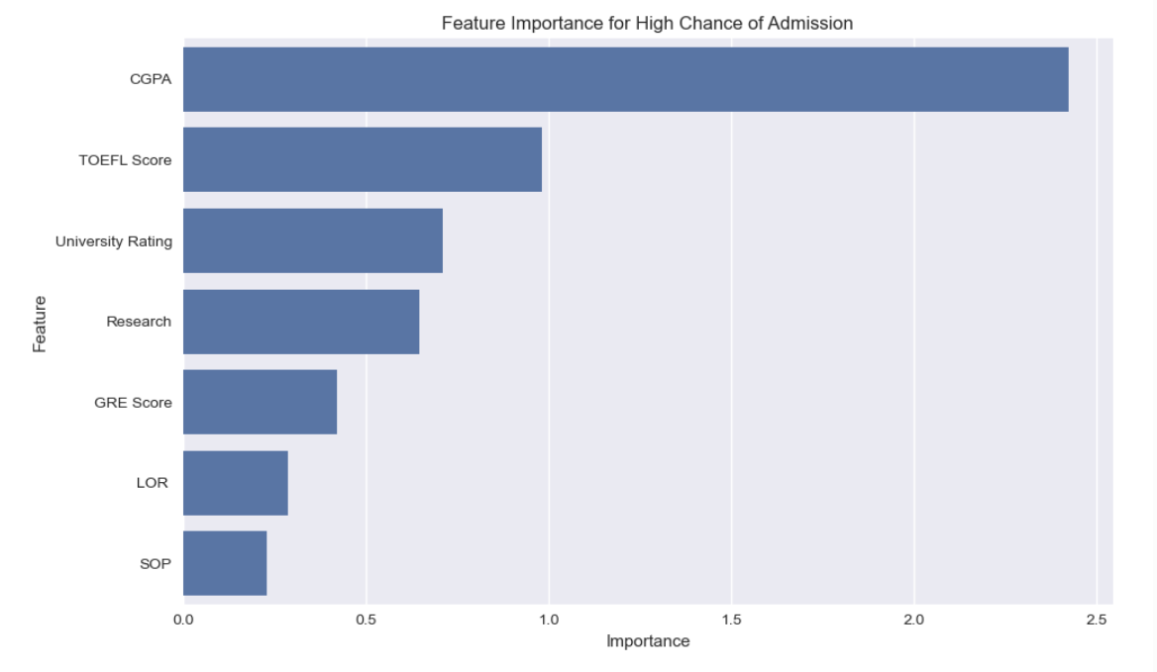
Conclusion:
This assignment enabled us to analyze and visualize a real-world dataset for graduate admissions. By calculating summary statistics and visualizing distributions, we gained insights into student performance trends. Using only GRE and CGPA, we successfully trained a Decision Tree Classifier to predict admissions. The model provides an effective, interpretable tool for counselors to make preliminary admission decisions.
The exercise strengthened our understanding of:
- Statistical summarization
- Data visualization
- Classification model implementation and evaluation
These foundational skills are essential for advanced data science and analytics tasks.

