

**Faculty of Technology**

**Department of Computer Engineering**

**Dharmsinh Desai University**

**April 2020**

B. Tech. CE Semester – VI

Subject – System Design Practice

**Project Title – B2B Mart**

By

Kartikey Undaviya (ID No. 17CEUOS125 )

Rushi Vachhani (ID No. 18CEUOD018 )

Mayur Raycha (ID No. 17CEUOS115 )

**Guided by**

Prof. Brijesh S. Bhatt

Assistant Professor

Department of Computer Engineering



**Faculty of Technology**

**Department of Computer Engineering**

**Dharmsinh Desai University**

**April 2020**

**CERTIFICATE**

This is to certify that the project work titled **B2B Protal** carried out in the Subject of System Design Practice and recorded in this report is the bonafide work of

|  |  |  |
| --- | --- | --- |
| **Name** | **College ID** | **Roll No** |
| Kartikey Undaviya | 17CEUOS125 | CE-138 |
| Rushi Vachhani | 18CEUOD018 | CE-115 |
| Mayur Raycha | 17CEUOS115 | CE-114 |

of the degree of Bachelor of Technology in the branch of Computer Engineering at Dharmsinh Desai University during academic session December 2019 to April 2020.

Prof. Brijesh S. Bhatt Dr. C. K. Bhensdadia

Assistant Professor Head of Department

Dept. of Computer Engg. Dept. of Computer Engg.

Faculty of Technology Faculty of Technology

Dharmsinh Desai University Dharmsinh Desai University

**TABLE OF CONTENTS**

Chapter 1) Introduction

1.1 Purpose

1.2 Technology used

Chapter 2) Software Requirement Specifications

2.1 Types of user

2.2 System functional requirements

2.3 Other non-functional requirements

Chapter 3) Design

3.1 Use Case Diagram

3.2 Class Diagram

3.3 State Diagram

3.4 Activity Diagram

3.5 Sequence Diagram

3.6 Data Dictionary

Chapter 4) Implementation Detail

4.1 Brief description of modules

4.2 Functional prototypes

4.3 Algorithm and it’s working

Chapter 5) Test Case Design

Chapter 6) Screenshots

Chapter 7) Conclusion and Future Extension

7.1 Conclusion

7.2 Future Entension

Chapter 8) Bibliography

**Abstract**

Our Project titled **B2B Mart** is online B2B marketplace platform , connecting buyers and sellers .This project gives buyers convenience of connecting with sellers anytime and anywhere and provides wider market place with a range of products and suppliers . It also provides payment protection program.

Using out Project, sellers can enhance their business visibility , sellers can increase credibility for their brand,sellers can lead management system and also sellers can use instant payment gateway using our project.Thus, our project provides platform for making easy connectivity between buyers and sellers.

**Chapter 1) Introduction**

* 1. **Purpose:**

Our project helps both buyers and sellers by connecting them easily .Using our project , thousands of buyers and sellers can access with each other for selling and buying their products using our market place platform.

Sellers needs to create their account by providing necessary details with products product details . Buyers need to register to our system and by logging in , buyer can make a request for required products and our system will provide sorted list to sellers of buyers who have requested to buy the products.This way, our project provides marketplace platform for easy connectivity between buyers and sellers.

* 1. **Technologies Used:**

For the implementation, we have used Django framework and python language as a backend.

Development Tools used during complete implementation of the project is Visual Studio Code and Umlet.

**Chapter 2) Software Requirements Specification**

**2.1 Types of User:**

1. Visitor
2. Buyer
3. Seller
4. Admin

**2.2 System Functional Requirements**

**R.1 Visitor**

R.1.1 Login in System

Description: Visitors can login to the website as a buyer to find product.

Input: Visitor click on submit button.

Output: Success message.

R.1.2 Search Product

Description: Visitors can search product according to city and Catagories.

R.1.2.1 Visitors can search product

Description: It will search the product according to the requirement.

Input: Visitors can click search button.

Output: It can see all product to their requirement.

R.1.2.2 Search according to their city

Description:It will search product according to their city.

Input: It will give the city at the time of registration.

Output: Search are success to their cities.

R.1.2.3 Search according to category

Description: It is searching product according to their catagories.

Input: It gives the category.

Output: Select data & give response by product category.

R.1.2.4 View all category

Description: It is view all category of product that buyer can buy the product.

Input: View to all category of product to click the button.

Output: Data search is success.

R.1.2.5 Submit requirement

Description: Submit requirement to along user phone number.

Input: It will give phone no. and click submit button.

Output: Data or request of product is submitted.

R.1.2.6 Can give feedback

Description: The user can give feedback according to their product.

Input: Visitors can give the feedback.

Output: Feedback shown by admin only.

R.1.2.7 Advanced Search

Description: It is used to search any product in category list.

Input: It is click on advanced search button.

Output: Submit the data.

R.1.2.8 Recent Activities

Description: It is track of visitors recently activities & notify according to product.

Input: Track of the recent activities.

Output: It gives response according to the search.

**R.2 Buyer**

R.2.1 Login in system

Description: Buyer can login to the website as a search product.

Input: Buyer can login system.

Output: success message.

R.2.2 View Category

Description: Buyer can view the category to search product.

Input: Click on the button to view category.

Output: Response according to their request.

R.2.3 Login with OTP

Description: Buyer can login to the website with OTP.

Input: OTP will give you to login.

Output: It is given to response to buyer.

R.2.4 Request Requirement

Description: Buyer can place the requirement.

Input: place the requirement and give book.

Output: It will give all the products that requires.

R.2.5 Manage Profile

R.2.5.1 Manage requirements

Description: It is manage all the buyer requirements according to product.

Input: Admin can manage requirements.

Output: Success message.

R.2.5.2 Contact seller

Description: It is contact to seller to search the product its details.

Input: To contact seller & its details.

Output: According to you are authorised than it is access contact details to seller.

R.2.5.3 Get Desktop notification

Description: It is get desktop notification.

Input: It is give the notification.

Output: Display your product information.

R.2.6 Make payment

Description: Seller can sell the product & buyer can paid to that seller.

Input: Seller can receive payment by credit or debits card.

Output: Give the payment to seller.

R.2.7 Assistants chat box

Description: It is used to give the further product details throw company assistants.

Input: It will give to chat box.

Output: It is message success & seller can replay with this message box.

**R.3 Seller**

R.3.1 Manage company profile

Description: It will used to manage the company information.

Input: It is used to manage the company information.

Output: Display the all details.

R.3.2 Manage business details

Description: It will display the details of product information.

Input: It will show Business Profile.

Output: All required details to show in seller page.

R.3.3 Access dashboard

Description: Admin can show the all details of buyer and seller.

Input: It is used to show admin login.

Output: Login success message show with all functionality.

R.3.4 manage bank details

Description: It is used to manage the bank details of seller and buyer.

Input: It will manage bank details data.

Output: It is show by only admin.

R.3.5 Create catalog URL

Description: It is url that share to company catalog to the buyer.

Input: It is show all the details of the products.

Output: url is send to share catalog to see product information.

R.3.6 Lead manager

Description: Lead is used for seller that it can used to contact their product to the buyer.

Input: Lead is maintain by company manager.

Output: show details of lead.

R.3.6.1 Search leads

Description: It is used to give search for leads.

Input: Details maintain by the lead manager.

Output: Show the total leads and all details.

R.3.6.2 Save replies

Description: It will give the replay according to user of lead.

Input: It is replies to show in replay page.

Output: Show the company response.

R.3.6.3 Chat with buyer

Description: It is used to buy a product to communicate with chat in chat pages.

Input: Give login to system to use features.

Output: Show the data.

R.3.6.4 Set remainder

Description: set reminder to any information which can use for further communication.

Input: It is set remainder.

Output: Show the remainder.

R.3.6.5 Generaate report

Description: It is used to generate report according to their details.

Input: whole report to show.

Output: Successfully show the data.

R.3.7 Buy leads

Description: you can by the leads for paying some amount.

Input: It is use to search company profile.

Output: Give the details of leads.

R.3.7.1 Contact buyer

Description: Contact with buyer to using lead.

Input: Buy the lead for company profile.

Output: Response of all company.

R.3.7.2 Filter buyer

Description: This app used to filter buyer according to their project.

Input: It is filter buyer details.

Output: Give success buyer information.

R.3.7.3 Buy leads

Description: Buyer and seller can buy the leads for marketing purpose.

Input: Buy leads from the buyer pages.

Output: Give and total leads in your account.

R.3.8 Manage product

Description: Seller is used to manage their product.

R.3.8.1 Add product

Description: Used to add their product details by seller.

Input: Add product information.

Output: Give buyer to see data.

R.3.8.2 Update product

Description: Used to update the product by seller and admin.

Input: change in their product details.

Output: Give to modify data.

R.3.8.3 Add photos to product

Description: Add the photos of product by seller only.

Input: Change images.

Output: Give to modify data.

**R.4 Admin**

R.4.1 Login to website

Description: Admin can login to the website and manage all data.

Input: Login to application.

Output: Success message.

R.4.2 Manage visitor details

Description: admin can manage the visitors all details in Records.

Input: Manage all details in report.

Output: Show the data in report.

R.4.3 Manage buyer details

Description: admin can manage all details of buyer.

Input: Manage data of buyer.

Output: Show the information.

R.4.4 Manage seller details

Description: Admin can manage all the seller details.

Input: Manage data of seller.

Output: Show all information.

R.4.5 Manage buyer request

Description: Admin can manage the buyer request of product and their information.

Input: Manage buyer request.

Output: Data saved successfully.

R.4.6 Manage product

Description: Admin can manage all the product from buyer to seller.

Input: Admin can manage all data.

Output: Data show in dashboard.

**2.3 Other non-functional requirements**

1. Performance

The system must be interactive and the delays involved must be less. So in every action- response of the system, there are no immediate delays. In case of opening App components, of popping error messages and saving the settings or sessions there is delay much below 3 seconds.

1. Safety

User details should be securely stored to the server. The main security concern is for user account hence proper login mechanism should be used to avoid hacking.

1. Reliability

As the system provides the right tools for discussion, problem solving it must be made sure that the system is reliable in its operations and for securing the sensitive details.

1. Database

System requires to access users data fast to maintain the performance.

**Chapter 3) Design**

**3.1. Use-Case Diagram:**

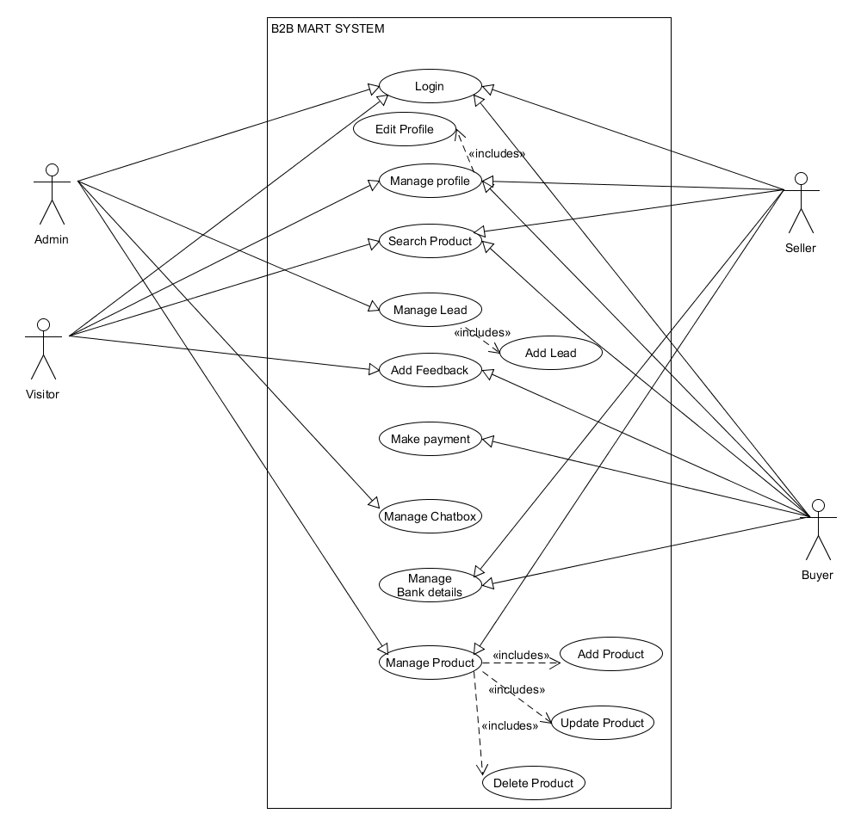

**3.2. Class Diagram:**

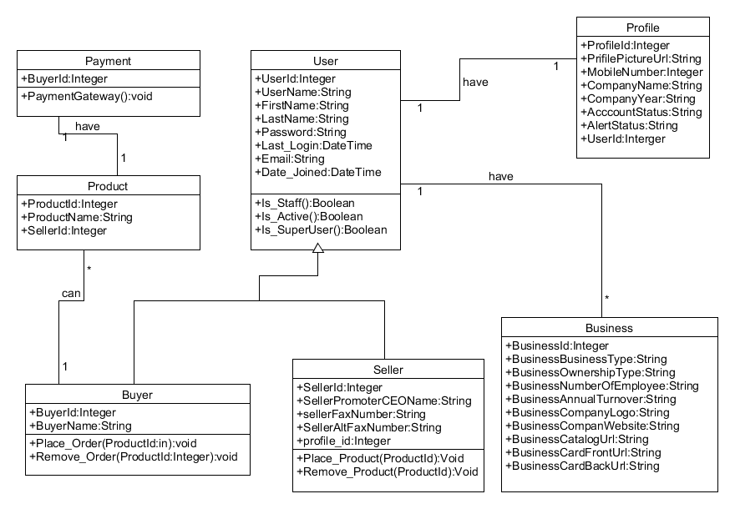

**3.3. Sequence Diagram:**

1. Sequence diagram of Seller:

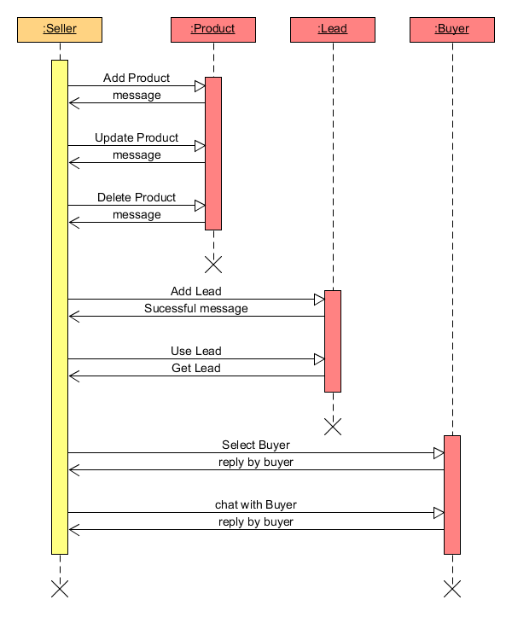

2. Sequence diagram of Buyer: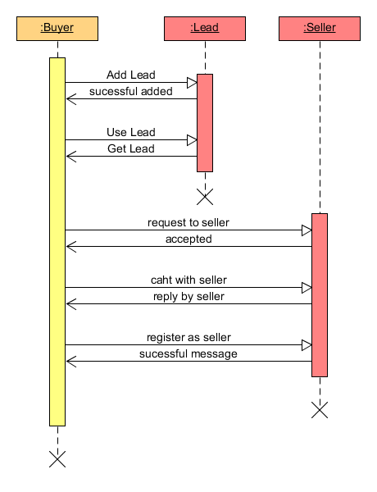

**3.4. State Diagram of B2B mart System:**

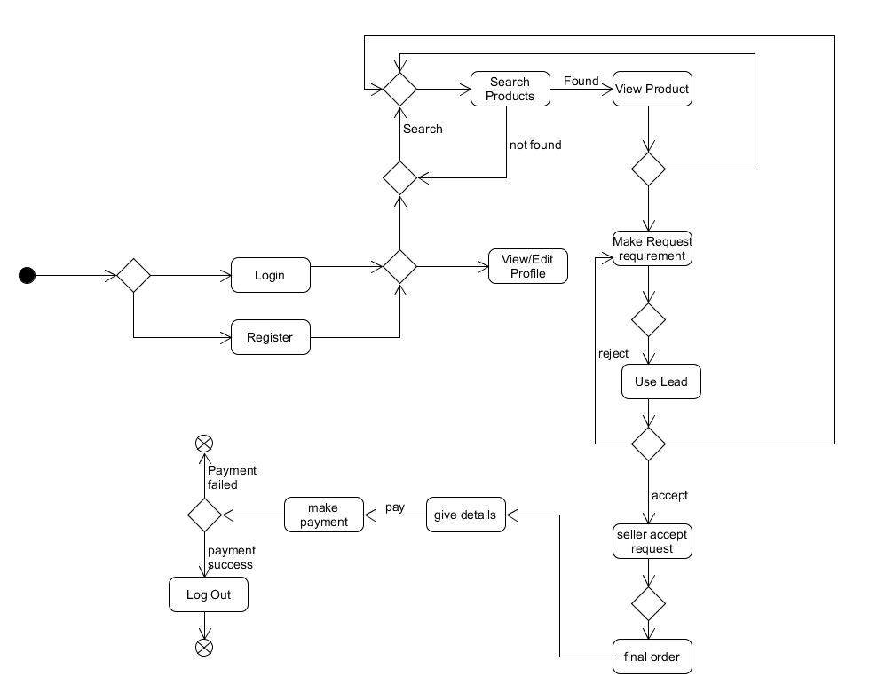

**3.5. Activity Diagram:**

1. Activity diagram of Buyer:

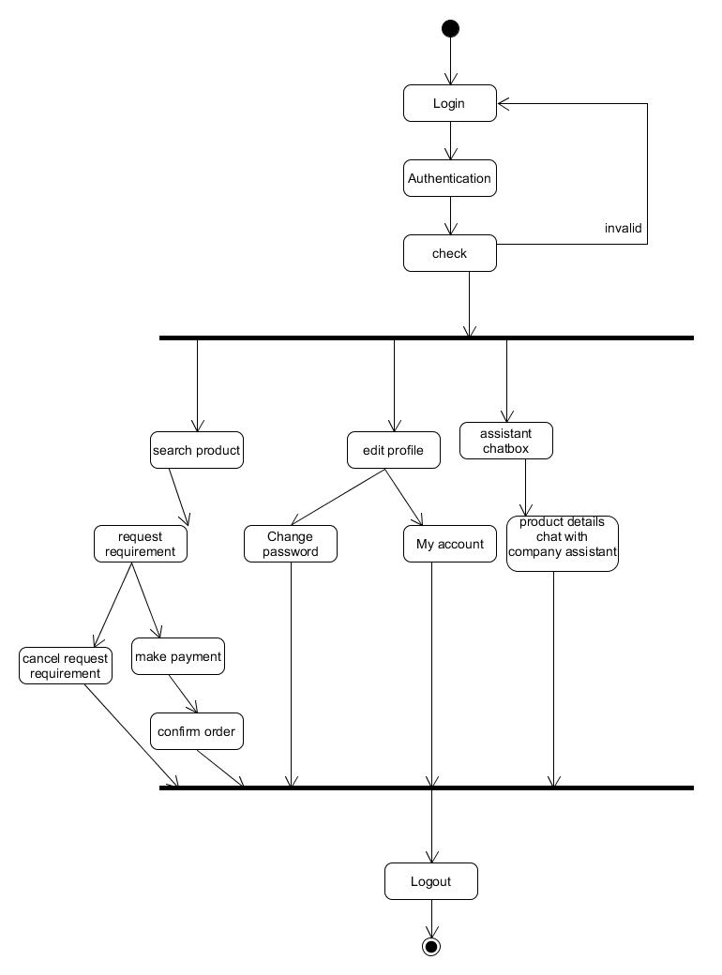

2. Activity diagram of visitor:

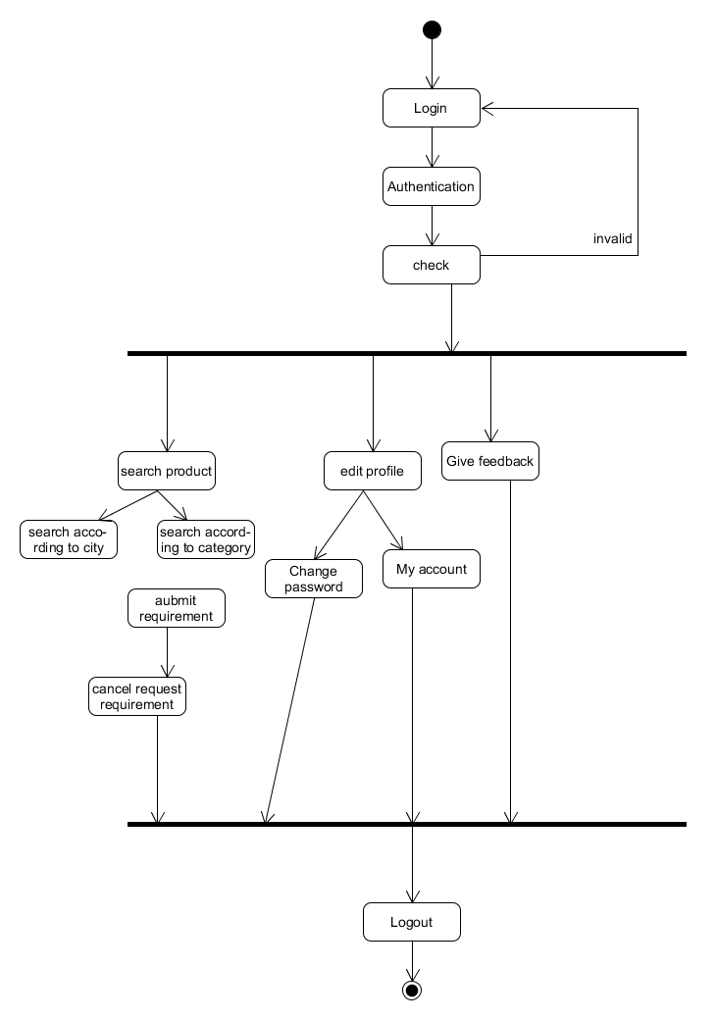

3. Activity Diagram of Seller:

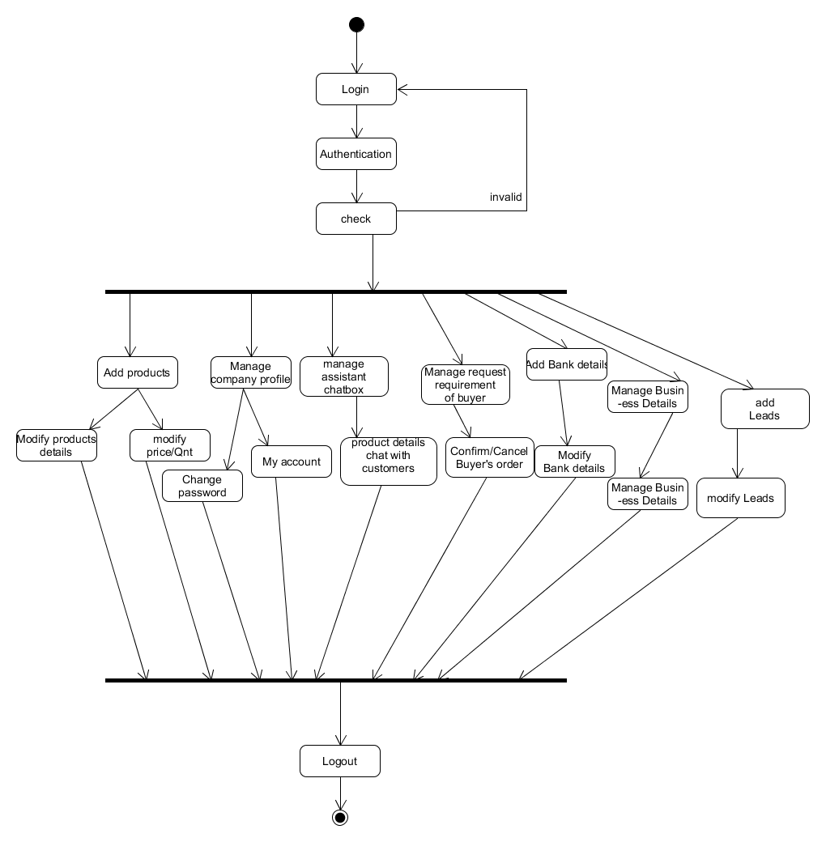

4. Activity Diagram of Admin:

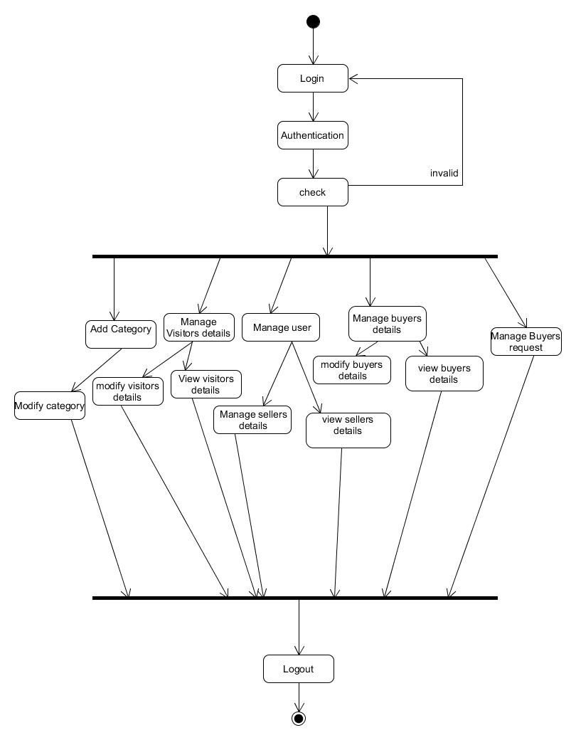

**3.6. E-R Diagram:**

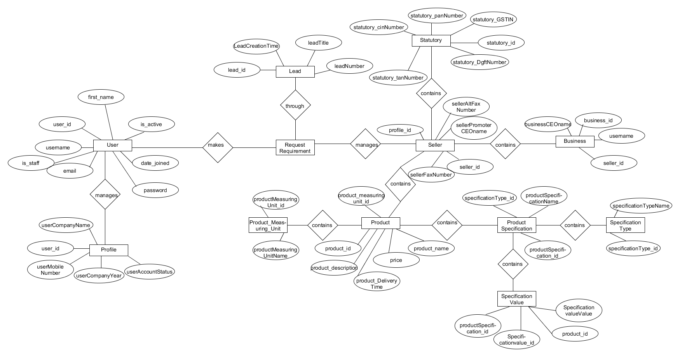

**3.7. Data Dictionary:**

The system Database consists of the following Table Schema:

**1. Profile:**

|  |  |  |  |  |
| --- | --- | --- | --- | --- |
| **Field** | **Data Type** | **Size** | **Constraint** | **Reference** |
| Id | integer |  | PK |  |
| UserProfilePictureUrl | varchar | 100 |  |  |
| UserMobileNumber | varchar | 10 |  |  |
| UserAltMobileNumber | varchar | 10 |  |  |
| UserCompanyName | varchar | 50 |  |  |
| UserCompanyYear | varchar | 4 |  |  |
| UserAccountStatus | varchar | 20 |  |  |
| UserAlertStatus | varchar | 20 |  |  |
| user_id | integer |  | FK, Unique | User |

**2. User:**

|  |  |  |  |  |
| --- | --- | --- | --- | --- |
| **Field** | **Data Type** | **Size** | **Constraint** | **Reference** |
| id | integer |  | PK |  |
| password | varchar | 128 |  |  |
| last_login | DateTime |  |  |  |
| is_superuser | boolean |  |  |  |
| username | varchar | 150 |  |  |
| first_name | varchar | 30 |  |  |
| last_name | varchar | 150 |  |  |
| email | varchar | 254 |  |  |
| is_staff | boolean |  |  |  |
| is_active | boolean |  |  |  |
| date_joined | DateTime |  |  |  |

**3. Seller:**

|  |  |  |  |  |
| --- | --- | --- | --- | --- |
| **Field** | **Data Type** | **Size** | **Constraint** | **Reference** |
| id | integer |  | PK |  |
| SellerPromoterCEOName | varchar | 30 |  |  |
| SellerFaxNumber | varchar | 15 |  |  |
| SellerAltFaxNumber | varchar | 15 |  |  |
| Profile_id | integer |  | FK, Unique | Profile |

**4. Business:**

|  |  |  |  |  |
| --- | --- | --- | --- | --- |
| **Field** | **Data Type** | **Size** | **Constraint** | **Reference** |
| Id | integer |  | PK |  |
| BusinessCeoName | varchar | 30 |  |  |
| BusinessBusinessType | varchar | 30 |  |  |
| BusinessOwnershipType | varchar | 30 |  |  |
| BusinessNumberOfEmployee | varchar | 6 |  |  |
| BusinessAnnualTurnover | varchar | 30 |  |  |
| BusinessCompanyLogo | varchar | 100 |  |  |
| BusinessCompanyWebsite | varchar | 100 |  |  |
| BusinessCatalogUrl | varchar | 100 |  |  |
| BusinessCardFrontUrl | varchar | 100 |  |  |
| BusinessCardBackUrl | varchar | 100 |  |  |
| Seller_id | Integer |  | FK, Unique | Seller |

**5. Statutory:**

|  |  |  |  |  |
| --- | --- | --- | --- | --- |
| **Field** | **Data Type** | **Size** | **Constraint** | **Reference** |
| id | integer |  | PK |  |
| StatutoryGSTIN | varchar | 15 |  |  |
| StatutoryPanNumber | varchar | 15 |  |  |
| StatutoryTanNumber | varchar | 15 |  |  |
| StatutoryCinNumber | varchar | 21 |  |  |
| StatutoryDgftNumber | varchar | 21 |  |  |
| Seller_id | integer | 100 | FK, Unique | Seller |

**6. SellerAddress:**

|  |  |  |  |  |
| --- | --- | --- | --- | --- |
| **Field** | **Data Type** | **Size** | **Constraint** | **Reference** |
| Id | integer |  | PK |  |
| SellerAddress | integer | 100 |  |  |
| SellerAddressBlockNumber | varchar | 10 |  |  |
| SellerAddressStreet | varchar | 30 |  |  |
| SellerAddressLocality | varchar | 20 |  |  |
| SellerAddressLandMark | varchar | 20 |  |  |
| SellerAddressCity | varchar | 20 |  |  |
| SellerAddressPinCode | varchar | 20 |  |  |
| SellerAddressState | varchar | 20 |  |  |
| SellerAddressCountry | varchar | 20 |  |  |
| SellerAddressType | varchar | 20 |  |  |
| Seller_id | integer | 100 | FK, Unique | Seller |

**7. Bank Details:**

|  |  |  |  |  |
| --- | --- | --- | --- | --- |
| **Field** | **Data Type** | **Size** | **Constraint** | **Reference** |
| BankId | integer |  |  |  |
| BankName | varchar | 50 |  |  |
| BankNumber | varchar | 50 |  |  |
| Seller_id | integer |  | FK, Unique | Seller |

**8. Product:**

|  |  |  |  |  |
| --- | --- | --- | --- | --- |
| **Field** | **Data Type** | **Size** | **Constraint** | **Reference** |
| ProductId | integer |  | PK |  |
| ProductName | varchar | 100 |  |  |
| ProductImageUrl | varchar | 100 |  |  |
| ProductPrice | integer | 10 |  |  |
| ProductCurrency_id | integer |  | FK | ProductCurrency |
| ProductMeasuringUnit_Id | integer |  | FK | ProductMeasuringUnit |
| ProductDescription | varchar | 150 |  |  |
| ProductMinimumOrderQuantity | integer | 10 |  |  |
| ProductProductionCapacity | varchar | 10 |  |  |
| ProductCode | varchar | 10 |  |  |
| ProductDeliveryTime | varchar | 10 |  |  |

**9. Product Currency:**

|  |  |  |  |  |
| --- | --- | --- | --- | --- |
| **Field** | **Data Type** | **Size** | **Constraint** | **Reference** |
| id | integer |  |  |  |
| ProductCurrencyName | varchar | 10 |  |  |

**10. Product measuring unit:**

|  |  |  |  |  |
| --- | --- | --- | --- | --- |
| **Field** | **Data Type** | **Size** | **Constraint** | **Reference** |
| id | integer |  |  |  |
| ProductMeasuringUnitName | varchar | 20 |  |  |

**11. SpecificationValue:**

|  |  |  |  |  |
| --- | --- | --- | --- | --- |
| **Field** | **Data Type** | **Size** | **Constraint** | **Reference** |
| Id | integer |  | PK |  |
| SpecificationValueValue | varchar | 100 |  |  |
| ProductSpecification_id | integer |  | FK | ProductSpecification |
| Product_id | integer |  | FK | Product |

**12. ProductSpecification:**

|  |  |  |  |  |
| --- | --- | --- | --- | --- |
| **Field** | **Data Type** | **Size** | **Constraint** | **Reference** |
| id | integer |  | PK |  |
| ProductSpecificationName | varchar | 100 |  |  |
| SpecificationType_id | integer |  | FK | SpecificationType |

**13. SpecificationType:**

|  |  |  |  |  |
| --- | --- | --- | --- | --- |
| **Field** | **Data Type** | **Size** | **Constraint** | **Reference** |
| id | integer |  | PK |  |
| SpecificationTypeName | varchar | 100 |  |  |

**14. ImpCategory:**

|  |  |  |  |  |
| --- | --- | --- | --- | --- |
| **Field** | **Data Type** | **Size** | **Constraint** | **Reference** |
| id | integer |  | PK |  |
| ImpCategoryName | varchar | 100 |  |  |
| ExportCategoryId | integer |  | FK | ExportCategory |

**15. IndustryCategory:**

|  |  |  |  |  |
| --- | --- | --- | --- | --- |
| **Field** | **Data Type** | **Size** | **Constraint** | **Reference** |
| id | integer |  | PK |  |
| IndustryCategoryName | varchar | 100 |  |  |

**16. IndustryCategory_ExportCategory:**

|  |  |  |  |  |
| --- | --- | --- | --- | --- |
| **Field** | **Data Type** | **Size** | **Constraint** | **Reference** |
| IndustryCategory_id | Integer |  | PK,FK | Industry Category |
| ExportCategory_id | Integer |  | PK,FK | Export Category |

**17. ExportCategory:**

|  |  |  |  |  |
| --- | --- | --- | --- | --- |
| **Field** | **Data Type** | **Size** | **Constraint** | **Reference** |
| id | integer |  | PK |  |
| ExportCategoryName | varchar | 100 |  |  |

**18. Lead:**

|  |  |  |  |  |
| --- | --- | --- | --- | --- |
| **Field** | **Data Type** | **Size** | **Constraint** | **Reference** |
| id | integer |  |  |  |
| LeadNumber | varchar | 100 | Unique |  |
| LeadTitle | varchar | 50 |  |  |
| LeadCreationTime | DateTime |  |  |  |
| User_id | integer |  | FK | User |

**19. Lead_seller:**

|  |  |  |  |  |
| --- | --- | --- | --- | --- |
| **Field** | **Data Type** | **Size** | **Constraint** | **Reference** |
| Lead_id | integer |  | PK,FK | Lead |
| Seller_id | integer |  | PK,FK | Seller |
| LeadStatus | varchar | 50 |  |  |
| LeadBuyTime | DateTime |  |  |  |

**Chapter 4) Implementation Details:**

**Brief Description of Modules:**

The system consists of 17 basic modules namely

1. User Module
2. Profile Module
3. Seller Module
4. BusinessDetail Module
5. Statutory Module
6. SellerAddress Module
7. BankDetail Module
8. Product Module
9. ProductCurrency Module
10. ProductMeasuringUnit Module
11. Specification Value Module
12. Product Specification Module
13. Specification Module
14. Important Category Module
15. Industry Category Module
16. Export Category Module
17. Lead

Each module consists of several methods to implement the required functionality. Implementation is done using Django. Database used in these modules is PostgreSQL.

**Chapter 5) Test case Design**

Manual testing was performed in order to find and fix the bugs in development process.

**Chapter 6) Screenshots**

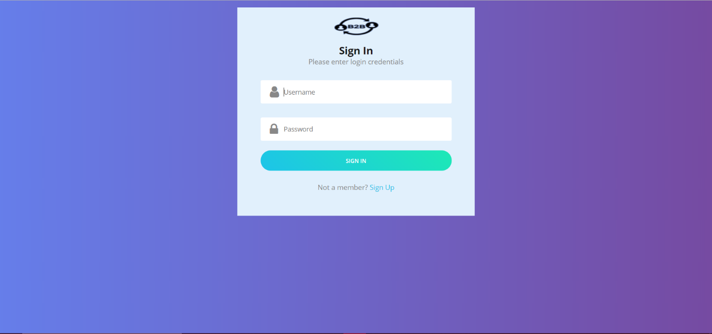

**Fig: Sign In**

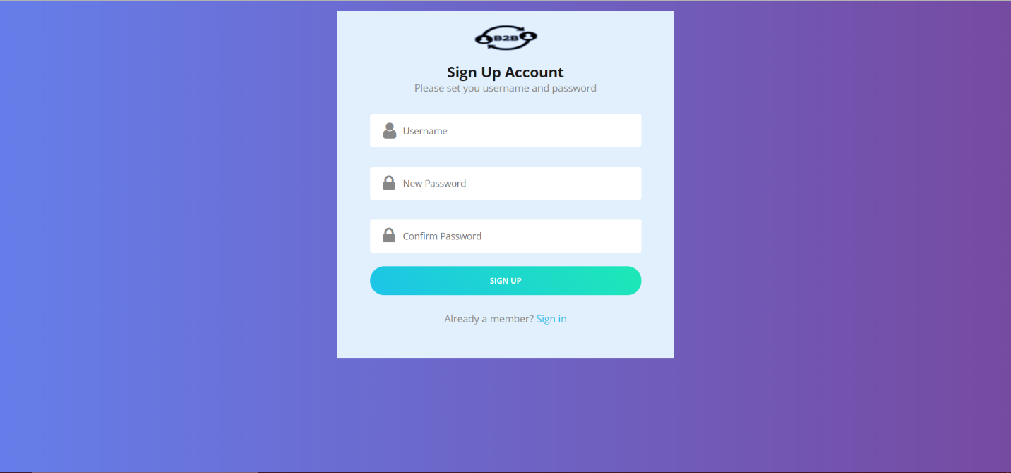

**Fig: Sign Up**

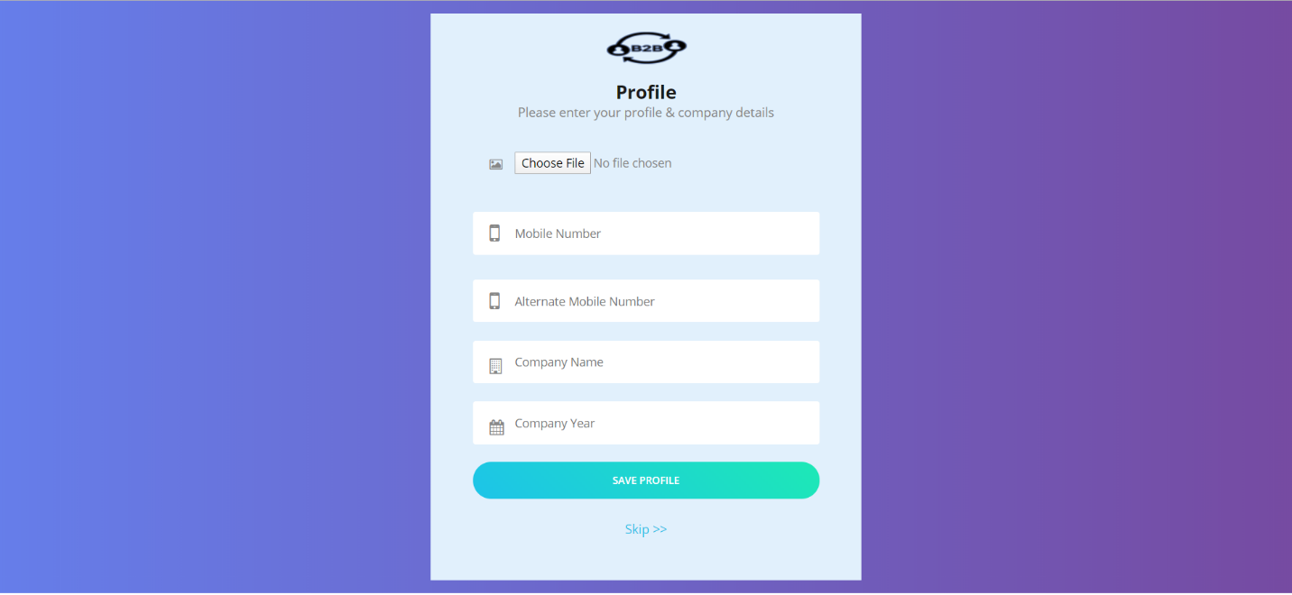

**Fig: Profile Registration**

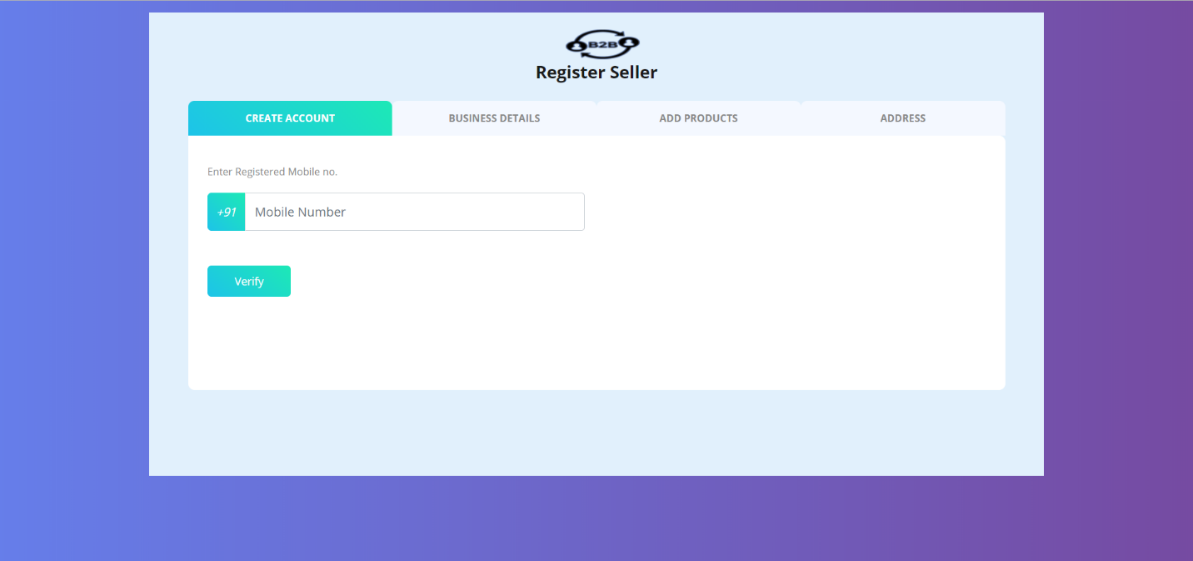

**Fig: Seller Registration**

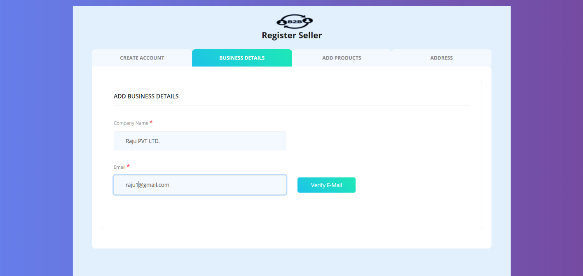

**Fig: Business Detail Insertion Page**

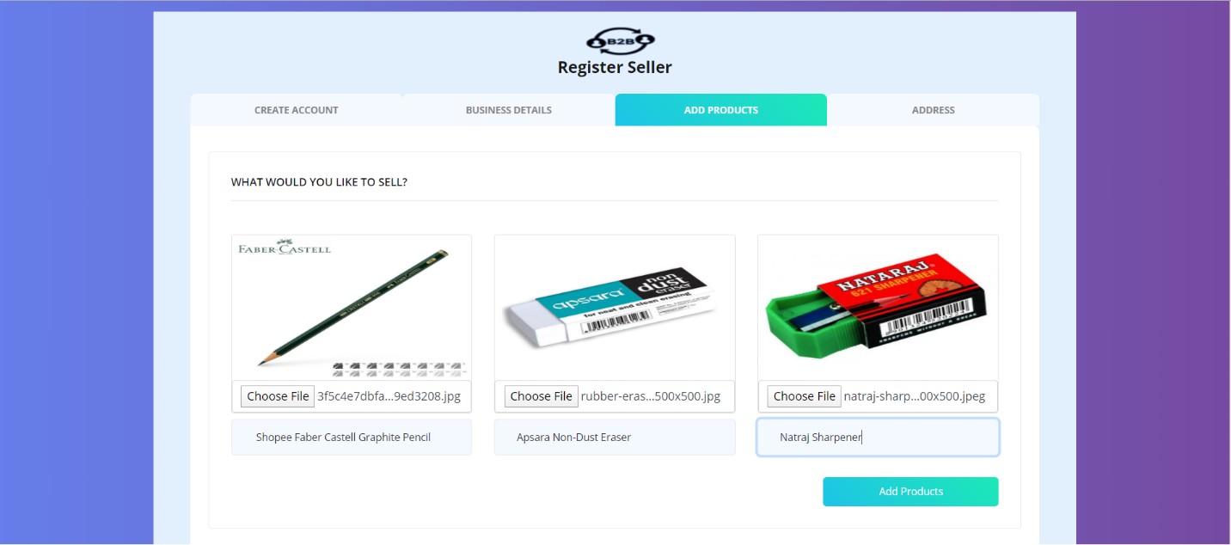

**Fig: Products Insertion Page**

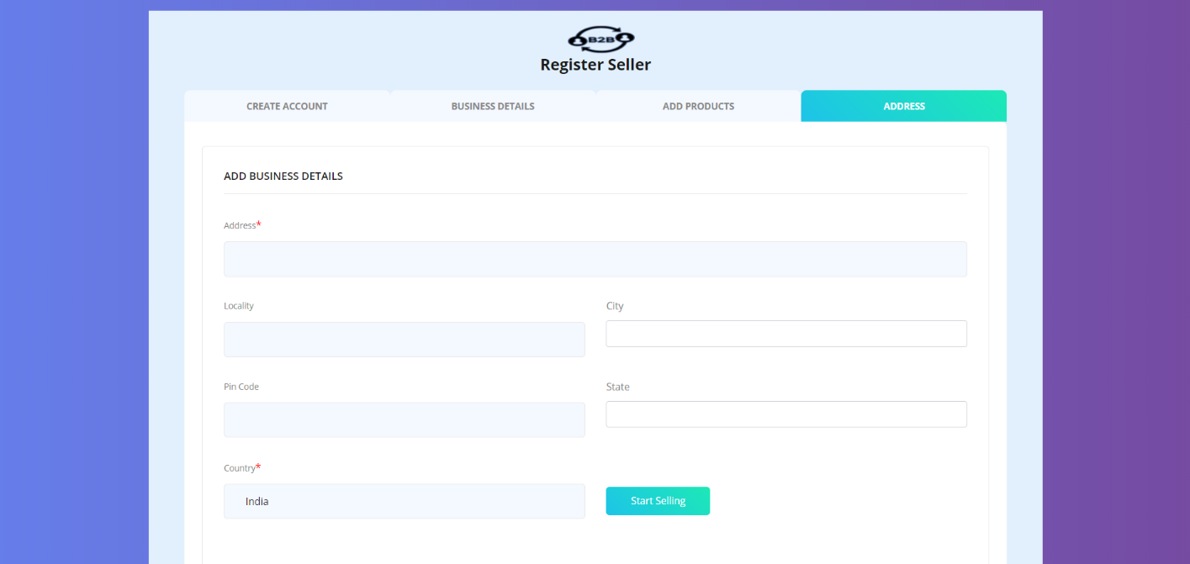

**Fig: Business Address Insertion Page**

**Chapter 7) Conclusion and further extensions**

**7.1. Conclusion:**

The functionalities are implemented in system after understanding all the system modules according to the requirements. Functionalities that are successfully implemented in the system are:

* **Buyer Sign Up**
* **Buyer Sign In**
* **Buyer Profile Insertion**
* **Seller Registration**
* **Seller Business Profile Insertion**
* **Seller Product Insertion**
* **Seller Business Address Insertion**

After the implementation and coding of system, comprehensive testing was performed on the system to determine the errors and possible flaws in the system.

**7.2. Further Extension:**

As this is a Business To Business platform the extensions are limitless.

Solr is the latest technology which can be implemented in our system which will make product search and retrieval very efficient and fast.

Lately we are have planned to integrate some machine learning techniques which and lead our seller to best fit and appropriate buyers they want to do business with.

**Chapter 8) Reference / Bibliography**

<https://www.indiamart.com/>

<https://www.codingblocks.net/programming/database-schema-for-multiple-types-of-products/>

<https://docs.djangoproject.com/en/3.0/>

<https://www.postgresql.org/docs/>