QUERY:
SELECT aep_channel_id, aep_raw_uom
FROM xfrm_interval.reading_ivl_nonvee_incr
WHERE serialnumber = '923530104'
AND aep_endtime_utc = '1775016900'
AND aep_opco = 'oh'
ORDER BY aep_channel_id;

DEV:
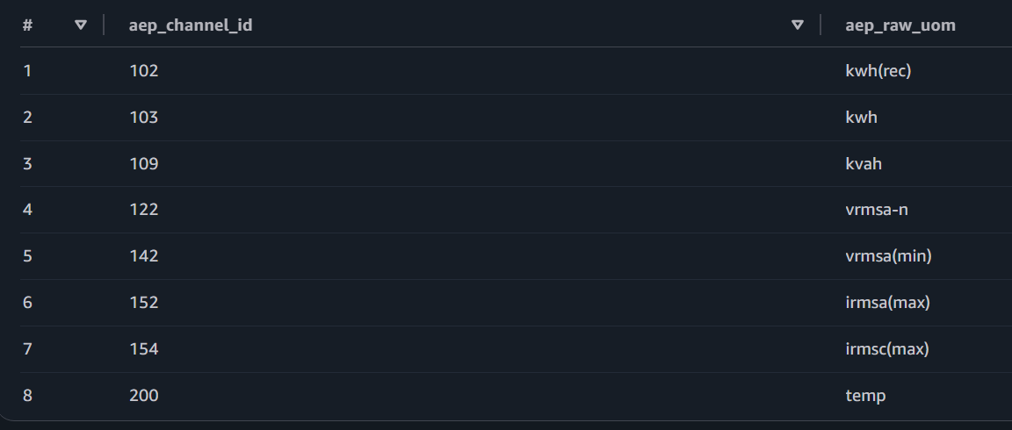
PROD:
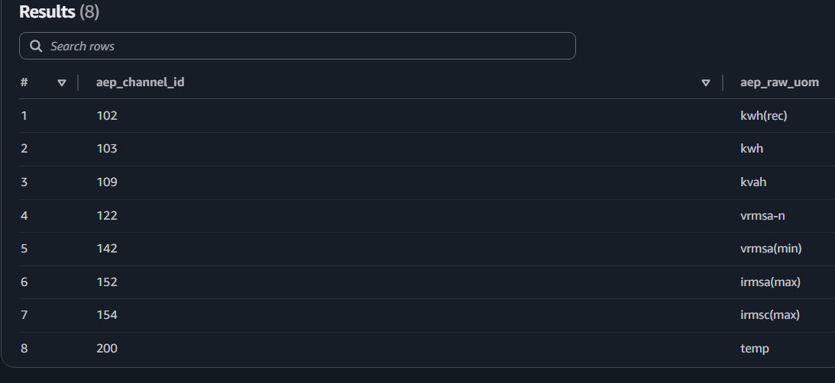
QUERY:
SELECT serialnumber, aep_endtime_utc, aep_channel_id, aep_raw_uom,
endtimeperiod, count(*) as cnt
FROM xfrm_interval.reading_ivl_nonvee_incr
WHERE serialnumber = '923530104'
AND aep_opco = 'oh'
AND aep_endtime_utc = '1775016900'
AND aep_usage_dt = '2026-04-01'
GROUP BY serialnumber, aep_endtime_utc, aep_channel_id, aep_raw_uom,
endtimeperiod;

DEV:
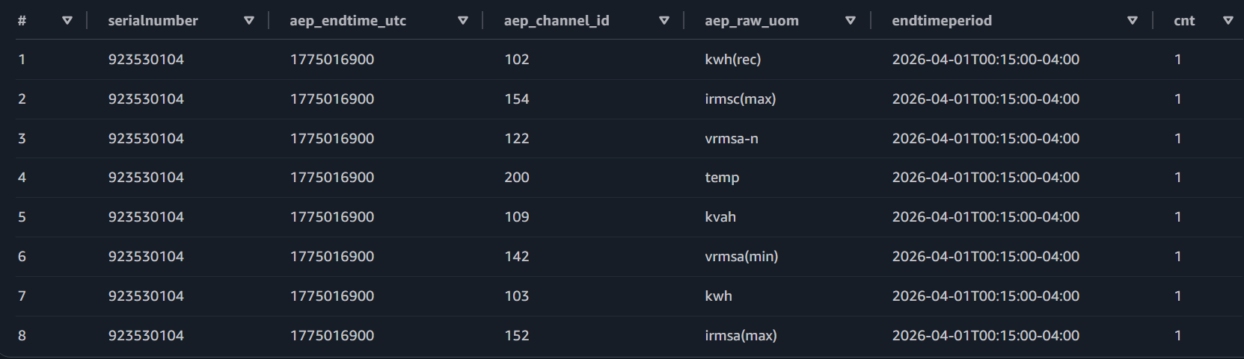

PROD
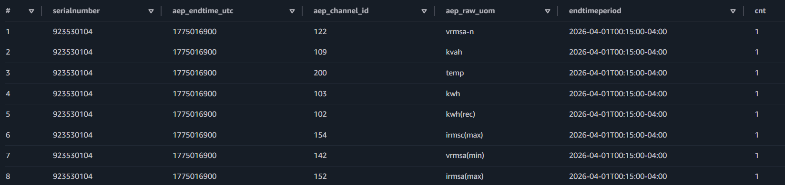

QUERY:
select count(*) from usage_nonvee.reading_ivl_nonvee_oh
WHERE serialnumber = '923530104'
AND aep_opco = 'oh'
AND aep_endtime_utc = '1775016900'
AND aep_usage_dt = '2026-04-01'

DEV:
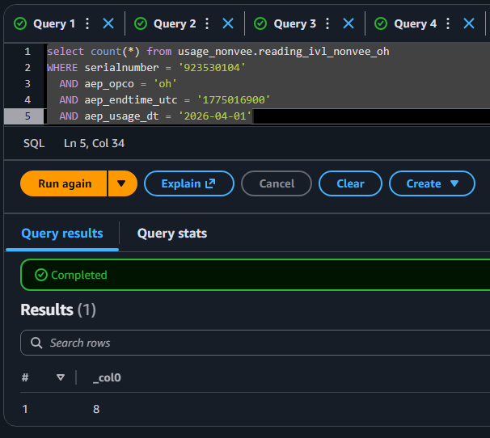
PROD:
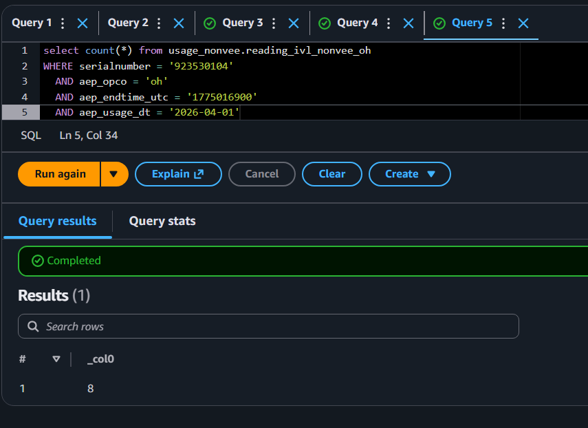

Query:
select count(*) from usage_nonvee.reading_ivl_nonvee_oh
WHERE serialnumber = '923530104'
AND aep_opco = 'oh'
AND aep_usage_dt = '2026-04-01'
AND hdp_update_user = 'info-insert'

DEV:
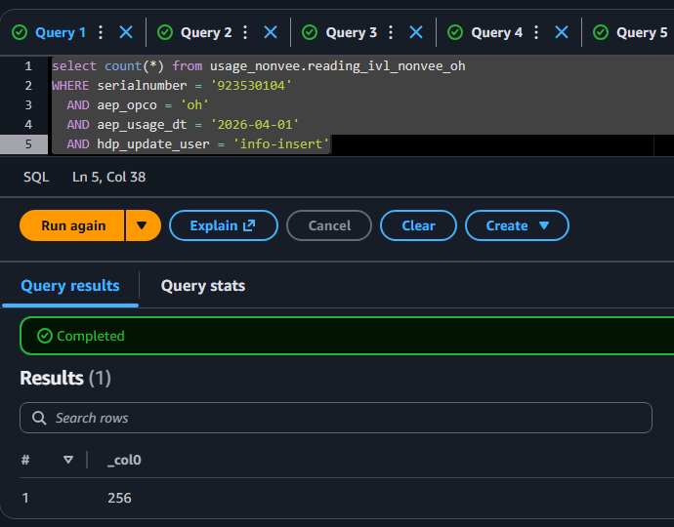

PROD:
