CONTENTS

List of Figures | VI
List of Tables | VII
1. Introduction | 1
1.1 Necessity | 1
1.2 Objective | 1
1.3 Theme | 2
1.4 Feasibility Study/ Market Survey
2. Literature Review | 3
3. System Development | 5
3.1 Design Calculations
3.2 Design on CAD / Mechanical Design | 5
3.3 Circuit Design and System Architecture
3.4 Hardware Components | 6
3.6 User Interface Software | 16
4. Experiments and Result/ Testing and Results
5. Conclusion | 22
4.1 Conclusion | 22
4.2 Future Work | 23
4.5 Reference | 24

LIST OF FIGURES
Fig. No. | Description | Page No.
3.1 | Robot Top View | 5
3.2 | Aluminium Extrusion Profile | 6
3.3 | Acrylic Plates | 7
3.4 | Aluminium Pulley | 7
3.5 | Belt | 8
3.6 | Motor Driver | 11
3.7 | Arduino UNO | 12
3.8 | SMPS | 13
3.9 | Stepper Motor | 14
3.10 | Block Diagram | 15
3.11(a) | Cartesian Robot (Without Wire) | 20
3.11(b) | Cartesian Robot (With Wire) | 20

Table No. | Description | Page No.
3.1 | Aluminium Extraction Profile Specification | 6
3.2 | Aluminium Pulley Specification | 8
3.3 | Belt Specification | 8
3.4 | Motor Driver Specification | 11
3.5 | Arduino UNO Specification | 12
3.6 | Switch Mode Power Supply Specification | 13
3.7 | Stepper Moter Specification | 14
List Of Tables

2. LITERATURE REVIEW

The evolution of electronics manufacturing has seen a significant shift towards automation, with a focus on enhancing precision, efficiency, and reliability in the assembly process. The utilization of Cartesian Robots in the development of Automatic PCB Soldering Machines represents a cutting-edge approach to address the challenges associated with traditional manual soldering methods. This literature review explores key aspects of existing research and developments related to the integration of Cartesian Robots in automated PCB soldering.

2.1. Low Cost XY Positioning System using Arduino
According to Shripad Jaygude & Manish Kothmire et al. 2017 [1], the goal of this project was to develop a XY Scanning stage to translate the motion stage along the X and Y axes of the gantry and to use this information as the output for a microcontroller that can modify the commanded position of the stepper motor as the input data provided. While implementing such methodology a close loop control must be developed which results in increased complications along with the cost of system integration.
We learn about the electrical setup and wiring from the above research paper the setup involving a NEMA 17 stepper motor, an easy driver motor controller board, and an Arduino microcontroller. The motor is controlled by the Arduino through wire connections. The Arduino program dictates the number of pulses for the stepper motor and manages the voltage level supplied to the motor through the easy driver circuit. This arrangement demonstrates the coordination between the microcontroller, motor controller, and stepper motor for precise control in terms of pulse generation and voltage regulation.

2.2. Design and Analysis of Gantry Robot for Pick and Place Mechanism with Arduino Mega 2560 Microcontroller and Processed Using Python
According to G.S. Sharath & Niranjan Hiremath et al. 2021[2], the paper focuses on the design and analysis of a gantry robot specifically for a pick and place mechanism. The core components of the system include an Arduino Mega 2560 microcontroller for hardware control and a Python programming environment for data processing.
We learn about the in-depth examination of the design procedure associated with the gantry robot. This includes considerations such as the mechanical structure, components, and overall architecture necessary for effective pick and place operations and the most important things that we get were the slection of materials for the framework of the whole system.
2.3. Wave soldering method for printed circuit board
According to Pan Weixin et al. 2016 [3], the paper describes a wave-soldering method for printed circuit boards, providing preparation for electronic components subjected to wave-soldering .The method involves drilling holes in the substrate, forming welding pads enclosing the periphery of the holes, and creating gaps penetrating to the inner wall of the holes .The welding holes and gaps are distributed along the advancing direction of the substrate, ensuring that when the holes pass through the peak of the tin surface, scolding tin flows out from the gaps to prevent blockage.
We learn about the specific details of the wave-soldering process, including temperature control, solder composition, and the overall advantages and considerations associated with this method.
2.4. Full-automatic intelligent-welding assembly line
According to Wang Qing-Fu et al. 2015 [4], the full-automatic intelligent-welding assembly line consists of an AOI device, a selective mist sprayer, a selective soldering machine, and a conveying device. The AOI device captures images of PCBs and compares them with images of non-defective PCBs to identify defective soldering points. It then calculates the coordinates of these points using software. The selective mist sprayer is used to spray soldering flux onto the defective soldering points on the PCBs. The selective soldering machine corrects the soldering of the defective soldering points. The conveying device sequentially transports the PCBs to the AOI device, the selective mist sprayer, and the selective soldering machine.
We learn about the spraying of soldering flux and soldering tin one-to-one ensures precise application and reduces the need for maintenance and repair, further improving efficiency.

3. SYSTEM DEVELOPMENT

Developing an automatic PCB (Printed Circuit Board) soldering system using a Cartesian robot involves integrating various hardware and software components to achieve precise and efficient soldering. Here's a general guide to help you understand the key steps and components involved in the system development:

3.1 System Hardware Design on CAD / Mechanical Design
Consider the situation and demand of soldering machine which is cost efficient. Unlike regular soldering machine this model is design in such a way that a cartesian robot will solder a PCB with the help of a unique technique of soldering known as soldering wave pot. Aluminium extrusion pipes are chosen because it has strength, cartesian robot X, Y, Z axis is made of this material.
We have built / design the cartesian robot with the help of SKETCHUP 3D modelling software as shown in figure 3.1(a) and 3.1(b).
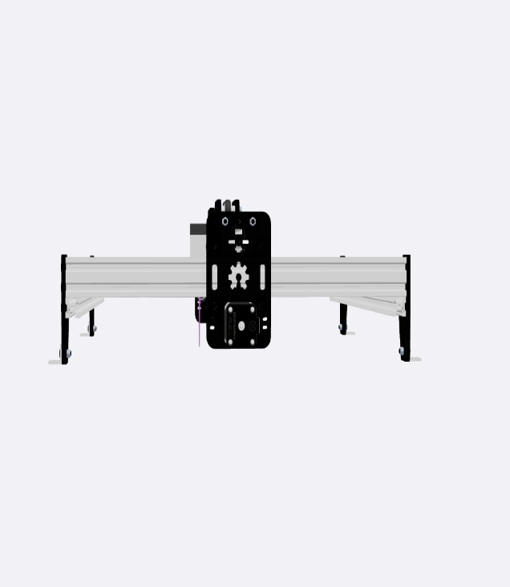
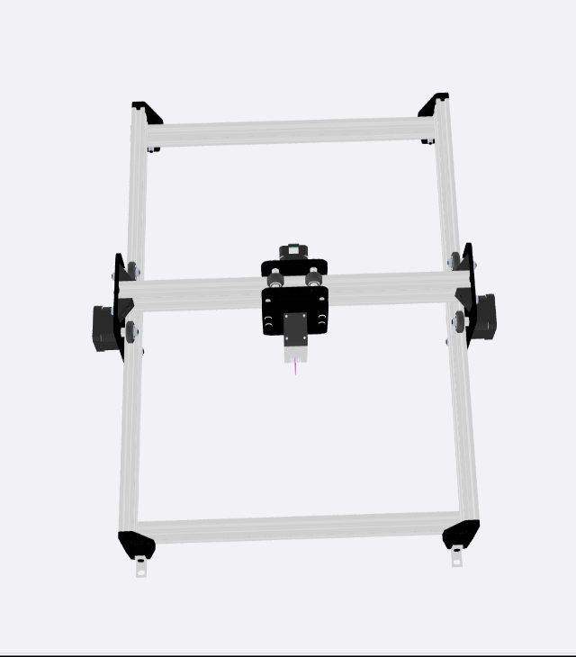
(a)Robot Top View
(b) Robot Front View
Fig. 3.1 The Cartesian Robot 3D CAD Model (Courtesy: SOLIDWORKS)

3.2 Hardware Components

3.2.1 Aluminium Extrusion Profile
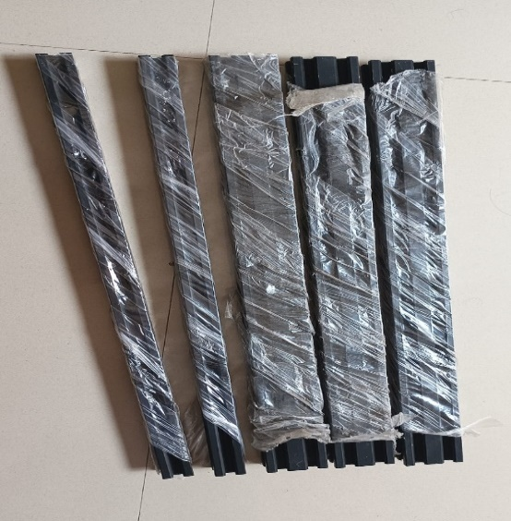

Fig. 3.2 Aluminium Extrusion Profile
Aluminium extrusion profiles are typically made from aluminium alloys, which are chosen for their specific properties, such as strength, corrosion resistance, and lightweight nature. Aluminium extrusion offers several advantages, including high strength-to-weight ratio, corrosion resistance, and the ability to create complex shapes with tight tolerances. Extruded aluminium profiles can undergo various surface finishes to enhance their appearance and properties. Common finishes include anodizing, powder coating, and polishing. Aluminium is a highly recyclable material, and the extrusion process itself is energy-efficient. This makes aluminium extrusion a sustainable choice in many applications. We have used this material to design/build cartesian robot as it is flexible for use and to that wheels are attached with the help of acrylic plates on which stepper motor is attached which moves wheels on the pipe smoothly as shown in figure 3.2 and specification in table 3.1
Table. 3.1 Aluminium Extrusion Pipes
Parameter | Value
Length (five pipes) | 500mm
Dimensions (three pipes) | 20 x 40
Dimensions (two pipes) | 20 x 20
Colour | Black

References

[1] Pavan K.K., Keerthi S.M., Vishal J., Design and Development of Gantry Robot for Object Validation of Pallets,2021, Journal of Emerging Technologies and Innovative Research, Vol. 8, Issue 8, PP 1-5.
URL:https://www.jetir.org/view?paper=JETIRFA06001

[2] Ji-Hyoung L., Jae-Kwon K., Development of multi-axis gantry type welding robot system using a PC-based controller., 2001, IEEE International Symposium on Industrial Electronics Proceedings, Vol.3, PP. 1536-1541.
URL:https://www.semanticscholar.org/paper/Development-of-multi-axis-gantry-type-welding-robot-Lee-Kim/6439229836f8e4ddcdf17b167c9fc327fd329a18

[3] Sharath G.S., Niranjan H., Design and analysis of gantry robot for pick and place mechanism with Arduino Mega 2560 microcontroller and processed using pythons., 2021, Materials Today: Proceedings, Vol. 45, PP 377-384.
URL:https://www.sciencedirect.com/science/article/abs/pii/S2214785320396413?via%3Dihb

[4] Peter M., Jye-Chyi L., Characterization and optimization of a wave-soldering process, 1994, Journal of the American Statistical Association., Vol.89, PP 1209-1217.
URL: http://www.stat.ncsu.edu/information/library/mimeo.archive/ISMS_1992_2226.pdf

[5] Shripad J., Manish K., Low Cost XY Positioning System using Arduino., 2017, International Conference on Ideas, Impact and Innovation in Mechanical Engineering, Vol.5, Issue: 6, PP 701 –706.
URL:https://ijritcc.org/download/conferences/ICIIIME_2017/ICIIIME_2017_Track/1497676920_17-06-2017.pdf

