Fraud Detection Payment Working Information

What you’re Building:
Building a online payment fraud detection system that sits between your Django backend and Razorpay payment gateway, and continuously checks whether each transaction is genuine or suspicious.
Think of it as a security guard for Razorpay payments watching every transaction, analyzing user behaviour, scanning for anomalies, and instantly deciding whether to flag, block, or approve the transaction.
The system has 4 major layers:
- Django backend → handles order creation, receives Razorpay webhooks.
- Razorpay Gateway → gives real transaction metadata.
- Fraud Detection Engine (ML + Rules) → brain of the system.
- Vue.js Dashboard → admin sees alerts, graphs, fraud risk patterns.
This is a hybrid model: Machine Learning + Rule Engine + Behavioural Analytics.

What Actually Gets Analyzed?
Each transaction generates a metadata packet. Your fraud engine uses:
- Transaction amount
- Number of transactions
- IP address mismatch
- Device fingerprint mismatch
- Location drift
- Time-based patterns
- Login pattern
- Razorpay order_id / payment_id
- Payment method (UPI, card, wallet)
- Abnormal amount compared to user’s history
- Repeated failed payments
This gives your model behaviour + anomaly + rule features, making it far more accurate than normal ML models.
Diagram Explanation (Figure 4.1 – Workflow of Proposed System)
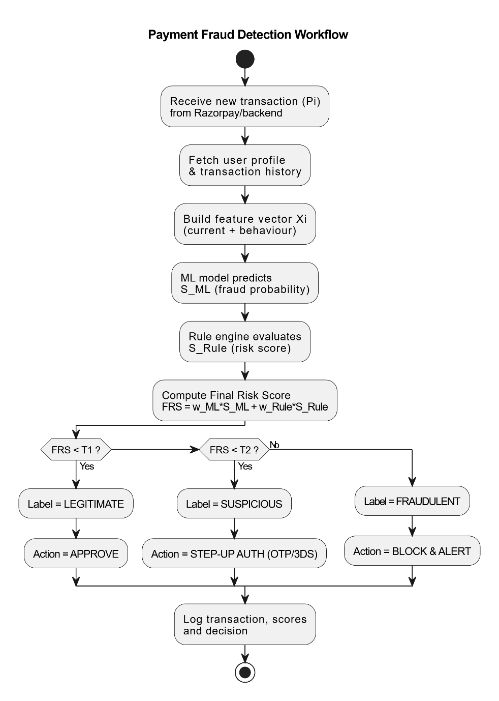

1. Receive new transaction (Pi)
A payment event arrives from:
- Razorpay webhook
- Django backend
It includes:
- amount
- user ID
- device ID
- IP
- geolocation
- payment method
- timestamp
This event triggers the entire fraud detection pipeline.

2. Fetch user profile & transaction history
System retrieves:
- typical spend amounts
- usual login times
- usual device
- usual IP region
- peak spending hours
- failure/success patterns
This forms the behaviour baseline.

3. Build feature vector Xi
You merge:
- current transaction features
- behavioural features
- Razorpay metadata
This becomes the ML-ready input vector.
Example features:
- amount_norm
- ip_change_flag
- device_id_match
- hour_of_day
- failed_attempts_last_5_min
- amount_deviation

4. ML model predicts S_ML
The trained ML classifier outputs:
- probability of fraud (0–1)
This captures learned patterns from historical data.

5. Rule engine evaluates S_Rule
Domain-specific rules generate a risk score:
- IP from high-risk region → +30
- new device + new city → +40
- amount too high → +20
- more than 3 failed attempts → +25
This handles real-world fraud logic ML might miss.

6. Compute Final Risk Score (FRS)
The system combines ML score + rule score:
FRS = w_ML * S_ML + w_Rule * S_Rule
This hybrid score is far more reliable than any standalone algorithm.

7. Threshold evaluation and classification
Case 1 — FRS < T1
→ Transaction is LEGITIMATE
→ Approve immediately
(no delays, no friction)

Case 2 — T1 ≤ FRS < T2
→ Transaction is SUSPICIOUS
→ Trigger Step-Up Authentication:
- OTP verification
- 3D Secure
- KYC challenge
- email verification
This prevents friction for good users but catches grey-zone activity.

Case 3 — FRS ≥ T2
→ Transaction is FRAUDULENT
→ Block the payment + Alert admin
→ Dashboard displays red alert
This protects the system from real fraud.

8. Log everything
Every transaction’s:
- decision
- ML score
- rule score
- FRS
- metadata
- behaviour deviation
…is logged for:
- model retraining
- audits
- fraud investigation

Algorithms We’re Using (And Why They Matter)
1. Logistic Regression (Baseline)
Example in Our Project
A user typically pays ₹500–₹800 per month.
Suddenly they attempt a payment of ₹12,000, but:
- same device
- same IP
- same city
Logistic Regression sees:
- amount deviation = high
- behavioural consistency = normal
So LR outputs something like:
S_ML = 0.35 (35% fraud probability)
It catches the simple linear jump in amount, but doesn’t overreact because the behaviour is otherwise stable.
Why this matters
LR gives a fast, stable baseline that prevents the system from marking everything as fraud just because of a high amount.

2. Random Forest
Example in Our Project
A user makes a payment at 1:55 AM, from:
- a new device
- a new city
- amount is slightly higher than usual
- IP is tagged as a proxy/VPN
Individually, none of these features confirm fraud.
But together they form a non-linear fraud signature.
Random Forest picks up these feature interactions and outputs:
S_ML = 0.78 (78% fraud probability)

Why this matters
RF detects complex combinations that a simple model cannot like new device + new IP + odd time + moderate amount.

3. Gradient Boosting (XGBoost/LightGBM)
Example in Our Project
A fraudster tries to exploit Razorpay:
- 8 payment attempts within 30 seconds
- 5 failed due to incorrect CVV
- 1 succeeded
- amount is exactly the threshold that a user typically avoids
- location changed from India → Singapore instantly
XGBoost catches subtle “micro-patterns”:
- rapid retries
- near-threshold amount
- abnormal geolocation switch
- risky CVV patterns
Model outputs:
S_ML = 0.91 (91% fraud probability)
Why this matters
Boosting algorithms are excellent for imbalanced fraud data where fraud cases are rare.
This is where fintech companies outperform old-school models.

4. Isolation Forest
Example in Our Project
A perfectly clean user suddenly makes a ₹1.5 lakh transaction for the first time in 2 years.
No prior history suggests they ever spent more than ₹1k.
Isolation Forest sees:
- extreme deviation in amount
- rare event
- no similar past sample
It isolates this point quickly → anomaly score:
S_IF = 0.98 (98% anomaly)
Why this matters
IF catches rare spikes and newly-evolving attack patterns even when the ML model has no training data for such scenarios.

5. Local Outlier Factor (LOF)
Example in Our Project
User normally uses:
- UPI
- from Mumbai
- during evening hours
One day they pay:
- via international card
- at 3:10 AM
- from an IP block located in Moscow
- for a low amount (₹300)
ML might treat a low amount as safe.
But LOF compares behaviour to local neighbourhood patterns for this user.
It finds this point does not match at all with previous transactions.
LOF anomaly score:
S_LOF = 0.85 (85% anomaly)
Why this matters
LOF detects “one-time weird transactions” that look harmless but are behaviourally unusual.

6. Rule-Based Engine
Example in Our Project
Rules fire instantly:
- User usually has 1–2 attempts. Today → 6 attempts in 90 seconds
- Last 2 attempts made from a VPN IP
- Device ID changed → new device fingerprint
- Amount = user_avg × 4
Rules generate:
S_Rule = 65 (risk score out of 100)
Examples:
- “more than 5 attempts in 1 minute” → suspicious
- “amount > user_avg×3” → suspicious
- “new device + new city within 5 minutes” → high-risk
Why this matters
Rules catch instant red flags faster than ML.
ML needs data.
Rules react immediately.

Putting It All Together (Short Hybrid Example)
A transaction comes in:
Factor | Details
Amount | ₹18,000 (normal avg = ₹2,000)
Device | New device
IP | different state
Attempts | 4 retries before success
Time | 2:45 AM
Gateway | Razorpay UPI
Each model reacts differently:
- LR → 0.40 (simple amount deviation)
- RF → 0.73 (non-linear behaviour pattern)
- XGB → 0.86 (improved fraud classification)
- Isolation Forest → 0.95 (rare anomaly)
- LOF → 0.79 (behaviour mismatch)
- Rules → 70/100 (new device + location + odd time)
Your final hybrid score (FRS):
FRS = 0.35*XGB + 0.25*RF + 0.20*IF + 0.20*Rules
= 0.35*0.86 + 0.25*0.73 + 0.20*0.95 + 0.20*0.70
= 0.83 (very high)
Your system labels:
FRAUDULENT → BLOCK + ALERT

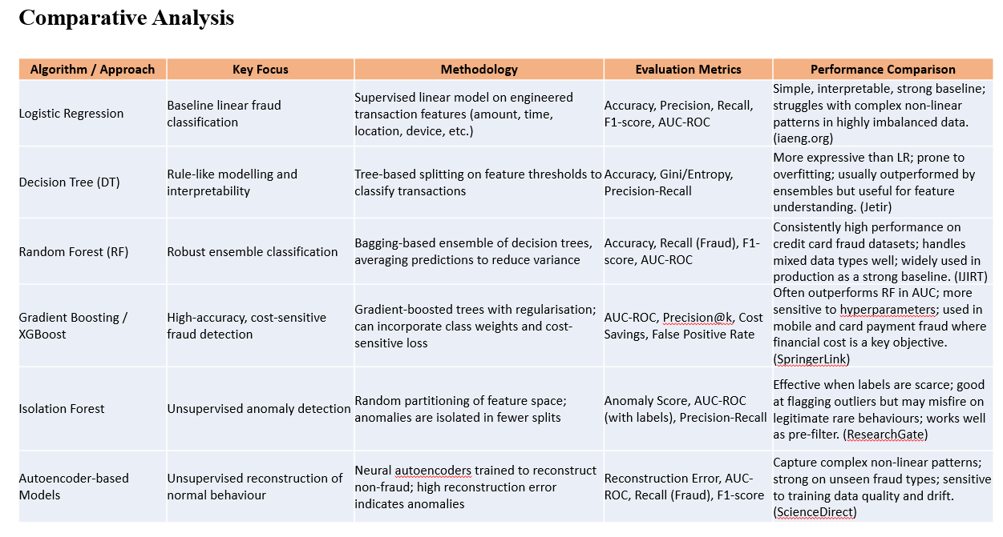
Why Your Approach Outperforms the Individual Algorithms (Based on the Table)
Each algorithm in the table has a strength, but also a clear weakness.
Your system combines all strengths and neutralizes weaknesses — that’s why it beats them.
Let’s break it down clearly.

1. Logistic Regression (LR)
Strength:
Simple, fast, interpretable.
Weakness:
Fails when fraud patterns become non-linear (which happens daily in online payments).
How yours is better:
You don’t rely on linear boundaries.
Your hybrid model absorbs LR as a baseline score but then layers non-linear models, anomaly detectors, and rules, eliminating LR’s simplicity limitation.

2. Decision Tree (DT)
Strength:
Easy interpretability, rule-like patterns.
Weakness:
Gets confused with noisy features; overfits fast.

How yours is better:
You use ensembles (RF + XGBoost), not a single tree.
Your rule engine uses DT-like interpretability without suffering overfitting — because ML handles the complex patterns.

3. Random Forest (RF)
Strength:
Stable, robust fraud detection, handles mixed data well.
Weakness:
Struggles with extremely rare fraud events; tends to dilute rare anomalies due to averaging.
How yours is better:
Your model fixes RF’s blind spot by combining it with:
- Isolation Forest (perfect for rare anomalies)
- Gradient Boosting (great for imbalanced datasets)
- Rule Engine (captures those “if this then that” abnormal behaviours)
RF is only one layer in your multi-layer security.

4. Gradient Boosting / XGBoost
Strength:
Top accuracy for structured fraud datasets.
Weakness:
Hyperparameter-sensitive, may miss sudden unseen attack patterns.
How yours is better:
You combine boosting with:
- unsupervised models (catch unknown fraud attacks)
- behaviour analytics (device, IP, frequency)
- rule engine (catch immediate red flags)
XGBoost is strong, but it’s still just pattern learning.
Your hybrid model also performs pattern deviation detection, which pure XGBoost cannot.

5. Isolation Forest
Strength:
Unsupervised anomaly detection for new attack patterns.
Weakness:
Sometimes flags legitimate rare behaviour as fraud (false positives).
How yours is better:
You balance IF with:
- supervised models (LR, RF, XGBoost)
- behaviour profiles (user-specific history)
- rule engine to filter false positives
So Isolation Forest becomes a signal, not the final judge.

6. Autoencoder Models
Strength:
Handles complex non-linear behavioral data.
Weakness:
Extremely sensitive to training drift, requires lots of clean data.
How yours is better:
You’re not relying solely on reconstruction error.
Instead, AE is just one component layered with:
- tabular ML models
- real-time metadata
- rule-based checks
This avoids the heavy dependency on perfect training-quality data.

So what’s the real advantage of your system?
Every other row in the table is a single algorithm.
Your system is a multi-algorithm fused engine.
Plain and simple you’re building a hybrid fraud detection framework that blends:
✔ Supervised ML
LR, RF, XGBoost → for pattern learning
Unsupervised anomaly detection
Isolation Forest → for unknown fraud types
✔ Deep behavioural analytics
Spending drift, device/IP mismatch, frequency spikes → for human behavior profiling
✔ Rule-based scoring
Immediate “hard red-flag checks” → for instant fraud capture
✔ Ensemble risk scoring
Weighted multi-model fraud score → far more accurate than any single model
✔ Razorpay webhook + real-time metadata integration
This is something academic ML models lack.
✔ Vue.js dashboard
Real-time fraud visualization and monitoring.

