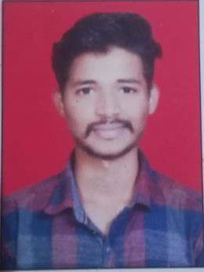

**RUSHIKESH PREMKISHAN SHELKE**

**BE Electronics and Telecommunication**

**Contact - +91-9552457999**

**Email –** [**shelkerushi22@gmail.com**](mailto:saurabhgorde426@gmail.com)

_________________________________________________________________________

# CAREER OBJECTIVE

To work in a firm with a professional work driven environment where I can utilize and apply my knowledge, skills which would enable me as a fresher to grow while fulfilling organizational goals.

# BASIC ACADEMIC CREDENTIALS

**University: Savitribai Phule Pune University (Maharashtra)**

|  |  |  |  |  |
| --- | --- | --- | --- | --- |
| **EXAMINATI ON** | **YEAR OF PASSING** | **INSTITUTE** | **BOARD/UNIVERS ITY** | **PERCENTAG E** |
| **BE** | pursuing | Pune Vidyarthi Griha’s College of Engineering and  Technology, Pune. | Pune University | - |
| **HSC** | 2020 | Dayanand Science College, Latur. | Maharashtra | 76.15% |
| **SSC** | 2018 | Shrikishan Somani School, Latur. | Maharashtra | 91.80% |

# SOFTWARE PROFICIENCY

* **IDE Known:** Visual Studio Code, Eclipse.
* **Application software:** MS- Office, Excel, PowerPoint.

# TECHNICAL SKILLS

* **Languages:** Java, C, C++
* **Web Technologies:** Javascript, HTML, CSS, Bootstrap

# EXTRACURRICULAR ACTIVITIES

* Participated in various events organized by college.
* Deco-head of the events organized by TESA.
* Organizer of the yearly event ‘SAMSARA’ at PVG COET.

# INTERPERSONAL SKILLS

* Strengths: Adaptability, Teamwork, Patience.
* Problem-solving skill
* Ability to rapidly build relationships and set up a trust.
* Confident and Determined.

# PERSONAL DETAILS

Name : Rushikesh Premkishan Shelke

Date of Birth : 22-06-2002

Permanent Address : At-Murambi, Post-Sugaon, Tal-Chakur, Dist-Latur,

Pincode-413531

Languages Known : English, Marathi, Hindi

Hobbies : Sketching, Playing Cricket, Watching movies.

# DECLARATION

I do hereby declare that the details mentioned above are true to the best of my knowledge and belief.

Rushikesh Premkishan Shelke