AI-Powered Automated Testing Report
Total tests: 15
Passed: 13
Failed: 2

TC-001: Complete valid booking flow
Steps: Open home
Search Mumbai
Open first room
Submit valid booking form
Expected: Confirmation page shows booking reference
Actual: Confirmation page shows a booking reference
AI Observation: AI verifier: The confirmation page shows a booking reference number. Confidence: 0.92
Status: PASS
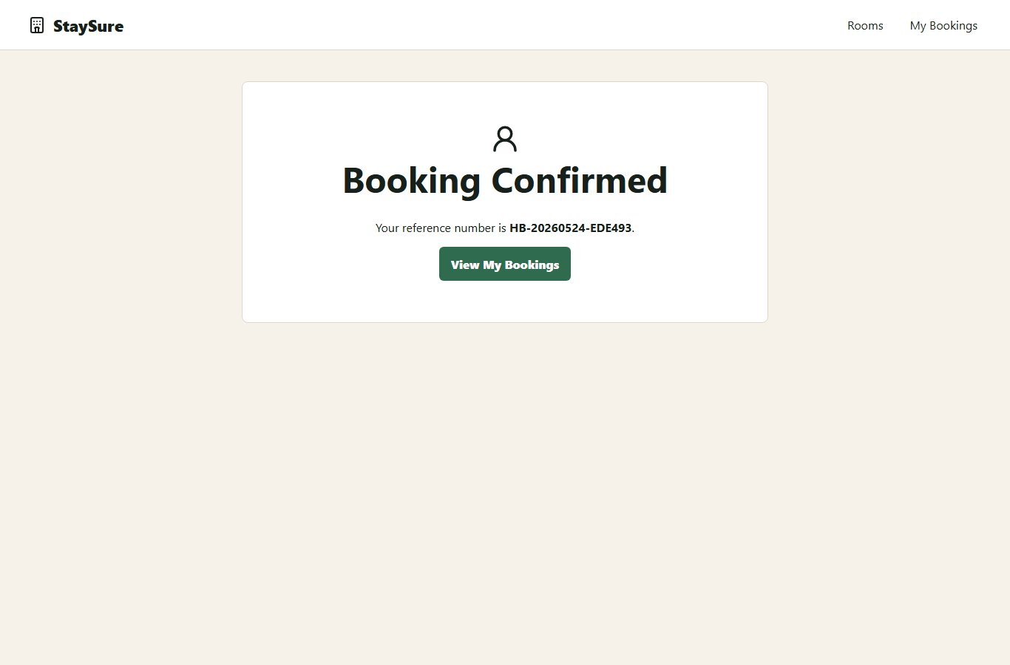

TC-002: Search for available rooms
Steps: Open home
Search Mumbai
Expected: Search results list available rooms with prices
Actual: Search results show available rooms with prices
AI Observation: AI verifier: The screenshot displays a list of available rooms with their prices. Confidence: 0.95
Status: PASS
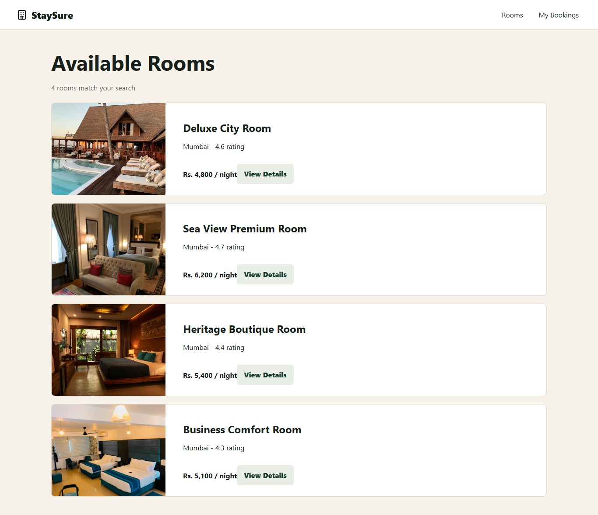

TC-003: View room details
Steps: Open search results
Open Deluxe City Room
Expected: Room details page shows amenities and Book Now button
Actual: Room details and amenities are visible
AI Observation: AI verifier: The room details page shows amenities and a 'Book Now' button. Confidence: 0.95
Status: PASS
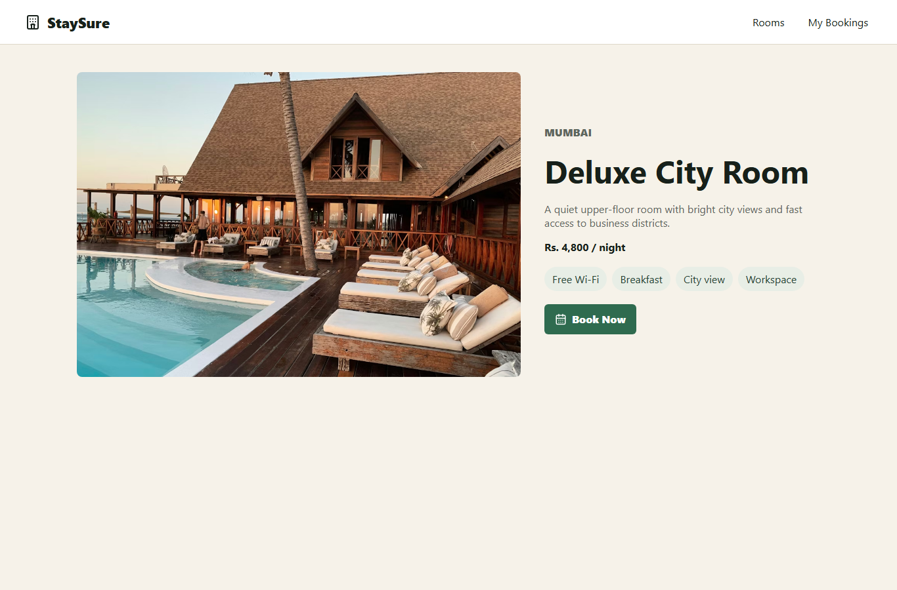

TC-004: View my bookings
Steps: Create valid booking
Open My Bookings
Expected: Created booking appears in booking list
Actual: The created booking appears in My Bookings
AI Observation: AI verifier: The created booking appears in the My Bookings list. Confidence: 0.95
Status: PASS
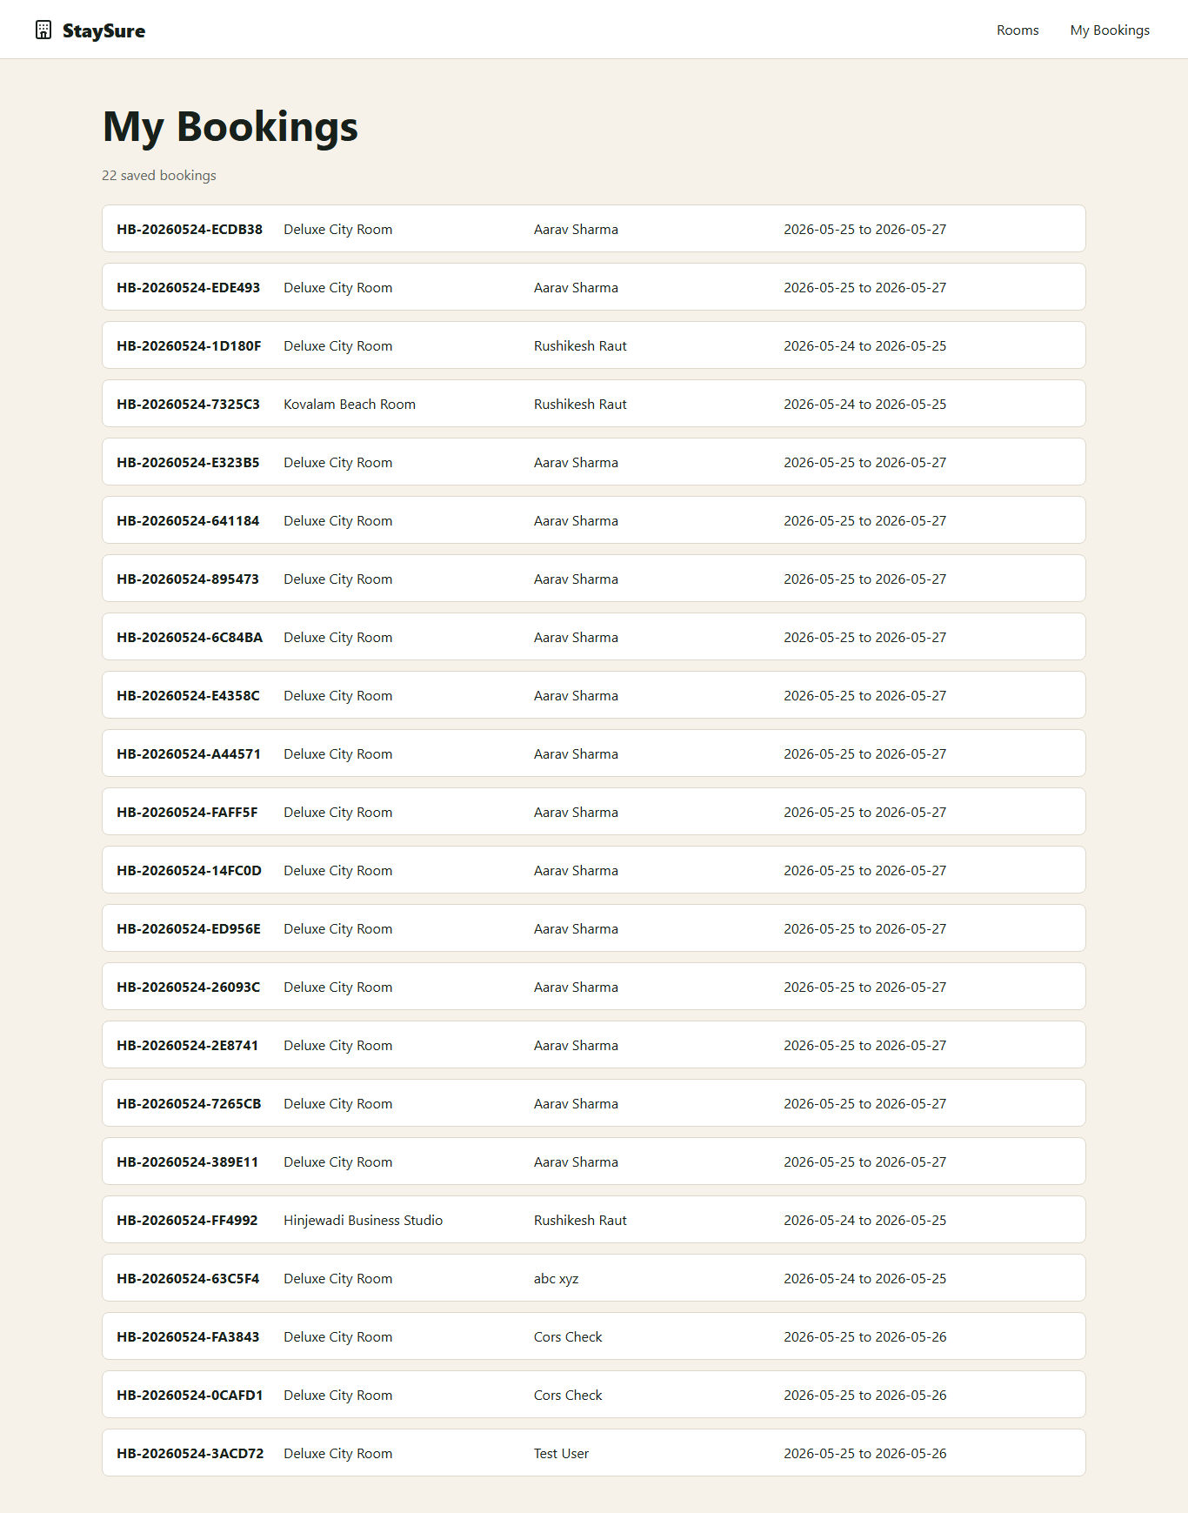

TC-005: Empty first name
Steps: Open booking form
Leave first name empty
Submit form
Expected: First name required error is shown
Actual: First name is required
AI Observation: AI verifier: The error message 'First name is required' is clearly visible. Confidence: 0.95
Status: PASS
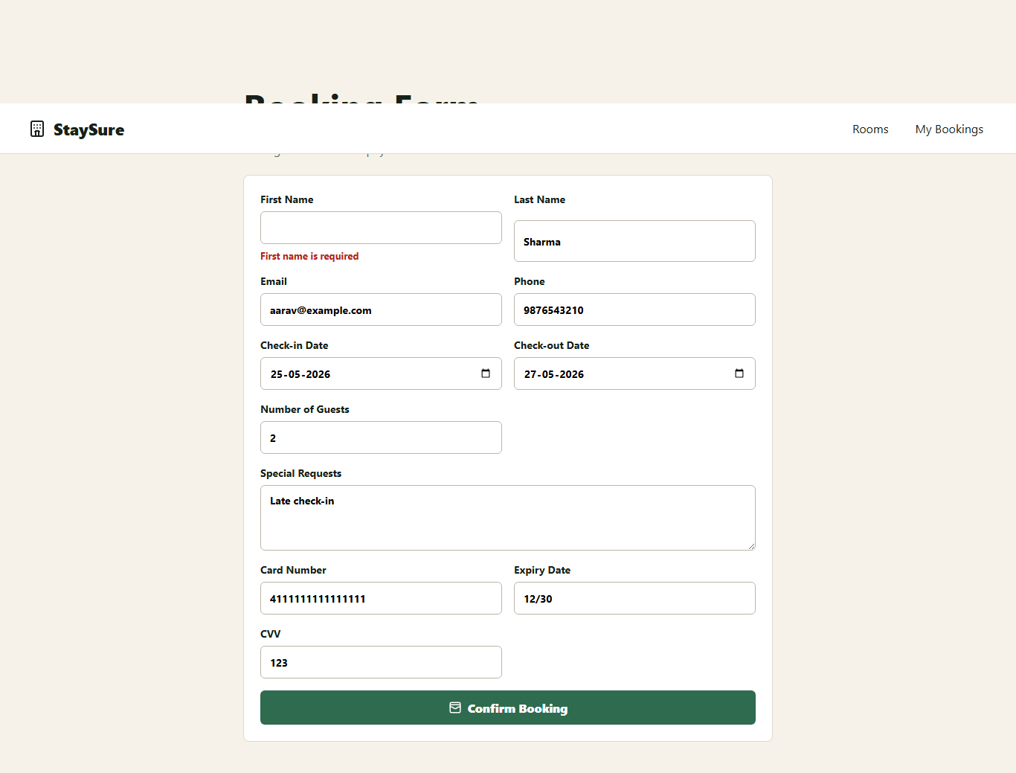

TC-006: Empty last name
Steps: Open booking form
Leave last name empty
Submit form
Expected: Last name required error is shown
Actual: Last name is required
AI Observation: AI verifier: The error message 'Last name is required' is clearly visible. Confidence: 0.95
Status: PASS
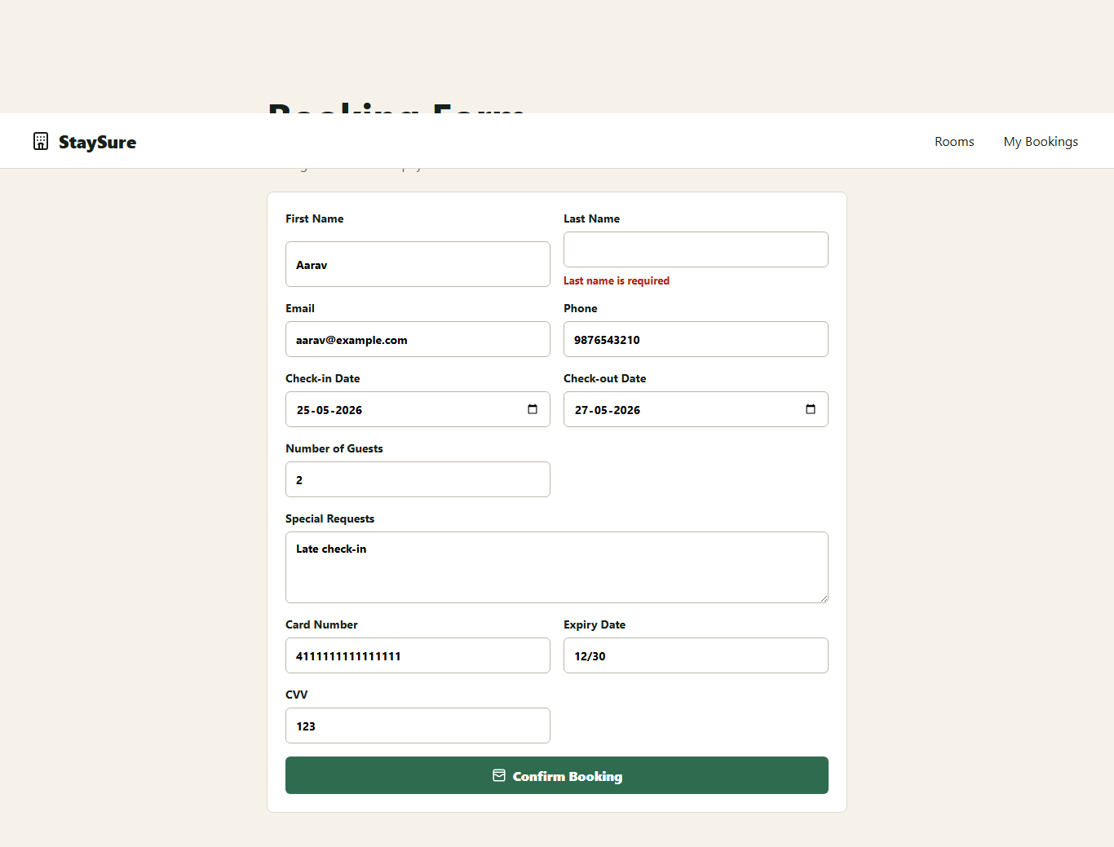

TC-007: Invalid email format
Steps: Open booking form
Enter invalid email
Submit form
Expected: Valid email error is shown
Actual: Enter a valid email address
AI Observation: AI verifier: An error message indicating 'Enter a valid email address' is visible. Confidence: 0.95
Status: PASS
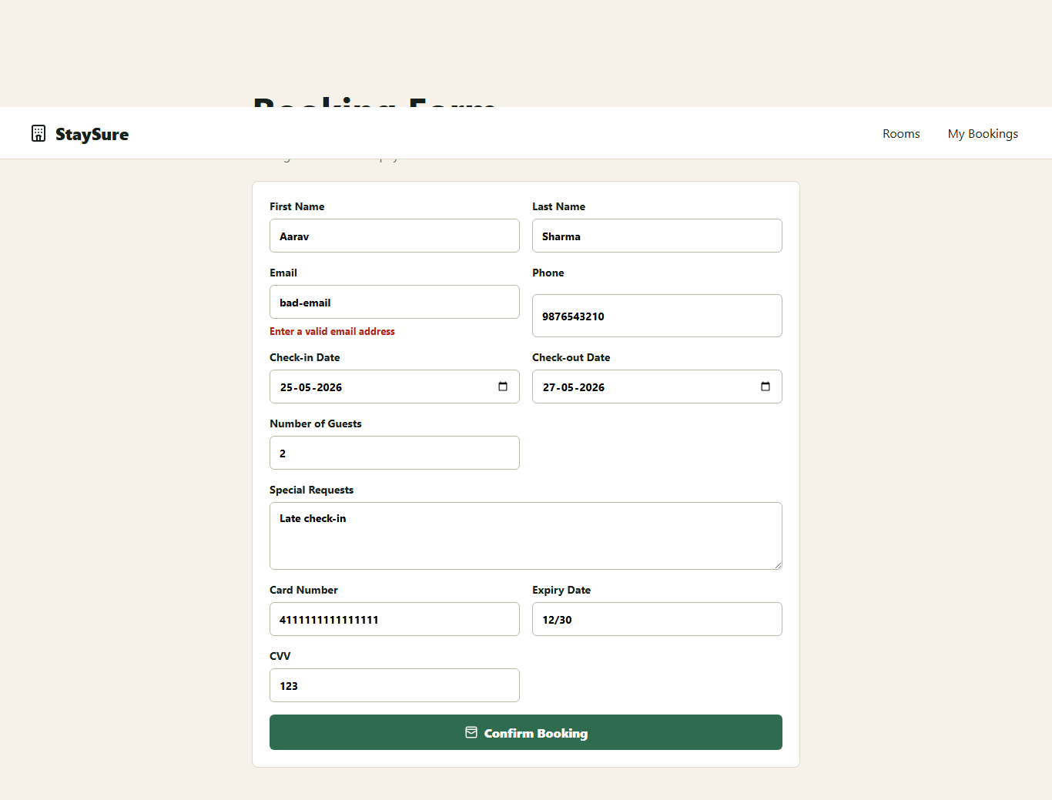

TC-008: Invalid phone letters
Steps: Open booking form
Enter letters in phone
Submit form
Expected: 10 digit phone error is shown
Actual: Phone must be exactly 10 digits
AI Observation: AI verifier: An error message indicates that the phone must be exactly 10 digits. Confidence: 0.95
Status: PASS
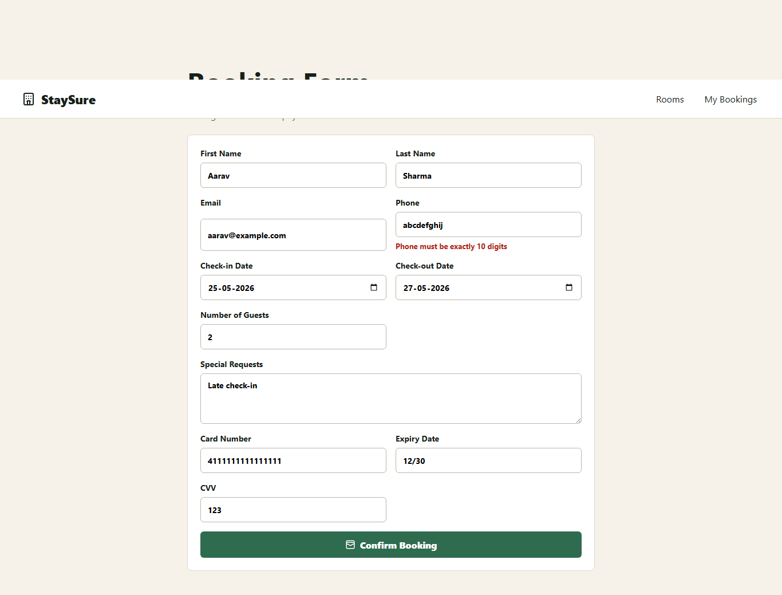

TC-009: Phone less than 10 digits
Steps: Open booking form
Enter 12345 as phone
Submit form
Expected: 10 digit phone error is shown
Actual: Phone must be exactly 10 digits
AI Observation: AI verifier: The error message indicating the phone must be exactly 10 digits is visible. Confidence: 0.95
Status: PASS
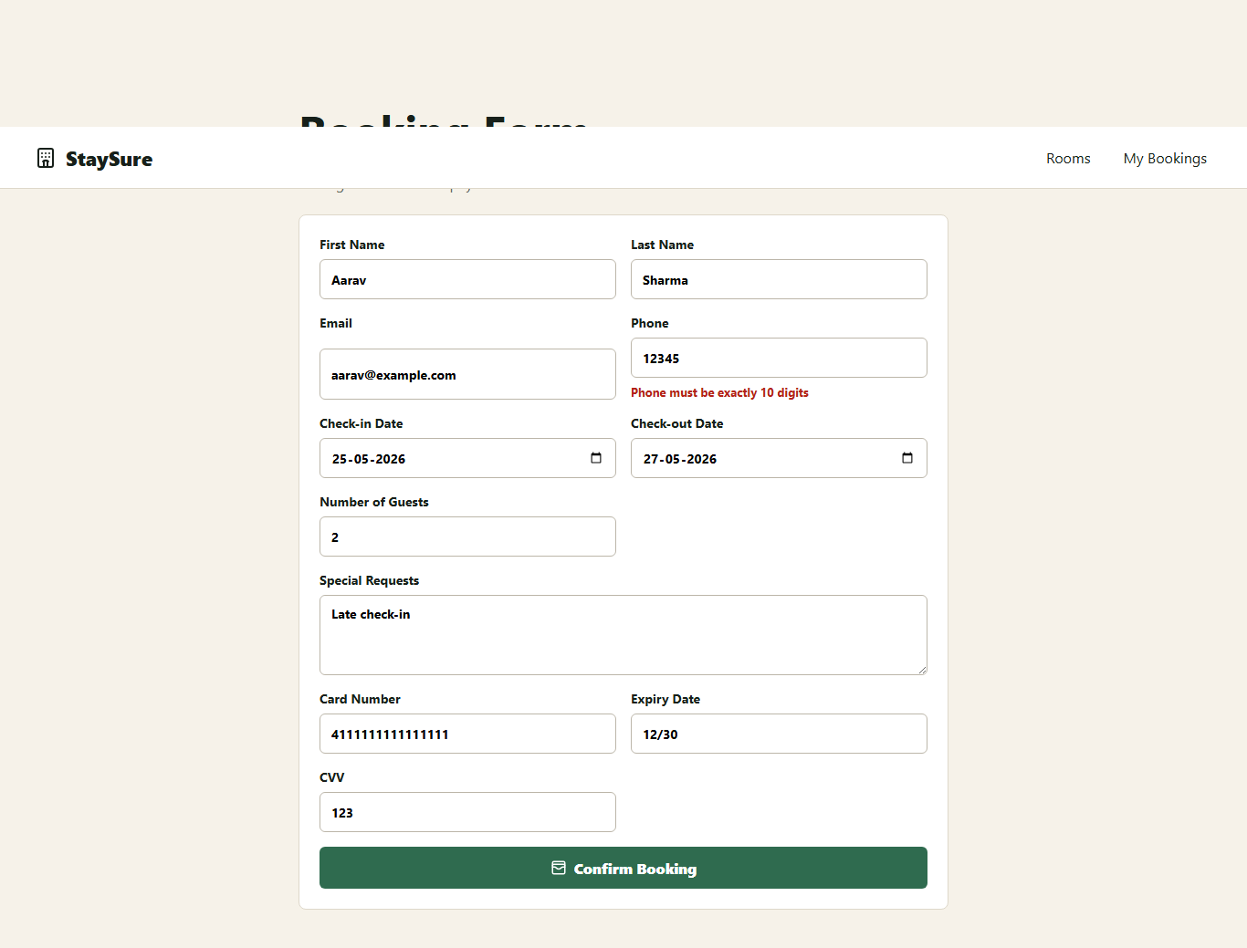

TC-010: Check-out before check-in
Steps: Open booking form
Set check-out before check-in
Submit form
Expected: Check-out after check-in error is shown
Actual: Check-out date must be after check-in
AI Observation: AI verifier: The screenshot shows an error message indicating the check-out date must be after the check-in date. Confidence: 0.85
Status: FAIL
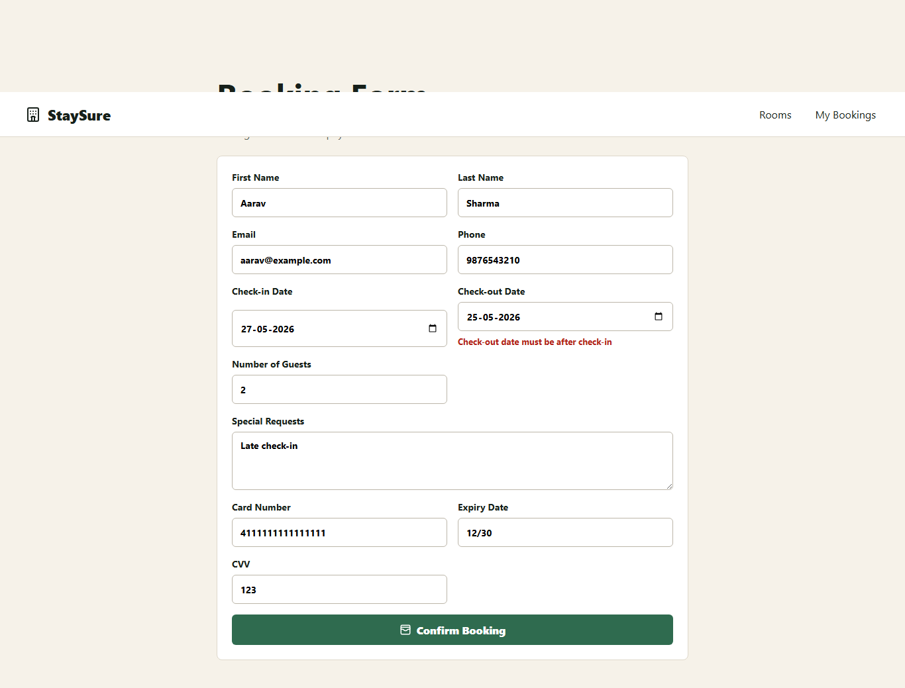

TC-011: Guests equals 0
Steps: Open booking form
Set guests to 0
Submit form
Expected: Guests between 1 and 10 error is shown
Actual: Guests must be between 1 and 10
AI Observation: AI verifier: An error message indicates that guests must be between 1 and 10. Confidence: 0.95
Status: PASS
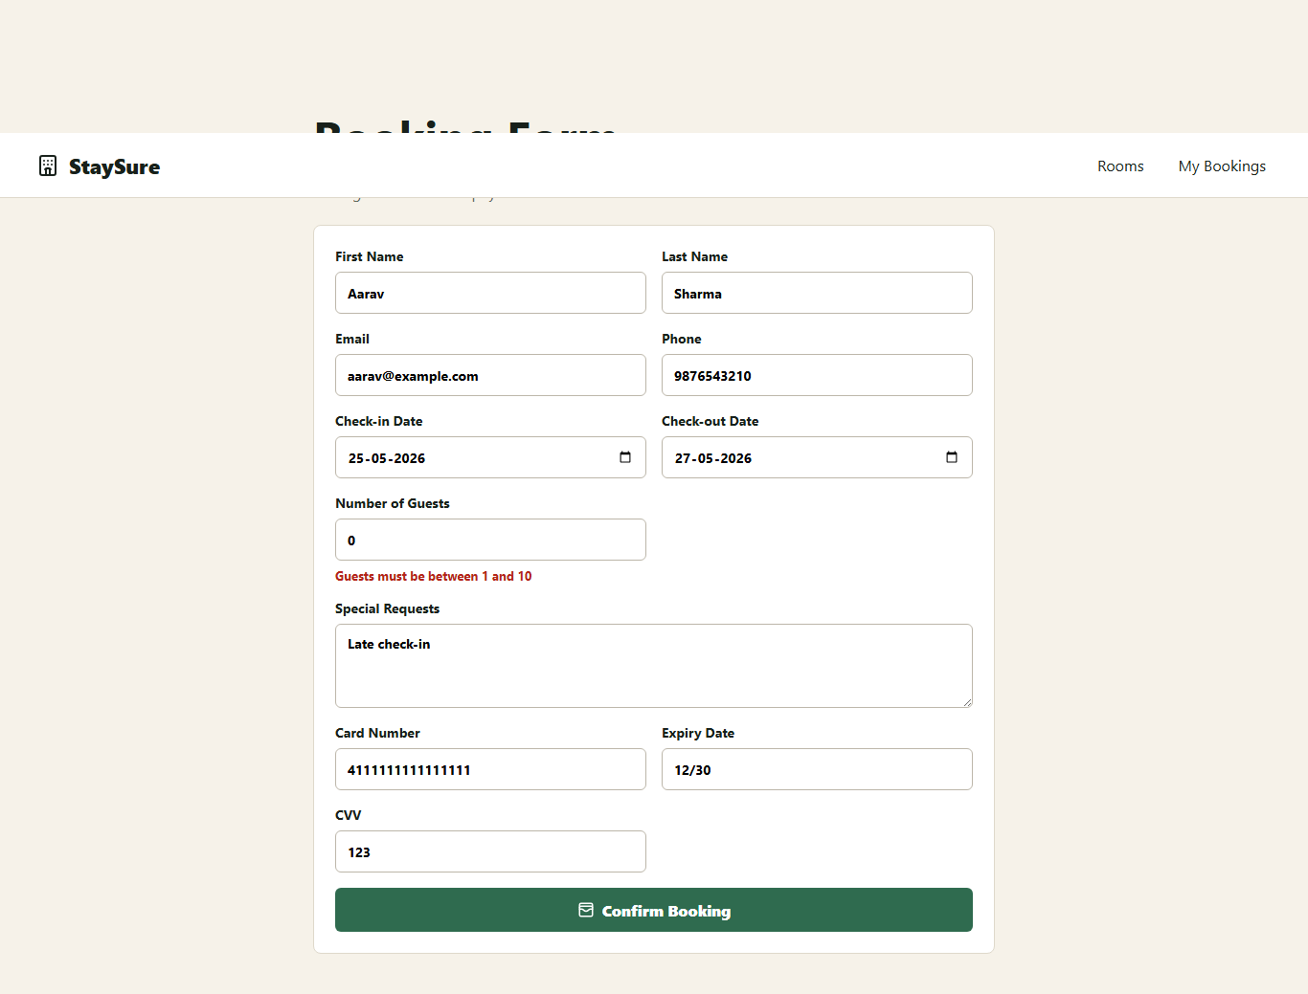

TC-012: Guests greater than 10
Steps: Open booking form
Set guests to 11
Submit form
Expected: Guests between 1 and 10 error is shown
Actual: Guests must be between 1 and 10
AI Observation: AI verifier: An error message indicates that guests must be between 1 and 10. Confidence: 0.95
Status: PASS
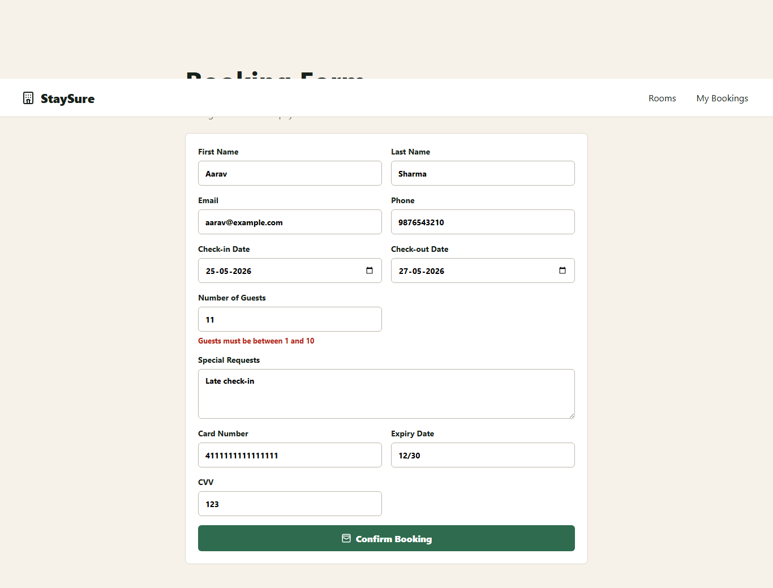

TC-013: Invalid card number
Steps: Open booking form
Enter short card number
Submit form
Expected: 16 digit card error is shown
Actual: Card number must be exactly 16 digits
AI Observation: AI verifier: The screenshot shows an error message indicating the card number must be exactly 16 digits. Confidence: 0.85
Status: FAIL
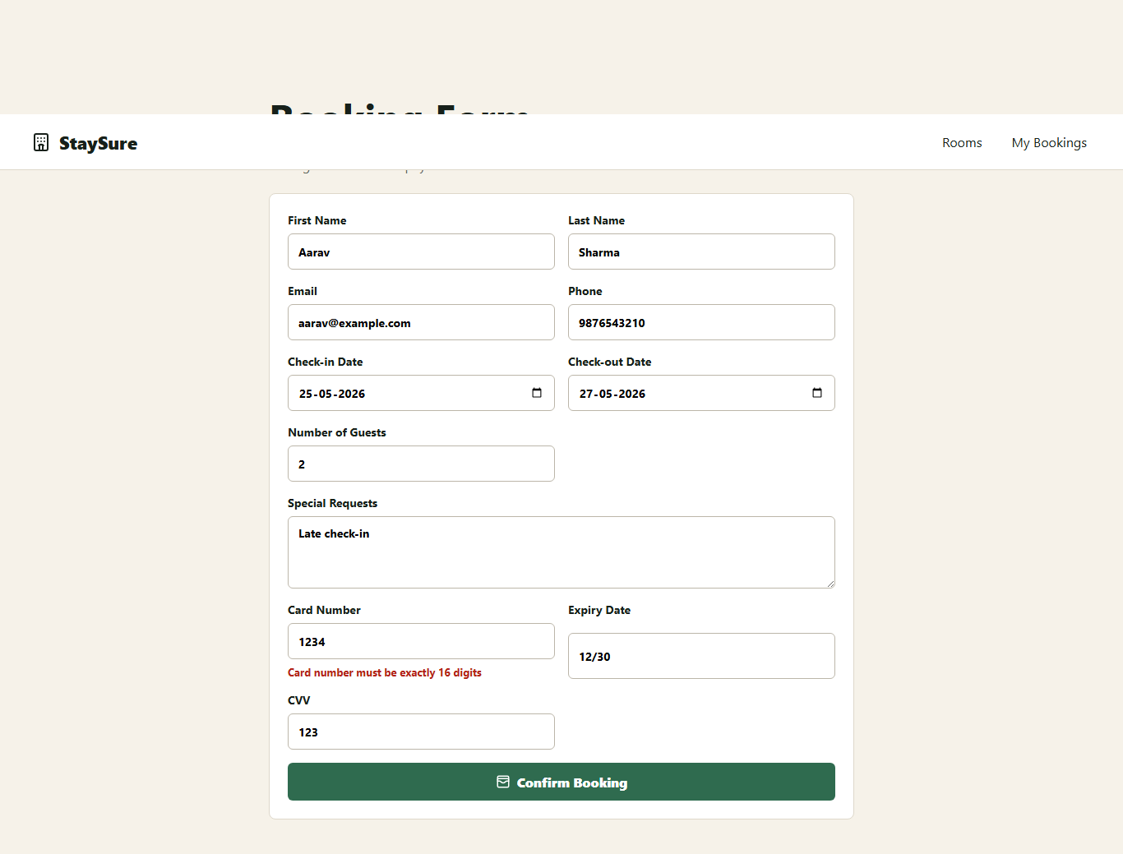

TC-014: Expired card date
Steps: Open booking form
Enter 01/20 expiry
Submit form
Expected: Expiry date expired error is shown
Actual: Expiry date must not be expired
AI Observation: Local verifier (OpenRouter HTTP 402: {"error":{"message":"This request requires more credits, or fewer max_tokens. You requested up to 16384 tokens, but can only afford 12875. To increase, visit ht): Expiry date must not be expired Confidence: 0.78
Status: PASS
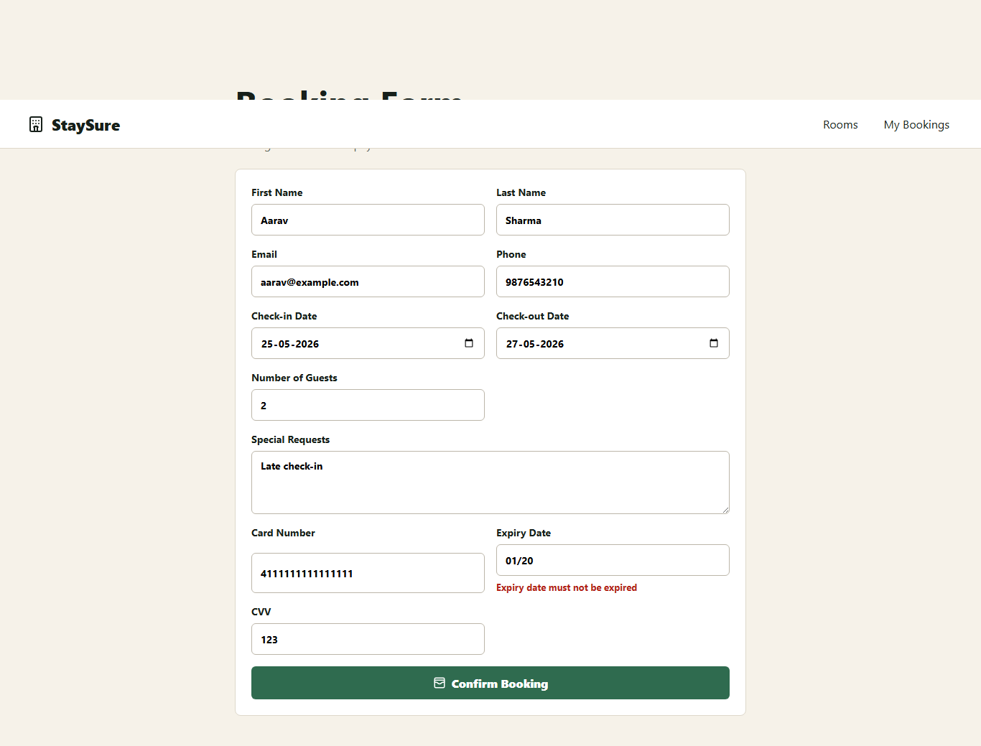

TC-015: Invalid CVV
Steps: Open booking form
Enter 12 as CVV
Submit form
Expected: 3 digit CVV error is shown
Actual: CVV must be exactly 3 digits
AI Observation: Local verifier (OpenRouter HTTP 402: {"error":{"message":"This request requires more credits, or fewer max_tokens. You requested up to 16384 tokens, but can only afford 12875. To increase, visit ht): CVV must be exactly 3 digits Confidence: 0.78
Status: PASS
