Docker
DEVOPS | Assignment

GitHub Repository Link : https://github.com/rushi2212/tutedude-docker.git
Docker Hub frontend link: https://hub.docker.com/r/rushikesh220703/rushikesh-docker-frontend

Docker Hub backend link: https://hub.docker.com/r/rushikesh220703/rushikesh-docker-backend

1. Frontend (Node.js with Express)
- Create a frontend using Express and Node.js.
- Include a form similar to the one from the Flask Assignment 2.
- Configure the form to send a request to the Flask backend.
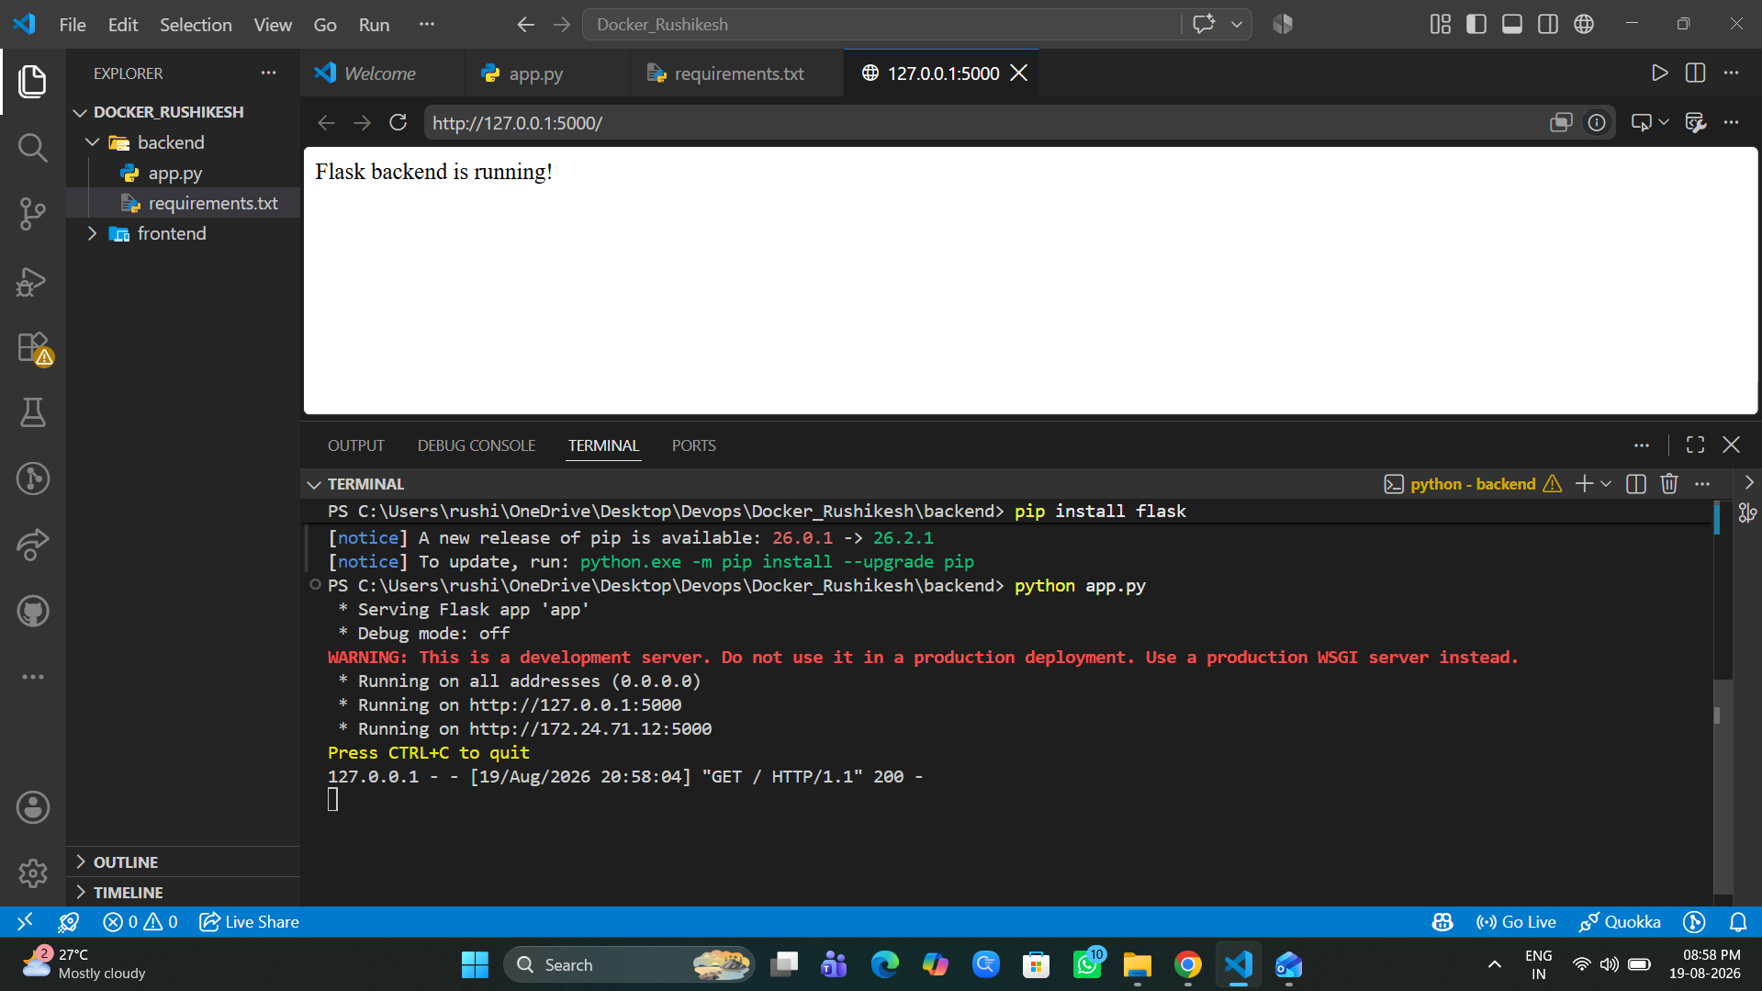
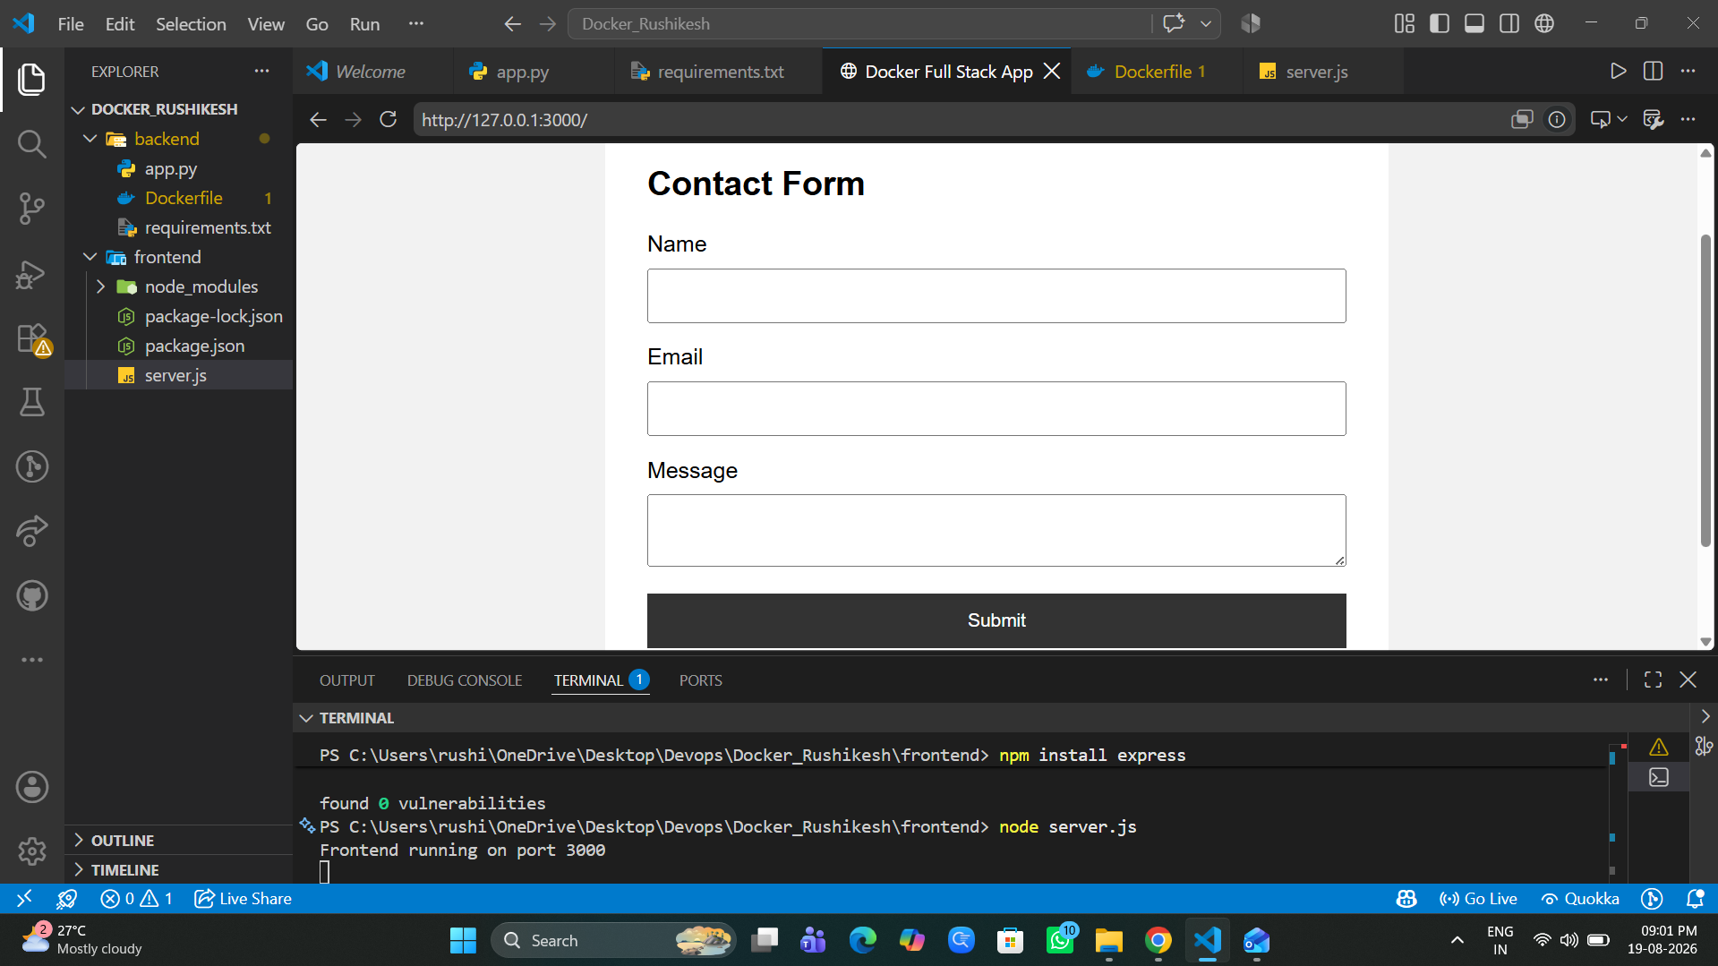
2. Backend (Flask)
- Use the Flask backend to handle the form submission and process the data.
3. Folder Structure
- Organize the project with separate folders for the frontend and backend.
4. Docker Configuration
- Create a Dockerfile for both the frontend and backend.
- Write a .yaml file (Docker Compose) to connect both services in the same network.
- Upload both images to Docker Hub, and push your whole code to GitHub. Add node_modules and other non-required files (e.g., .vscode) to .gitignore.
