TikTok Ads AI Agent (Mock Mode)

OVERVIEW :

This project implements a CLI-based AI Agent that helps users create a TikTok Ad configuration via conversation.
The focus is on:
• Prompt design
• Business rule enforcement
• OAuth reasoning
• Graceful API failure handling

Due to TikTok Ads geo-restrictions in India 🇮🇳 and the requirement for verified business accounts,
this project uses MOCKED TikTok credentials while preserving a production-ready workflow.

────────────────────────────

🧩 WHAT THE AGENT DOES :

1️⃣ Simulates TikTok OAuth Authorization Code flow
2️⃣ Collects ad inputs step-by-step via CLI
3️⃣ Enforces TikTok business rules BEFORE submission
4️⃣ Produces structured ad payload (JSON-like schema)
5️⃣ Simulates ad submission & interprets failures clearly
This is a reasoning-first AI workflow, not a chatbot 🤖

📁 PROJECT STRUCTURE :
my_agent/
│
├── app.py ▶ Entry point (agent lifecycle)
├── agent.py ▶ Conversational flow
├── oauth.py ▶ Mock OAuth logic
├── token_store.py ▶ Token persistence
├── tiktok_api.py ▶ Mock TikTok Ads API
├── validator.py ▶ Business rule enforcement
├── schemas.py ▶ Structured payload schema
├── config.py ▶ Mock configuration
└── README.md
────────────────────────────
🔐 OAUTH HANDLING (MOCKED) :
Why mocked?
• TikTok Ads requires verified business details
• TikTok is geo-restricted in India
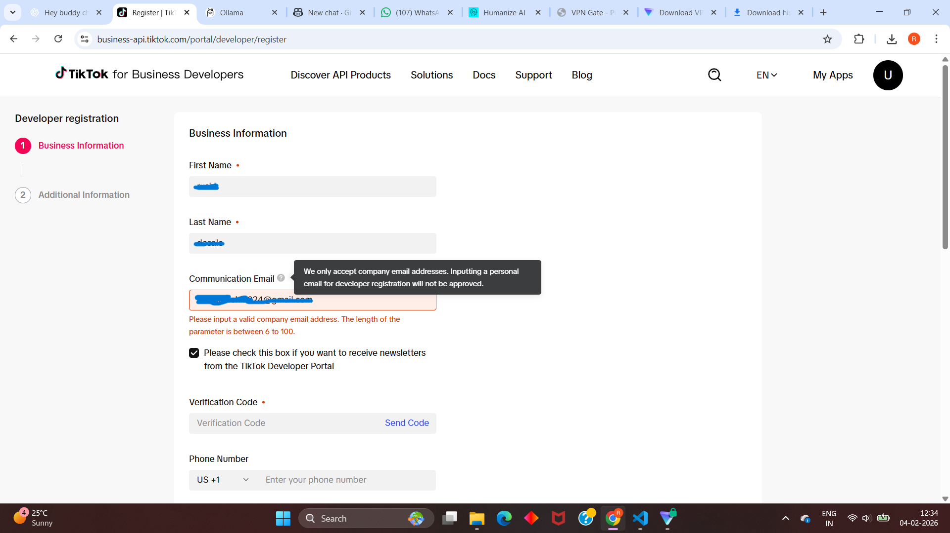

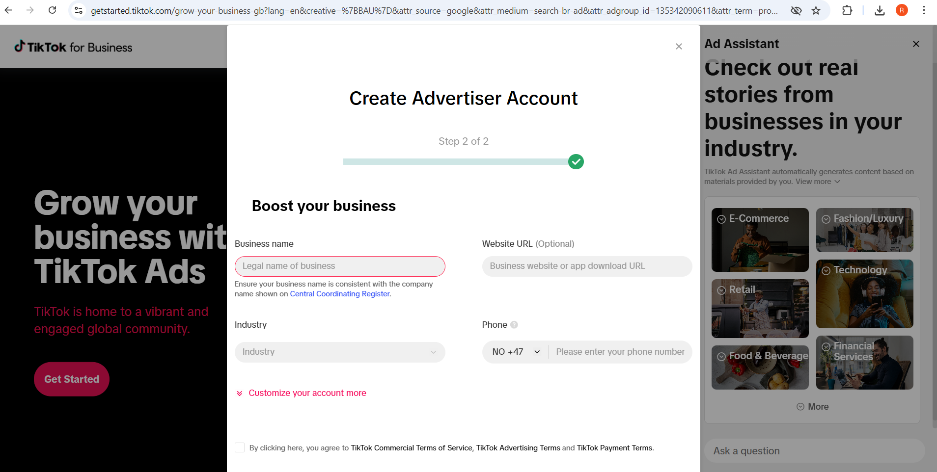

────────────────────────────

What is still implemented:
✔ Authorization Code flow logic
✔ Token lifecycle handling
✔ Failure interpretation
✔ Production-ready design

The system can switch to real credentials without code changes .

────────────────────────────

🎵 MUSIC LOGIC (KEY EVALUATION AREA):

Supported cases:
• Existing Music ID
• Custom Music Upload
• No Music

Rules enforced:
No music is ALLOWED only for Traffic campaigns
No music is BLOCKED for Conversions campaigns (before API call)

Rules are enforced in CODE, not by the LLM.

────────────────────────────

📦 STRUCTURED OUTPUT :

Final payload format:

{
"campaign_name": "...",
"objective": "...",
"creative": {
"text": "...",
"cta": "...",
"music_id": "..."
}
}

Conversation, reasoning, and output are clearly separated .

────────────────────────────

🧪 API FAILURE HANDLING :

The agent reasons about:
• Invalid OAuth token
• Invalid music ID
• Geo restriction

Instead of raw errors, the agent:
✔ Explains the issue
✔ Suggests corrective action
✔ Decides retry vs stop

────────────────────────────

⚙️ TECH STACK :

• Language: Python
• Interface: CLI
• LLM: Local LLaMA (via Ollama)
• APIs: Mocked TikTok Ads API
• No UI, no fine-tuning, no vector DB

────────────────────────────

▶️ HOW TO RUN

1️⃣ Navigate to project root
2️⃣ Run:

python app.py

Follow CLI prompts to simulate ad creation .

────────────────────────────

🧠 DESIGN DECISIONS :

• Business rules enforced deterministically
• LLM used only for reasoning, not control
• APIs mocked for reproducibility
• Quality > Quantity

────────────────────────────

🚧 LIMITATIONS & FUTURE WORK :

With real credentials:
• Live OAuth token refresh
• Real TikTok Ads API
• Retry & backoff strategies

────────────────────────────

FINAL NOTE :

This project demonstrates practical AI workflow engineering under real-world constraints.
If I get enough time to create this one ,then I will find all possible ways to connect with that app and make sure my Agnet is smartly handling all the requests and real time authorization.
My Agent is ready to work it just need the important credentials .

Thank you .
Author
Rushikesh desale.

