**GROUP 5.9**

**Name - Rushikesh Nalla**

**ID - 201401106**

**Name - Omkar Damle**

**ID - 201401114**

**DATA FLOW DIAGRAM**

**CENTRALISED SCHOLARSHIP MANAGEMENT SYSTEM**

**NOTE - DIA Files are uploaded as well (as Level 0 and 1 are not clearly visible)**

**1. Context level diagram :**

* The context level diagram is used to provide a high level abstraction of the system.
* The important external entities can be observed from the diagram. External entities : Student, Funding organisation, software manager, bank.
* The processes are shown in the level 0 diagram.

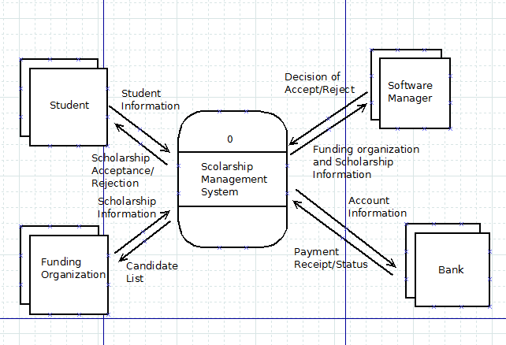

**2. Level 0 diagram :**

* Each use case has been mapped to a process in the DFD.
* The data stores used are : student information, funding organisation information, scholarship information, payment information, student bank account information.
* Each data store corresponds to an entity in the ER diagram.
* ‘Scholarship information’ data store contains the list of applied candidates for the scholarship, and the list of selected candidates and the scholarship information.

**As we mapped each use case to a process in DFD, we got a complicated DFD at level 0. In the next version, we plan to make it simpler.**

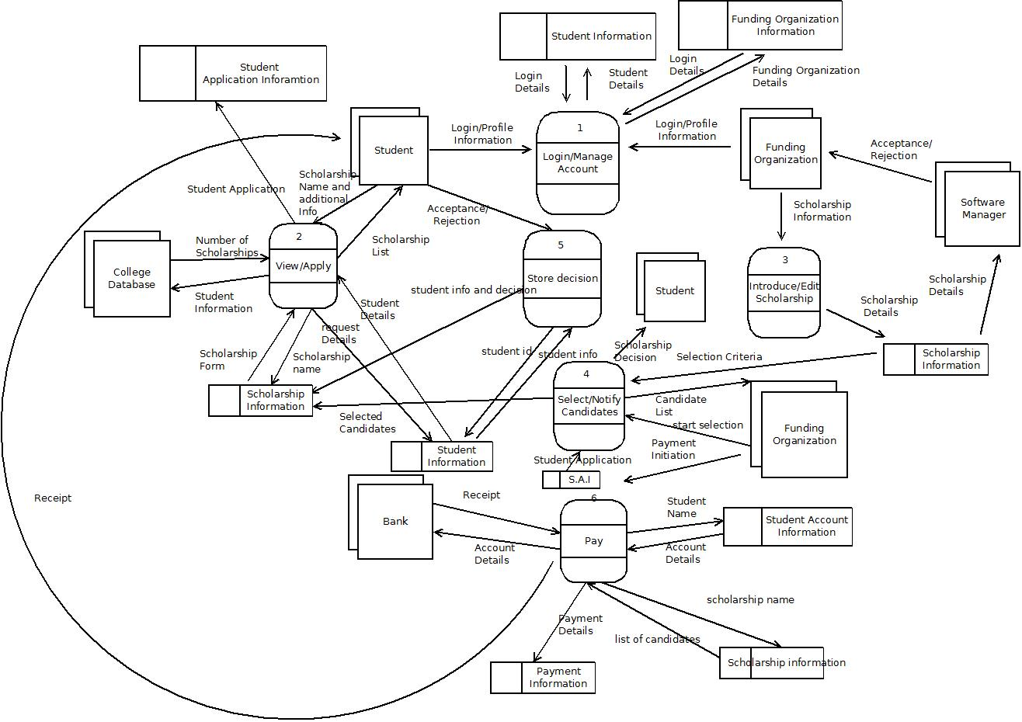

**3. Level 1 diagram :**

* The following processes have been expanded

1. Login/Manage account

2. View/Apply scholarship

3. Select/Notify candidates

4. Pay

**Process 1:**

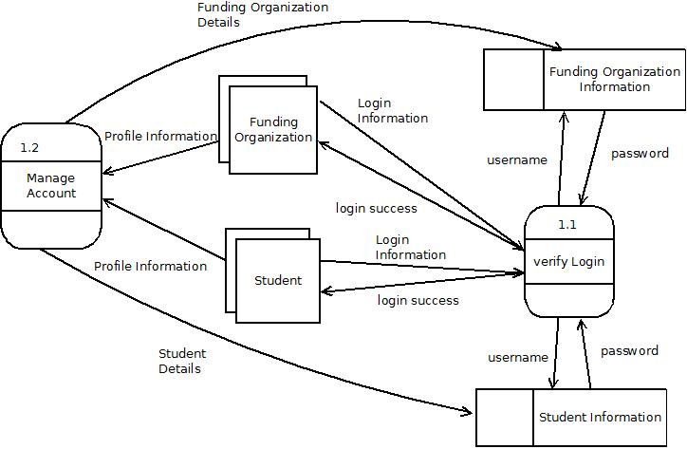

**Process 2:**

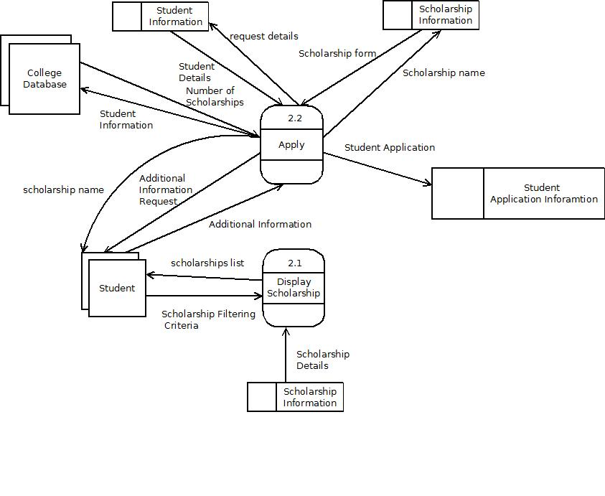

**Process 4:**

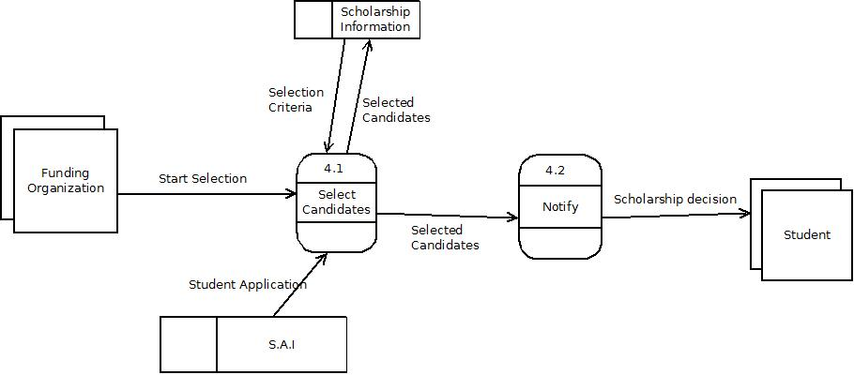

**Process 6:**

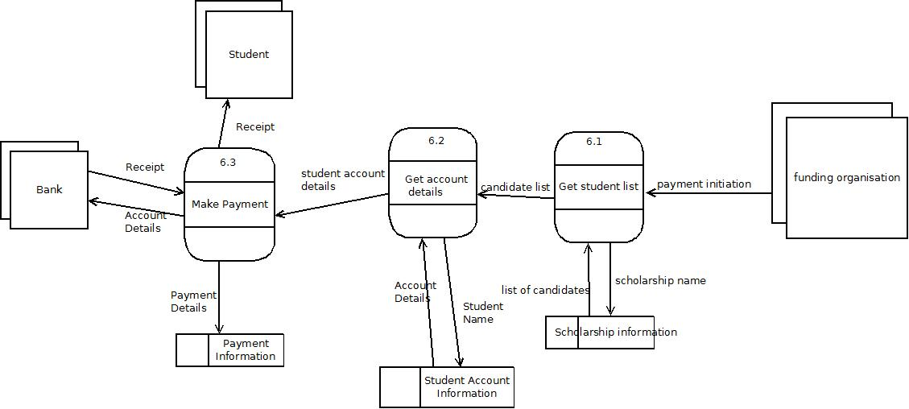

**List of data stores -**

1. **Student information** - Contains basic information(profile) of the student
2. **Student account information(financial)** - Contains Student account information
3. **Funding organisation information** - Contains basic information of the Funding organization.
4. **Scholarship information** - Contains detailed information about each scholarship
5. **Payment information** - Contains payment information made by the bank.
6. **Student application information** - Contains application information

**4. Level 2 diagram -**

**Manage account is expanded -**

