**GROUP 5.9**

**Name - Rushikesh Nalla**

**ID - 201401106**

**Name - Omkar Damle**

**ID - 201401114**

**FINAL REPORT**

**CENTRALISED SCHOLARSHIP MANAGEMENT SYSTEM**

[**PROBLEM DESCRIPTION**](#_nu68jhnx0lm) **2**

[**SYSTEM REQUIREMENTS AND SPECIFICATIONS**](#_pc1xlrhkoh8f) **12**

[Questionnaire:](#_1z9nydfyq8gp) 12

[Survey Analysis -](#_qct3mqwvvb3o) 14

[Interview -](#_1udrko97nfhj) 16

[Background reading :](#_xe8fd6c2ozgr) 26

[Requirements :](#_zch2g5ai32r) 31

[Observations :](#_kceps1q2qn9o) 32

[User Categories :](#_c4271q19uu6d) 32

[User Privileges(Access Permissions) :](#_ue6aepcgb9an) 33

[Assumptions :](#_9ryw8g8ice62) 33

[Business Constraints:](#_uj04q43r5py3) 34

[Fact Finding Techniques :](#_ev32lmba6xoj) 34

[**USE CASE DIAGRAM(WITH ALTERNATE FLOWS)**](#_m48gur6i8ej) **36**

[**DATA FLOW DIAGRAM(DFD)**](#_dt65fkuc99dr) **42**

[1. Context level diagram :](#_gf4u265lb8ja) 42

[2. Level 0 diagram :](#_va8m80av9wgx) 43

[3. Level 1 diagram :](#_b195l861o72d) 44

[4. Level 2 diagram -](#_bs8ez8eb9p7s) 48

[**CLASS MODEL**](#_d49zjj8zlzgz) **48**

[Initial Nouns](#_pauxrgxljuyn) 48

[Potential Classes and Attributes List](#_1ttq5l39o086) 52

[Class Diagram :](#_3z4gkz03s4c) 53

[Classes After Noun Analysis](#_e2p89b9i2y5w) 53

[CRC cards](#_osyujmz9cpov) 54

[Data Dictionary](#_mi7d06y21l74) 57

[**USE CASE SCENARIO WALKTHROUGH**](#_abmipg9nvkw7) **59**

[Revised Class Diagram after Scenario Walk through :](#_6bdccdki61o5) 72

[Revised Class Model after Scenario Walk through :](#_pt7labgwyojp) 72

[**INTERACTION MODELING**](#_fu7h7r0p5f) **75**

[Class Diagram Post Interaction Modeling](#_dn15cqcm2io6) 80

[Revised Class Diagram Post Interaction Modeling:](#_w7yniy95v343) 81

[**STATE MODELING**](#_sstxu26875mo) **82**

[**ACTIVITY MODELING**](#_oz5q1l9u3mmo) **84**

[Class Diagram Post Activity Modeling](#_utqmdbajky78) 89

[**IMPLEMENTATION**](#_7f1awu4jp3v2) **90**

[**JUNIT TESTING**](#_sivxc1segev1) **93**

# **PROBLEM DESCRIPTION**

**Database for Organizations providing Student Scholarships -**

Consider an organization that provides **scholarship** to Students based on **different criteria**. These scholarships are sponsored by different **people** and **organizations**. Each of them may provide different criteria for scholarship. Some prefer Students with good **academic performance** others prefer to provide scholarships to students going for **foreign education and some to poor and needy students**. Design and develop a system that efficiently handles all these features.

**Need of a centralized system:**

A scholarship is an important component concerning education for an individual. For some, the scholarship serves as a means of motivation and for others it makes education possible by providing financial support. There are many types of scholarships available.

**Workflow of the scholarship process :**

1. A scholarship applicant fills out the form and details for the scholarship programme.
2. He/she also needs to provide relevant documents like transcripts, letters of recommendation, etc.
3. The organisation then filters the students according to a predefined criteria. The students who fulfill the criteria are selected for the scholarship.
4. Many a times, the scholarship provider needs to sort the students in decreasing order of their academic merit and select the top, say, 20.
5. Then the students are informed of their selection and an offer is made to them. If the student accepts the scholarship, then the required funding is provided.

The funding process can also vary from one organisation to another. Usually, the student needs to pay the fees/travel fare/accommodation charges beforehand. Later on, the scholarship provider reimburses either the full cost or a partial cost of the financial expenditure.

**When is such a system used?**

Scholarships are provided by organisations throughout the year. However, most academic scholarships are provided after the start of the academic semester(needs to be confirmed ). Certain international internship scholarships for undergraduate students open their portals in November-December period. A survey needs to be conducted to predict when the load on the system will be at its peak.

**Types of scholarships:**

There are a number of types of scholarships:

1. Merit and academic scholarships
2. Research scholarships
3. Minority scholarships (caste and women)
4. Need based scholarships
5. Sports scholarships
6. Community service scholarships
7. First in family scholarships
8. Military scholarships
9. Special talent scholarships

All these scholarships are available for students from different backgrounds. Some scholarships are based on academic performance, while some are based on ethnicity. There are scholarships for students who require economic assistance. Some scholarships are provided for those who provide possess specific skills in sports or arts.

In conclusion, it is important to inform students about the different types of scholarships and help them in deciding which one is best suited for them.

**Entities involved:**

The main entities involved will be:

1. **Schools, colleges and universities**

Schools, colleges and universities will be associated with the students. However, our system does not deal with schools, colleges and universities directly. Our system deals directly with the students.

2. **Students**

Students will be the ones most benefited from this software as they can apply to various scholarships through one central system.

The students can be distinguished according to different parameters :

1)Level of education–

Students can be categorised in the following classes :

1. School student
2. High school student (11th and 12th std)
3. Undergraduate student
4. Graduate student
5. Post-graduate student

Undergraduate, graduate, and doctoral students each have specific financial needs. While there are some general scholarship programs that may be applicable to all students, the majority will be specific to student type and will only be available to students at a particular level of their college career. It is not uncommon for first time scholarship seekers to track down a promising program, only to find that they are ineligible because they are not at the specified degree level. In addition to degree level, many scholarships are designed to target students pursuing a specific major or course of study. These subject-specific awards make up a large part of the scholarship field, and students with definite career goals are likely to have better luck in their search for scholarship opportunities.

2) Field of study –

Students have different fields of study like the ones mentioned below :

1. Engineering
2. Medicine
3. Commerce
4. Arts(music, dance)
5. Literature

Most scholarship providers are looking for specific criteria when handing out awards. These criteria can range from excellent writing to original thinking to great research skills to demonstrated commitment to service. The characteristics sought by specific scholarships may also align themselves well with particular majors. English, journalism, and philosophy majors may find themselves excelling at essay scholarships, as their writing-intensive coursework and demanding reading assignments prepare them uniquely for the task. Competitions that ask for original artwork or designs are likely to draw art students, fashion majors, and design majors who have experience and interest in creating something new. Students most familiar with the rigors of scientific research and engineering projects will shine at competitions that emphasize those skills, even if they are open to students of all academic backgrounds.

3. **Scholarship providers(Funding Organisations)**

Various government and private funding companies help in providing the funds.

Types **:**

1. Company sponsored or Private scholarships –

There are so many large companies that believe in investing in education — so much, in fact, that they’ve dedicated foundations to sponsor scholarships for students. These organizations offer great opportunities for high school, and sometimes college students, to win money to help pay for their dream school. These scholarship programs often target women and minorities as a way to diversify the growing workforce. Many of these scholarships will also be dedicated to students pursuing a specific career path that is closely linked to the sponsoring corporation.

Some of them are -

* Food and soft drink manufacturers
* Pharmaceutical manufacturers
* IT companies
* Investment and commodity brokers
* Insurance underwriters
* Restaurants and retail chains
* Industrial firms

2. Government funded scholarships –

Many countries have their state governments provide scholarships for students based on merit, financial condition and their future goals. All these criteria depends on the funds of the existing governments and to what extent they want to help the students. Some of these are –

1. National government scholarship
2. State government scholarship
3. Civic government scholarship
4. Inter-government scholarship (Some international scholarships are provided by organisations formed by two countries).

**4. Software Manager :**

We need a software manager to verify new funding organisations to the system and to maintain the software.

**Current System:**

In the current scenario, we are assuming that there exists no software solution for a centralised scholarship portal. Each scholarship provider has its own Such a system experiences a number of drawbacks which are listed below :

**Drawbacks in current system :**

1. Student needs to apply to numerous organisations multiple times -

Students have to apply for various scholarships and filling out their basic personal informations for very scholarship program is a tedious task.

1. Lot of paperwork for the organisation - man hours wasted

Filling of various forms by the applicants and their evaluation by people leads to lot of paper-work and human labour which can be avoided by using an online system.

1. Matching the student with the criteria required by the organisation takes time.

It requires a lot human strain in verifying the documents and finding if they are qualified for the scholarship, this is next to impossible considering the huge amount of applicants.

1. Student is unaware of scholarships for which he is applicable

Currently, information about scholarships spreads through newspapers, pamphlets and word of mouth. However, there is no central repository which can assimilate all the information about scholarships. As a result, students have a hard time finding about scholarships and keeping track of the deadlines.

1. Students needs to send multiple documents for different organisation

Students usually apply to different organisations and the documents required are usually the same. The student faces a lot of inconvenience because he/she has to submit the same documents to numerous organisations.

**Features to be provided:**

1.A centralized system to view all available scholarships

Many a times, students spend a lot of time searching for scholarship information. Because of less publicity, some scholarships are not known by students. Spreading awareness of scholarships is an important feature of the application.

Additionally, it will be easier for the applicant to search for different scholarships at one place.

He/she can gauge his options and apply wisely to scholarships where he/she has a good chance of getting selected.

The centralized system will be helpful to the scholarship providers too. They need not spend their resources in making a reliable software for managing the scholarship process.

2. Two types of accounts – one for applicant and another one for scholarship provider.

The software platform will have two types of accounts - one for the applicant and another one for the scholarship provider organisation.

3. Authentication and storing relevant documents at a single place

A student may apply to a number of scholarships because he is not sure whether he will get selected in a particular scholarship. In this case, he/she will have to fill the application form for each scholarship individually. Instead if the student uses this software, he/she can fill all his personal and academic details only once. This eases the application process.

4. Previous years records of successful scholarship recipients(If possible)

Many a times, a student would like to know about his/her seniors who got selected in scholarships in which he/she is interested in. If such records of previous scholarship applications are stored in the software and provided on the website, then it will be easier for the student to gauge his/her chances of getting selected.

5. Duration of internship scholarships and matching it with student’s academic calendar(If possible)

The academic calendars of different universities and colleges is not the same. The system should ask the student about the preferred duration of internship scholarship and provide recommendations(possible options) accordingly. Furthermore, while validating the student’s academic information, it should ensure that the academic calendar of the student’s college does not conflict with the internship duration.

6. Acceptance/Rejection of scholarship

After the scholarship provider has offered a scholarship to a particular student, the student may or may not accept the scholarship. Such a scenario arises because the students may apply for numerous scholarships because they may not be sure of getting a particular one. If a student is accepted for multiple scholarships, he may have to reject some because of time(internship during same period) or law constraint(The Government provides various scholarships for poor and needy students. However, at a given point of time, the student can avail only one such scholarship).

The system needs to ensure that the student has the option of rejecting the scholarship.

7. Selection of students from a pool of candidates based on different criteria

In order to filter the candidates who have applied for the scholarship, the scholarship providers have different criteria. In some cases, the criteria are simple enough to be modelled within the software system and don’t need outside support. For example, consider a scholarship provider which selects the student with 1st rank from each of the IITs in India. This selection criteria is fairly easy to model and can be programmed easily.

However in some cases, the scholarship provider’s subjective inputs are needed for filtering. For example, consider a summer research scholarship for undergraduate students. For such a system, the candidate enters his research profile and lists his research experiences in a subjective manner. It is very difficult to model a software to compare the research profiles of two candidates. Furthermore, professors from the scholarship provider university might want to select candidates by checking how closely the candidates match with the professor’s research interests. In such a scenario, the system needs to provide the relevant information to scholarship provider and accept their response in an appropriate manner.

8. Status updation communicated to applicants

If the application status of an applicant changes, then the applicant is informed of the decision through email. Further actions for the applicant can be communicated well in advance. For example, if an organisation wants to conduct interviews as a part of its screening process, it can inform the candidate about the date and time through email.

9. Screening test for scholarship(If possible)

Some scholarship providing organisations conduct a screening test for the applicants. Based on the results of the screening test, the organisation selects candidates and awards them the scholarship. Currently, the organisation conducts the screening test offline. It needs to evaluate the results and select candidates accordingly. Instead of spending resources like time and money to conduct the test, the organisation can conduct the test on the software platform itself.

10. Provision of online interviews(If possible)

Many a times, the scholarship providing organisation needs to conduct interviews to filter out applicants. Currently, the system may conduct the interviews on skype or gmail. However, it would be more convenient if the interviews could be handled by the software platform itself. After the interview, the scholarship provider can rate the applicant and accordingly change his/her status.

11. Online transactions for providing scholarship

Currently, the scholarship providing organisation provide the scholarship funding through checks. Delivery of checks (or other physical procedures for transferring money) to students is a cumbersome process. Instead the organisation can use internet banking facilities to transfer the account to the student’s bank account. The details of the students’ bank account can be stored in his/her profile.

12. Forum for discussing queries related to scholarship application(If possible)

Scholarship applicants often have numerous queries related to the scholarship application process. A forum for discussing such queries in the software can help the students to clear their doubts.

**Anticipated challenges:**

1. Different types of requirements for different types of scholarships:

As explained previously, there are a number of scholarships and they fall into different categories. Hence making a general software which manages the scholarship process is a difficult task.

2. Good search system for applicants to find scholarships for which they are applicable:

There are so many types of scholarships having different criteria, suggesting the best scholarships applicable to them is a challenging task. Even the best search algorithm could face issues in providing accurate results.

3. Management of finances in a reliable way:

There are various organisations providing funds for students and managing all the finances would be hectic because those organizations need to provide the funds on time so as to meet with the deadlines of paying the college fee.

4. Verification of documents with actual records:

Nowadays students are providing false documents in relation to their financial situation just to satisfy the criteria for various scholarships. These need to be validated which would be a tedious task. Even the college transcripts could be fallacious and many other documents could be erroneous.

5. Management of finances across international boundaries

The scholarship provider may be an international body formed by a pact between the government of two countries. For example, consider the Viterbi-India program which gives Indian students scholarship for spending two months at the Viterbi School of University of Southern California. The scholarship is given by IUSSTF - Indo-US science and technology forum which is an international organisation supported by Indian and US governments.

In such a case, the finances need to be managed across international boundaries. International laws for transfer of money need to be considered.

6. Iterations for a particular scholarship

If the student rejects a scholarship, then another student who qualifies for the scholarship should be awarded the scholarship. Hence a waiting list needs to be maintained and iterations(rounds of selection) for a scholarship need to be performed. For example, MITACS globalink research internship scholarship.

# **SYSTEM REQUIREMENTS AND SPECIFICATIONS**

**Introduction to problem:**

A scholarship is an important component related to the education of an individual. For some, the scholarship serves as a **means of motivation** and for others it makes education possible by providing **financial support**. There are many types of scholarships available. Many a times, students are unaware of the different scholarships available and as a result are unable to make use of them. Our system is designed to be a one stop solution for searching about various scholarships applicable to the applicant and comparing them. Furthermore, the student can apply to various scholarships through a single portal. There are many other benefits for the students using this portal.

The basic requirements of the system are mentioned in this document. The different ways of gathering information to arrive at these requirements has also been mentioned.

## **Questionnaire:**

The following questions were asked as a part of the survey which was conducted among DAIICT students.

|  |
| --- |
| 1. Which of the following type of scholarship you are aware of?   * Academic Scholarship (like Scholarship for Undergraduate,Graduate,PhD) * Minority Scholarships * Gender based Scholarship * Research scholarship * Sports Scholarship * Other   2. Are you receiving scholarship from any organisation(Governmental or non -governmental)  Yes/No  (Answer is Yes then answer questions 3-8)  3. Which type of scholarship are you receiving?  Merit/Merit cum means/Only means based  4. What is the name of your scholarship?  RComm/CM scholarship/TFWS/PM scholarship/DAIICT scholarship/other  5. Do you receive reimbursement for the fees(Eg. CM scholarship) or you pay less fee (Eg. TFWS - where you don't pay the tuition fee)  Receive reimbursement/Pay deducted fee  6. How much scholarship amount do you receive per semester?  <10k Rs/10k to 20k Rs/20k to 30k Rs/30k to 40k Rs/40k to 50k Rs/>50k Rs  7. Do you feel that the current scholarship system is tedious and cumbersome. Please select the options which are applicable.   * Need to fill same personal details each semester * Need to physically visit scholarship center and verify documents each semester * Transfer of funds(in case of reimbursement) is through cheque and not through net banking which needs to be handled carefully * Delay in transfer of funds due to procedural delays   8. While selecting your scholarship, did you compare it with other applicable scholarships?   * I did not know of other scholarships * I wanted to compare with other scholarships, but could not find detailed information. * Yes I compared, but information was scattered and took a lot of time to compare * I could easily compare the scholarships applicable to me.   9. Consider a centralized online scholarship application system. You will need to provide your personal and academic details for completing your profile. Will you give your personal and academic details?  Yes/No  10. Are you aware of any private company/NGO that provide scholarships?  Yes/No  11. If yes,then state name of the any such company/NGO.  \_\_\_\_\_\_\_\_\_\_\_\_\_\_\_  12. In case you have been informed of a particular scholarship, what was the source of your information?   * Newspaper * Friends * Relatives * Internet searching * College administration * National scholarship portal of government * Other : \_\_\_\_\_\_\_\_\_\_   13. How many scholarships have you applied to at one time. For example, if you are searching for college education scholarships, you would have applied to multiple scholarships like CM scholarship, TFWS, PM scholarship, etc ?  none/1-2/2-4/4-6/>6  14. Have you experienced problems in searching for scholarships applicable to you due to lack of a centralized system?  Yes/No  15. Any special feature you would like to include in our our centralized scholarship portal ?  \_\_\_\_\_\_\_\_\_\_\_\_\_\_\_\_\_\_\_\_\_\_\_\_\_\_\_\_\_\_\_\_\_\_\_\_\_\_\_\_\_\_\_\_\_\_\_\_\_\_\_\_\_\_\_\_\_\_  \_\_\_\_\_\_\_\_\_\_\_\_\_\_\_\_\_\_\_\_\_\_\_\_\_\_\_\_\_\_\_\_\_\_\_\_\_\_\_\_\_\_\_\_\_\_\_\_\_\_\_\_\_\_\_\_\_\_  Thank you for completing the questionnaire. |

## **Survey Analysis -**

We conducted a survey among DAIICT students and **inferred** the following :

1. **75%** of the students receive merit cum means scholarship.

2. **84.6%** of the students receive **reimbursement funding**.

3. The students found their scholarship application process **tedious and cumbersome** because of the following reasons :

* 1. Need to fill same personal details each semester (76.9%)
  2. Need to physically visit scholarship center and verify documents each semester(53.8%)
  3. Transfer of funds(in case of reimbursement) is through cheque and not through net banking which needs to be handled carefully(38.5% - low percentage may be because CM scholarship which has an online portal and online money transaction facility).
  4. Delay in transfer of funds due to procedural delays(84.6%)

4. More than half of the students surveyed told that they wanted to **compare different scholarships at the time of applying** but could not do so because of lack of detailed information.

5. Majority of the students (67.6%) are **willing to share academic and financial information** required as a part of their profile in the system.

6. Most of the students relied on their friends and college administration for information about scholarships. Some also used internet sources, however **they could not find any centralised system which provided information about different scholarships at a single place.**

7. Finally, in one of the suggestions, the survey student cited the example of national Government portal launched by the Government of India. The portal faced problems in its backend and hence he/she was unable to receive scholarships. This emphasizes the need for **reliability** of the system.

## 

## 

## **Interview -**

**Interview 1 - Interview for students (student who has applied to various research scholarships.)**

**System : Centralised Scholarship Management System**

**Participants:**

Omkar Damle (Organization)

Aditya Joglekar ( Student)

Date: 23/1/2017

Time : 13:30

Duration : 30 minutes

Place: Hostel

**Purpose of Interview :**

Preliminary meeting to identify problems and requirements of scholarship management system from the perspective of a student who has applied to various research scholarships.

**Agenda :**

Problems that students face in applying for multiple scholarships

What features they need in the new system?

**Documents to be brought to the interview :**

None

**Aditya Joglekar: Interview Summary**

System : Centralised Scholarship Management System

Reference : SF/SJ/2003/12

**Participants:**

Omkar Damle (Organization)

Aditya Joglekar ( Student)

Date: 23/1/2017

Time : 13:30

Duration : 30 minutes

Place: Hostel

**Purpose of Interview :**

Preliminary meeting to identify problems and requirements of scholarship management system from the perspective of a **student who has applied to various research scholarships.**

1. Had to research a lot about **international research scholarships**. No centralised portal which gives a list of all international research scholarships applicable to a student pursuing Bachelors in computer science.
2. The applications for the research scholarships have **different due dates**. It is difficult to keep track of all of them
3. Different research scholarships require almost the **same documents**. However, we need to submit the documents to all portals.
4. It is difficult to keep **track of the application status** as one needs to visit the sites of all the portals.
5. Difficult to find seniors from other colleges who were accepted for a particular research scholarship.

**Interview 2 - (student who received Maharashtra Government scholarship in 7th standard)**

**System : Centralised Scholarship Management System**

**Participants:**

Rushikesh Nalla (Organization)

Omkar Damle (Student)

Date: 23/1/2017

Time : 18:30

Duration : 30 minutes

Place: Hostel

**Purpose of Interview :**

Preliminary meeting to identify problems and requirements of scholarship management system from the perspective of a student who received Maharashtra Government scholarship in 7th standard.

**Agenda :**

Do funds allocated for scholarship applicant reach the student in time?

No point of contact for student to enquire about scholarship funds.

**Documents to be brought to the interview :**

None

**Omkar Damle : Interview Summary**

System : Centralised Scholarship Management System

Reference : SF/SJ/2003/12

**Participants:**

Rushikesh Nalla (Organization)

Omkar Damle (Student)

Date: 23/1/2017

Time : 18:30

Duration : 30 minutes

Place: Hostel

**Purpose of Interview :**

Preliminary meeting to identify problems and requirements of scholarship management system from the perspective of a student who **received Maharashtra Government scholarship in 7th standard.**

1. Applied to **only one scholarship** offered by the Maharashtra Government as it was the only one known among students.
2. Applied for the scholarship by **filling physical forms** in school. It would have been better if an online portal was available.
3. Got selected for the scholarship by scoring marks above the cutoff.
4. **Delivery of funds was mishandled**. We received the funds through the school. The status of fund transfer was not transparent and the funds arrived 1 year late.
5. A centralised online system would be very beneficial as it would make the process **transparent** and it would be easy to check the fund transfer status.

**Interview 3 - (student who is receiving merit cum means scholarship provided by Reliance Communications in DAIICT)**

**System : Centralised Scholarship Management System**

**Participants:**

Omkar Damle (Organisation)

Uttam Chaudhary (College Student)

Date: 24/1/2017

Time : 13:30

Duration : 30 minutes

Place: Hostel

**Purpose of Interview :**

Preliminary meeting to identify problems and requirements of scholarship management system from the perspective of a student who is receiving merit cum means scholarship provided by Reliance Communications.

**Agenda :**

Do funds allocated for scholarship applicant reach the student in time?

No point of contact for student to enquire about scholarship funds.

**Documents to be brought to the interview :**

None

**Uttam Chaudhury : Interview Summary**

System : Centralised Scholarship Management System

Reference : SF/SJ/2003/12

**Participants:**

Omkar Damle (Organisation)

Uttam Chaudhary (College Student)

Date: 24/1/2017

Time : 13:30

Duration : 30 minutes

Place: Hostel

**Purpose of Interview :**

Preliminary meeting to identify problems and requirements of scholarship management system from the perspective of a student who is **receiving merit cum means scholarship provided by Reliance Communications.**

1. Thought that criteria for scholarship was too stringent and hence did not apply in 1st year. **Lack of information about the scholarship**
2. As this was a college scholarship, the student was **unaware** of it before coming to college.
3. Fortunately, as some students were denied the scholarship due to academic requirements, he got scholarship in 2nd year.
4. Had to fill **physical form** in college for personal details and income verification.
5. The student has to pay the tuition fees for the semester. Later the fees are reimbursed. However, the **reimbursement takes a lot of time** and there is almost a **6 month delay** in getting the reimbursement (through cheque).
6. It would be better if the **fund transaction** can be made directly to the bank account of the student instead of a cheque. The bank account details can be saved in the profile of the student.
7. Each year, one needs to fill the **entire form of personal details** and verify the documents. This is **unnecessary** work. If the details are saved on a personal account of the applicant, then he/she would not need to fill the form again.

**Interview 4 - (student who is receiving TFWS - merit cum means scholarship provided by Ministry of Human Resource Development, Government of India)**

**System : Centralised Scholarship Management System**

**Participants:**

Omkar Damle (Organisation)

Abhi Shah (College Student)

Date: 24/1/2017

Time : 18:30

Duration : 30 minutes

Place: Hostel

**Purpose of Interview :**

Preliminary meeting to identify problems and requirements of scholarship management system from the perspective of a student who is receiving TFWS - merit cum means scholarship provided by Ministry of Human Resource Development.

**Agenda :**

How are funds allocated to you? Do you need to pay the tuition fee and then you are reimbursed?

**Documents to be brought to the interview :**

None

**Abhi Shah : Interview Summary**

System : Centralised Scholarship Management System

Reference : SF/SJ/2003/12

**Participants:**

Omkar Damle (Organisation)

Abhi Shah (College Student)

Date: 24/1/2017

Time : 18:30

Duration : 30 minutes

Place: Hostel

**Purpose of Interview :**

Preliminary meeting to identify problems and requirements of scholarship management system from the perspective of a student who is receiving **TFWS( Tuition Fee Waiver Scheme)** - merit cum means scholarship provided by **Ministry of Human Resource Development.**

1. Scholarship selection based on **12th board exam and JEE mains**
2. Application through **common admission portal for engineering in Gujarat**
3. **No fee reimbursement - hassle free.**
4. Only criteria - Student should **pass** in all the semesters
5. **Comparison with other scholarships is an issue** because of lack of centralised portal.
6. Best scholarship in terms of financial support - entire tuition fee waived

**Interview 5 - (student who is receiving CM scholarship provided by Education Department, Gujarat State)**

**System : Centralised Scholarship Management System**

**Participants:**

Omkar Damle (Organisation)

Deep Raiya (College Student)

Date: 25/1/2017

Time : 13:30

Duration : 30 minutes

Place: Hostel

**Purpose of Interview :**

Preliminary meeting to identify problems and requirements of scholarship management system from the perspective of a student who is receiving CM scholarship provided by Education Department, Gujarat State.

**Agenda :**

How are funds allocated?

**Documents to be brought to the interview :**

None

**Deep Raiya : Interview Summary**

System : Centralised Scholarship Management System

Reference : SF/SJ/2003/12

**Participants:**

Omkar Damle (Organisation)

Deep Raiya(College Student)

Date: 25/1/2017

Time : 13:30

Duration : 30 minutes

Place: Hostel

**Purpose of Interview :**

Preliminary meeting to identify problems and requirements of scholarship management system from the perspective of a student who is receiving **CM scholarship** - merit cum means scholarship provided by Education Department, Gujarat State.

1. Reimbursement of fees can cause problems. If no education loan, how will student pay the fees.
2. **Student didn’t have information about other scholarships better suited for him like the one provided by RComm. CM scholarship - 50000 yearly and RComm - Entire tuition fee per semester.**
3. Renewal is yearly - 2 semesters together.
4. Portal is present - <http://scholarships.gujarat.gov.in/cmscholarships/>
5. Personal details need not be filled yearly.
6. Only CPI and SPI needs to be updated.
7. **Document verification done at centers (near Gandhinagar medical hospital) yearly. Why do they need to verify if the documents are submitted online?**
8. **Good feature - Money transferred directly to bank account. The bank account details are stored in the student profile.**

**Interview 6 - (student who is receiving scholarship from NGO named Khushboo Charitable Trust**.**)**

**System : Centralised Scholarship Management System**

**Participants:**

Omkar Damle (Organisation)

Dhaval Prajapati (College Student)

Date: 25/1/2017

Time : 18:30

Duration : 30 minutes

Place: Hostel

**Purpose of Interview :**

Preliminary meeting to identify problems and requirements of scholarship management system from the perspective of a student who is receiving **scholarship from NGO named Khushboo Charitable Trust.**

**http://www.scholarships.net.in/8732.html**

**Agenda :**

How are funds allocated?

**Documents to be brought to the interview :**

None

**Dhaval Prajapati : Interview Summary**

System : Centralised Scholarship Management System

Reference : SF/SJ/2003/12

**Participants:**

Omkar Damle (Organisation)

Dhaval Prajapati (College Student)

Date: 25/1/2017

Time : 18:30

Duration : 30 minutes

Place: Hostel

**Purpose of Interview :**

Preliminary meeting to identify problems and requirements of scholarship management system from the perspective of a student who is receiving **scholarship from NGO named Khushboo Charitable Trust.**

**http://www.scholarships.net.in/8732.html**

1. Applied after 12th to various scholarships. **No centralised portal**
2. **Very less people know about the scholarship**
3. Compared with CM - problem with comparing - lack of knowledge
4. Verification done manually - first time(through paperwork)
5. **Publicized through paper**
6. JEE rank + Gujarat board (merit cum means)
7. Per semester - 50000 (given on time)
8. Reimbursement(bank account transfer)
9. No unnecessary checking per year
10. **No relation with college**

**Interview 7 : Interview of DAIICT Admin (Senior Secretary, Registrar’s Office) -**

**System : Centralised Scholarship Management System**

**Participants:**

Rushikesh Nalla (Organisation)

Abhilash Bhaskaran (Senior Secretary, Registrar’s Office)

Date: 30/1/2017

Time : 12:00

Duration : 60 minutes

Place: DAIICT Admin Block

**Purpose of Interview :**

Preliminary meeting to identify problems and requirements of scholarship management system from the perspective of the organisation who are providing and managing various scholarships.

**Agenda :**

Do funds allocated for scholarship come in time from different public and private organisations?

How are scholarships provided and managed?

How are applicants selected? Is there some online system?

**Documents to be brought to the interview :**

None

**Abhilash Bhaskaran : Interview Summary**

System : Centralised Scholarship Management System

Reference : SF/SJ/2003/12

**Participants:**

Rushikesh Nalla (Organisation)

Abhilash Bhaskaran (Senior Secretary, Registrar’s Office)

Date: 30/1/2017

Time : 12:00

Duration : 60 minutes

Place: DAIICT Admin Block

**Purpose of Interview :**

Preliminary meeting to identify problems and requirements of scholarship management system from the perspective of the organisation who are providing and managing various scholarships.

1. There are many types of scholarships that DAIICT provides such as RComm UG and PG scholarships, Merit scholarship and merit cum means scholarship. Students have to **fill in different application forms** and provide various documents according to their requirements.
2. Some scholarships such as CM scholarship, TFWS (Tuition Fee Waiver Scholarship),Mukhyamantri Yuya Swavalamban Yojana (MYSY) scholarship, SC/ST scholarship **have separate online portals** for applying but are finally approved by the registrar of DAIICT.
3. There is different criteria for each scholarship so students can apply to many but in the end the **student has to choose one** if he has received multiple scholarships.
4. For scholarships provided by DAIICT there is an **selection Committee** which looks through all the applications and makes decision based on various factors.
5. Scholarships like SC/ST, Central Sector, ONGC etc **issue the cheque/DD** in the name of DAIICT which is later given to the student by the college.
6. Some scholarship providers **directly transfer the funds** to the student’s account which saves a lot of time and others give the funds to DAIICT and it provides reimbursement to the student.
7. There is **no delay in receiving funds** especially if it from the government and very less instances of delay in funds provided by private companies.
8. **Significant amount of time is invested** for the scholarship process each year as they have to handle so many applicants and funds coming from different organizations. Hence it is **tedious and requires effort as there is a lot of paperwork and no central online system**.

## **Background reading :**

In order to understand our problem domain we conducted some background reading. The background reading was done for gathering more information about the following :

1. Types of scholarships
2. Types of funding organisations
3. Types of students
4. Types of documents required

**1. TYPES OF SCHOLARSHIPS –**

1. **Merit and Academic scholarships –**

Some of the more competitive of scholarships are academic scholarships, or merit scholarships. In order to receive an academic scholarship to pay for school ,strong grades are encouraged, as well as ranking in the **top five to ten percent of your graduating class**. Merit scholarships are often related to academic performance, but can also be given to a candidate displaying artistic or athletic excellence, or even a combination of both. It is safe to say that, while all academic scholarships are merit scholarships, not all merit scholarships are academic scholarships.

1. **Research scholarships –**

One of the **most well-funded international scholarships** are research scholarships. Foreign governments fund international research scholarships to establish their countries as global research hubs. Universities set up international research scholarship programs to attract high quality students to contribute to their research efforts. Research scholarships are usually towards **Masters by Research/Thesis or PhD Degree.**

1. **Minority scholarships (caste and women) –**

College scholarships aren’t limited to grade averages or talents, but are also designed to help minorities, women, or students from certain countries receive education.

1. **Need based scholarships –**

Need-based scholarships are awarded based on you or your parents’ financial background. These need based scholarships are designed to provide assistance for studies when students or their guardians are **not able to afford tuition and fees.**

There are many factors a university or a government organization considers when assessing your financial status. They may look at you and your family's income level, the number of members in your household, tax statements, citizenship, employment, or your country of origin.

1. **Sports scholarships –**

Athletic scholarships are given to **top-notch athletes by universities** to recruit them for their athletic teams. Full-ride scholarships for athletes are common among many universities. Athletes compete for these prized athletic scholarships, but they also come with a price. While benefiting from a free education, athletes pay with their rigorous training while balancing their studies. Often athletic scholarships by awarded by athletes while in high-school based on their performance in sports. Each scholarship has its own its own criteria and its own objective.

1. **Community service scholarships –**

Participating in community service activities as a high school student can be highly beneficial, and not just in acing a college interview. Students who get involved can expect to reap many benefits from their extracurricular work, than those who don't.

1. **First in family scholarships –**

The road to a college degree is paved with countless detours for the average student but if you're the first in your family to choose that path, you should expect a road with even more twists and turns. There are scholarship designated to help first-in-family students in their academic pursuits.

1. **Military scholarships –**

Whether you are a member of the Air Force, Army, Coast Guard, Marine Corps, or Navy, there are a number of college scholarships and grants available for service members, veterans and their families.

1. **Special talent scholarships –**

Students with **unusual talents and interests** often find themselves uniquely suited to art scholarships, creative scholarships, and many others that require "special" talents.

**URL’s –**

1. <http://www.scholars4dev.com/11549/top-25-research-scholarships-for-international-students/>
2. <https://www.scholarships.com/financial-aid/college-scholarships/scholarships-by-type/>

3. <https://www.educations.com/scholarships/types-of-scholarships-8577>

4. <http://www.schoolguides.com/types_of_scholarships.html>

**2. TYPES OF ORGANISATIONS PROVIDING SCHOLARSHIPS –**

1. **Company sponsored or Private scholarships –**

There are so many large companies that believe in investing in education — so much, in fact, that they’ve dedicated foundations to sponsor scholarships for students. These organizations offer great opportunities for high school, and sometimes college students, to win money to help pay for their dream school. These scholarship programs often target women and minorities as a way to diversify the growing workforce. **Many of these scholarships will also be dedicated to students pursuing a specific career path that is closely linked to the sponsoring corporation.** Some of them are -

* **Food and soft drink manufacturers**
* **Pharmaceutical manufacturers**
* **IT companies**
* **Investment and commodity brokers**
* **Insurance underwriters**
* **Restaurants and retail chains**
* **Industrial firms**

1. **Government funded scholarships –**

Many countries have their state governments provide scholarships for students based on merit, financial condition and their future goals. All these criteria depends on the **funds of the existing governments** and to what extent they want to help the students. Some of these are –

* 1. **National Merit Scholarship Scheme**
  2. **Maulana Azad National Fellowship for Minority Students**
  3. **CM scholarship**

**URL’s –**

1. <https://www.scholarships.com/financial-aid/college-scholarships/scholarships-by-type/>
2. <http://www.collegescholarships.org/fortune500.htm>
3. <http://scholarships.gov.in/>
4. <https://www.unigo.com/scholarships/company-sponsored>

**3. TYPES OF STUDENTS CONCERNED –**

1. **Degree level of study –**

Like college students themselves, scholarships come in a variety of shapes and sizes. **Undergraduate, graduate, and doctoral students** each have specific financial needs. While there are some general scholarship programs that may be applicable to all students, the majority will be specific to student type and will only be available to students at a particular level of their college career. It is not uncommon for first time scholarship seekers to track down a promising program, only to find that they are ineligible because they are not at the specified degree level. In addition to degree level, **many scholarships are designed to target students pursuing a specific major or course of study.** These subject-specific awards make up a large part of the scholarship field, and students with definite career goals are likely to have better luck in their search for scholarship opportunities.

1. **Field of study –**

Most scholarship providers are looking for specific criteria when handing out awards. These criteria can range from excellent writing to original thinking to great research skills to demonstrated commitment to service. The characteristics sought by specific scholarships may also align themselves well with particular majors. **English, journalism, and philosophy majors** may find themselves excelling at essay scholarships, as their writing-intensive coursework and demanding reading assignments prepare them uniquely for the task. Competitions that ask for original artwork or designs are likely to draw art students, fashion majors, and design majors who have experience and interest in creating something new. Students most familiar with the rigors of scientific research and engineering projects will shine at competitions that emphasize those skills, even if they are open to students of all academic backgrounds.

**URL’s –**

* 1. <https://www.scholarships.com/financial-aid/college-scholarships/scholarships-by-major/>
  2. http://www.collegescholarships.org/scholarships/degree-level.htm

**4. DOCUMENTS REQUIRED TO BE SUBMITTED BY STUDENTS –**

1. **Completed scholarship application form**
2. **Copy of passport/ID**
3. **Copies of transcripts/diplomas**
4. **Statement of purpose/Letter of motivation**
5. **Letter of recommendation (1 or 2)**
6. **CV (Curriculum Vitae)/Resume**
7. **Standardized test scores**

**URL’s –**

1. <http://www.scholarshipportal.com/article/what-documents-would-i-need-for-a-successful-scholarship-application>

## **Requirements** :

1. **Functional Requirements**
   1. Student applicant should be able to **sign up and maintain academic details** in his/her account.
   2. Student should be able to view scholarships and filter them based on his level of education, type of scholarship, field of study, etc. All the **important details regarding the scholarship** like application form due date, documents required, funding information, duration of scholarship should be **visible** to the applicant.
   3. Student should be able to **apply** to scholarships through the portal.
   4. The scholarship provider will have a **separate login** for managing the scholarship application process. The scholarship provider can view the pool of applicants and filter them based on their specified criteria(only certain filtering can be guaranteed by the software.)
   5. The student will be informed by the software/system in case his **application status is changed**.
   6. In case of reimbursement, the student will receive the funding into his bank account through online transaction based on his **bank account details** in his profile.
   7. The student will be able to **update his academic detail**s like CPI and SPI at the end of his academic semester. Other than that, the student need not re-enter other academic information each semester.
   8. The student applicant will have the provision of **uploading relevant academic documents** like Academic transcript, fee receipt of semester and income statements.
2. **Non-functional requirements**
   1. The account details should be **secured** as the candidate’s academic and financial details are stored.
   2. The system should be able to **handle increase in load** which can happen close to scholarship due dates.
   3. The information provided on the scholarship portal about the scholarships should be **reliable.**

## **Observations :**

We have observed the DAIICT scholarship system which has helped us in **identifying some features lacking in this system and some of the flaws** which can be overcome by a centralized online scholarship management system.

1. There are many types of scholarships that DAIICT provides such as RComm UG and PG scholarships, Merit scholarship and merit cum means scholarship. Students have to fill in an application and provide various documents according to their requirements. **In our system there is a common application form for each organization.**
2. Some scholarships such as CM scholarship, TFWS (Tuition Fee Waiver Scholarship),Mukhyamantri Yuya Swavalamban Yojana (MYSY) scholarship, SC/ST scholarship and many others have separate online portals for applying. **We are developing a common online portal.**
3. There is different criteria for each scholarship so students can apply to many but in the end the student has to choose one if he has received multiple scholarships. The committee decides the students who deserve a scholarship. **In our system the funding organisation decides who gets the scholarship.**
4. Scholarships like SC/ST, Central Sector, ONGC etc issue the cheque/DD in the name of DAIICT which is later given to the student by the college. **In our system, reimbursement is done by the funding organisation.**
5. Significant amount of time is invested for the scholarship process each year as they have to handle so many applicants and funds coming from different organizations. **Hence it is tedious and requires effort as there is a lot of paperwork**. **This can be overcomed by using our system.**

## **User Categories :**

This software is aimed at providing a platform for students to apply for various scholarships and various organisations to provide funds.

**1. Students :**

Students will be the ones most benefited from this software as they can apply to various scholarships through one central system.

**2. Funding Organizations :**

Various government and private funding companies help in providing scholarships to deserving students.

**3. Software Manager :**

We need a software manager to verify new funding organisations to the system and to maintain the software.

## **User Privileges(Access Permissions) :**

**Students :**

1. Can update their profile and other basic information.
2. Access to apply to different scholarships.
3. Can accept/reject any scholarship offer.

**Funding Organizations :**

1. Can update the criteria for the scholarships.
2. Access to student’s application(who apply for that scholarship).
3. Can request additional information from students.

**Software Manager :**

1. Can verify funding organizations (new scholarship providers).
2. Access to all the records.

## **Assumptions** :

1. For the sake of simplicity, the system does not take into account the colleges/universities. The student pays the fees to the colleges and then he receives a reimbursement for the fees. This assumption is backed by the survey data.
2. The software manager is able to verify the genuinity of the funding organisation which wishes to use the centralised scholarship portal for giving scholarships.
3. It is assumed that the students of the country have access to an internet facility.

## **Business Constraints:**

1. The system is not responsible for delay in transfer of funds caused by the funding organisation.
2. Software should be user friendly so that it is understandable to a non-technical person as well.
3. The system requires the application form to be dynamic which is difficult to implement.

## **Fact Finding Techniques :**

|  |  |  |  |
| --- | --- | --- | --- |
| **Objective** | **Technique** | **Subject(s)** | **Time Commitment** |
| To get an understanding of the purpose and requirements of a scholarships. | Background  Reading | Online Articles | 4.5 Hours |
| To understand the DAIICT student community scholarships | Survey | DAIICT student community | (2+1) Hours |
| To identify problems and requirements of scholarship management system from the perspective of the organisation who are providing and managing various scholarships. | Interview | Senior Secretary  Registrar’s Office  DAIICT | 1 Hour |
| To identify problems and requirements of scholarship management system from the perspective of a student who has applied to various **research scholarships**. | Interview | Students | 0.5 Hour |
| To identify problems and requirements of scholarship management system from the perspective of a student who received **Maharashtra Government scholarship in 7th standard.** | Interview | Students | 0.5 Hour |
| To identify problems and requirements of scholarship management system from the perspective of a student who is receiving **merit cum means scholarship provided by Reliance Communications**. | Interview | Students | 0.5 Hour |
| To identify problems and requirements of scholarship management system from the perspective of a student who is receiving **TFWS - merit cum means scholarship provided by Ministry of Human Resource Development**. | Interview | Students | 0.5 Hour |
| To identify problems and requirements of scholarship management system from the perspective of a student who is receiving **CM scholarship provided by Education Department, Gujarat State.** | Interview | Students | 0.5 Hour |
| Preliminary meeting to identify problems and requirements of scholarship management system from the perspective of a student who is receiving **scholarship from NGO named Khushboo Charitable Trust.** | Interview | Students | 0.5 Hour |
| To understand the current scholarship management system in DAIICT. | Observations | DAIICT scholarship management system | 2 Hours |

# **USE CASE DIAGRAM(WITH ALTERNATE FLOWS)**

|  |  |
| --- | --- |
| Identifier | Use Case 1 |
| Name | Apply for scholarship |
| Actors | Student, College DB |
| Description | The student applies for a particular scholarship |
| PreCondition | 1. User must be logged in the system 2. He/she must satisfy the basic criterias for the scholarship |
| PostCondition | The student will receive a confirmation email about his application submission. |
| Basic Flow | Student enters some basic filtering criteria for viewing scholarships(field of study, level of study). Based on the criteria, a list of scholarships is shown. The student selects a particular scholarship from the list. The details of the scholarship are shown. The student starts applying for the scholarship by filling the form [A1][A2].The academic details of the student are pre-filled according to his profile.[A3] The student uploads any additional documents if required.[A4]. The software confirms from the college DB that the selected candidate does not have any existing scholarship[A5]. After evaluation, the status of the applicant for that particular scholarship is updated. |
| Alternate Flow | [A1] : There may not exist any scholarships which match the criteria set by the student. In such a case, the student is prompted to change the criteria and use case starts afresh.  [A2] : The deadline for the scholarship might be over. In such a case, an error message is shown and the student is shown the list of scholarships again.  [A3] : If some additional details are required by the application, the student is required to fill them.  [A4] : The format of the documents is checked with the required format. If it does not match, the student is prompted to resubmit in the required format.  [A5] : If the candidate has an existing scholarship, he/she will be prompted to first discontinue that scholarship and then apply for a new scholarship.(Assumption : A particular student can receive only one scholarship at a particular time instant.) |

|  |  |
| --- | --- |
| Identifier | Use Case 2 |
| Name | Introduce/Edit scholarship |
| Actors | Funding organisation |
| Description | The funding organisation introduces a new scholarship in the system or updates or deletes an existing scholarship. |
| PreCondition | 1. The funding organisation must be logged in. 2. The funding organisation should be verified by the software manager. |
| PostCondition | The scholarship is shown publicly on the portal and available for application. |
| Basic Flow | In case of a new scholarship, the funding organisation enters the details(eligibility, funding) of the scholarship in the system.Otherwise, the organisation can edit the scholarship application criterias and information related to the scholarship(funding amount, duration of scholarship, etc)[A1][A2] Additionally, they specify the application form and the relevant documents required. The software manager verifies the authenticity of the scholarship and if the organisation has the financial capability of providing the scholarship.[A3] Finally, the organisation gives its consent to make the new/modified scholarship available to the public. The scholarship is added to the database of the system and shown publicly. |
| Alternate Flow | [A1] : The organisation must select the criteria for selection available in the portal. For example, the criteria can be academic parameters, maximum family income. If the criteria is not available for selection, the organisation can request the portal to include that criteria.  [A2] : The organisation may want to delete the scholarship. In such a case, the portal verifies that no students are currently getting the scholarship and then allows for deletion. The scholarship is no longer shown on the portal. The use case ends.  [A3] : If the software manager rejects the scholarship, then the provider is informed about the decision and the reason behind the decision. |

|  |  |
| --- | --- |
| Identifier | Use Case 3 |
| Name | Select candidates |
| Actors | Funding Organization |
| Description | The funding organization looks at all the applicants and takes a decision depending on their requirements. Students are notified about their selection. |
| PreCondition | 1. Scholarship application period is completed. 2. Students have applied for the scholarship. |
| PostCondition | The candidates are requested to inform about their acceptance/rejection of the scholarship. |
| Basic Flow | After the application deadline is over, our system starts filtering out the candidates based on the criteria provided[A1]. The candidate list is sent to the funding organisation [A2]. The system notifies the candidates of their status(accepted/rejected) through email/phone call. |
| Alternate Flow | [A1] : Incomplete applications(if present) will be discarded before criteria filtering is done.  [A2] : The funding organisation may do a further subjective evaluation of the applicants before sending the final list to our system. |

|  |  |
| --- | --- |
| Identifier | Use Case 4 |
| Name | Pay Scholarship |
| Actors | Funding organisation, Bank |
| Description | The funding organisation pays the scholarship amount to the selected candidates using their bank account details |
| PreCondition | The selection process of the scholarship candidates is finished |
| PostCondition | The candidate is informed about the transfer of funds. |
| Basic Flow | The funding organisation informs the system to start transfer of funds to the selected candidates. The system checks the eligibility of the selected candidates.(the system needs to check the eligibility each semester).[A1] The bank is informed about the student’s bank accounts details and told to initiate the transaction. On successful transfer, the bank account sends the receipt to the system.[A2] The system sends the receipt to the student. |
| Alternate Flow | [A1] : If the candidate is no longer eligible, he/she is informed about the same and the scholarship is discontinued.  [A2] : If the transfer is not successful due to wrong bank account details, the student is informed about the same. After the student changes the details, the transaction is done again. |

|  |  |
| --- | --- |
| Identifier | Use Case 5 |
| Name | Accept/Reject Scholarship |
| Actors | Student |
| Description | The students receive a scholarship offer and they accept or reject the scholarship. |
| PreCondition | 1. Student has applied for that particular scholarship. 2. He was selected for that scholarship by the funding organization. |
| PostCondition | After all the students have confirmed their decisions, the payment of scholarship is initiated by the funding organisation. |
| Basic Flow | Selected students are informed about their selection. Students accept the scholarship and send their acceptance.[A1]. Students are requested to recheck their bank account details before the funds are transferred.[A2]. The funding organisation is informed about the student’s decision. |
| Alternate Flow | [A1] : A student may reject the scholarship as he/she may have got other better offers. In such a case, the student is not awarded the scholarship.  [A2] : A student may change the bank account details if he/she wishes to. |

|  |  |
| --- | --- |
| Identifier | Use Case 6 |
| Name | User Login |
| Actors | Student, Funding Organization |
| Description | A login page for the user to enter the system. |
| PreCondition | User has an account in the portal. |
| PostCondition | User gains access to the system and is directed to homepage. |
| Basic Flow | User opens portal. The system prompts user for account credentials. Student enters his user ID and password. The system authenticates the credentials.[A1]. The user is directed to the homepage. |
| Alternate Flow | [A1] : If the login is unsuccessful, the user is requested to try again. |

|  |  |
| --- | --- |
| Identifier | Use Case 7 |
| Name | Manage account |
| Actors | Student, funding organisation |
| Description | The user can register and update profile. |
| PreCondition | For updating profile, user must be logged in. |
| PostCondition | The updated profile is reflected in the corresponding database. |
| Basic Flow | User requests the system for editing his profile and the system grants it[A1]. User fills in his details and edits the profile. Upon finishing, user is asked for confirmation.[A2] The updated profile is stored in the database. |
| Alternate Flow | [A1] : If the user is not registered, user is first registered in the system.  [A2] : If user does not confirm, user is taken back to the editing page. |
|  |  |

**USE CASE DIAGRAM -**

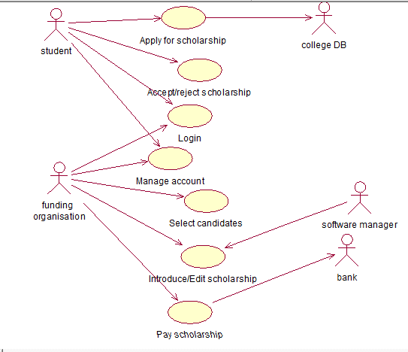

# **DATA FLOW DIAGRAM(DFD)**

## **1. Context level diagram :**

* The context level diagram is used to provide a high level abstraction of the system.
* The important external entities can be observed from the diagram. External entities : Student, Funding organisation, software manager, bank.
* The processes are shown in the level 0 diagram.

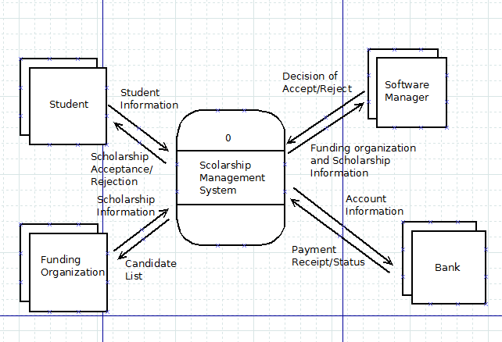

## **2. Level 0 diagram :**

* Each use case has been mapped to a process in the DFD.
* The data stores used are : student information, funding organisation information, scholarship information, payment information, student bank account information.
* Each data store corresponds to an entity in the ER diagram.
* ‘Scholarship information’ data store contains the list of applied candidates for the scholarship, and the list of selected candidates and the scholarship information.

**As we mapped each use case to a process in DFD, we got a complicated DFD at level 0.(For a clear picture, please refer to the DFD file)**

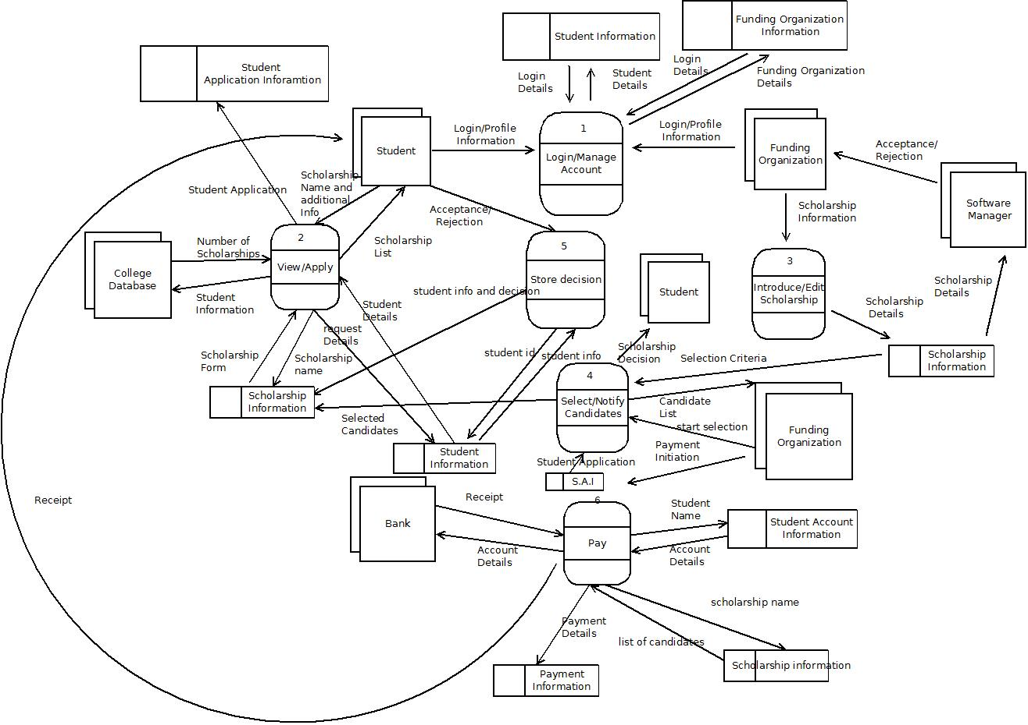

## **3. Level 1 diagram :**

The following processes have been expanded:

**1. Login/Manage account**

**2. View/Apply scholarship**

**3. Select/Notify candidates**

**4. Pay**

**Process 1:**

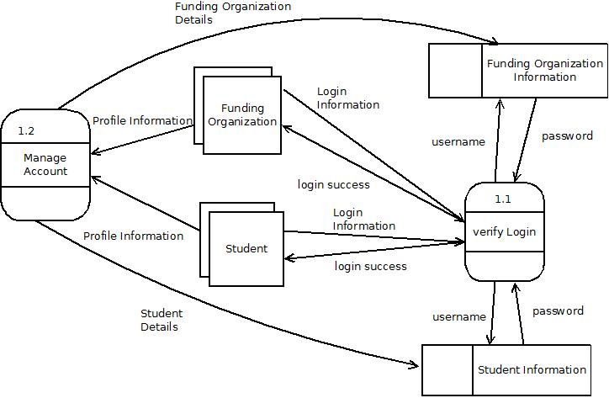

**Process 2:**

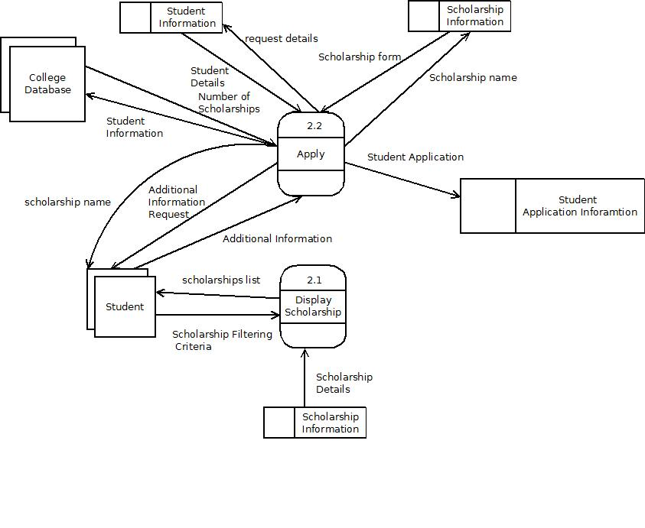

**Process 4:**

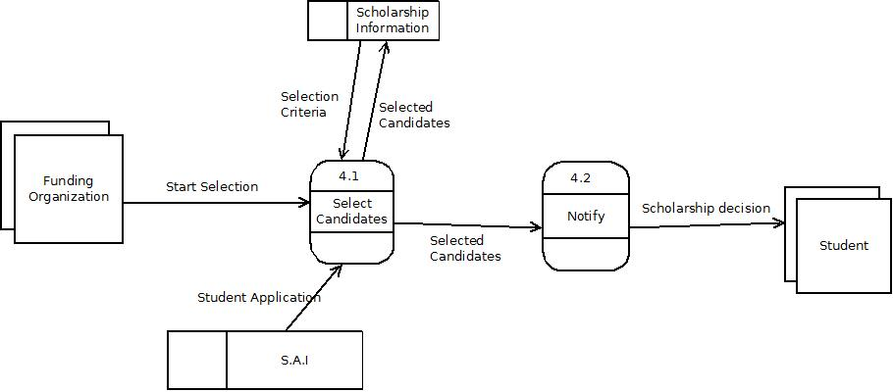

**Process 6:**

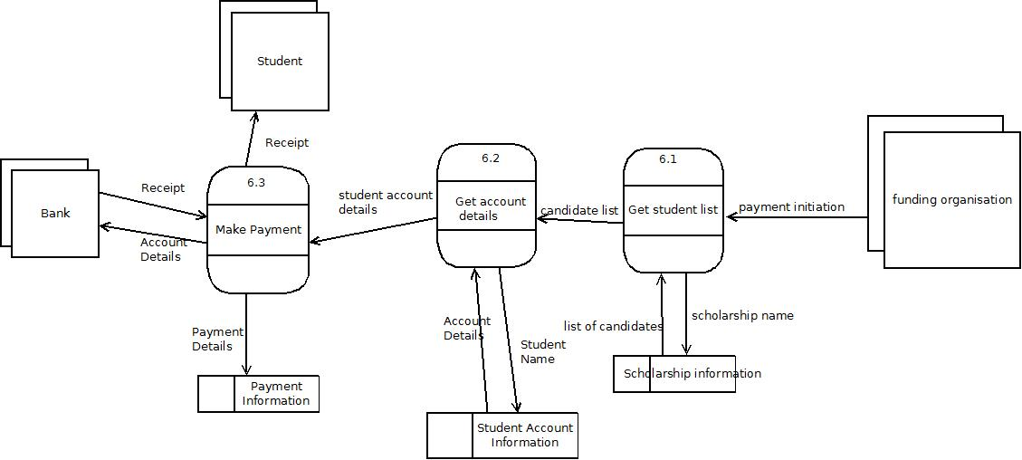

**List of data stores -**

1. **Student information** - Contains basic information(profile) of the student
2. **Student account information(financial)** - Contains Student account information
3. **Funding organisation information** - Contains basic information of the Funding organization.
4. **Scholarship information** - Contains detailed information about each scholarship
5. **Payment information** - Contains payment information made by the bank.
6. **Student application information** - Contains application information

## **4. Level 2 diagram -**

**Manage account is expanded :**

**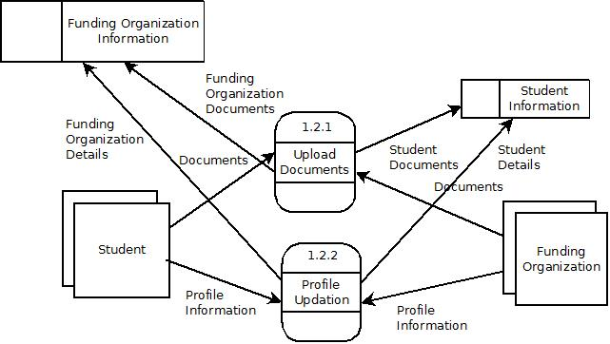**

# **CLASS MODEL**

**Note : The class model has been revised many times. The class model after the activity diagram is the final one.**

## **Initial Nouns**

Please refer to the following short forms used :

**A - Accept, R - reject, V - vague, I - irrelevant, At - attributes, As - Association, G - General. S - Synonyms, E - External entities**

|  |  |  |
| --- | --- | --- |
| **Initial nouns** | **Decision** | **Reason** |
| Database | R | V |
| Organisation | R | V |
| Student | A |  |
| Scholarship | A |  |
| criteria | R | AT |
| people | R | G |
| academic | R | G |
| education | R | G |
| features | R | G |
| system | R | V |
| motivation | R | V |
| support | R | V |
| workflow | R | V |
| form | R | AT |
| programme | R | V |
| documents | R | AT |
| transcript | R | AT |
| LOR | R | AT |
| funding | R | V |
| fees | R | V |

|  |  |  |
| --- | --- | --- |
| **Initial nouns** | **Decision** | **Reason** |
| expenditure | R | V |
| undergraduate | R | G |
| portal | A |  |
| Type of scholarship | R | AT |
| school | R | AT |
| college | R | AT |
| university | R | AT |
| Level of education | R | AT |
| Field of study | R | AT |
| Private scholarship | R | G |
| Company scholarship | R | G |
| Financial condition | R | V |
| Funding Organization | A |  |
| profile | A |  |
| Application status | R | AT |
| email | R | AT |
| interview | R | I |
| date | R | V |
| time | R | V |
| awards | R | G |
| money | R | G |

|  |  |  |
| --- | --- | --- |
| **Initial nouns** | **Decision** | **Reason** |
| software | R | V |
| paperwork | R | V |
| applicant | R | S |
| Scholarship amount | R | AT |
| information | R | G |
| newspaper | R | I |
| pamphlets | R | I |
| repository | R | G |
| awareness | R | G |
| feature | R | G |
| application | A |  |
| bank | R | E |
| forum | R | I |
| category | R | AT |
| algorithm | R | G |
| finance | R | G |
| deadline | R | AT |
| international | R | V |

|  |  |  |
| --- | --- | --- |
| **Initial nouns** | **Decision** | **Reason** |
| option | R | I |
| resources | R | G |
| Student bank account | R | AT |
| authentication | R | V |
| record | R | G |
| internship | R | G |
| calendar | R | G |
| Scholarship Duration | R | AT |
| recommendation | R | V |
| Government | R | G |
| pool | R | G |
| Scholarship filter | R | S |
| research | R | V |
| funds | R |  |
| payment | A |  |

## **Potential Classes and Attributes List**

|  |  |
| --- | --- |
| **POTENTIAL CLASSES** | **ATTRIBUTES LIST** |
| Student | -Criteria |
| Scholarship | -Form |
| Portal | -Documents |
| Funding organisation | -Transcript |
| Profile | -LOR |
| Payment | -Scholarship type |
| Software Manager | -Field of study |
| Scholarship application | -Application status |
|  | -Email |
|  | -Scholarship Duration |
|  | -Student bank account |
|  | -deadline |
|  | -category |
|  | -Scholarship amount |
|  | -school/college/university |
|  | -Education level |

## **Class Diagram :**

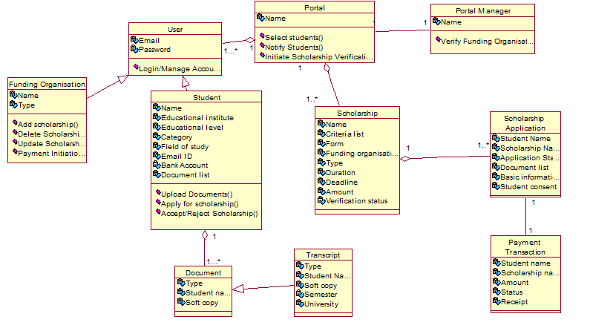

## **Classes After Noun Analysis**

|  |  |  |
| --- | --- | --- |
| **Classes** | **Attributes** | **Methods** |
| User | Email, Password | Login/Manage Account |
| Student | Student Name, University, Document list, Education Level, Field of Study, Email, Bank account, Category. | Upload Documents, Accept/Reject Scholarship, Apply For Scholarship |
| Scholarship | Scholarship Name, Criteria, Form, Funding Organization, Scholarship Type, Scholarship Duration, Scholarship Deadline, Scholarship Amount, Verification status |  |
| Funding organisation | Funding Organization Name, Funding Organization Type | Add/Update/Delete Scholarship, Payment Initiation |
| Portal Manager | Name | Verify Funding Organization |
| Portal | Name | Select/Notify Students, Initiate Scholarship Verification |
| Scholarship Application | Student Name, Scholarship Name, Application status, Documents,basic information, student consent(if accepted) |  |
| Payment transaction | Student Name, Scholarship Name, Amount, status, receipt |  |
| Document | Type, student name, soft copy |  |
| Transcript | student name, type, semester number, university, soft copy. |  |

## **CRC cards**

|  |  |
| --- | --- |
| User | |
| Superclass : - NA | |
| Subclass : - Student, Funding Organization | |
| Responsibilities | Collaborators |
| Login/Manage account |  |

|  |  |
| --- | --- |
| Student | |
| Superclass : - User | |
| Subclass : - NA | |
| Responsibilities | Collaborators |
| Apply for scholarship | Scholarship application, Document, Transcript |
| Accept/Reject scholarship | Scholarship application |

|  |  |
| --- | --- |
| Scholarship | |
| Superclass : - NA | |
| Subclass : - NA | |
| Responsibilities | Collaborators |
| Keeps record of scholarships |  |

|  |  |
| --- | --- |
| Funding Organisation | |
| Superclass : - User | |
| Subclass : - NA | |
| Responsibilities | Collaborators |
| Add/Update/Delete Scholarship and inform portal about changes | Scholarship, Portal |
| Payment Initiation | Scholarship, Student Application, Payment transaction |

|  |  |
| --- | --- |
| Portal manager | |
| Superclass : - NA | |
| Subclass : - NA | |
| Responsibilities | Collaborators |
| Verify Scholarship | Scholarship |

|  |  |
| --- | --- |
| Portal | |
| Superclass : - NA | |
| Subclass : - NA | |
| Responsibilities | Collaborators |
| Initiate Scholarship Verification | Scholarship, Portal Manager |
| Select students based on some criteria | Scholarship, Student Application |
| Notify Students | Scholarship, Student Application |

|  |  |
| --- | --- |
| Scholarship Application | |
| Superclass : - NA | |
| Subclass : - NA | |
| Responsibilities | Collaborators |
| Keeps record of scholarship applications |  |

|  |  |
| --- | --- |
| Payment transaction | |
| Superclass : - NA | |
| Subclass : - NA | |
| Responsibilities | Collaborators |
| Keeps record of payment transactions |  |

|  |  |
| --- | --- |
| Document | |
| Superclass : - NA | |
| Subclass : - Transcript | |
| Responsibilities | Collaborators |
| Keeps record of documents uploaded by students |  |

|  |  |
| --- | --- |
| Transcript | |
| Superclass : - Document | |
| Subclass : - NA | |
| Responsibilities | Collaborators |
| Keeps record of transcripts uploaded by student each semester |  |

## **Data Dictionary**

1.

User = email + password

2.

Student = {first name} + last name + university + (document list) +

Education Level + Field of study + Email + Bank Account + Category

Education Level = [“Bachelors”|”Masters”|”PHD”]

Field of study = [“Science”|”Arts”|”Commerce”]

Category = [“General”|”OBC”|”SC”|”ST”]

3.

Scholarship = name + criteria + form + funding organization + scholarship type + scholarship duration + scholarship deadline + scholarship amount + verification status

scholarship type = [“merit and academic”|“research”|“minority”|“need based”|“sports”|“community service”|“first in family”|“legacy”|“military”|“special talent”]

Verification status = [“Verified”|”Not Verified”]

4.

Funding Organization = name + type

type = [“Private”|”Government”]

5.

Portal manager = {first name} + last name

6.

Portal = name

7.

Scholarship Application = {first name}+ last name + scholarship name + application status + {documents} + {basic information} + student consent

application status = [“pending”|”accepted”|”rejected”]

student consent = [“Accept”|”Reject”]

8.

Payment Transaction = {first name} + last name + scholarship name + amount + status + receipt

status = [“completed”|”pending”]

9.

Document = {first name} + last name + type + soft copy

type = [“LOR”|”SOP”|”NOC”|”CV”|”Transcript”]

10.

Transcript = {first name} + last name + type + semester number + university + soft copy

type = [“Transcript”]

semester number = [“1”|“2”|“3”|“4”|“5”|“6”|“7”|“8”|“9”|“10”|“11”|“12”]

# **USE CASE SCENARIO WALKTHROUGH**

**Use case 1 : Apply for scholarship**

**Scenario 1 : successful scenario**

**Steps :**

1.Student enters some basic filtering criteria for viewing scholarships(field

of study, level of study). Based on the criteria, a list of scholarships is shown.

2. The student selects a particular scholarship from the list. The

details of the scholarship are shown.

3. The student starts applying for the scholarship by filling the form. The academic details of the student are pre-filled according to his profile.

4. The student uploads any additional documents if required.

5. The software confirms from the college DB that the selected candidate does not have any existing scholarship. After evaluation, the status of the applicant for that

particular scholarship is updated.

|  |  |  |  |  |
| --- | --- | --- | --- | --- |
| **Steps** | **Classes** | **Relationships** | **Attributes** | **Methods** |
| **1** | **Student, Scholarship,Portal** | **Student - Portal (Association)**  **Scholarship- Portal (Association)** | **Attributes of Scholarship class :**  **Funding Organization,**  **Scholarship Type,**  **Scholarship Duration,**  **Scholarship Deadline,**  **Scholarship Amount,** | **Student : enterCriteria()**  **Portal : showListOfScholarships()** |
| **2** | **Student, Portal** | **Student - Portal (Association)** | **All attributes of scholarship class** | **Student : selectScholarship()**  **Portal : showScholarshipDetails()** |
| **3** | **Student, Scholarship Application** | **Student - Scholarship Application(Association)** | **All attributes of ScholarshipApplication** | **Student : fillForm()** |
| **4** | **Student, Scholarship Application** | **Student - Scholarship Application(Association)** | **Documents** | **Student : uploadDocuments()** |
| **5** | **Portal** | **Portal - Scholarship Application(Association)** |  | **Portal : checkSingleScholarship()**  **Portal : saveStudentApplication()** |
|  |  |  |  |  |

**Scenario 2 : Unsuccessful scenario(no matching scholarships)**

**Steps:**

1.Student enters some basic filtering criteria for viewing scholarships(field

of study, level of study).

2. No scholarships satisfy given criteria. A display message is shown requesting user to change criteria.

|  |  |  |  |  |
| --- | --- | --- | --- | --- |
| **1** | **Student, Scholarship,Portal** | **Student - Portal (Association)**  **Scholarship- Portal (Association)** | **Attributes of Scholarship class :**  **Funding Organization,**  **Scholarship Type,**  **Scholarship Duration,**  **Scholarship Deadline,**  **Scholarship Amount,** | **Student : enterCriteria()**  **Portal : showListOfScholarships()** |
| **2** | **Portal** |  |  | **Portal : displayPrompt() - for changing criteria** |

**Scenario 3 : Unsuccessful scenario(has existing scholarship)**

**Steps :**

1.Student enters some basic filtering criteria for viewing scholarships(field

of study, level of study). Based on the criteria, a list of scholarships is shown.

2. The student selects a particular scholarship from the list. The

details of the scholarship are shown.

3. The student starts applying for the scholarship by filling the form. The academic details of the student are pre-filled according to his profile.

4. The student uploads any additional documents if required.

5.The software confirms from the college DB that the selected candidate does not have any existing scholarship. After evaluation, the status of the applicant for that

particular scholarship is updated.

**6.** If the candidate has an existing scholarship, he/she will be prompted to first discontinue that scholarship and then apply for a new scholarship.(**Assumption**: A particular student can receive only one scholarship at a particular time instant.)

**Steps 1 to 4 are the same as the ones mentioned in successful scenario.**

|  |  |  |  |  |
| --- | --- | --- | --- | --- |
| **Steps** | **Classes** | **Relationships** | **Attributes** | **Methods** |
| **5** | **Portal** | **Portal - Scholarship Application(Association)** |  | **Portal : checkSingleScholarship()**  **Portal : saveApplication()** |
| **6** | **Student** |  |  | **discontinueScholarship()** |

**Note : In use case model, we had 5 alternating scenarios. Here, we have mentioned only 2. The other 3 can be managed using the displayPrompt() method of Portal class. No further changes are required in class model.**

**Use Case 2 : Introduce/Edit Scholarship**

**Scenario 1: Successful Scenario**

**Steps:**

1.In case of a new scholarship, the funding organisation enters the details(eligibility, funding) of the scholarship in the system.Otherwise, the organisation can edit the scholarship application criterias and information related to the scholarship(funding amount, duration of scholarship, etc).

2.Additionally, they specify the application form and the relevant documents required. The software manager verifies the authenticity of the scholarship and if the organisation has the financial capability of providing the scholarship.

3.Finally, the organisation gives its consent to make the new/modified scholarship available to the public. The scholarship is added to the database of the system and shown publicly.

|  |  |  |  |  |
| --- | --- | --- | --- | --- |
| **Steps** | **Classes** | **Relationships** | **Attributes** | **Methods** |
| **1** | **Funding Organization,**  **Scholarship,**  **Portal** | **Funding Organization-Portal (Aggregation)**  **Funding Organization-Scholarship (Association)** | **Amount, Criteria List** | **Funding Organization -**  **EnterScholarshipDetails()**  **Funding Organization -**  **EditScholarship()** |
| **2** | **Funding Organization,**  **Scholarship Application,**  **Portal Manager,**  **Portal** | **Funding Organization-Scholarship Application(Association)**  **Portal Manager-Portal(Association)** | **Document List** | **Portal Manager -**  **VerifyFundingOrganization()**  **Portal Manager -**  **VerifyScholarship()** |
| **3** | **Funding Organization** |  |  | **addScholarship()** |

**Scenario 2: Unsuccessful Scenario**

**Steps:**

1.In case of a new scholarship, the funding organisation enters the details(eligibility, funding) of the scholarship in the system.Otherwise, the organisation can edit the scholarship application criterias and information related to the scholarship(funding amount, duration of scholarship, etc)

2.The organisation must select the criteria for selection available in

the portal. For example, the criteria can be academic parameters, maximum family income.

3.If the criteria is not available for selection, the organisation can request the portal to include that criteria.

**Step 1 is same as the one mentioned in successful scenario**

|  |  |  |  |  |
| --- | --- | --- | --- | --- |
| **Steps** | **Classes** | **Relationships** | **Attributes** | **Methods** |
| **2** | **Funding Organization,**  **Portal** | **Funding Organization-Portal (Aggregation)** |  | **Funding Orgainzation -**  **SetCriteria()** |
| **3** | **Funding Organization,**  **Portal** | **Funding Organization-Portal (Aggregation)** |  | **Funding Organization -**  **RequestCriteria()** |

**Scenario 3: Unsuccessful Scenario**

**Steps:**

1.In case of a new scholarship, the funding organisation enters the details(eligibility, funding) of the scholarship in the system.Otherwise, the organisation can edit the scholarship application criterias and information related to the scholarship(funding amount, duration of scholarship, etc)

2.The organisation may want to delete the scholarship.

3.In such a case, the portal verifies that no students are currently getting the scholarship and then allows for deletion. The scholarship is no longer shown on the portal. The use case ends.

**Step 1 is same as the one mentioned in successful scenario**

|  |  |  |  |  |
| --- | --- | --- | --- | --- |
| **Steps** | **Classes** | **Relationships** | **Attributes** | **Methods** |
| **2** | **Funding Organization** |  |  | **deleteScholarship()** |
| **3** | **Funding Organization,**  **Portal** | **Funding Organization-Portal (Aggregation)** |  | **Portal-**  **VerifyScholarshipDeletion()** |

**Scenario 4: Unsuccessful Scenario**

**Steps:**

1.In case of a new scholarship, the funding organisation enters the details(eligibility, funding) of the scholarship in the system.Otherwise, the organisation can edit the scholarship application criterias and information related to the scholarship(funding amount, duration of scholarship, etc).

2.Additionally, they specify the application form and the relevant documents required. The software manager verifies the authenticity of the scholarship and if the organisation has the financial capability of providing the scholarship.

3.If the software manager rejects the scholarship, then the provider is informed about the decision and the reason behind the decision.

**Step 1,2 are same as the ones mentioned in successful scenario**

|  |  |  |  |  |
| --- | --- | --- | --- | --- |
| **Steps** | **Classes** | **Relationships** | **Attributes** | **Methods** |
| **3** | **Funding Organization,**  **Portal Manager,**  **Portal** | **Funding Organization-Portal(Aggregation)**  **Portal-Portal Manager(Association)** |  | **Portal-**  **informDecision()** |

**Use case 3 : Select candidates**

**Scenario 1 : Successful scenario**

**Steps :**

1. After the application deadline is over, our system starts filtering out the

candidates based on the criteria provided.

2. The candidate list is sent to the funding organisation.

3. The system notifies the candidates of their status(accepted/rejected) through email/phone call.

|  |  |  |  |  |
| --- | --- | --- | --- | --- |
| **Steps** | **Classes** | **Relationships** | **Attributes** | **Methods** |
| **1** | **Portal** |  |  | **selectStudents()** |
| **2** | **Portal, Funding Organization.** | **Portal-Funding Organization(Association)** |  | **sendListToFO()** |
| **3** | **Portal, Student** | **Portal-student(Association)** |  | **notifyStudents()** |

**Scenario 2 : Unsuccessful scenario**

1. After the application deadline is over, our system starts filtering out the

candidates based on the criteria provided.

2. The candidate list is sent to the funding organisation.

3. The funding organisation does a further screening and sends the list to the portal.

**Steps 1 and 2 are same. However, before notifying candidates, the funding organisation may do a further screening.**

|  |  |  |  |  |
| --- | --- | --- | --- | --- |
| **Steps** | **Classes** | **Relationships** | **Attributes** | **Methods** |
| **3** | **Funding Organization, Portal** | **Portal-Funding Organization(Association)** |  | **Portal -**  **sendFurtherScreenedStudents()** |

**Use case 4: Pay Scholarship**

**Scenario 1 : Successful scenario**

**Steps :**

1.The funding organisation informs the system to start transfer of funds to the selected candidates.

2. The system checks the eligibility of the selected candidates.(the system needs to check the eligibility each semester).

3. The bank is informed about the student’s bank accounts details and told to initiate the transaction.

4.On successful transfer, the bank account sends the receipt to the system.The system sends the receipt to the student.

|  |  |  |  |  |
| --- | --- | --- | --- | --- |
| **Steps** | **Classes** | **Relationships** | **Attributes** | **Methods** |
| **1** | **Funding Organization** |  |  | **paymentInitiation()** |
| **2** | **Portal** |  | **Semester** | **checkEligibiltyOfStudent()** |
| **3** | **Portal** |  | **Bank Account** | **informBank()** |
| **4** | **Portal** |  | **Receipt** | **sendReceipt()** |

**Scenario 2 : Unsuccessful Scenario**

**Steps :**

1.The funding organisation informs the system to start transfer of funds to the selected candidates.

2. The system checks the eligibility of the selected candidates.(the system needs to check the eligibility each semester)

3.If the candidate is no longer eligible, he/she is informed about the same and the scholarship is discontinued.

**Step 1,2 are same as the ones mentioned in successful scenario**

|  |  |  |  |  |
| --- | --- | --- | --- | --- |
| **Steps** | **Classes** | **Relationships** | **Attributes** | **Methods** |
| **3** | **Portal** |  |  | **informStudent()** |

**Scenario 3 : Unsuccessful Scenario**

**Steps :**

1.The funding organisation informs the system to start transfer of funds to the selected candidates.

2. The system checks the eligibility of the selected candidates.(the system needs to check the eligibility each semester).

3. The bank is informed about the student’s bank accounts details and told to initiate the transaction.

4.If the transfer is not successful due to wrong bank account details, the student is informed about the same. After the student changes the details, the transaction is done again.

**Step 1-3 are same as the ones mentioned in successful scenario**

|  |  |  |  |  |
| --- | --- | --- | --- | --- |
| **Steps** | **Classes** | **Relationships** | **Attributes** | **Methods** |
| **4** | **Portal** |  |  | **informStudent()** |

**Use case 5 : Accept/Reject Scholarship**

**Scenario 1 : Successful scenario**

**Steps :**

1. Students accept the scholarship and send their acceptance.

2. Students are requested to recheck their bank account details before the funds are transferred. The funding organisation is informed about the student’s decision.

|  |  |  |  |  |
| --- | --- | --- | --- | --- |
| **Steps** | **Classes** | **Relationships** | **Attributes** | **Methods** |
| **1** | **Student, F.O.** | **Student - Funding organisation(Association)** |  | **Student -**  **acceptScholarship()** |
| **2** | **Student** |  | **bankAccount** | **checkBankDetails()** |

**Scenario 2 : Unsuccessful scenario**

1. Student rejects scholarship

|  |  |  |  |  |
| --- | --- | --- | --- | --- |
| **Steps** | **Classes** | **Relationships** | **Attributes** | **Methods** |
| **1** | **Student, F.O.** | **Student - Funding organisation(Association)** |  | **rejectScholarship()** |

**Scenario 3 : Unsuccessful scenario**

**Steps:**

1.Students accept the scholarship and send their acceptance

2.Student changes bank account details

|  |  |  |  |  |
| --- | --- | --- | --- | --- |
| **Steps** | **Classes** | **Relationships** | **Attributes** | **Methods** |
| **1** | **Student, F.O.** | **Student - Funding organisation(Association)** |  | **Student -**  **acceptScholarship()** |
| **2** | **Student** |  | **bankAccount** | **changeBankDetails()** |

**Use case 6 : User Login**

**Scenario 1 : Successful scenario**

**Steps :**

1. User opens portal. The system prompts user for account credentials. User enters his user ID and password. The system authenticates the credentials. The user is directed to the homepage.

|  |  |  |  |  |
| --- | --- | --- | --- | --- |
| **Steps** | **Classes** | **Relationships** | **Attributes** | **Methods** |
| **1** | **Student, Funding Organization,**  **Portal, User** | **Student - Portal (Aggregation)**  **Funding Organization-Portal (Aggregation)**  **User-Student (Inheritence)**  **User-Funding Organization (Inheritence)** | **Email, Password** | **Portal -**  **EnterCredentials()**  **AuthenticateUser()**  **User -**  **Login()** |

**Use case 7 : Manage account**

**Scenario 1 : Successful scenario**

**Steps :**

1. User requests the system for editing his profile and the system grants it. User fills in his details and edits the profile.

2. Upon finishing, user is asked for confirmation. The updated profile is stored in the database.

|  |  |  |  |  |
| --- | --- | --- | --- | --- |
| **Steps** | **Classes** | **Relationships** | **Attributes** | **Methods** |
| **1** | **Student, Funding Organization, User** | **Student-User(Inheritance)**  **Funding Organization - User (Inheritance)** | **All attributes of Student/Funding Organization** | **User : editProfile()** |
| **2** | **Student, Funding Organization, User, Portal** | **Student-User(Inheritance)**  **Funding Organization - User (Inheritance)** |  | **User: confirmChanges(),**  **Portal : storeInDatabase()** |

**Scenario 2 : Unsuccessful scenario**

**Steps :**

1. If user is not registered in system, he/she is registered first.

|  |  |  |  |  |
| --- | --- | --- | --- | --- |
| **Steps** | **Classes** | **Relationships** | **Attributes** | **Methods** |
| **1** | **Student, Funding Organization, User** | **Student-User(Inheritance)**  **Funding Organization - User (Inheritance)** | **Email, Password, basic details in registration form** | **User : register()** |

**Scenario 3: Unsuccessful scenario**

**Steps :**

1. User requests the system for editing his profile and the system grants it. User fills in his details and edits the profile.

2. Upon finishing, user is asked for confirmation. If user doesn’t confirm, user is taken back to editing page.

|  |  |  |  |  |
| --- | --- | --- | --- | --- |
| **Steps** | **Classes** | **Relationships** | **Attributes** | **Methods** |
| **1** | **Student, Funding Organization, User** | **Student-User(Inheritance)**  **Funding Organization - User (Inheritance)** | **All attributes of Student/Funding Organization** | **User : editProfile()** |
| **2** | **Student, Funding Organization, User, Portal** | **Student-User(Inheritance)**  **Funding Organization - User (Inheritance)** |  | **User: ConfirmChanges(),**  **(pass false as argument)** |

## **Revised Class Diagram after Scenario Walk through :**

**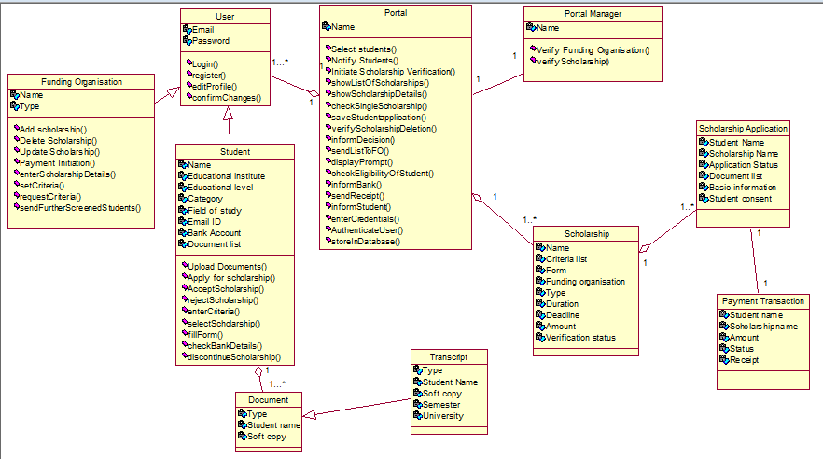**

## **Revised Class Model after Scenario Walk through :**

|  |  |  |
| --- | --- | --- |
| **Classes** | **Attributes** | **Methods** |
| User | Email,  Password | Login(),  register(),  editProfile(),  confirmChanges(), |
| Student | Student Name, University,  Document list, Education Level,  Field of Study,  Email,  Bank account, Category. | enterCriteria(), selectScholarship(),  fillForm(),  uploadDocuments(), acceptScholarship(), checkBankDetails(), rejectScholarship(), changeBankDetails(),  discontinueScholarship() |
| Scholarship | Scholarship Name, Criteria, Form,  Funding Organization, Scholarship Type, Scholarship Duration, Scholarship Deadline, Scholarship Amount, Verification status |  |
| Funding organisation | Funding Organization Name,  Funding Organization Type | AddScholarship(), UpdateScholarship(),  Payment Initiation(), EnterScholarshipDetails(),  SetCriteria(),  RequestCriteria(),  deleteScholarship()  sendFurtherScreenedStudents() |
| Portal Manager | Name | VerifyFundingOrganization(),  VerifyScholarship() |
| Portal | Name | showListOfScholarships(),  showScholarshipDetails(),  checkSingleScholarship(),  saveStudentApplication(),  VerifyScholarshipDeletion(),  informDecision(),  sendListToFO(),  SelectStudents(),  NotifyStudents(),  displayPrompt(),  checkEligibiltyOfStudent(),  informBank(),  sendReceipt(),  informStudent(),  EnterCredentials(),  AuthenticateUser(),  storeInDatabase() |
| Scholarship Application | Student Name, Scholarship Name, Application status, Documents,  basic information, student consent (if accepted) |  |
| Payment transaction | Student Name, Scholarship Name, Amount,  status,  receipt |  |
| Document | Type,  student name,  soft copy |  |
| Transcript | student name,  type,  semester number, university,  soft copy. |  |

# 

# 

# 

# 

# **INTERACTION MODELING**

1. **Use case scenario: Apply for scholarship**

**Sequence Diagram**

**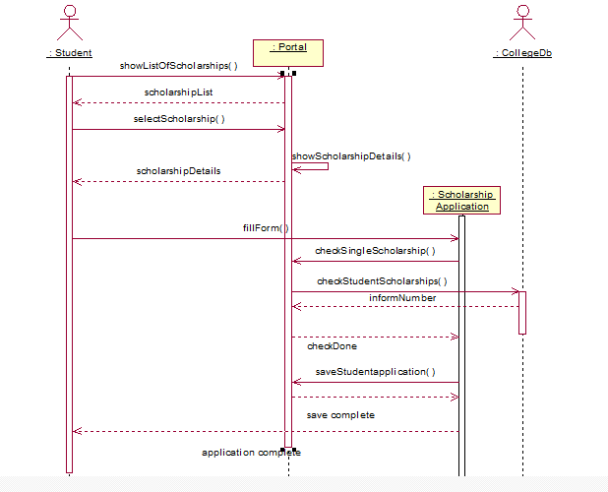**

**Collaboration Diagram**

**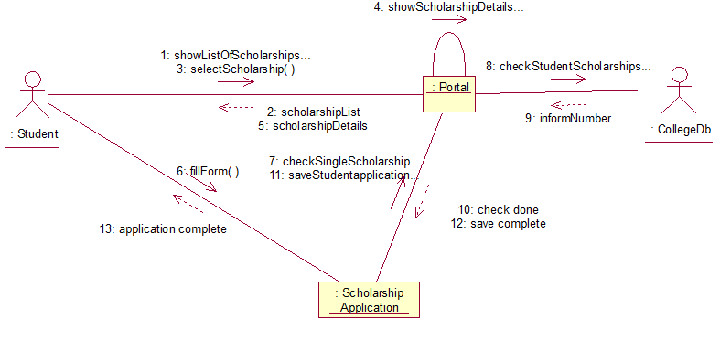**

**2. Use case scenario: Introduce/Edit scholarship**

**Sequence Diagram**

**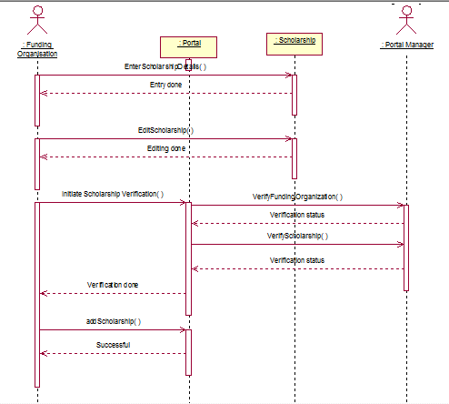**

**Collaboration Diagram**

**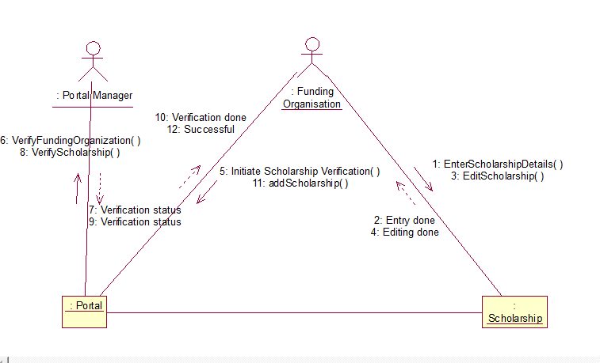**

**3. Use case scenario: Pay scholarship**

**Sequence Diagram**

**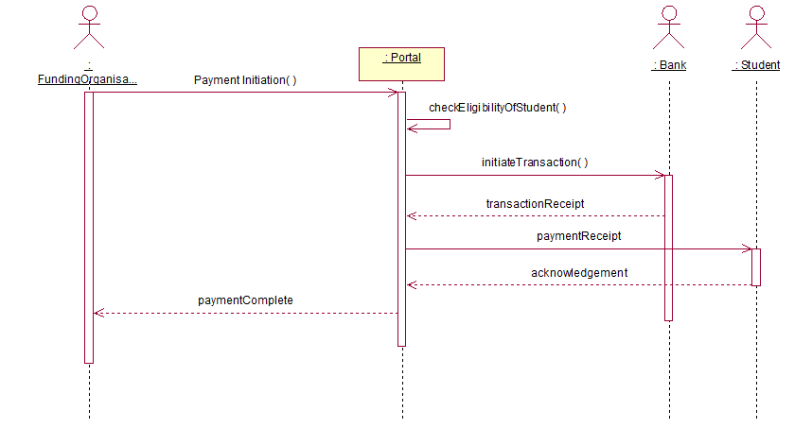**

**Collaboration Diagram**

**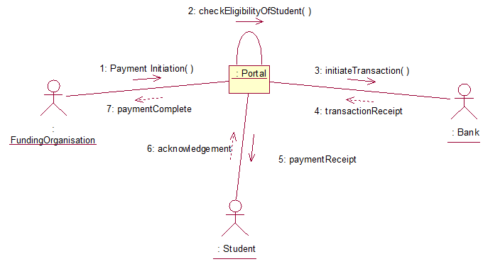**

## **Class Diagram Post Interaction Modeling**

While conducting the interaction modelling, we made a few changes in the class diagram. The changes have been listed below :

**Change of location of methods:**

1. **selectScholarship()** - moved to Portal class
2. **Fill form()** - moved to scholarship Application class
3. **Upload documents()** - moved to scholarship Application class
4. **Payment initiation()** - moved to Portal class
5. **EnterScholarshipDetails()** - moved to scholarship class
6. **EditScholarship()** - moved to scholarship class
7. **addScholarship()** - moved to Portal class

## **Revised Class Diagram Post Interaction Modeling:**classDiagram_postInteractionModelling.PNG

# 

# 

# 

# 

# 

# 

# 

# **STATE MODELING**

**State Diagram for scholarship Application process :**

**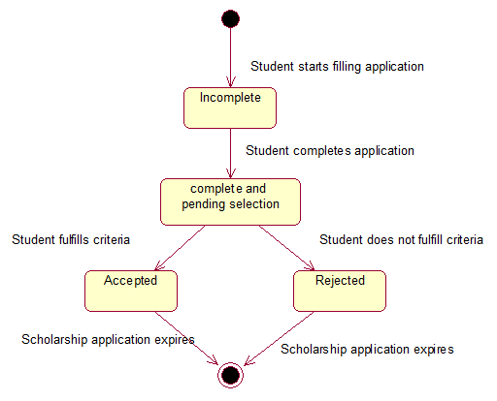**

**State Diagram for scholarship class :**

**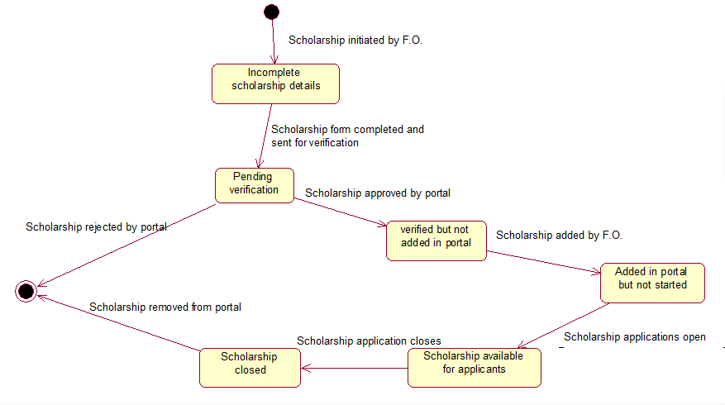**

**State Diagram for Payment Transaction:**

**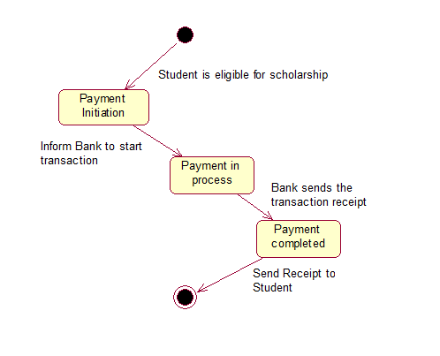**

# **ACTIVITY MODELING**

The Activity diagrams(with and without swimlanes have been shown below):

Because of size constraint the diagrams have been split into 3 images.

**Activity diagrams(.dia) files are in the submission folder.**

After the activity model, we revised the class model. This is the final version of the class model.

Activity diagram(without swimlanes) :

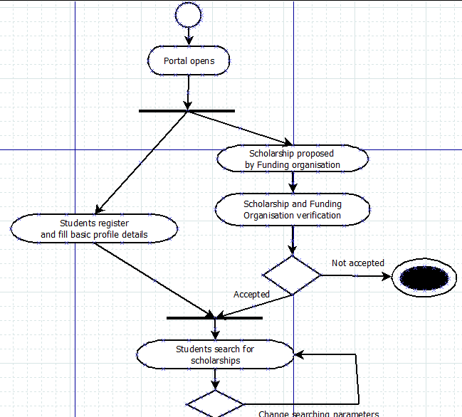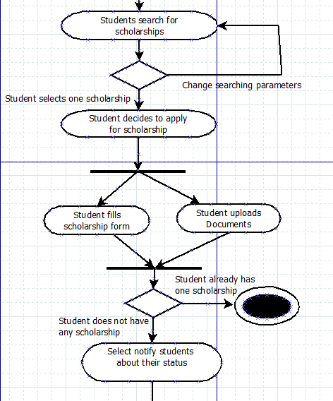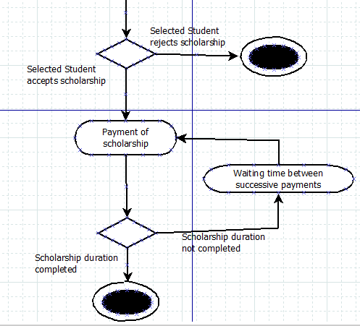

**Swimlane diagram :**

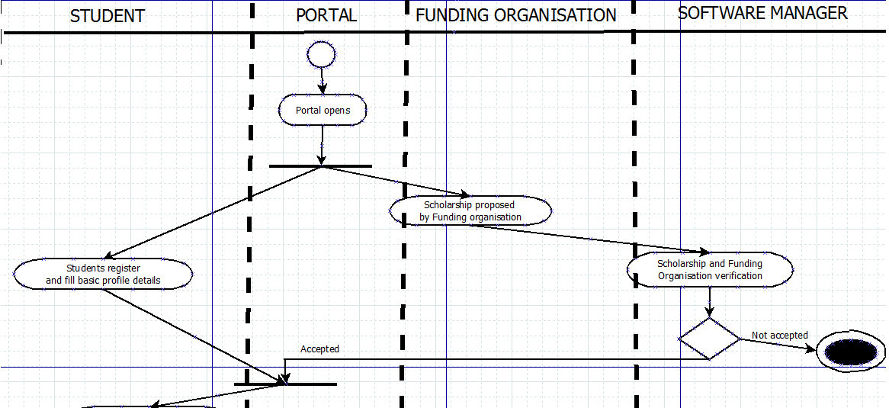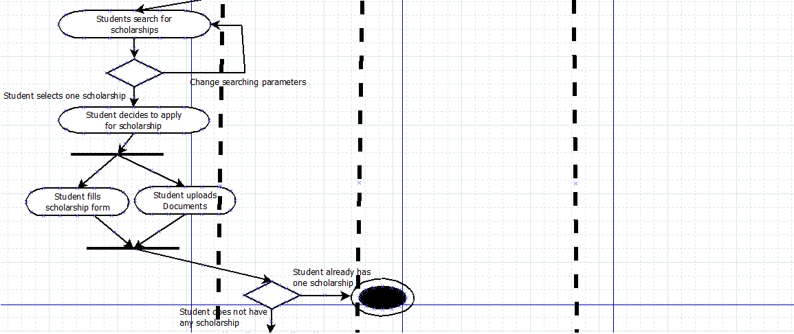

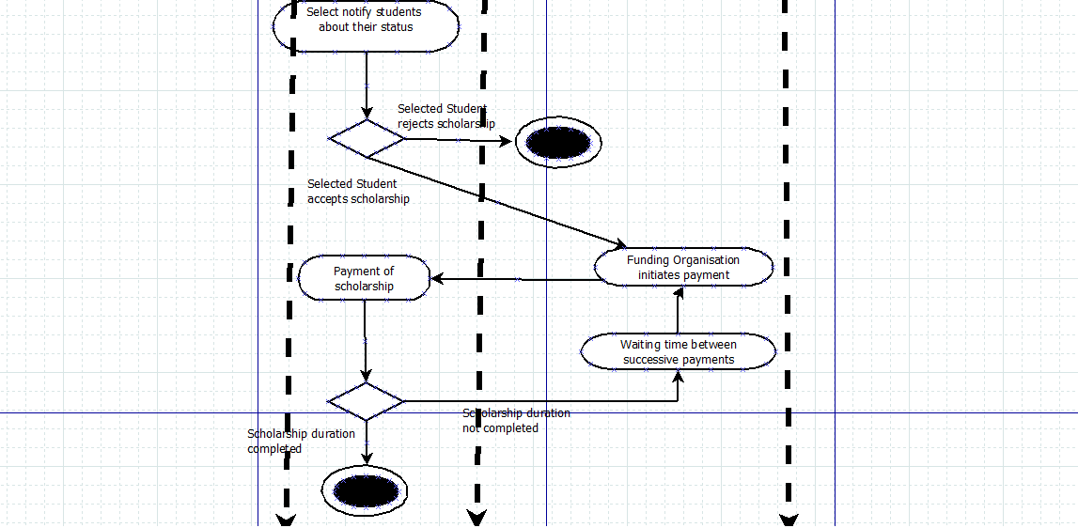

## **Class Diagram Post Activity Modeling**

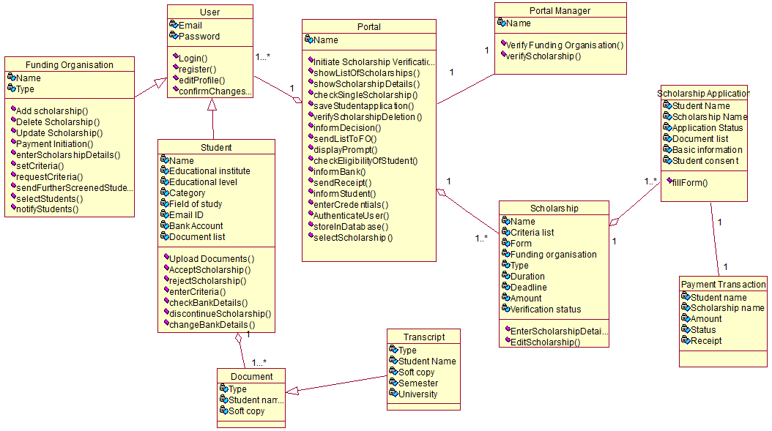

**Check finalClassModel.png in the submission folder**.

# **IMPLEMENTATION**

1. Driver class :

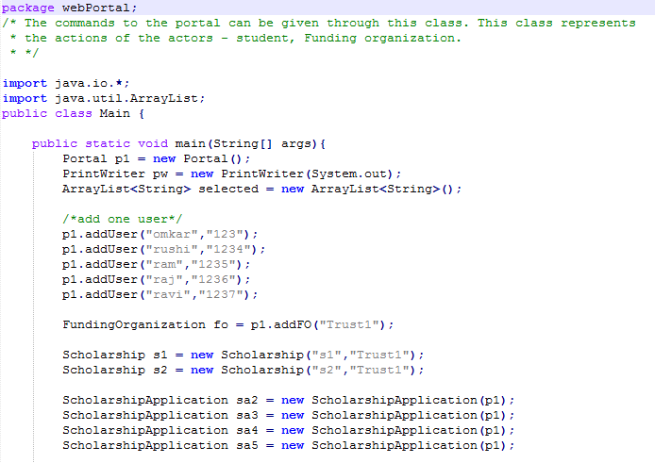

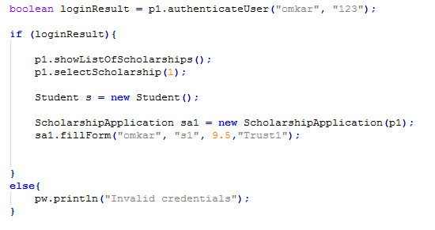

1. selectStudents() method from FundingOrganization class :

Note that we have implemented a naive version of the actual method. Here, we have considered **only one filtering criteria - CPI**. The scholarship name and number of students to select is passed as the arguments and the names of the selected students are returned as output.

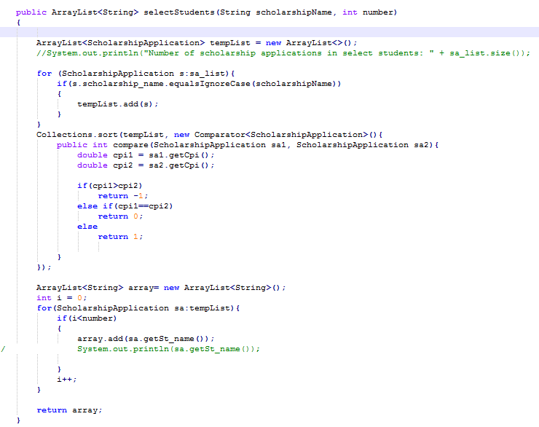

2. notifyStudents() method from FundingOrganization class:

# notifyStudentsFunction.PNG

3. fillForm() method from ScholarshipApplication class :

# fillForm_s_a_Class.PNG

# **JUNIT TESTING**

**We carried out JUnit testing for the following methods :**

1. **fillForm()** : This method belongs to ScholarshipApplication class which checks if the student has received any scholarship before and if he hasn’t yet received it saves the application details.
2. **selectStudents()** : This method belongs to FundingOrganization class which selects desired number of students based some criteria(cpi).
3. **authenticateUser()** : This method belongs to the Portal class which checks if the user is valid or not by checking the username and password.
4. **selectScholarship()** : This method belongs to Portal class which gives us scholarship details if it exists.
5. **showListOfScholarships()** : This method belongs to Portal class which returns the scholarships it provides.

**The codes for the JUnit testing are given after the table.**

**We have used branch coverage method for finding the test cases.**

|  |  |  |  |  |  |
| --- | --- | --- | --- | --- | --- |
| **Test case number** | **Test case name** | **Test description** | **Input** | **Expected result** | **Actual result** |
| TC\_01 | TC\_fillForm\_Positive test case | If applicant fills form details and doesn’t have any existing scholarship, method returns 1 | {“rushi", "s1", 8.5, "Trust1} | 1 | 1 |
| TC\_02 | TC\_fillForm\_Negative test case | If applicant fills form details and has any existing scholarship, method returns 0 | {"omkar", "s1", 9.5,"Trust1"} | 0 | 0 |
| TC\_03 | TC\_selectSudents\_positive | The funding organisations returns top 2 eligible students for given scholarship | {"s1",2} | {“ram”, ”rushi”} | {“ram”, ”rushi”} |
| TC\_04 | TC\_selectSudents\_negative | If the mentioned scholarship doesn’t exist, an error message is returned | {“s4”,2} | “Scholarship doesn’t exist” | “Scholarship doesn’t exist” |
| TC\_05 | TC\_AuthenticateUserTest\_Positive test case | Given the login details i.e., username and password, the method should return true if the user is valid | {“omkar”,  “123”} | true | true |
| TC\_06 | TC\_AuthenticateUserTest\_Negative test case | Given the login details i.e., username and password, the method should return false if the user is invalid | {“omkar”,  “1234”} | false | false |
| TC\_07 | TC\_SelectScholarship\_Positive test case | Given the scholarship name, the method should return its scholarship details if existing | {“s1”} | {“Trust1”,”Government”,”2”} | {“Trust1”,”Government”,”2”} |
| TC\_08 | TC\_SelectScholarship\_Negative test case | Given the scholarship name, the method should return “invalid scholarship” if it does not exist | {“Hi”} | “invalid scholarship” | “invalid scholarship” |
| TC\_9 | TC\_ScholarshipList\_Postive test case | Given the funding organization name, the method should return the scholarships it provides if it exists | {“Trust1”} | {“s1”,”s2”} | {“s1”,”s2”} |
| TC\_10 | TC\_ScholarshipList\_Negative test case | Given the funding organization name, the method should return “invalid funding organization” if it doesn’t exist | {“Hello”} | {“invalid funding organization”} | {“invalid funding organization”} |

**Codes :**

1. fillForm() positive and negative test case :

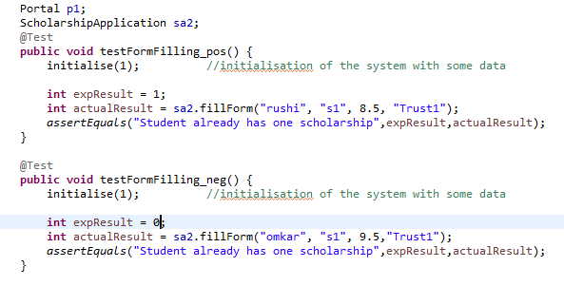

2. selectStudents() method positive and negative test case :

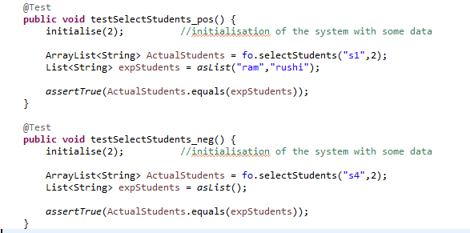

3.authenticateUser() method positive and negative test case :



 