**GROUP 5.9**

**Name - Rushikesh Nalla**

**ID - 201401106**

**Name - Omkar Damle**

**ID - 201401114**

**CENTRALISED SCHOLARSHIP**

**MANAGEMENT SYSTEM**

**JUNIT Testing**

**We carried out JUnit testing for the following methods :**

1. fillForm() : This method belongs to ScholarshipApplication class which checks if the student has received any scholarship before and if he hasn’t yet received it saves the application details.
2. selectStudents() : This method belongs to FundingOrganization class which selects desired number of students based some criteria(cpi).
3. authenticateUser() : This method belongs to the Portal class which checks if the user is valid or not by checking the username and password.
4. selectScholarship() : This method belongs to FundingOrganization class which gives us scholarship details if it exists.
5. showListOfScholarships() : This method belongs to FundingOrganization class which returns the scholarships it provides.

**The codes for the JUnit testing are given after the table.**

**We have used branch coverage method for finding the test cases.**

|  |  |  |  |  |  |
| --- | --- | --- | --- | --- | --- |
| Test case number | Test case name | Test description | Input | Expected result | Actual result |
| TC_01 | TC_fillForm_Positive test case | If applicant fills form details and doesn’t have any existing scholarship, method returns 1 | {“rushi", "s1", 8.5, "Trust1} | 1 | 1 |
| TC_02 | TC_fillForm_Negative test case | If applicant fills form details and has any existing scholarship, method returns 0 | {"omkar", "s1", 9.5,"Trust1"} | 0 | 0 |
| TC_03 | TC_selectSudents_positive | The funding organisations returns top 2 eligible students for given scholarship | {"s1",2} | {“ram”, ”rushi”} | {“ram”, ”rushi”} |
| TC_04 | TC_selectSudents_negative | If the mentioned scholarship doesn’t exist, an error message is returned | {“s4”,2} | “Scholarship doesn’t exist” | “Scholarship doesn’t exist” |
| TC_05 | TC_AuthenticateUserTest_Positive test case | Given the login details i.e., username and password, the method should return true if the user is valid | {“omkar”,  “123”} | true | true |
| TC_06 | TC_AuthenticateUserTest_Negative test case | Given the login details i.e., username and password, the method should return false if the user is invalid | {“omkar”,  “1234”} | false | false |
| TC_07 | TC_SelectScholarship_Positive test case | Given the scholarship name, the method should return its scholarship details if existing | {“s1”} | {“Trust1”,”Government”,”2”} | {“Trust1”,”Government”,”2”} |
| TC_08 | TC_SelectScholarship_Negative test case | Given the scholarship name, the method should return “invalid scholarship” if it does not exist | {“Hi”} | “invalid scholarship” | “invalid scholarship” |
| TC_9 | TC_ScholarshipList_Postive test case | Given the funding organization name, the method should return the scholarships it provides if it exists | {“Trust1”} | {“s1”,”s2”} | {“s1”,”s2”} |
| TC_10 | TC_ScholarshipList_Negative test case | Given the funding organization name, the method should return “invalid funding organization” if it doesn’t exist | {“Hello”} | {“invalid funding organization”} | {“invalid funding organization”} |

**Codes :**

1. fillForm positive and negative test case :

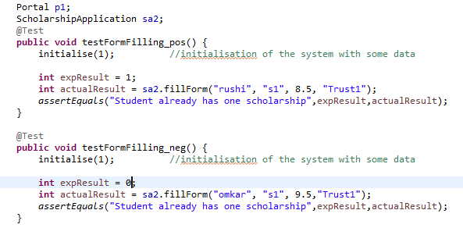

2. selectStudents() method positive and negative test case :

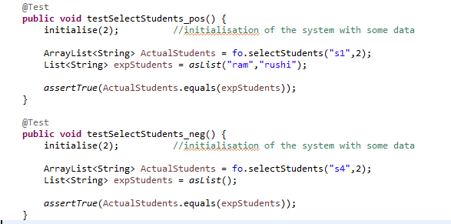

3.authenticateUser() method positive and negative test case :

