Assignment 4:
You have private GitHub repo here you have index.html. You have S3 bucket and here we have enabled static website hosting. This index we have to deploy on S3 using Jenkins. We can enable static website hosting using S3 CLI command. Don’t go to AWS console for creating S3 and enabling static website hosting.

Steps:
- Created IAM Role with s3 full access and attached this role to Jenkins manager instance.
- Installed aws cli on jenkins master.
- Created github secret and selected source code management as git and added private repo url and secret to it
- Added below shell script in build step.
#!/bin/bash

# 1. Generate a timestamp and define a globally unique bucket name
TIMESTAMP=$(date +%Y%m%d%H%M%S)
BUCKET_NAME="my-jenkins-website-${TIMESTAMP}"
REGION="ap-south-1"

echo "Starting deployment process for new bucket: $BUCKET_NAME"

# 2. Create the S3 bucket
aws s3 mb s3://$BUCKET_NAME --region $REGION

# 3. Disable Block Public Access
aws s3api put-public-access-block \
--bucket $BUCKET_NAME \
--public-access-block-configuration "BlockPublicAcls=false,IgnorePublicAcls=false,BlockPublicPolicy=false,RestrictPublicBuckets=false"

# 4. Create a temporary policy.json file for public read access
cat <<EOF > policy.json
{
"Version": "2012-10-17",
"Statement": [
{
"Sid": "PublicReadGetObject",
"Effect": "Allow",
"Principal": "*",
"Action": "s3:GetObject",
"Resource": "arn:aws:s3:::$BUCKET_NAME/*"
}
]
}
EOF

# 5. Apply the public read bucket policy
aws s3api put-bucket-policy --bucket $BUCKET_NAME --policy file://policy.json

# 6. Enable Static Website Hosting
aws s3 website s3://$BUCKET_NAME/ --index-document index.html

# 7. Deploy the index.html file to S3
aws s3 cp index.html s3://$BUCKET_NAME/

# 8. Clean up the workspace
rm -f policy.json

echo "=========================================================="
echo "Deployment complete!"
echo "Your unique website URL is: http://$BUCKET_NAME.s3-website.$REGION.amazonaws.com/"
echo "=========================================================="

Output:
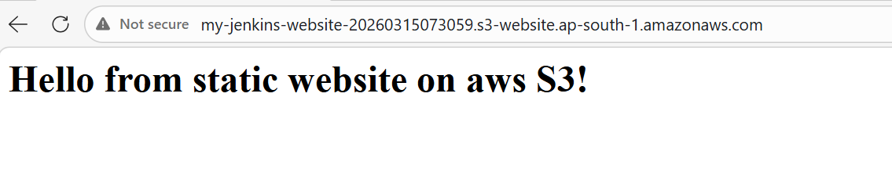
Console output logs:
Started by user admin
Running as SYSTEM
Building in workspace /root/.jenkins/workspace/s3_website_hosting
[WS-CLEANUP] Deleting project workspace...
[WS-CLEANUP] Deferred wipeout is used...
[WS-CLEANUP] Done
The recommended git tool is: NONE
using credential Github_secrets
Cloning the remote Git repository
Cloning repository https://github.com/rushibhosale/priv_repo.git
> git init /root/.jenkins/workspace/s3_website_hosting # timeout=10
Fetching upstream changes from https://github.com/rushibhosale/priv_repo.git
> git --version # timeout=10
> git --version # 'git version 2.50.1'
using GIT_ASKPASS to set credentials
> git fetch --tags --force --progress -- https://github.com/rushibhosale/priv_repo.git +refs/heads/*:refs/remotes/origin/* # timeout=10
> git config remote.origin.url https://github.com/rushibhosale/priv_repo.git # timeout=10
> git config --add remote.origin.fetch +refs/heads/*:refs/remotes/origin/* # timeout=10
Avoid second fetch
> git rev-parse refs/remotes/origin/main^{commit} # timeout=10
Checking out Revision f291142d871a5fab0a3a5cc0fa167ac0ac34d60c (refs/remotes/origin/main)
> git config core.sparsecheckout # timeout=10
> git checkout -f f291142d871a5fab0a3a5cc0fa167ac0ac34d60c # timeout=10
Commit message: "Update index.html"
> git rev-list --no-walk f291142d871a5fab0a3a5cc0fa167ac0ac34d60c # timeout=10
[s3_website_hosting] $ /bin/bash /mnt/apache-tomcat-10.1.52/temp/jenkins9124466730271426133.sh
Starting deployment process for new bucket: my-jenkins-website-20260315073059
make_bucket: my-jenkins-website-20260315073059
Completed 46 Bytes/46 Bytes (916 Bytes/s) with 1 file(s) remaining
upload: ./index.html to s3://my-jenkins-website-20260315073059/index.html
==========================================================
Deployment complete!
Your unique website URL is: http://my-jenkins-website-20260315073059.s3-website.ap-south-1.amazonaws.com/
==========================================================
Finished: SUCCESS

