Do below using docker volume:
1 repo with 3 branches contains index.html in all. We have jenkins master and we need create a job and 3 container and deploy these 3 indices in three containers with port 80, 90 and 8080 use docker plugin and use declarative pipeline
Output:
Refer Jenkinsfile present in same directory
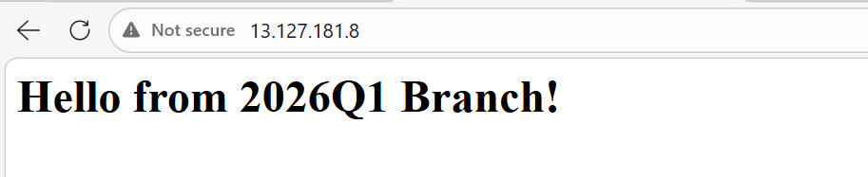
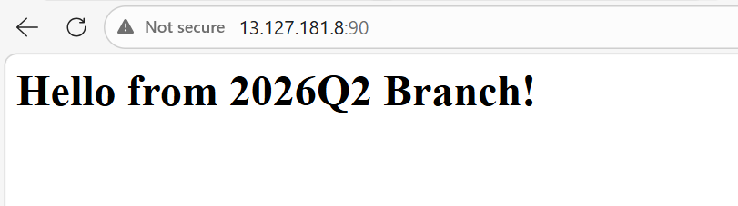
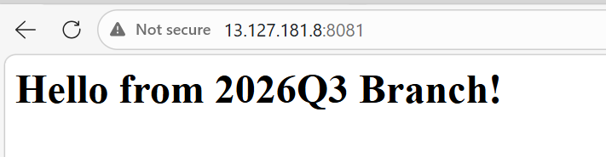

Console output:
Started by user admin
[Pipeline] Start of Pipeline
[Pipeline] node
Running on Jenkins in /root/.jenkins/workspace/docker-volume
[Pipeline] {
[Pipeline] withEnv
[Pipeline] {
[Pipeline] stage
[Pipeline] { (Cleanup Old Containers)
[Pipeline] echo
Removing previous containers...
[Pipeline] sh
+ docker rm -f container-branch1 container-branch2 container-branch3
container-branch1
container-branch2
container-branch3
[Pipeline] }
[Pipeline] // stage
[Pipeline] stage
[Pipeline] { (Deploy Branch 1 (Port 80))
[Pipeline] dir
Running in /root/.jenkins/workspace/docker-volume/branch1_dir
[Pipeline] {
[Pipeline] echo
Checking out 2026Q1 branch
[Pipeline] git
The recommended git tool is: NONE
using credential github-token
Cloning the remote Git repository
Cloning repository https://github.com/rushibhosale/priv_repo.git
> git init /root/.jenkins/workspace/docker-volume/branch1_dir # timeout=10
Fetching upstream changes from https://github.com/rushibhosale/priv_repo.git
> git --version # timeout=10
> git --version # 'git version 2.50.1'
using GIT_ASKPASS to set credentials
> git fetch --tags --force --progress -- https://github.com/rushibhosale/priv_repo.git +refs/heads/*:refs/remotes/origin/* # timeout=10
> git config remote.origin.url https://github.com/rushibhosale/priv_repo.git # timeout=10
> git config --add remote.origin.fetch +refs/heads/*:refs/remotes/origin/* # timeout=10
Avoid second fetch
> git rev-parse refs/remotes/origin/2026Q1^{commit} # timeout=10
Checking out Revision 52284177e5431ead9e2469bd6fc614817376e737 (refs/remotes/origin/2026Q1)
> git config core.sparsecheckout # timeout=10
> git checkout -f 52284177e5431ead9e2469bd6fc614817376e737 # timeout=10
> git branch -a -v --no-abbrev # timeout=10
> git checkout -b 2026Q1 52284177e5431ead9e2469bd6fc614817376e737 # timeout=10
Commit message: "branch1"
First time build. Skipping changelog.
[Pipeline] sh
+ chmod 644 index.html
+ docker run -d --name container-branch1 -p 80:80 -v /root/.jenkins/workspace/docker-volume/branch1_dir/index.html:/usr/local/apache2/htdocs/index.html httpd
dfa3952a98596af2077b4bbf7073efb632e57ebea401ecc178488d0c4fb95628
[Pipeline] }
[Pipeline] // dir
[Pipeline] }
[Pipeline] // stage
[Pipeline] stage
[Pipeline] { (Deploy Branch 2 (port 90))
[Pipeline] dir
Running in /root/.jenkins/workspace/docker-volume/branch2_dir
[Pipeline] {
[Pipeline] git
The recommended git tool is: NONE
using credential github-token
Cloning the remote Git repository
Cloning repository https://github.com/rushibhosale/priv_repo.git
> git init /root/.jenkins/workspace/docker-volume/branch2_dir # timeout=10
Fetching upstream changes from https://github.com/rushibhosale/priv_repo.git
> git --version # timeout=10
> git --version # 'git version 2.50.1'
using GIT_ASKPASS to set credentials
> git fetch --tags --force --progress -- https://github.com/rushibhosale/priv_repo.git +refs/heads/*:refs/remotes/origin/* # timeout=10
> git config remote.origin.url https://github.com/rushibhosale/priv_repo.git # timeout=10
> git config --add remote.origin.fetch +refs/heads/*:refs/remotes/origin/* # timeout=10
Avoid second fetch
> git rev-parse refs/remotes/origin/2026Q2^{commit} # timeout=10
Checking out Revision a17804419cc4e4d85b23bc5eb26119066e8be356 (refs/remotes/origin/2026Q2)
> git config core.sparsecheckout # timeout=10
> git checkout -f a17804419cc4e4d85b23bc5eb26119066e8be356 # timeout=10
> git branch -a -v --no-abbrev # timeout=10
> git checkout -b 2026Q2 a17804419cc4e4d85b23bc5eb26119066e8be356 # timeout=10
Commit message: "branch2"
First time build. Skipping changelog.
[Pipeline] sh
+ chmod 644 index.html
+ docker run -d --name container-branch2 -p 90:80 -v /root/.jenkins/workspace/docker-volume/branch2_dir/index.html:/usr/local/apache2/htdocs/index.html httpd
28da7a761590c9fe10f47990a1ed6e1466794d1e15be93fced8d766a3b074a8e
[Pipeline] }
[Pipeline] // dir
[Pipeline] }
[Pipeline] // stage
[Pipeline] stage
[Pipeline] { (Deploy Branch 3 (port 8081))
[Pipeline] dir
Running in /root/.jenkins/workspace/docker-volume/branch3_dir
[Pipeline] {
[Pipeline] git
The recommended git tool is: NONE
using credential github-token
Cloning the remote Git repository
Cloning repository https://github.com/rushibhosale/priv_repo.git
> git init /root/.jenkins/workspace/docker-volume/branch3_dir # timeout=10
Fetching upstream changes from https://github.com/rushibhosale/priv_repo.git
> git --version # timeout=10
> git --version # 'git version 2.50.1'
using GIT_ASKPASS to set credentials
> git fetch --tags --force --progress -- https://github.com/rushibhosale/priv_repo.git +refs/heads/*:refs/remotes/origin/* # timeout=10
> git config remote.origin.url https://github.com/rushibhosale/priv_repo.git # timeout=10
> git config --add remote.origin.fetch +refs/heads/*:refs/remotes/origin/* # timeout=10
Avoid second fetch
> git rev-parse refs/remotes/origin/2026Q3^{commit} # timeout=10
Checking out Revision 7a2ef298bb3e45aa5aacc54167a33d015fc138de (refs/remotes/origin/2026Q3)
> git config core.sparsecheckout # timeout=10
> git checkout -f 7a2ef298bb3e45aa5aacc54167a33d015fc138de # timeout=10
> git branch -a -v --no-abbrev # timeout=10
> git checkout -b 2026Q3 7a2ef298bb3e45aa5aacc54167a33d015fc138de # timeout=10
Commit message: "Update greeting in index.html"
First time build. Skipping changelog.
[Pipeline] sh
+ chmod 644 index.html
+ docker run -d --name container-branch3 -p 8081:80 -v /root/.jenkins/workspace/docker-volume/branch3_dir/index.html:/usr/local/apache2/htdocs/index.html httpd
5727e6383334263cdf1fc7016162dc18112e7f42e1d5e0a2760ce1aa1592342f
[Pipeline] }
[Pipeline] // dir
[Pipeline] }
[Pipeline] // stage
[Pipeline] }
[Pipeline] // withEnv
[Pipeline] }
[Pipeline] // node
[Pipeline] End of Pipeline
Finished: SUCCESS

