Assignment 5:
On GitHub you have project loginwebapp. You create a war file for this webapp and uploading to S3. Then downloading this war file to tomcat from S3 and deploy to tomcat. this war file must have date and time in its name when uploaded to S3. When deploying rename the file. you have to create shell script in between and trigger it. or you can write the shell script in Jenkins itself

Steps:
- Create freestyle job in Jenkins and add below steps
- In Source code management select git and add below url
  - https://github.com/Shantanumajan6/project.git
- Then in build steps add below shell script
#!/bin/bash
set -e

# ==========================================
# 1. Define Variables
# ==========================================
# Generate a single timestamp to use for both the bucket and the WAR file
TIMESTAMP=$(date +%Y%m%d%H%M%S)

BUCKET_NAME="my-tomcat-artifacts-repo-unique123"
REGION="ap-south-1"

PROJECT_NAME="loginwebapp"
S3_WAR_NAME="${PROJECT_NAME}-${TIMESTAMP}.war"

# Change this to where your Tomcat webapps folder is located on the server
TOMCAT_WEBAPPS_DIR="/mnt/apache-tomcat-10.1.52/webapps"

echo "Starting build and deployment process for $PROJECT_NAME..."

# ==========================================
# 2. Create the Unique S3 Bucket (Only if it doesn't exist)
# ==========================================
if aws s3api head-bucket --bucket "$BUCKET_NAME" 2>/dev/null; then
echo "S3 Bucket '$BUCKET_NAME' already exists. Skipping creation."
else
echo "Creating new S3 bucket: $BUCKET_NAME"
aws s3 mb s3://$BUCKET_NAME --region $REGION
fi

# ==========================================
# 3. Build the WAR file using Maven
# ==========================================
# Force Java to open the 'java.util' module so the old plugin can access the Properties field
export MAVEN_OPTS="--add-opens java.base/java.util=ALL-UNNAMED --add-opens java.base/java.text=ALL-UNNAMED --add-opens java.desktop/java.awt.font=ALL-UNNAMED"

echo "Building the application with Maven..."
mvn clean package

# Find the exact name of the generated WAR file in the target directory
BUILT_WAR_FILE=$(ls target/*.war | head -n 1)

# ==========================================
# 4. Upload to S3 with Timestamp
# ==========================================
echo "Uploading $BUILT_WAR_FILE to S3 as: $S3_WAR_NAME"
aws s3 cp $BUILT_WAR_FILE s3://${BUCKET_NAME}/${S3_WAR_NAME}

# ==========================================
# 5. Download the WAR file from S3
# ==========================================
echo "Downloading $S3_WAR_NAME from S3..."
aws s3 cp s3://${BUCKET_NAME}/${S3_WAR_NAME} ./${S3_WAR_NAME}

# ==========================================
# 6. Rename and Deploy to Tomcat
# ==========================================
echo "Deploying to Tomcat..."
# Copying it to the webapps folder and renaming it back to 'loginwebapp.war'
sudo cp ./${S3_WAR_NAME} ${TOMCAT_WEBAPPS_DIR}/${PROJECT_NAME}.war

# ==========================================
# 7. Clean up the Jenkins workspace
# ==========================================
rm -f ./${S3_WAR_NAME}

echo "=========================================================="
echo "Deployment successful!"
echo "Artifact stored in bucket: $BUCKET_NAME"
echo "=========================================================="

Output:
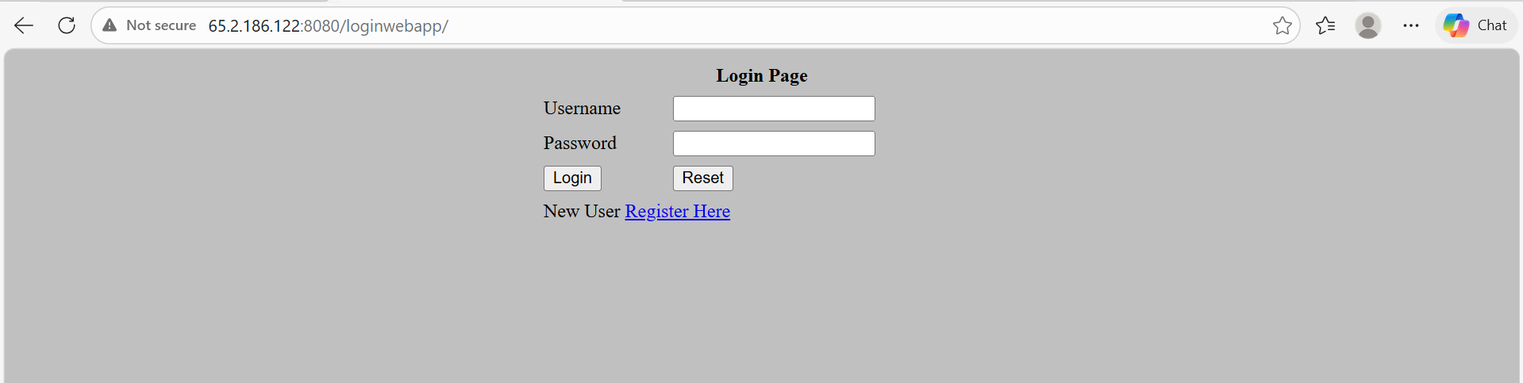

AWS s3 output:
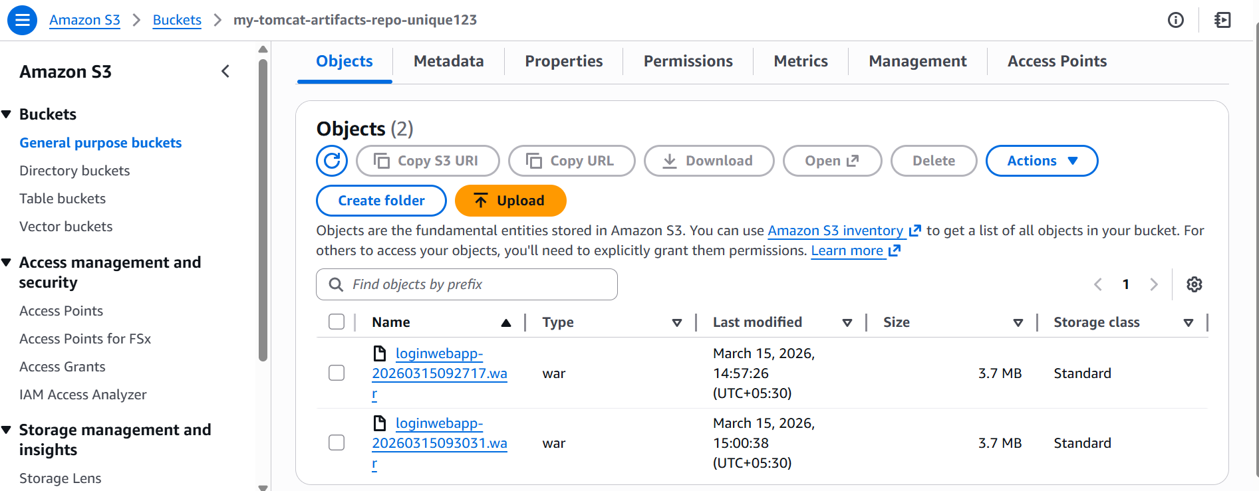

Console output:
Started by user admin
Running as SYSTEM
Building in workspace /root/.jenkins/workspace/war_from_s3
[WS-CLEANUP] Deleting project workspace...
[WS-CLEANUP] Deferred wipeout is used...
[WS-CLEANUP] Done
The recommended git tool is: NONE
No credentials specified
Cloning the remote Git repository
Cloning repository https://github.com/Shantanumajan6/project.git
> git init /root/.jenkins/workspace/war_from_s3 # timeout=10
Fetching upstream changes from https://github.com/Shantanumajan6/project.git
> git --version # timeout=10
> git --version # 'git version 2.50.1'
> git fetch --tags --force --progress -- https://github.com/Shantanumajan6/project.git +refs/heads/*:refs/remotes/origin/* # timeout=10
> git config remote.origin.url https://github.com/Shantanumajan6/project.git # timeout=10
> git config --add remote.origin.fetch +refs/heads/*:refs/remotes/origin/* # timeout=10
Avoid second fetch
> git rev-parse refs/remotes/origin/master^{commit} # timeout=10
Checking out Revision dad4cbb1657dd0bc83e677cdf2588836f9c329f2 (refs/remotes/origin/master)
> git config core.sparsecheckout # timeout=10
> git checkout -f dad4cbb1657dd0bc83e677cdf2588836f9c329f2 # timeout=10
Commit message: "Create maven.yml"
> git rev-list --no-walk dad4cbb1657dd0bc83e677cdf2588836f9c329f2 # timeout=10
[war_from_s3] $ /bin/bash /mnt/apache-tomcat-10.1.52/temp/jenkins15727498039941999419.sh
Starting build and deployment process for loginwebapp...
{
"BucketArn": "arn:aws:s3:::my-tomcat-artifacts-repo-unique123",
"BucketRegion": "ap-south-1",
"AccessPointAlias": false
}
S3 Bucket 'my-tomcat-artifacts-repo-unique123' already exists. Skipping creation.
Building the application with Maven...
[INFO] Scanning for projects...
[INFO]
[INFO] --------------------< com.javawebtutor:LoginWebApp >--------------------
[INFO] Building LoginWebApp Maven Webapp 1.0-SNAPSHOT
[INFO] --------------------------------[ war ]---------------------------------
[INFO]
[INFO] --- maven-clean-plugin:2.5:clean (default-clean) @ LoginWebApp ---
[INFO]
[INFO] --- maven-resources-plugin:2.6:resources (default-resources) @ LoginWebApp ---
[WARNING] Using platform encoding (UTF-8 actually) to copy filtered resources, i.e. build is platform dependent!
[INFO] skip non existing resourceDirectory /root/.jenkins/workspace/war_from_s3/src/main/resources
[INFO]
[INFO] --- maven-compiler-plugin:3.1:compile (default-compile) @ LoginWebApp ---
[INFO] No sources to compile
[INFO]
[INFO] --- maven-resources-plugin:2.6:testResources (default-testResources) @ LoginWebApp ---
[WARNING] Using platform encoding (UTF-8 actually) to copy filtered resources, i.e. build is platform dependent!
[INFO] skip non existing resourceDirectory /root/.jenkins/workspace/war_from_s3/src/test/resources
[INFO]
[INFO] --- maven-compiler-plugin:3.1:testCompile (default-testCompile) @ LoginWebApp ---
[INFO] No sources to compile
[INFO]
[INFO] --- maven-surefire-plugin:2.12.4:test (default-test) @ LoginWebApp ---
[INFO] No tests to run.
[INFO]
[INFO] --- maven-war-plugin:2.2:war (default-war) @ LoginWebApp ---
[INFO] Packaging webapp
[INFO] Assembling webapp [LoginWebApp] in [/root/.jenkins/workspace/war_from_s3/target/LoginWebApp]
[INFO] Processing war project
[INFO] Copying webapp resources [/root/.jenkins/workspace/war_from_s3/src/main/webapp]
[INFO] Webapp assembled in [82 msecs]
[INFO] Building war: /root/.jenkins/workspace/war_from_s3/target/LoginWebApp.war
[INFO] WEB-INF/web.xml already added, skipping
[INFO] ------------------------------------------------------------------------
[INFO] BUILD SUCCESS
[INFO] ------------------------------------------------------------------------
[INFO] Total time: 2.292 s
[INFO] Finished at: 2026-03-15T09:30:36Z
[INFO] ------------------------------------------------------------------------
Uploading target/LoginWebApp.war to S3 as: loginwebapp-20260315093031.war
Completed 1.0 MiB/3.7 MiB (26.9 MiB/s) with 1 file(s) remaining
Completed 2.0 MiB/3.7 MiB (48.3 MiB/s) with 1 file(s) remaining
Completed 3.0 MiB/3.7 MiB (68.2 MiB/s) with 1 file(s) remaining
Completed 3.7 MiB/3.7 MiB (81.0 MiB/s) with 1 file(s) remaining
upload: target/LoginWebApp.war to s3://my-tomcat-artifacts-repo-unique123/loginwebapp-20260315093031.war
Downloading loginwebapp-20260315093031.war from S3...
Completed 256.0 KiB/3.7 MiB (5.0 MiB/s) with 1 file(s) remaining
Completed 512.0 KiB/3.7 MiB (9.6 MiB/s) with 1 file(s) remaining
Completed 768.0 KiB/3.7 MiB (14.1 MiB/s) with 1 file(s) remaining
Completed 1.0 MiB/3.7 MiB (18.5 MiB/s) with 1 file(s) remaining
Completed 1.2 MiB/3.7 MiB (22.8 MiB/s) with 1 file(s) remaining
Completed 1.5 MiB/3.7 MiB (26.9 MiB/s) with 1 file(s) remaining
Completed 1.8 MiB/3.7 MiB (30.8 MiB/s) with 1 file(s) remaining
Completed 2.0 MiB/3.7 MiB (34.7 MiB/s) with 1 file(s) remaining
Completed 2.2 MiB/3.7 MiB (38.6 MiB/s) with 1 file(s) remaining
Completed 2.5 MiB/3.7 MiB (42.5 MiB/s) with 1 file(s) remaining
Completed 2.8 MiB/3.7 MiB (46.2 MiB/s) with 1 file(s) remaining
Completed 3.0 MiB/3.7 MiB (49.9 MiB/s) with 1 file(s) remaining
Completed 3.2 MiB/3.7 MiB (53.6 MiB/s) with 1 file(s) remaining
Completed 3.5 MiB/3.7 MiB (57.1 MiB/s) with 1 file(s) remaining
Completed 3.7 MiB/3.7 MiB (60.6 MiB/s) with 1 file(s) remaining
download: s3://my-tomcat-artifacts-repo-unique123/loginwebapp-20260315093031.war to ./loginwebapp-20260315093031.war
Deploying to Tomcat...
==========================================================
Deployment successful!
Artifact stored in bucket: my-tomcat-artifacts-repo-unique123
==========================================================
Finished: SUCCESS

