Assignment 7:
You have three repos 2026Q1, Q2, Q3. Every branch has index.html. Deploy this on Jenkins master httpd. create jobs accordingly so that whichever index.html is updated that index.html is deployed on httpd and previous index is deleted.

Steps:
- Create jenkins freestyle project
- Select Source Code Management as git and give repo url
- If repo is private create credential and select it
- Goto github Select Repo Settings Webhook Create webhook like below
- 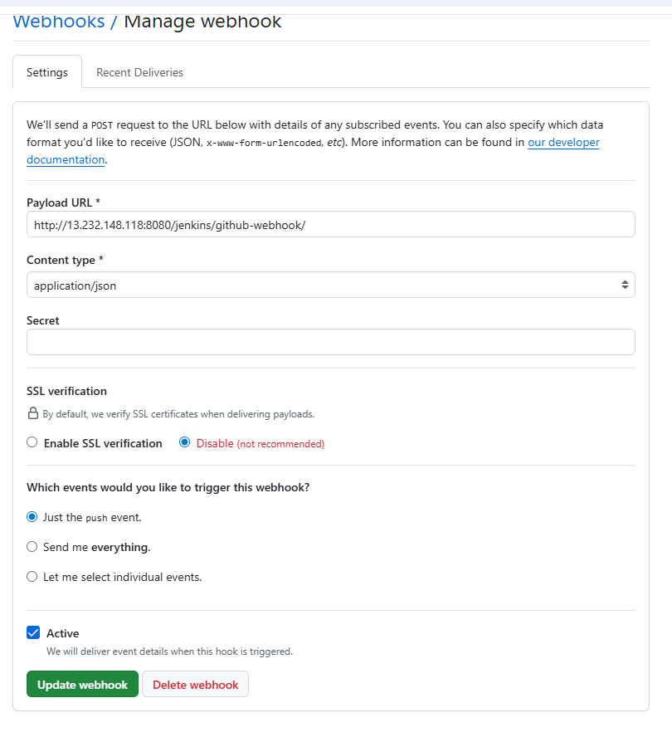
- In triggers select “GitHub hook trigger for GITScm polling”
- Add below shell script in build steps
#!/bin/bash
set -e

# Define the standard Apache httpd web directory
HTTPD_DIR="/var/www/html"

echo "Starting deployment from 2026Q2 repository..."

# 1. Delete the previous index.html explicitly
# (Using sudo in case /var/www/html is owned by root or apache)
sudo rm -f ${HTTPD_DIR}/index.html

# 2. Copy the new index.html to the httpd directory
sudo cp index.html ${HTTPD_DIR}/index.html
chmod -R 755 ${HTTPD_DIR}/index.html

echo "=========================================================="
echo "Deployment successful! 2026Q2 is now live on httpd."
echo "=========================================================="
- Do these above steps for remaining 2 repos and create 2 more jobs
- Update index.html in 2026Q1 branch
Output: 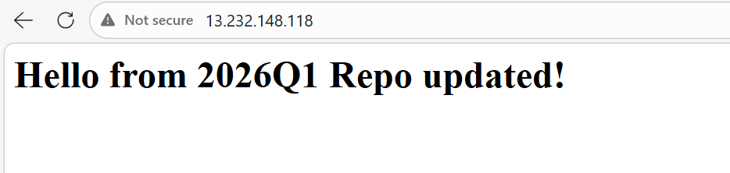
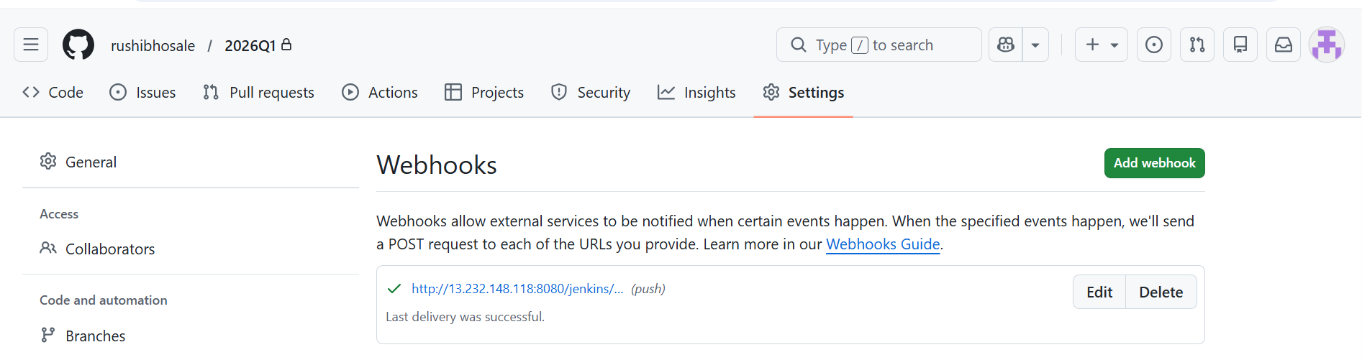

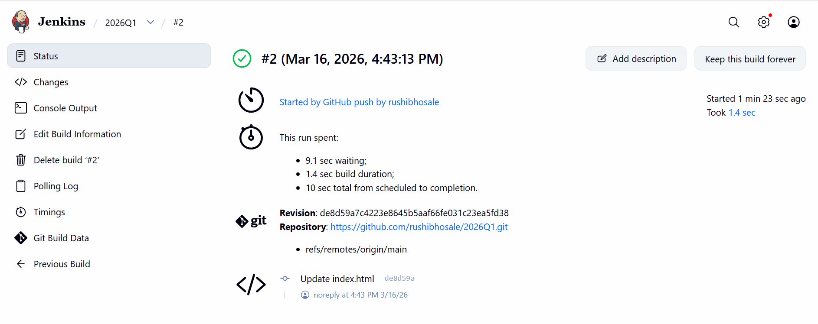
Update index.html in 2026Q2 repo.
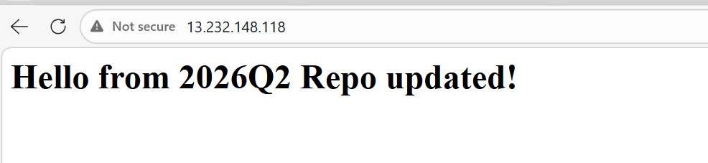
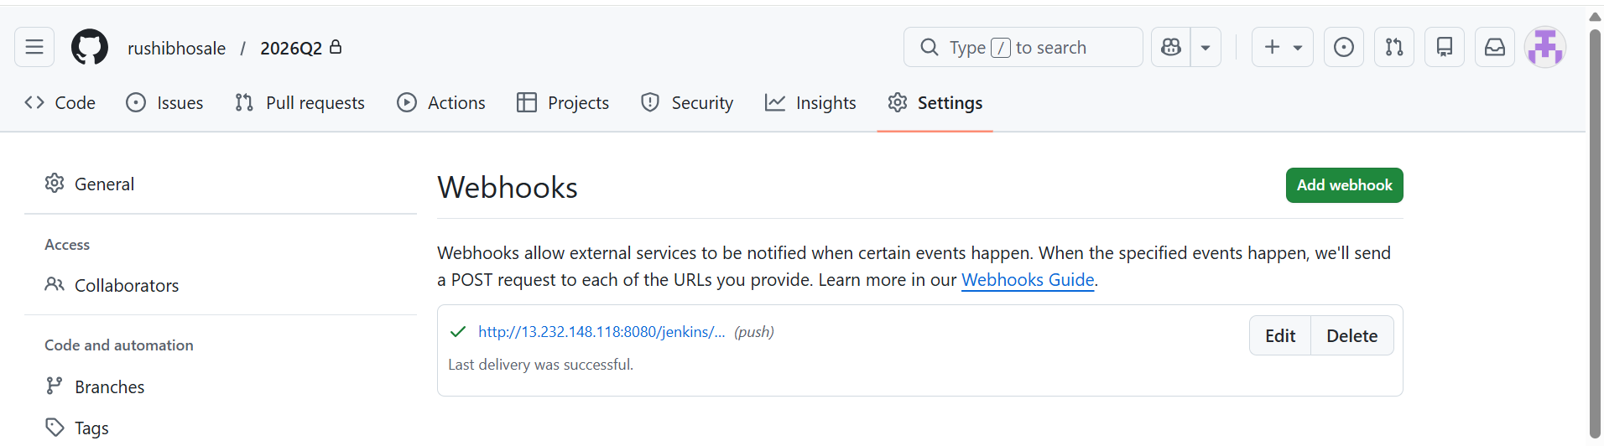
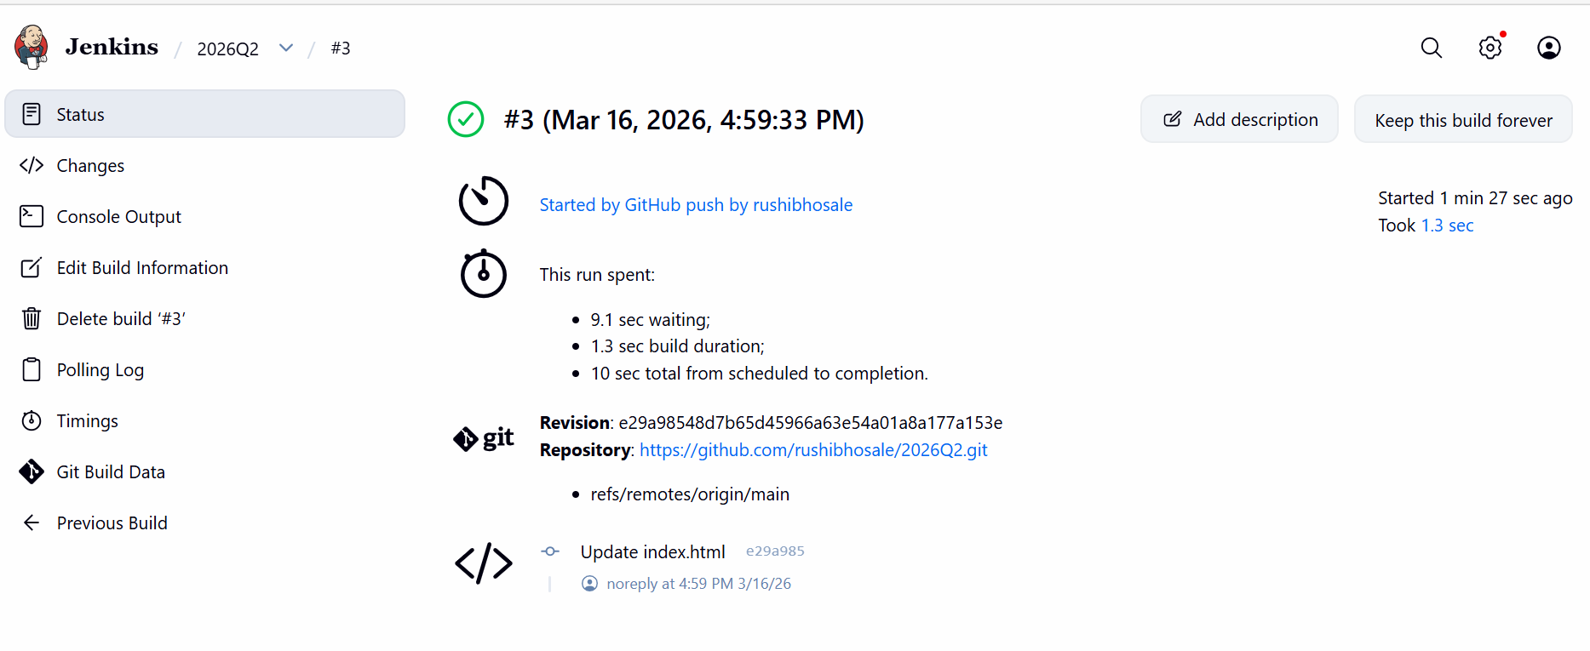
Update index.html in 2026Q3 branch
