Assignment 10:
You have Jenkins master and slave create war on slave deploy on slave itself.
Steps:
- Create freestyle project and in source code management select git and add below
https://github.com/Shantanumajan6/project.git
- In “Restrict where this project can be run” select slave-1
- Add below shell script in build steps
#!/bin/bash
set -e

# ==========================================
# 1. Define Variables
# ==========================================
PROJECT_NAME="loginwebapp"
TOMCAT_WEBAPPS_DIR="/mnt/apache-tomcat-10.1.52/webapps"

echo "Starting local build and deploy on Slave 1..."

# ==========================================
# 2. Build the WAR file locally on Slave 1
# ==========================================
# Force Java to open the required modules so the old plugin can access them
export MAVEN_OPTS="--add-opens java.base/java.util=ALL-UNNAMED --add-opens java.base/java.text=ALL-UNNAMED --add-opens java.desktop/java.awt.font=ALL-UNNAMED"

echo "Compiling code with Maven..."
mvn clean package

# Find the exact name of the generated WAR file in the local target directory
BUILT_WAR_FILE=$(ls target/*.war | head -n 1)

# ==========================================
# 3. Deploy Directly to Local Tomcat
# ==========================================
echo "Deploying $BUILT_WAR_FILE directly into local Tomcat webapps directory..."

# Because the script is already running on Slave 1, a simple 'cp' command moves it into Tomcat
cp $BUILT_WAR_FILE ${TOMCAT_WEBAPPS_DIR}/${PROJECT_NAME}.war

echo "=========================================================="
echo "Deployment successful! WAR built and deployed entirely on Slave 1."
echo "=========================================================="

Output:
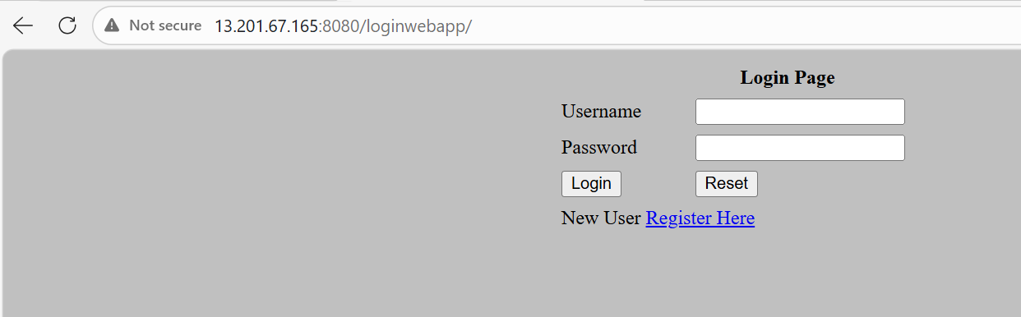
Started by user admin
Running as SYSTEM
Building remotely on slave-1 (qa) in workspace /mnt/slave_dir/workspace/deploy_on_slave
[WS-CLEANUP] Deleting project workspace...
[WS-CLEANUP] Deferred wipeout is used...
[WS-CLEANUP] Done
The recommended git tool is: NONE
No credentials specified
Cloning the remote Git repository
Cloning repository https://github.com/Shantanumajan6/project.git
> git init /mnt/slave_dir/workspace/deploy_on_slave # timeout=10
Fetching upstream changes from https://github.com/Shantanumajan6/project.git
> git --version # timeout=10
> git --version # 'git version 2.50.1'
> git fetch --tags --force --progress -- https://github.com/Shantanumajan6/project.git +refs/heads/*:refs/remotes/origin/* # timeout=10
> git config remote.origin.url https://github.com/Shantanumajan6/project.git # timeout=10
> git config --add remote.origin.fetch +refs/heads/*:refs/remotes/origin/* # timeout=10
Avoid second fetch
> git rev-parse refs/remotes/origin/master^{commit} # timeout=10
Checking out Revision dad4cbb1657dd0bc83e677cdf2588836f9c329f2 (refs/remotes/origin/master)
> git config core.sparsecheckout # timeout=10
> git checkout -f dad4cbb1657dd0bc83e677cdf2588836f9c329f2 # timeout=10
Commit message: "Create maven.yml"
> git rev-list --no-walk dad4cbb1657dd0bc83e677cdf2588836f9c329f2 # timeout=10
[deploy_on_slave] $ /bin/bash /tmp/jenkins16086429066102512148.sh
Starting local build and deploy on Slave 1...
Compiling code with Maven...
[INFO] Scanning for projects...
[INFO]
[INFO] --------------------< com.javawebtutor:LoginWebApp >--------------------
[INFO] Building LoginWebApp Maven Webapp 1.0-SNAPSHOT
[INFO] --------------------------------[ war ]---------------------------------
[INFO]
[INFO] --- maven-clean-plugin:2.5:clean (default-clean) @ LoginWebApp ---
[INFO]
[INFO] --- maven-resources-plugin:2.6:resources (default-resources) @ LoginWebApp ---
[WARNING] Using platform encoding (UTF-8 actually) to copy filtered resources, i.e. build is platform dependent!
[INFO] skip non existing resourceDirectory /mnt/slave_dir/workspace/deploy_on_slave/src/main/resources
[INFO]
[INFO] --- maven-compiler-plugin:3.1:compile (default-compile) @ LoginWebApp ---
[INFO] No sources to compile
[INFO]
[INFO] --- maven-resources-plugin:2.6:testResources (default-testResources) @ LoginWebApp ---
[WARNING] Using platform encoding (UTF-8 actually) to copy filtered resources, i.e. build is platform dependent!
[INFO] skip non existing resourceDirectory /mnt/slave_dir/workspace/deploy_on_slave/src/test/resources
[INFO]
[INFO] --- maven-compiler-plugin:3.1:testCompile (default-testCompile) @ LoginWebApp ---
[INFO] No sources to compile
[INFO]
[INFO] --- maven-surefire-plugin:2.12.4:test (default-test) @ LoginWebApp ---
[INFO] No tests to run.
[INFO]
[INFO] --- maven-war-plugin:2.2:war (default-war) @ LoginWebApp ---
[INFO] Packaging webapp
[INFO] Assembling webapp [LoginWebApp] in [/mnt/slave_dir/workspace/deploy_on_slave/target/LoginWebApp]
[INFO] Processing war project
[INFO] Copying webapp resources [/mnt/slave_dir/workspace/deploy_on_slave/src/main/webapp]
[INFO] Webapp assembled in [58 msecs]
[INFO] Building war: /mnt/slave_dir/workspace/deploy_on_slave/target/LoginWebApp.war
[INFO] WEB-INF/web.xml already added, skipping
[INFO] ------------------------------------------------------------------------
[INFO] BUILD SUCCESS
[INFO] ------------------------------------------------------------------------
[INFO] Total time: 1.683 s
[INFO] Finished at: 2026-03-21T09:08:08Z
[INFO] ------------------------------------------------------------------------
Deploying target/LoginWebApp.war directly into local Tomcat webapps directory...
==========================================================
Deployment successful! WAR built and deployed entirely on Slave 1.
==========================================================
Finished: SUCCESS

