Assignment 9:
A : Create War file in jenkins master and deploy it on Slave 1 tomcat

- Create freestyle project and in Source code management select git and add below url
https://github.com/Shantanumajan6/project.git
- In build step add below shell script
#!/bin/bash
set -e

# ==========================================
# 1. Define Variables
# ==========================================
PROJECT_NAME="loginwebapp"

# --- SLAVE 1 VARIABLES ---
# Replace this with the actual private IP of your Slave 1 EC2 instance
SLAVE1_IP="172.31.36.66"
SLAVE1_USER="ec2-user"
SSH_KEY="/root/linux.pem"
TOMCAT_WEBAPPS_DIR="/mnt/apache-tomcat-10.1.52/webapps"

echo "Starting build on Jenkins Master..."

# ==========================================
# 2. Build the WAR file using Maven
# ==========================================
# Force Java to open the required modules so the old plugin can access them
export MAVEN_OPTS="--add-opens java.base/java.util=ALL-UNNAMED --add-opens java.base/java.text=ALL-UNNAMED --add-opens java.desktop/java.awt.font=ALL-UNNAMED"

echo "Compiling code with Maven..."
mvn clean package

# Find the exact name of the generated WAR file in the target directory
BUILT_WAR_FILE=$(ls target/*.war | head -n 1)

# ==========================================
# 3. Direct SCP Transfer to Slave 1
# ==========================================
echo "Transferring $BUILT_WAR_FILE directly to Tomcat on Slave 1 ($SLAVE1_IP)..."

# Direct SCP transfer from Master to Slave 1
scp -i $SSH_KEY -o StrictHostKeyChecking=no $BUILT_WAR_FILE ${SLAVE1_USER}@${SLAVE1_IP}:${TOMCAT_WEBAPPS_DIR}/${PROJECT_NAME}.war

echo "=========================================================="
echo "Deployment successful! WAR built on Master and pushed to Slave 1."
echo "=========================================================="
- Create Slave-1 and this node to Jenkins master

Output:
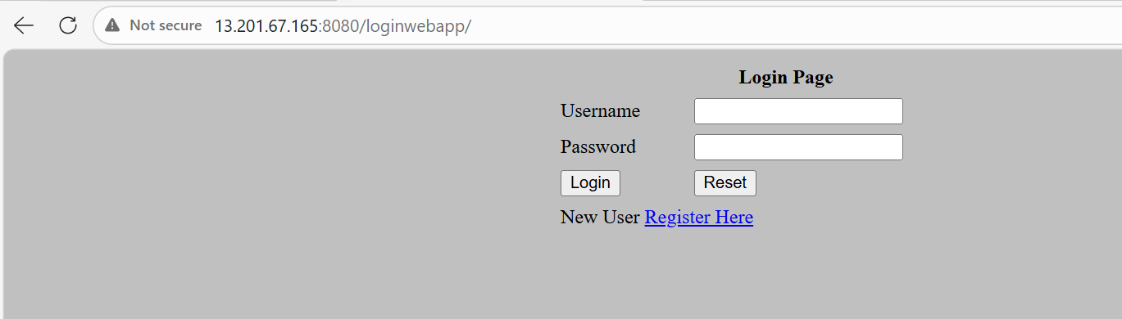
Started by user admin
Running as SYSTEM
Building on the built-in node in workspace /root/.jenkins/workspace/copy_master_to_slave
[WS-CLEANUP] Deleting project workspace...
[WS-CLEANUP] Deferred wipeout is used...
[WS-CLEANUP] Done
The recommended git tool is: NONE
No credentials specified
Cloning the remote Git repository
Cloning repository https://github.com/Shantanumajan6/project.git
> git init /root/.jenkins/workspace/copy_master_to_slave # timeout=10
Fetching upstream changes from https://github.com/Shantanumajan6/project.git
> git --version # timeout=10
> git --version # 'git version 2.50.1'
> git fetch --tags --force --progress -- https://github.com/Shantanumajan6/project.git +refs/heads/*:refs/remotes/origin/* # timeout=10
> git config remote.origin.url https://github.com/Shantanumajan6/project.git # timeout=10
> git config --add remote.origin.fetch +refs/heads/*:refs/remotes/origin/* # timeout=10
Avoid second fetch
> git rev-parse refs/remotes/origin/master^{commit} # timeout=10
Checking out Revision dad4cbb1657dd0bc83e677cdf2588836f9c329f2 (refs/remotes/origin/master)
> git config core.sparsecheckout # timeout=10
> git checkout -f dad4cbb1657dd0bc83e677cdf2588836f9c329f2 # timeout=10
Commit message: "Create maven.yml"
> git rev-list --no-walk dad4cbb1657dd0bc83e677cdf2588836f9c329f2 # timeout=10
[copy_master_to_slave] $ /bin/bash /mnt/servers/apache-tomcat-10.1.52/temp/jenkins7701475683335061896.sh
Starting build on Jenkins Master...
Compiling code with Maven...
[INFO] Scanning for projects...
[INFO]
[INFO] --------------------< com.javawebtutor:LoginWebApp >--------------------
[INFO] Building LoginWebApp Maven Webapp 1.0-SNAPSHOT
[INFO] --------------------------------[ war ]---------------------------------
[INFO]
[INFO] --- maven-clean-plugin:2.5:clean (default-clean) @ LoginWebApp ---
[INFO]
[INFO] --- maven-resources-plugin:2.6:resources (default-resources) @ LoginWebApp ---
[WARNING] Using platform encoding (UTF-8 actually) to copy filtered resources, i.e. build is platform dependent!
[INFO] skip non existing resourceDirectory /root/.jenkins/workspace/copy_master_to_slave/src/main/resources
[INFO]
[INFO] --- maven-compiler-plugin:3.1:compile (default-compile) @ LoginWebApp ---
[INFO] No sources to compile
[INFO]
[INFO] --- maven-resources-plugin:2.6:testResources (default-testResources) @ LoginWebApp ---
[WARNING] Using platform encoding (UTF-8 actually) to copy filtered resources, i.e. build is platform dependent!
[INFO] skip non existing resourceDirectory /root/.jenkins/workspace/copy_master_to_slave/src/test/resources
[INFO]
[INFO] --- maven-compiler-plugin:3.1:testCompile (default-testCompile) @ LoginWebApp ---
[INFO] No sources to compile
[INFO]
[INFO] --- maven-surefire-plugin:2.12.4:test (default-test) @ LoginWebApp ---
[INFO] No tests to run.
[INFO]
[INFO] --- maven-war-plugin:2.2:war (default-war) @ LoginWebApp ---
[INFO] Packaging webapp
[INFO] Assembling webapp [LoginWebApp] in [/root/.jenkins/workspace/copy_master_to_slave/target/LoginWebApp]
[INFO] Processing war project
[INFO] Copying webapp resources [/root/.jenkins/workspace/copy_master_to_slave/src/main/webapp]
[INFO] Webapp assembled in [66 msecs]
[INFO] Building war: /root/.jenkins/workspace/copy_master_to_slave/target/LoginWebApp.war
[INFO] WEB-INF/web.xml already added, skipping
[INFO] ------------------------------------------------------------------------
[INFO] BUILD SUCCESS
[INFO] ------------------------------------------------------------------------
[INFO] Total time: 2.041 s
[INFO] Finished at: 2026-03-21T08:05:09Z
[INFO] ------------------------------------------------------------------------
Transferring target/LoginWebApp.war directly to Tomcat on Slave 1 (172.31.36.66)...
==========================================================
Deployment successful! WAR built on Master and pushed to Slave 1.
==========================================================
Finished: SUCCESS

B. Create war on jenkins master publish it to S3 and then deploy it to slave 1

- Create a new freestyle project and follow same steps. Just add below shell script in build steps
#!/bin/bash
set -e

# ==========================================
# 1. Define Variables
# ==========================================
TIMESTAMP=$(date +%Y%m%d%H%M%S)
PROJECT_NAME="loginwebapp"

# --- S3 VARIABLES ---
BUCKET_NAME="my-tomcat-artifacts-repo-unique123" # Must be globally unique
REGION="ap-south-1"
S3_WAR_NAME="${PROJECT_NAME}-${TIMESTAMP}.war"

# --- SLAVE 1 VARIABLES ---
SLAVE1_IP="172.31.36.66" # Change to the Private IP of Slave 1
SLAVE1_USER="ec2-user"
SSH_KEY="/root/linux.pem"
TOMCAT_WEBAPPS_DIR="/mnt/apache-tomcat-10.1.52/webapps"

echo "Starting build, publish, and deploy pipeline..."

# ==========================================
# 2. Create the S3 Bucket (Only if it doesn't exist)
# ==========================================
if aws s3api head-bucket --bucket "$BUCKET_NAME" 2>/dev/null; then
echo "S3 Bucket '$BUCKET_NAME' already exists. Skipping creation."
else
echo "Creating new S3 bucket: $BUCKET_NAME"
aws s3 mb s3://$BUCKET_NAME --region $REGION
fi

# ==========================================
# 3. Build the WAR file using Maven
# ==========================================
# Force Java to open the required modules so the old plugin can access them
export MAVEN_OPTS="--add-opens java.base/java.util=ALL-UNNAMED --add-opens java.base/java.text=ALL-UNNAMED --add-opens java.desktop/java.awt.font=ALL-UNNAMED"

echo "Compiling code with Maven..."
mvn clean package

BUILT_WAR_FILE=$(ls target/*.war | head -n 1)

# ==========================================
# 4. Publish Artifact to S3
# ==========================================
echo "Publishing $BUILT_WAR_FILE to S3 as: $S3_WAR_NAME"
aws s3 cp $BUILT_WAR_FILE s3://${BUCKET_NAME}/${S3_WAR_NAME}

# ==========================================
# 5. Deploy to Slave 1 Tomcat
# ==========================================
echo "Transferring WAR directly to Tomcat on Slave 1 ($SLAVE1_IP)..."

# Direct SCP transfer from Master to Slave 1
scp -i $SSH_KEY -o StrictHostKeyChecking=no $BUILT_WAR_FILE ${SLAVE1_USER}@${SLAVE1_IP}:${TOMCAT_WEBAPPS_DIR}/${PROJECT_NAME}.war

echo "=========================================================="
echo "Success! WAR published to S3 ($BUCKET_NAME) and deployed to Slave 1."
echo "=========================================================="

Output:
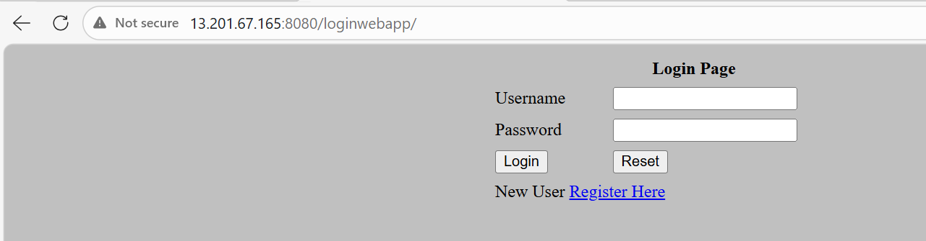
Started by user admin
Running as SYSTEM
Building on the built-in node in workspace /root/.jenkins/workspace/copy_s3_to_slave
[WS-CLEANUP] Deleting project workspace...
[WS-CLEANUP] Deferred wipeout is used...
[WS-CLEANUP] Done
The recommended git tool is: NONE
No credentials specified
Cloning the remote Git repository
Cloning repository https://github.com/Shantanumajan6/project.git
> git init /root/.jenkins/workspace/copy_s3_to_slave # timeout=10
Fetching upstream changes from https://github.com/Shantanumajan6/project.git
> git --version # timeout=10
> git --version # 'git version 2.50.1'
> git fetch --tags --force --progress -- https://github.com/Shantanumajan6/project.git +refs/heads/*:refs/remotes/origin/* # timeout=10
> git config remote.origin.url https://github.com/Shantanumajan6/project.git # timeout=10
> git config --add remote.origin.fetch +refs/heads/*:refs/remotes/origin/* # timeout=10
Avoid second fetch
> git rev-parse refs/remotes/origin/master^{commit} # timeout=10
Checking out Revision dad4cbb1657dd0bc83e677cdf2588836f9c329f2 (refs/remotes/origin/master)
> git config core.sparsecheckout # timeout=10
> git checkout -f dad4cbb1657dd0bc83e677cdf2588836f9c329f2 # timeout=10
Commit message: "Create maven.yml"
> git rev-list --no-walk dad4cbb1657dd0bc83e677cdf2588836f9c329f2 # timeout=10
[copy_s3_to_slave] $ /bin/bash /mnt/servers/apache-tomcat-10.1.52/temp/jenkins17055916146193979929.sh
Starting build, publish, and deploy pipeline...
{
"BucketArn": "arn:aws:s3:::my-tomcat-artifacts-repo-unique123",
"BucketRegion": "ap-south-1",
"AccessPointAlias": false
}
S3 Bucket 'my-tomcat-artifacts-repo-unique123' already exists. Skipping creation.
Compiling code with Maven...
[INFO] Scanning for projects...
[INFO]
[INFO] --------------------< com.javawebtutor:LoginWebApp >--------------------
[INFO] Building LoginWebApp Maven Webapp 1.0-SNAPSHOT
[INFO] --------------------------------[ war ]---------------------------------
[INFO]
[INFO] --- maven-clean-plugin:2.5:clean (default-clean) @ LoginWebApp ---
[INFO]
[INFO] --- maven-resources-plugin:2.6:resources (default-resources) @ LoginWebApp ---
[WARNING] Using platform encoding (UTF-8 actually) to copy filtered resources, i.e. build is platform dependent!
[INFO] skip non existing resourceDirectory /root/.jenkins/workspace/copy_s3_to_slave/src/main/resources
[INFO]
[INFO] --- maven-compiler-plugin:3.1:compile (default-compile) @ LoginWebApp ---
[INFO] No sources to compile
[INFO]
[INFO] --- maven-resources-plugin:2.6:testResources (default-testResources) @ LoginWebApp ---
[WARNING] Using platform encoding (UTF-8 actually) to copy filtered resources, i.e. build is platform dependent!
[INFO] skip non existing resourceDirectory /root/.jenkins/workspace/copy_s3_to_slave/src/test/resources
[INFO]
[INFO] --- maven-compiler-plugin:3.1:testCompile (default-testCompile) @ LoginWebApp ---
[INFO] No sources to compile
[INFO]
[INFO] --- maven-surefire-plugin:2.12.4:test (default-test) @ LoginWebApp ---
[INFO] No tests to run.
[INFO]
[INFO] --- maven-war-plugin:2.2:war (default-war) @ LoginWebApp ---
[INFO] Packaging webapp
[INFO] Assembling webapp [LoginWebApp] in [/root/.jenkins/workspace/copy_s3_to_slave/target/LoginWebApp]
[INFO] Processing war project
[INFO] Copying webapp resources [/root/.jenkins/workspace/copy_s3_to_slave/src/main/webapp]
[INFO] Webapp assembled in [75 msecs]
[INFO] Building war: /root/.jenkins/workspace/copy_s3_to_slave/target/LoginWebApp.war
[INFO] WEB-INF/web.xml already added, skipping
[INFO] ------------------------------------------------------------------------
[INFO] BUILD SUCCESS
[INFO] ------------------------------------------------------------------------
[INFO] Total time: 2.267 s
[INFO] Finished at: 2026-03-21T08:50:12Z
[INFO] ------------------------------------------------------------------------
Publishing target/LoginWebApp.war to S3 as: loginwebapp-20260321085007.war
Completed 1.0 MiB/3.7 MiB (29.3 MiB/s) with 1 file(s) remaining
Completed 2.0 MiB/3.7 MiB (37.5 MiB/s) with 1 file(s) remaining
Completed 3.0 MiB/3.7 MiB (53.0 MiB/s) with 1 file(s) remaining
Completed 3.7 MiB/3.7 MiB (63.2 MiB/s) with 1 file(s) remaining
upload: target/LoginWebApp.war to s3://my-tomcat-artifacts-repo-unique123/loginwebapp-20260321085007.war
Transferring WAR directly to Tomcat on Slave 1 (172.31.36.66)...
==========================================================
Success! WAR published to S3 (my-tomcat-artifacts-repo-unique123) and deployed to Slave 1.
==========================================================
Finished: SUCCESS

