Assignment 8:
We have three repositories on GitHub like 2026Q1, 2026Q2, 2026Q3. Each repo contains index.html. You have Jenkins master and two slaves. Deploy Q1 on master, Q2 on slave1, Q3 on slave 3. Whenever you update index, it should be deployed on respective node.

Steps:
- Setup Jenkins Master and 2 slave’s machines
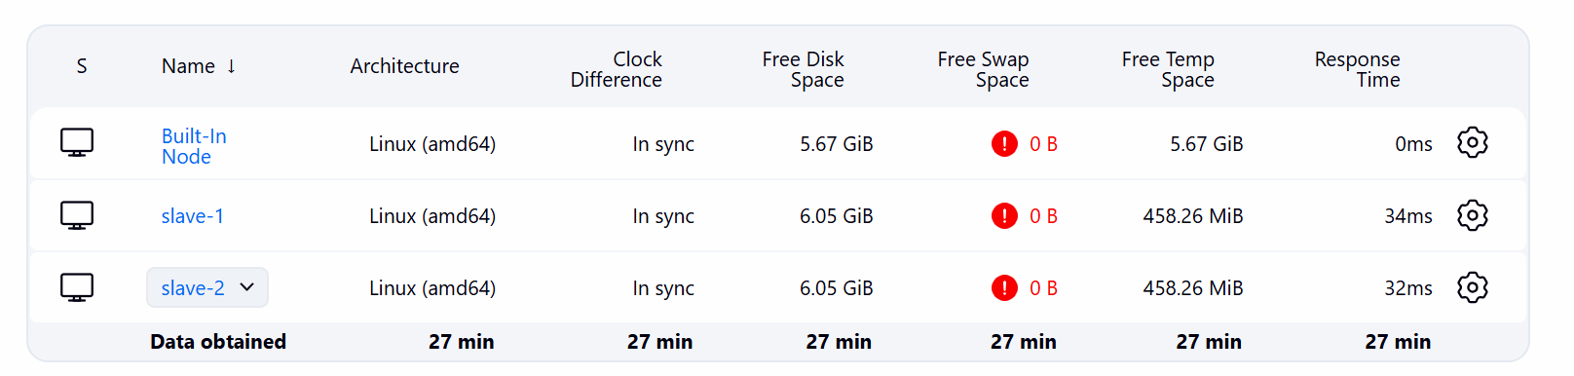
- Create freestyle job and select github repo and credentials
- Install httpd in JM as well as on slaves
- In build step add below shell script
#!/bin/bash
set -e
HTTPD_DIR="/var/www/html"
sudo rm -f ${HTTPD_DIR}/index.html
sudo cp index.html ${HTTPD_DIR}/index.html
sudo chmod 644 ${HTTPD_DIR}/index.html
echo "2026Q1 deployed to Master node."
- Same create 2 freestyle projects for slaves just select slave in below option
Restrict where this project can be run
- Update index.html present in each repo. It will trigger the job due to github webhook
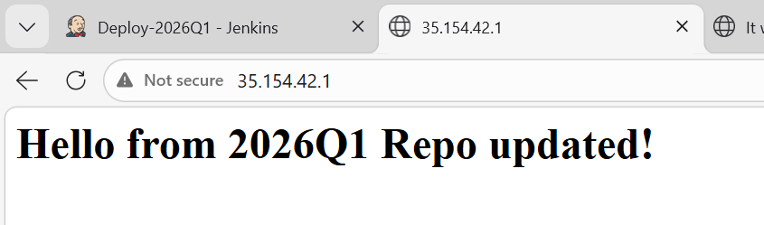
Started by GitHub push by rushibhosale
Running as SYSTEM
Building on the built-in node in workspace /root/.jenkins/workspace/Deploy-2026Q1
[WS-CLEANUP] Deleting project workspace...
[WS-CLEANUP] Deferred wipeout is used...
[WS-CLEANUP] Done
The recommended git tool is: NONE
using credential git-token
Cloning the remote Git repository
Cloning repository https://github.com/rushibhosale/2026Q1.git
> git init /root/.jenkins/workspace/Deploy-2026Q1 # timeout=10
Fetching upstream changes from https://github.com/rushibhosale/2026Q1.git
> git --version # timeout=10
> git --version # 'git version 2.50.1'
using GIT_ASKPASS to set credentials
> git fetch --tags --force --progress -- https://github.com/rushibhosale/2026Q1.git +refs/heads/*:refs/remotes/origin/* # timeout=10
> git config remote.origin.url https://github.com/rushibhosale/2026Q1.git # timeout=10
> git config --add remote.origin.fetch +refs/heads/*:refs/remotes/origin/* # timeout=10
Avoid second fetch
> git rev-parse refs/remotes/origin/main^{commit} # timeout=10
Checking out Revision b2df8933694468bb353f9d68b3d5048e7b853303 (refs/remotes/origin/main)
> git config core.sparsecheckout # timeout=10
> git checkout -f b2df8933694468bb353f9d68b3d5048e7b853303 # timeout=10
Commit message: "Update header text in index.html"
> git rev-list --no-walk 1560acd480280123c7cc9264c521fd14d9d00589 # timeout=10
[Deploy-2026Q1] $ /bin/bash /mnt/servers/apache-tomcat-10.1.52/temp/jenkins10154934553354722121.sh
2026Q1 deployed to Master node.
Finished: SUCCESS
Slave1:
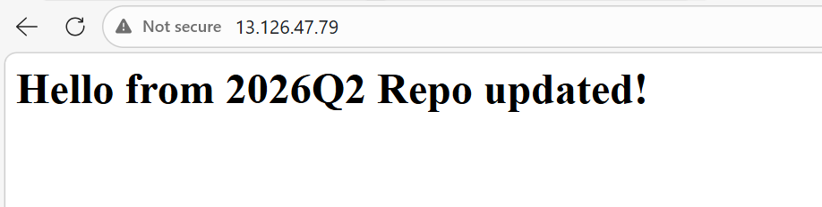
Started by GitHub push by rushibhosale
Running as SYSTEM
Building remotely on slave-1 (qa) in workspace /mnt/slave_dir/workspace/Deploy-2026Q2
[WS-CLEANUP] Deleting project workspace...
[WS-CLEANUP] Deferred wipeout is used...
The recommended git tool is: NONE
using credential git-token
Cloning the remote Git repository
Cloning repository https://github.com/rushibhosale/2026Q2.git
> git init /mnt/slave_dir/workspace/Deploy-2026Q2 # timeout=10
Fetching upstream changes from https://github.com/rushibhosale/2026Q2.git
> git --version # timeout=10
> git --version # 'git version 2.50.1'
using GIT_ASKPASS to set credentials
> git fetch --tags --force --progress -- https://github.com/rushibhosale/2026Q2.git +refs/heads/*:refs/remotes/origin/* # timeout=10
> git config remote.origin.url https://github.com/rushibhosale/2026Q2.git # timeout=10
> git config --add remote.origin.fetch +refs/heads/*:refs/remotes/origin/* # timeout=10
Avoid second fetch
> git rev-parse refs/remotes/origin/main^{commit} # timeout=10
Checking out Revision 3f0ddd77039be2338caac5454a3c95d96e2c3ae6 (refs/remotes/origin/main)
> git config core.sparsecheckout # timeout=10
> git checkout -f 3f0ddd77039be2338caac5454a3c95d96e2c3ae6 # timeout=10
Commit message: "Update index.html"
First time build. Skipping changelog.
[Deploy-2026Q2] $ /bin/bash /tmp/jenkins5370989034019820098.sh
2026Q2 deployed to Slave 1.
Finished: SUCCESS

Slave2:
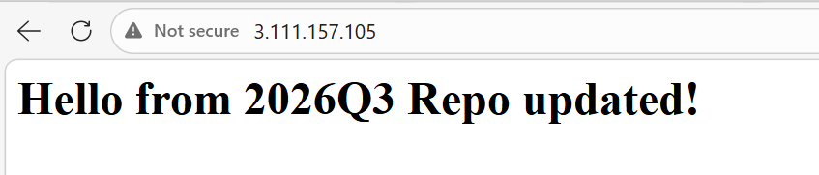

Started by GitHub push by rushibhosale
Running as SYSTEM
Building remotely on slave-2 (qa) in workspace /mnt/slave_dir/workspace/Deploy-2026Q3
[WS-CLEANUP] Deleting project workspace...
[WS-CLEANUP] Deferred wipeout is used...
The recommended git tool is: NONE
using credential git-token
Cloning the remote Git repository
Cloning repository https://github.com/rushibhosale/2026Q3.git
> git init /mnt/slave_dir/workspace/Deploy-2026Q3 # timeout=10
Fetching upstream changes from https://github.com/rushibhosale/2026Q3.git
> git --version # timeout=10
> git --version # 'git version 2.50.1'
using GIT_ASKPASS to set credentials
> git fetch --tags --force --progress -- https://github.com/rushibhosale/2026Q3.git +refs/heads/*:refs/remotes/origin/* # timeout=10
> git config remote.origin.url https://github.com/rushibhosale/2026Q3.git # timeout=10
> git config --add remote.origin.fetch +refs/heads/*:refs/remotes/origin/* # timeout=10
Avoid second fetch
> git rev-parse refs/remotes/origin/main^{commit} # timeout=10
Checking out Revision ba9a6923d7f85cb614323b99c1cdebcc35db03d6 (refs/remotes/origin/main)
> git config core.sparsecheckout # timeout=10
> git checkout -f ba9a6923d7f85cb614323b99c1cdebcc35db03d6 # timeout=10
Commit message: "Update greeting message in index.html"
First time build. Skipping changelog.
[Deploy-2026Q3] $ /bin/bash /tmp/jenkins13998389465942152801.sh
2026Q3 deployed to Slave 2.
Finished: SUCCESS

