Assignment 11:
Create index.html and deploy using httpd server using Jenkins build.
Check Jenkinsfile present in same directory

Output:
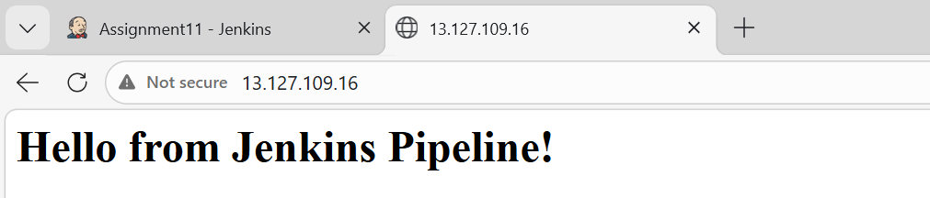
Started by user admin
[Pipeline] Start of Pipeline
[Pipeline] node
Running on Jenkins in /root/.jenkins/workspace/Assignment11
[Pipeline] {
[Pipeline] stage
[Pipeline] { (Install and configure apache)
[Pipeline] echo
Starting deployment script..
[Pipeline] sh
+ set -e
+ yum install httpd -y
Last metadata expiration check: 0:08:03 ago on Mon Mar 23 16:39:10 2026.
Package httpd-2.4.66-1.amzn2023.0.1.x86_64 is already installed.
Dependencies resolved.
Nothing to do.
Complete!
+ systemctl start httpd
+ systemctl enable httpd
Created symlink /etc/systemd/system/multi-user.target.wants/httpd.service → /usr/lib/systemd/system/httpd.service.
[Pipeline] }
[Pipeline] // stage
[Pipeline] stage
[Pipeline] { (Deploy html and restart)
[Pipeline] sh
+ echo '<h1>Hello from Jenkins Pipeline!</h1>'
+ cp index.html /var/www/html/
+ sudo chmod -R 777 /var/www/html/index.html
+ systemctl restart httpd
[Pipeline] }
[Pipeline] // stage
[Pipeline] }
[Pipeline] // node
[Pipeline] End of Pipeline
Finished: SUCCESS

