Assignment 2:
Github repo you have branch 2026Q1 here you have index.html. This is private repo. In jenkins master you have apache httpd installed. create a job that will pull index.html from this repo and deploy on httpd

Check Jenkinsfile in same directory.

Output:
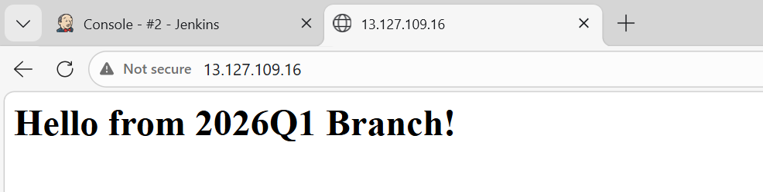
Started by user admin
[Pipeline] Start of Pipeline
[Pipeline] node
Running on Jenkins in /root/.jenkins/workspace/Assignment12
[Pipeline] {
[Pipeline] stage
[Pipeline] { (Checkout code )
[Pipeline] echo
Pulling index.html from private GitHub repo (Branch: 2026Q1)...
[Pipeline] git
The recommended git tool is: NONE
using credential ssh-key
> git rev-parse --resolve-git-dir /root/.jenkins/workspace/Assignment12/.git # timeout=10
Fetching changes from the remote Git repository
> git config remote.origin.url https://github.com/rushibhosale/priv_repo.git # timeout=10
Fetching upstream changes from https://github.com/rushibhosale/priv_repo.git
> git --version # timeout=10
> git --version # 'git version 2.50.1'
using GIT_ASKPASS to set credentials
> git fetch --tags --force --progress -- https://github.com/rushibhosale/priv_repo.git +refs/heads/*:refs/remotes/origin/* # timeout=10
> git rev-parse refs/remotes/origin/2026Q1^{commit} # timeout=10
Checking out Revision 52284177e5431ead9e2469bd6fc614817376e737 (refs/remotes/origin/2026Q1)
> git config core.sparsecheckout # timeout=10
> git checkout -f 52284177e5431ead9e2469bd6fc614817376e737 # timeout=10
> git branch -a -v --no-abbrev # timeout=10
> git branch -D 2026Q1 # timeout=10
> git checkout -b 2026Q1 52284177e5431ead9e2469bd6fc614817376e737 # timeout=10
Commit message: "branch1"
> git rev-list --no-walk 52284177e5431ead9e2469bd6fc614817376e737 # timeout=10
[Pipeline] }
[Pipeline] // stage
[Pipeline] stage
[Pipeline] { (Deploy to apache httpd)
[Pipeline] sh
+ echo 'Startingg deployment'
Startingg deployment
+ cp index.html /var/www/html/
+ chmod 644 /var/www/html/index.html
+ sudo systemctl restart httpd
[Pipeline] }
[Pipeline] // stage
[Pipeline] }
[Pipeline] // node
[Pipeline] End of Pipeline
Finished: SUCCESS

