Assignment 13:
You have three repos private on github. in first you have branch 2026Q1, in second you have branch 2026Q2, in third you have 2026Q3. all repos have index.html. In 1st the content is
<h1>this is repo1 q1 brach </h1>
and so on respectively in next two index files
In your jenkins master you have apache httpd. create jobs (3)
so that if i run job1 then index from q1 will be deployed. If I run job2 then previous index will be deleted and index from repo 2 will be deployed and so on.

Check Jenkinsfile in same directory.

Output:
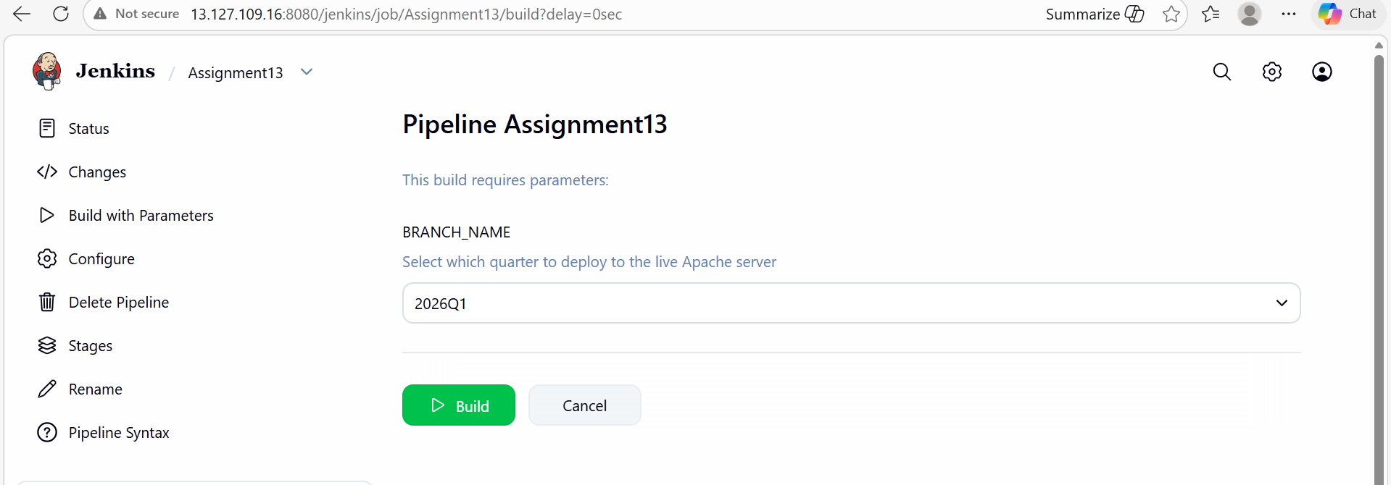
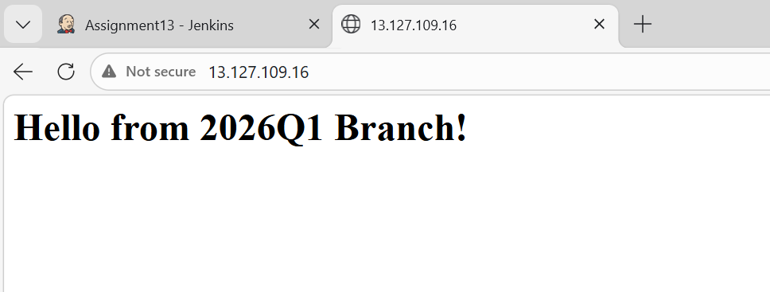
Started by user admin
[Pipeline] Start of Pipeline
[Pipeline] node
Running on Jenkins in /root/.jenkins/workspace/Assignment13
[Pipeline] {
[Pipeline] stage
[Pipeline] { (Checkout code)
[Pipeline] echo
Pulling index.html from branch: 2026Q1...
[Pipeline] git
The recommended git tool is: NONE
using credential ssh-key
> git rev-parse --resolve-git-dir /root/.jenkins/workspace/Assignment13/.git # timeout=10
Fetching changes from the remote Git repository
> git config remote.origin.url https://github.com/rushibhosale/priv_repo.git # timeout=10
Fetching upstream changes from https://github.com/rushibhosale/priv_repo.git
> git --version # timeout=10
> git --version # 'git version 2.50.1'
using GIT_ASKPASS to set credentials
> git fetch --tags --force --progress -- https://github.com/rushibhosale/priv_repo.git +refs/heads/*:refs/remotes/origin/* # timeout=10
> git rev-parse refs/remotes/origin/2026Q1^{commit} # timeout=10
Checking out Revision 52284177e5431ead9e2469bd6fc614817376e737 (refs/remotes/origin/2026Q1)
> git config core.sparsecheckout # timeout=10
> git checkout -f 52284177e5431ead9e2469bd6fc614817376e737 # timeout=10
> git branch -a -v --no-abbrev # timeout=10
> git branch -D 2026Q1 # timeout=10
> git checkout -b 2026Q1 52284177e5431ead9e2469bd6fc614817376e737 # timeout=10
Commit message: "branch1"
> git rev-list --no-walk 52284177e5431ead9e2469bd6fc614817376e737 # timeout=10
[Pipeline] }
[Pipeline] // stage
[Pipeline] stage
[Pipeline] { (Deploy to httpd)
[Pipeline] echo
Deploying 2026Q1 to Apache...
[Pipeline] sh
+ sudo rm -f /var/www/html/index.html
+ sudo cp index.html /var/www/html/
+ sudo chmod 644 /var/www/html/index.html
+ sudo systemctl restart httpd
[Pipeline] }
[Pipeline] // stage
[Pipeline] }
[Pipeline] // node
[Pipeline] End of Pipeline
Finished: SUCCESS

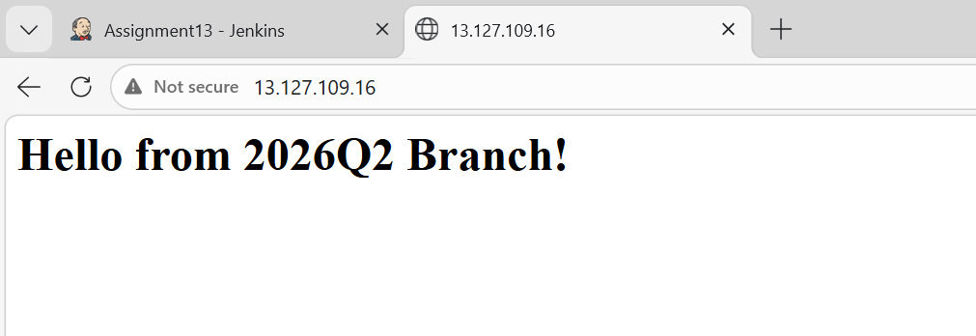
Started by user admin
[Pipeline] Start of Pipeline
[Pipeline] node
Running on Jenkins in /root/.jenkins/workspace/Assignment13
[Pipeline] {
[Pipeline] stage
[Pipeline] { (Checkout code)
[Pipeline] echo
Pulling index.html from branch: 2026Q2...
[Pipeline] git
The recommended git tool is: NONE
using credential ssh-key
> git rev-parse --resolve-git-dir /root/.jenkins/workspace/Assignment13/.git # timeout=10
Fetching changes from the remote Git repository
> git config remote.origin.url https://github.com/rushibhosale/priv_repo.git # timeout=10
Fetching upstream changes from https://github.com/rushibhosale/priv_repo.git
> git --version # timeout=10
> git --version # 'git version 2.50.1'
using GIT_ASKPASS to set credentials
> git fetch --tags --force --progress -- https://github.com/rushibhosale/priv_repo.git +refs/heads/*:refs/remotes/origin/* # timeout=10
> git rev-parse refs/remotes/origin/2026Q2^{commit} # timeout=10
Checking out Revision a17804419cc4e4d85b23bc5eb26119066e8be356 (refs/remotes/origin/2026Q2)
> git config core.sparsecheckout # timeout=10
> git checkout -f a17804419cc4e4d85b23bc5eb26119066e8be356 # timeout=10
> git branch -a -v --no-abbrev # timeout=10
> git checkout -b 2026Q2 a17804419cc4e4d85b23bc5eb26119066e8be356 # timeout=10
Commit message: "branch2"
First time build. Skipping changelog.
[Pipeline] }
[Pipeline] // stage
[Pipeline] stage
[Pipeline] { (Deploy to httpd)
[Pipeline] echo
Deploying 2026Q2 to Apache...
[Pipeline] sh
+ sudo rm -f /var/www/html/index.html
+ sudo cp index.html /var/www/html/
+ sudo chmod 644 /var/www/html/index.html
+ sudo systemctl restart httpd
[Pipeline] }
[Pipeline] // stage
[Pipeline] }
[Pipeline] // node
[Pipeline] End of Pipeline
Finished: SUCCESS

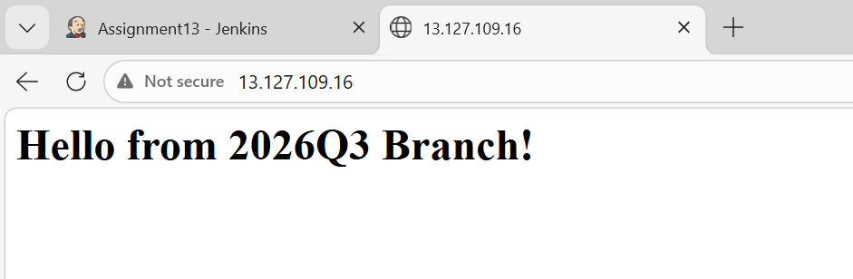
Started by user admin
[Pipeline] Start of Pipeline
[Pipeline] node
Running on Jenkins in /root/.jenkins/workspace/Assignment13
[Pipeline] {
[Pipeline] stage
[Pipeline] { (Checkout code)
[Pipeline] echo
Pulling index.html from branch: 2026Q3...
[Pipeline] git
The recommended git tool is: NONE
using credential ssh-key
> git rev-parse --resolve-git-dir /root/.jenkins/workspace/Assignment13/.git # timeout=10
Fetching changes from the remote Git repository
> git config remote.origin.url https://github.com/rushibhosale/priv_repo.git # timeout=10
Fetching upstream changes from https://github.com/rushibhosale/priv_repo.git
> git --version # timeout=10
> git --version # 'git version 2.50.1'
using GIT_ASKPASS to set credentials
> git fetch --tags --force --progress -- https://github.com/rushibhosale/priv_repo.git +refs/heads/*:refs/remotes/origin/* # timeout=10
> git rev-parse refs/remotes/origin/2026Q3^{commit} # timeout=10
Checking out Revision 7a2ef298bb3e45aa5aacc54167a33d015fc138de (refs/remotes/origin/2026Q3)
> git config core.sparsecheckout # timeout=10
> git checkout -f 7a2ef298bb3e45aa5aacc54167a33d015fc138de # timeout=10
> git branch -a -v --no-abbrev # timeout=10
> git checkout -b 2026Q3 7a2ef298bb3e45aa5aacc54167a33d015fc138de # timeout=10
Commit message: "Update greeting in index.html"
First time build. Skipping changelog.
[Pipeline] }
[Pipeline] // stage
[Pipeline] stage
[Pipeline] { (Deploy to httpd)
[Pipeline] echo
Deploying 2026Q3 to Apache...
[Pipeline] sh
+ sudo rm -f /var/www/html/index.html
+ sudo cp index.html /var/www/html/
+ sudo chmod 644 /var/www/html/index.html
+ sudo systemctl restart httpd
[Pipeline] }
[Pipeline] // stage
[Pipeline] }
[Pipeline] // node
[Pipeline] End of Pipeline
Finished: SUCCESS

