Assignment 14:
You have private GitHub repo here you have index.html. You have S3 bucket and here we have enabled static website hosting. This index we have to deploy on S3 using Jenkins. We can enable static website hosting using S3 CLI command. Don’t go to AWS console for creating S3 and enabling static website hosting.

Check Jenkinsfile in same directory.

Output:
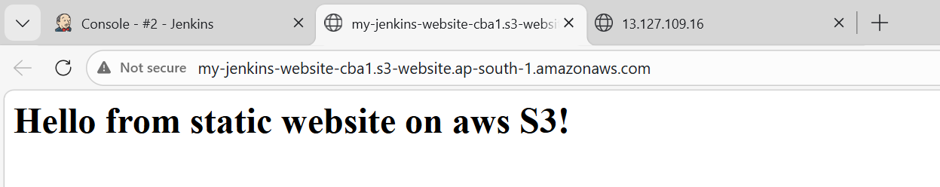

Started by user admin
[Pipeline] Start of Pipeline
[Pipeline] node
Running on Jenkins in /root/.jenkins/workspace/Assignment14
[Pipeline] {
[Pipeline] stage
[Pipeline] { (Checkout code)
[Pipeline] echo
Pulling index.html from private GitHub repo...
[Pipeline] git
The recommended git tool is: NONE
using credential ssh-key
Cloning the remote Git repository
Cloning repository https://github.com/rushibhosale/priv_repo.git
> git init /root/.jenkins/workspace/Assignment14 # timeout=10
Fetching upstream changes from https://github.com/rushibhosale/priv_repo.git
> git --version # timeout=10
> git --version # 'git version 2.50.1'
using GIT_ASKPASS to set credentials
> git fetch --tags --force --progress -- https://github.com/rushibhosale/priv_repo.git +refs/heads/*:refs/remotes/origin/* # timeout=10
> git config remote.origin.url https://github.com/rushibhosale/priv_repo.git # timeout=10
> git config --add remote.origin.fetch +refs/heads/*:refs/remotes/origin/* # timeout=10
Avoid second fetch
> git rev-parse refs/remotes/origin/main^{commit} # timeout=10
Checking out Revision f291142d871a5fab0a3a5cc0fa167ac0ac34d60c (refs/remotes/origin/main)
> git config core.sparsecheckout # timeout=10
> git checkout -f f291142d871a5fab0a3a5cc0fa167ac0ac34d60c # timeout=10
> git branch -a -v --no-abbrev # timeout=10
> git checkout -b main f291142d871a5fab0a3a5cc0fa167ac0ac34d60c # timeout=10
Commit message: "Update index.html"
First time build. Skipping changelog.
[Pipeline] }
[Pipeline] // stage
[Pipeline] stage
[Pipeline] { (Fetch index.html from s3)
[Pipeline] sh
+ BUCKET_NAME=my-jenkins-website-cba1
+ REGION=ap-south-1
+ s3api head-bucket --bucket my-jenkins-website-cba1
+ echo 'Creating S3 bucket: my-jenkins-website-cba1'
Creating S3 bucket: my-jenkins-website-cba1
+ aws s3 mb s3://my-jenkins-website-cba1 --region ap-south-1
make_bucket: my-jenkins-website-cba1
+ echo 'Disabling Block Public Access...'
Disabling Block Public Access...
+ aws s3api put-public-access-block --bucket my-jenkins-website-cba1 --public-access-block-configuration BlockPublicAcls=false,IgnorePublicAcls=false,BlockPublicPolicy=false,RestrictPublicBuckets=false
+ echo 'Creating and applying public read policy...'
Creating and applying public read policy...
+ cat
+ aws s3api put-bucket-policy --bucket my-jenkins-website-cba1 --policy file://policy.json
+ rm -f policy.json
+ echo 'Enabling Static Website Hosting...'
Enabling Static Website Hosting...
+ aws s3 website s3://my-jenkins-website-cba1/ --index-document index.html
+ echo 'Uploading new index.html to S3...'
Uploading new index.html to S3...
+ aws s3 cp index.html s3://my-jenkins-website-cba1/
Completed 46 Bytes/46 Bytes (503 Bytes/s) with 1 file(s) remaining
upload: ./index.html to s3://my-jenkins-website-cba1/index.html
+ echo ==========================================================
==========================================================
+ echo 'Deployment complete!'
Deployment complete!
+ echo 'Your live website URL is: http://my-jenkins-website-cba1.s3-website.ap-south-1.amazonaws.com/'
Your live website URL is: http://my-jenkins-website-cba1.s3-website.ap-south-1.amazonaws.com/
+ echo ==========================================================
==========================================================
[Pipeline] }
[Pipeline] // stage
[Pipeline] }
[Pipeline] // node
[Pipeline] End of Pipeline
Finished: SUCCESS

