Assignment 3:
You have three repos private on github. in first you have branch 2026Q1, in second you have branch 2026Q2, in third you have 2026Q3. all repos have index.html. In 1st the content is
<h1>this is repo1 q1 brach </h1>
and so on respectively in next two index files
In your jenkins master you have apache httpd. create jobs (3)
so that if i run job1 then index from q1 will be deployed. If I run job2 then previous index will be deleted and index from repo 2 will be deployed and so on.

Steps:
- Create 3 branch and in private github repo. Add index.html in 3 branches with different heading.
- Create 3 jobs and for each job select value of Branches to build according to branch name
- Add below shell script in each job
#!/bin/bash
echo "Starting deployment from GitHub repo"

# 1. Copy the index.html from the workspace to the Apache web root
cp index.html /var/www/html/

# 2. Fix permissions so Apache can read the newly copied file
chmod 644 /var/www/html/index.html

# 3. Restart the HTTPD service to ensure changes are live
systemctl restart httpd

echo "Deployment complete! Your GitHub file is now live."

Output:
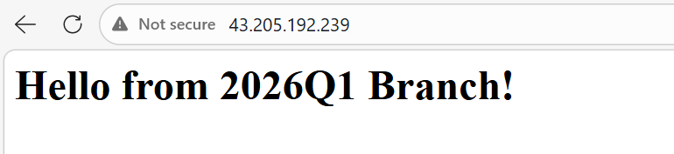
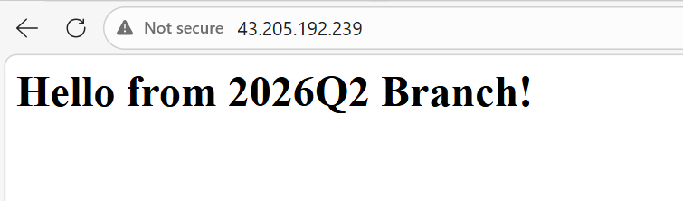
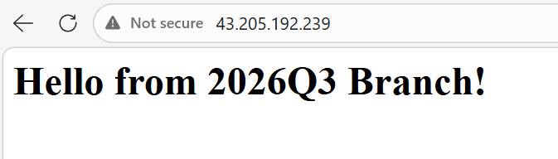

Jobs:
