1 repo with 3 branches contains index.html. 1 JM and slave 1 and slave2 in different zone. Deploy all 3 branches in slave1 and slave2

Output:
Please find Jenkinsfile in same folder
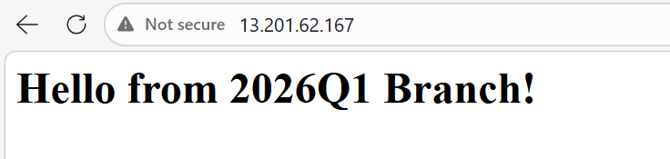
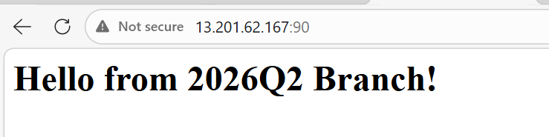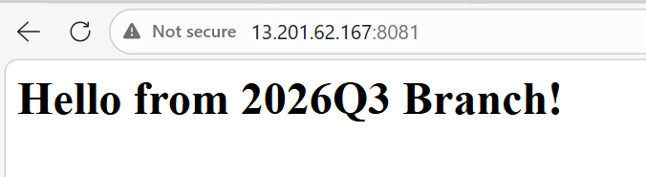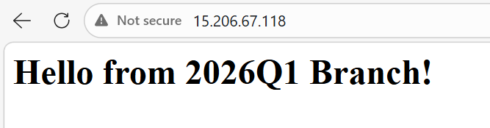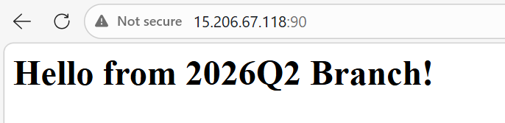
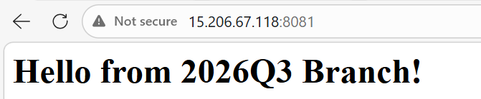
Slave1:
Slave2:
Started by user admin
[Pipeline] Start of Pipeline
[Pipeline] withEnv
[Pipeline] {
[Pipeline] stage
[Pipeline] { (Distributed deployment..)
[Pipeline] parallel
[Pipeline] { (Branch: Deploy to slave1)
[Pipeline] { (Branch: Deploy on slave2)
[Pipeline] stage
[Pipeline] { (Deploy to slave1)
[Pipeline] stage
[Pipeline] { (Deploy on slave2)
[Pipeline] node
[Pipeline] node
Running on slave1 in /mnt/slave_dir/workspace/docker-deploy
Running on slave2 in /mnt/slave_dir/workspace/docker-deploy
[Pipeline] {
[Pipeline] {
[Pipeline] echo
Starting cleanup on slave2
[Pipeline] sh
[Pipeline] echo
Starting cleanup on slave1
[Pipeline] sh
+ docker rm container-branch1 container-branch2 container-branch3
Error response from daemon: No such container: container-branch1
Error response from daemon: No such container: container-branch2
Error response from daemon: No such container: container-branch3
+ true
[Pipeline] dir
Running in /mnt/slave_dir/workspace/docker-deploy/branch1_dir
[Pipeline] {
[Pipeline] echo
Checking out 2026Q1 on Slave 2
[Pipeline] git
The recommended git tool is: NONE
+ docker rm container-branch1 container-branch2 container-branch3
Error response from daemon: No such container: container-branch1
Error response from daemon: No such container: container-branch2
Error response from daemon: No such container: container-branch3
+ true
[Pipeline] dir
Running in /mnt/slave_dir/workspace/docker-deploy/branch1_dir
[Pipeline] {
[Pipeline] echo
Checking out 2026Q1 on Slave 1
[Pipeline] git
The recommended git tool is: NONE
using credential github-token
Fetching changes from the remote Git repository
using credential github-token
Fetching changes from the remote Git repository
> git rev-parse --resolve-git-dir /mnt/slave_dir/workspace/docker-deploy/branch1_dir/.git # timeout=10
> git rev-parse --resolve-git-dir /mnt/slave_dir/workspace/docker-deploy/branch1_dir/.git # timeout=10
Checking out Revision 52284177e5431ead9e2469bd6fc614817376e737 (refs/remotes/origin/2026Q1)
> git config remote.origin.url https://github.com/rushibhosale/priv_repo.git # timeout=10
Fetching upstream changes from https://github.com/rushibhosale/priv_repo.git
> git --version # timeout=10
> git --version # 'git version 2.50.1'
using GIT_ASKPASS to set credentials
> git fetch --tags --force --progress -- https://github.com/rushibhosale/priv_repo.git +refs/heads/*:refs/remotes/origin/* # timeout=10
> git rev-parse refs/remotes/origin/2026Q1^{commit} # timeout=10
> git config core.sparsecheckout # timeout=10
> git checkout -f 52284177e5431ead9e2469bd6fc614817376e737 # timeout=10
> git branch -a -v --no-abbrev # timeout=10
> git branch -D 2026Q1 # timeout=10
> git checkout -b 2026Q1 52284177e5431ead9e2469bd6fc614817376e737 # timeout=10
Checking out Revision 52284177e5431ead9e2469bd6fc614817376e737 (refs/remotes/origin/2026Q1)
> git config remote.origin.url https://github.com/rushibhosale/priv_repo.git # timeout=10
Fetching upstream changes from https://github.com/rushibhosale/priv_repo.git
> git --version # timeout=10
> git --version # 'git version 2.50.1'
using GIT_ASKPASS to set credentials
> git fetch --tags --force --progress -- https://github.com/rushibhosale/priv_repo.git +refs/heads/*:refs/remotes/origin/* # timeout=10
> git rev-parse refs/remotes/origin/2026Q1^{commit} # timeout=10
> git config core.sparsecheckout # timeout=10
> git checkout -f 52284177e5431ead9e2469bd6fc614817376e737 # timeout=10
> git branch -a -v --no-abbrev # timeout=10
> git branch -D 2026Q1 # timeout=10
> git checkout -b 2026Q1 52284177e5431ead9e2469bd6fc614817376e737 # timeout=10
Commit message: "branch1"
> git rev-list --no-walk 52284177e5431ead9e2469bd6fc614817376e737 # timeout=10
[Pipeline] sh
Commit message: "branch1"
+ chmod 644 index.html
+ docker run -d --name container-branch1 -p 80:80 -v /mnt/slave_dir/workspace/docker-deploy/branch1_dir/index.html:/usr/local/apache2/htdocs/index.html httpd
Unable to find image 'httpd:latest' locally
[Pipeline] sh
+ chmod 644 index.html
+ docker run -d --name container-branch1 -p 80:80 -v /mnt/slave_dir/workspace/docker-deploy/branch1_dir/index.html:/usr/local/apache2/htdocs/index.html httpd
Unable to find image 'httpd:latest' locally
latest: Pulling from library/httpd
latest: Pulling from library/httpd
ec781dee3f47: Pulling fs layer
09625190bc81: Pulling fs layer
4f4fb700ef54: Pulling fs layer
a1897530540b: Pulling fs layer
753dca1c3a38: Pulling fs layer
5184cf4f524b: Pulling fs layer
a1897530540b: Waiting
753dca1c3a38: Waiting
5184cf4f524b: Waiting
ec781dee3f47: Pulling fs layer
09625190bc81: Pulling fs layer
4f4fb700ef54: Pulling fs layer
a1897530540b: Pulling fs layer
753dca1c3a38: Pulling fs layer
5184cf4f524b: Pulling fs layer
a1897530540b: Waiting
753dca1c3a38: Waiting
5184cf4f524b: Waiting
4f4fb700ef54: Verifying Checksum
4f4fb700ef54: Download complete
09625190bc81: Verifying Checksum
09625190bc81: Download complete
ec781dee3f47: Verifying Checksum
ec781dee3f47: Download complete
09625190bc81: Verifying Checksum
09625190bc81: Download complete
4f4fb700ef54: Verifying Checksum
4f4fb700ef54: Download complete
ec781dee3f47: Verifying Checksum
ec781dee3f47: Download complete
a1897530540b: Verifying Checksum
a1897530540b: Download complete
753dca1c3a38: Verifying Checksum
753dca1c3a38: Download complete
5184cf4f524b: Verifying Checksum
5184cf4f524b: Download complete
a1897530540b: Verifying Checksum
a1897530540b: Download complete
753dca1c3a38: Verifying Checksum
753dca1c3a38: Download complete
5184cf4f524b: Verifying Checksum
5184cf4f524b: Download complete
ec781dee3f47: Pull complete
09625190bc81: Pull complete
4f4fb700ef54: Pull complete
a1897530540b: Pull complete
ec781dee3f47: Pull complete
09625190bc81: Pull complete
4f4fb700ef54: Pull complete
a1897530540b: Pull complete
753dca1c3a38: Pull complete
753dca1c3a38: Pull complete
5184cf4f524b: Pull complete
Digest: sha256:331548c5249bdeced0f048bc2fb8c6b6427d2ec6508bed9c1fec6c57d0b27a60
Status: Downloaded newer image for httpd:latest
5184cf4f524b: Pull complete
Digest: sha256:331548c5249bdeced0f048bc2fb8c6b6427d2ec6508bed9c1fec6c57d0b27a60
Status: Downloaded newer image for httpd:latest
8255c6924061d0557bd37179003270d76f4a748ecf0c7c2c304179006ce42dc4
387743a8d7217f2baf291d6952cad193aaff57faeaa9ac0abbdb11b1e13cd76a
[Pipeline] }
[Pipeline] // dir
[Pipeline] dir
Running in /mnt/slave_dir/workspace/docker-deploy/branch2_dir
[Pipeline] {
[Pipeline] }
[Pipeline] echo
Checking out 2026Q2 on Slave 1
[Pipeline] git
The recommended git tool is: NONE
using credential github-token
Cloning the remote Git repository
[Pipeline] // dir
[Pipeline] dir
Running in /mnt/slave_dir/workspace/docker-deploy/branch2_dir
[Pipeline] {
[Pipeline] echo
Checking out 2026Q2 on Slave 2
[Pipeline] git
The recommended git tool is: NONE
using credential github-token
Cloning the remote Git repository
Cloning repository https://github.com/rushibhosale/priv_repo.git
> git init /mnt/slave_dir/workspace/docker-deploy/branch2_dir # timeout=10
Fetching upstream changes from https://github.com/rushibhosale/priv_repo.git
> git --version # timeout=10
> git --version # 'git version 2.50.1'
using GIT_ASKPASS to set credentials
> git fetch --tags --force --progress -- https://github.com/rushibhosale/priv_repo.git +refs/heads/*:refs/remotes/origin/* # timeout=10
Cloning repository https://github.com/rushibhosale/priv_repo.git
> git init /mnt/slave_dir/workspace/docker-deploy/branch2_dir # timeout=10
Fetching upstream changes from https://github.com/rushibhosale/priv_repo.git
> git --version # timeout=10
> git --version # 'git version 2.50.1'
using GIT_ASKPASS to set credentials
> git fetch --tags --force --progress -- https://github.com/rushibhosale/priv_repo.git +refs/heads/*:refs/remotes/origin/* # timeout=10
Avoid second fetch
Checking out Revision a17804419cc4e4d85b23bc5eb26119066e8be356 (refs/remotes/origin/2026Q2)
Commit message: "branch2"
First time build. Skipping changelog.
[Pipeline] sh
Avoid second fetch
Checking out Revision a17804419cc4e4d85b23bc5eb26119066e8be356 (refs/remotes/origin/2026Q2)
Commit message: "branch2"
[Pipeline] sh
+ chmod 644 index.html
+ docker run -d --name container-branch2 -p 90:80 -v /mnt/slave_dir/workspace/docker-deploy/branch2_dir/index.html:/usr/local/apache2/htdocs/index.html httpd
e28db873ad9188c9c82d39e56c0fdab679389d0afc3a201f2ca69a23a0d45293
+ chmod 644 index.html
+ docker run -d --name container-branch2 -p 90:80 -v /mnt/slave_dir/workspace/docker-deploy/branch2_dir/index.html:/usr/local/apache2/htdocs/index.html httpd
a2864fe7cacc852d75fa3d53d288592c66fc65037925dd5ac42b9fb552bf86dc
[Pipeline] }
[Pipeline] // dir
[Pipeline] dir
Running in /mnt/slave_dir/workspace/docker-deploy/branch3_dir
[Pipeline] {
[Pipeline] echo
Checking out 2026Q3 on Slave 2
[Pipeline] git
The recommended git tool is: NONE
using credential github-token
> git config remote.origin.url https://github.com/rushibhosale/priv_repo.git # timeout=10
> git config --add remote.origin.fetch +refs/heads/*:refs/remotes/origin/* # timeout=10
> git rev-parse refs/remotes/origin/2026Q2^{commit} # timeout=10
> git config core.sparsecheckout # timeout=10
> git checkout -f a17804419cc4e4d85b23bc5eb26119066e8be356 # timeout=10
> git branch -a -v --no-abbrev # timeout=10
> git checkout -b 2026Q2 a17804419cc4e4d85b23bc5eb26119066e8be356 # timeout=10
Cloning the remote Git repository
[Pipeline] }
[Pipeline] // dir
[Pipeline] dir
Running in /mnt/slave_dir/workspace/docker-deploy/branch3_dir
[Pipeline] {
[Pipeline] echo
Checking out 2026Q3 on Slave 1
[Pipeline] git
The recommended git tool is: NONE
> git config remote.origin.url https://github.com/rushibhosale/priv_repo.git # timeout=10
> git config --add remote.origin.fetch +refs/heads/*:refs/remotes/origin/* # timeout=10
> git rev-parse refs/remotes/origin/2026Q2^{commit} # timeout=10
> git config core.sparsecheckout # timeout=10
> git checkout -f a17804419cc4e4d85b23bc5eb26119066e8be356 # timeout=10
> git branch -a -v --no-abbrev # timeout=10
> git checkout -b 2026Q2 a17804419cc4e4d85b23bc5eb26119066e8be356 # timeout=10
using credential github-token
Cloning the remote Git repository
Cloning repository https://github.com/rushibhosale/priv_repo.git
> git init /mnt/slave_dir/workspace/docker-deploy/branch3_dir # timeout=10
Fetching upstream changes from https://github.com/rushibhosale/priv_repo.git
> git --version # timeout=10
> git --version # 'git version 2.50.1'
using GIT_ASKPASS to set credentials
> git fetch --tags --force --progress -- https://github.com/rushibhosale/priv_repo.git +refs/heads/*:refs/remotes/origin/* # timeout=10
Avoid second fetch
Checking out Revision 7a2ef298bb3e45aa5aacc54167a33d015fc138de (refs/remotes/origin/2026Q3)
Cloning repository https://github.com/rushibhosale/priv_repo.git
> git init /mnt/slave_dir/workspace/docker-deploy/branch3_dir # timeout=10
Fetching upstream changes from https://github.com/rushibhosale/priv_repo.git
> git --version # timeout=10
> git --version # 'git version 2.50.1'
using GIT_ASKPASS to set credentials
> git fetch --tags --force --progress -- https://github.com/rushibhosale/priv_repo.git +refs/heads/*:refs/remotes/origin/* # timeout=10
Commit message: "Update greeting in index.html"
First time build. Skipping changelog.
[Pipeline] sh
Avoid second fetch
+ chmod 644 index.html
+ docker run -d --name container-branch3 -p 8081:80 -v /mnt/slave_dir/workspace/docker-deploy/branch3_dir/index.html:/usr/local/apache2/htdocs/index.html httpd
3d9a758bc6ab7e31ff2ad6fe483f9cca9e655f9cfbb0b5a762ef7a82d275d70f
Checking out Revision 7a2ef298bb3e45aa5aacc54167a33d015fc138de (refs/remotes/origin/2026Q3)
Commit message: "Update greeting in index.html"
[Pipeline] sh
[Pipeline] }
[Pipeline] // dir
[Pipeline] }
+ chmod 644 index.html
+ docker run -d --name container-branch3 -p 8081:80 -v /mnt/slave_dir/workspace/docker-deploy/branch3_dir/index.html:/usr/local/apache2/htdocs/index.html httpd
8fc78ac51a440cf11ace31a5ebbdfb2b78026de5b694400814c7c3a848f3e45f
[Pipeline] // node
[Pipeline] }
[Pipeline] // stage
[Pipeline] }
[Pipeline] }
[Pipeline] // dir
> git config remote.origin.url https://github.com/rushibhosale/priv_repo.git # timeout=10
> git config --add remote.origin.fetch +refs/heads/*:refs/remotes/origin/* # timeout=10
> git rev-parse refs/remotes/origin/2026Q3^{commit} # timeout=10
> git config core.sparsecheckout # timeout=10
> git checkout -f 7a2ef298bb3e45aa5aacc54167a33d015fc138de # timeout=10
> git branch -a -v --no-abbrev # timeout=10
> git checkout -b 2026Q3 7a2ef298bb3e45aa5aacc54167a33d015fc138de # timeout=10
[Pipeline] }
[Pipeline] // node
[Pipeline] }
[Pipeline] // stage
[Pipeline] }
> git config remote.origin.url https://github.com/rushibhosale/priv_repo.git # timeout=10
> git config --add remote.origin.fetch +refs/heads/*:refs/remotes/origin/* # timeout=10
> git rev-parse refs/remotes/origin/2026Q3^{commit} # timeout=10
> git config core.sparsecheckout # timeout=10
> git checkout -f 7a2ef298bb3e45aa5aacc54167a33d015fc138de # timeout=10
> git branch -a -v --no-abbrev # timeout=10
> git checkout -b 2026Q3 7a2ef298bb3e45aa5aacc54167a33d015fc138de # timeout=10
[Pipeline] // parallel
[Pipeline] }
[Pipeline] // stage
[Pipeline] }
[Pipeline] // withEnv
[Pipeline] End of Pipeline
Finished: SUCCESS

