1 repo with 3 branches contains index.html in all. We have jenkins master and we need create a job and 3 container and deploy these 3 indices in three containers with port 80, 90 and 8080 use docker plugin and use declarative pipeline

Output:
Refer Jenkinsfile present in same directory
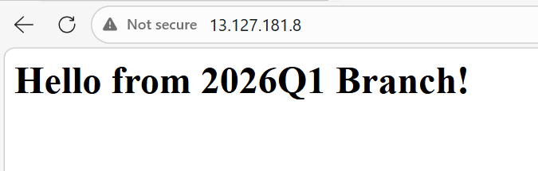
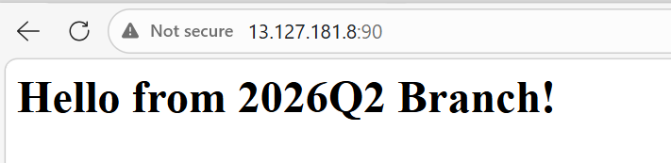
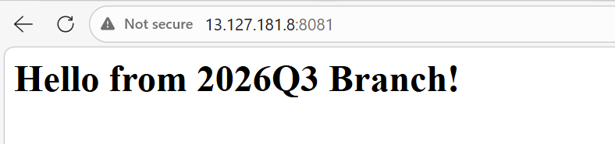

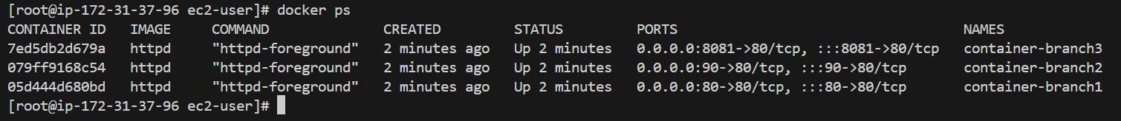

Console output:
Started by user admin
[Pipeline] Start of Pipeline
[Pipeline] node
Running on Jenkins in /root/.jenkins/workspace/docker-deploy
[Pipeline] {
[Pipeline] withEnv
[Pipeline] {
[Pipeline] stage
[Pipeline] { (Cleanup Old Containers)
[Pipeline] echo
Removing previous containers...
[Pipeline] sh
+ docker rm -f container-branch1 container-branch2 container-branch3
container-branch1
container-branch2
container-branch3
[Pipeline] }
[Pipeline] // stage
[Pipeline] stage
[Pipeline] { (Deploy Branch 1 (Port 80))
[Pipeline] dir
Running in /root/.jenkins/workspace/docker-deploy/branch1_dir
[Pipeline] {
[Pipeline] echo
Checking out 2026Q1 branch
[Pipeline] git
The recommended git tool is: NONE
using credential github-token
> git rev-parse --resolve-git-dir /root/.jenkins/workspace/docker-deploy/branch1_dir/.git # timeout=10
Fetching changes from the remote Git repository
> git config remote.origin.url https://github.com/rushibhosale/priv_repo.git # timeout=10
Fetching upstream changes from https://github.com/rushibhosale/priv_repo.git
> git --version # timeout=10
> git --version # 'git version 2.50.1'
using GIT_ASKPASS to set credentials
> git fetch --tags --force --progress -- https://github.com/rushibhosale/priv_repo.git +refs/heads/*:refs/remotes/origin/* # timeout=10
> git rev-parse refs/remotes/origin/2026Q1^{commit} # timeout=10
Checking out Revision 52284177e5431ead9e2469bd6fc614817376e737 (refs/remotes/origin/2026Q1)
> git config core.sparsecheckout # timeout=10
> git checkout -f 52284177e5431ead9e2469bd6fc614817376e737 # timeout=10
> git branch -a -v --no-abbrev # timeout=10
> git branch -D 2026Q1 # timeout=10
> git checkout -b 2026Q1 52284177e5431ead9e2469bd6fc614817376e737 # timeout=10
Commit message: "branch1"
First time build. Skipping changelog.
[Pipeline] sh
+ docker run -d --name container-branch1 -p 80:80 httpd
05d444d680bd097ae16568be0123ede31a5d06bf92fc25ce2d097eba3e50df27
+ docker cp index.html container-branch1:/usr/local/apache2/htdocs/index.html
+ docker exec container-branch1 chmod 644 /usr/local/apache2/htdocs/index.html
[Pipeline] }
[Pipeline] // dir
[Pipeline] }
[Pipeline] // stage
[Pipeline] stage
[Pipeline] { (Deploy Branch 2 (port 90))
[Pipeline] dir
Running in /root/.jenkins/workspace/docker-deploy/branch2-dir
[Pipeline] {
[Pipeline] git
The recommended git tool is: NONE
using credential github-token
> git rev-parse --resolve-git-dir /root/.jenkins/workspace/docker-deploy/branch2-dir/.git # timeout=10
Fetching changes from the remote Git repository
> git config remote.origin.url https://github.com/rushibhosale/priv_repo.git # timeout=10
Fetching upstream changes from https://github.com/rushibhosale/priv_repo.git
> git --version # timeout=10
> git --version # 'git version 2.50.1'
using GIT_ASKPASS to set credentials
> git fetch --tags --force --progress -- https://github.com/rushibhosale/priv_repo.git +refs/heads/*:refs/remotes/origin/* # timeout=10
> git rev-parse refs/remotes/origin/2026Q2^{commit} # timeout=10
Checking out Revision a17804419cc4e4d85b23bc5eb26119066e8be356 (refs/remotes/origin/2026Q2)
> git config core.sparsecheckout # timeout=10
> git checkout -f a17804419cc4e4d85b23bc5eb26119066e8be356 # timeout=10
> git branch -a -v --no-abbrev # timeout=10
> git branch -D 2026Q2 # timeout=10
> git checkout -b 2026Q2 a17804419cc4e4d85b23bc5eb26119066e8be356 # timeout=10
Commit message: "branch2"
First time build. Skipping changelog.
[Pipeline] sh
+ docker run -d --name container-branch2 -p 90:80 httpd
079ff9168c546e606f207ad91bdbac01e7276a496270feb45452acbf1be811bb
+ docker cp index.html container-branch2:/usr/local/apache2/htdocs/index.html
+ docker exec container-branch2 chmod 644 /usr/local/apache2/htdocs/index.html
[Pipeline] }
[Pipeline] // dir
[Pipeline] }
[Pipeline] // stage
[Pipeline] stage
[Pipeline] { (Deploy Branch 3 (port 8081))
[Pipeline] dir
Running in /root/.jenkins/workspace/docker-deploy/branch3-dir
[Pipeline] {
[Pipeline] git
The recommended git tool is: NONE
using credential github-token
> git rev-parse --resolve-git-dir /root/.jenkins/workspace/docker-deploy/branch3-dir/.git # timeout=10
Fetching changes from the remote Git repository
> git config remote.origin.url https://github.com/rushibhosale/priv_repo.git # timeout=10
Fetching upstream changes from https://github.com/rushibhosale/priv_repo.git
> git --version # timeout=10
> git --version # 'git version 2.50.1'
using GIT_ASKPASS to set credentials
> git fetch --tags --force --progress -- https://github.com/rushibhosale/priv_repo.git +refs/heads/*:refs/remotes/origin/* # timeout=10
> git rev-parse refs/remotes/origin/2026Q3^{commit} # timeout=10
Checking out Revision 7a2ef298bb3e45aa5aacc54167a33d015fc138de (refs/remotes/origin/2026Q3)
> git config core.sparsecheckout # timeout=10
> git checkout -f 7a2ef298bb3e45aa5aacc54167a33d015fc138de # timeout=10
> git branch -a -v --no-abbrev # timeout=10
> git branch -D 2026Q3 # timeout=10
> git checkout -b 2026Q3 7a2ef298bb3e45aa5aacc54167a33d015fc138de # timeout=10
Commit message: "Update greeting in index.html"
> git rev-list --no-walk 7a2ef298bb3e45aa5aacc54167a33d015fc138de # timeout=10
[Pipeline] sh
+ docker run -d --name container-branch3 -p 8081:80 httpd
7ed5db2d679a623e451de2c8471e725bf3ac31e0b6a5867f6187dd78884e13ad
+ docker cp index.html container-branch3:/usr/local/apache2/htdocs/index.html
+ docker exec container-branch3 chmod 644 /usr/local/apache2/htdocs/index.html
[Pipeline] }
[Pipeline] // dir
[Pipeline] }
[Pipeline] // stage
[Pipeline] }
[Pipeline] // withEnv
[Pipeline] }
[Pipeline] // node
[Pipeline] End of Pipeline
Finished: SUCCESS

