Chapter 12
Output/Snapshots of Project
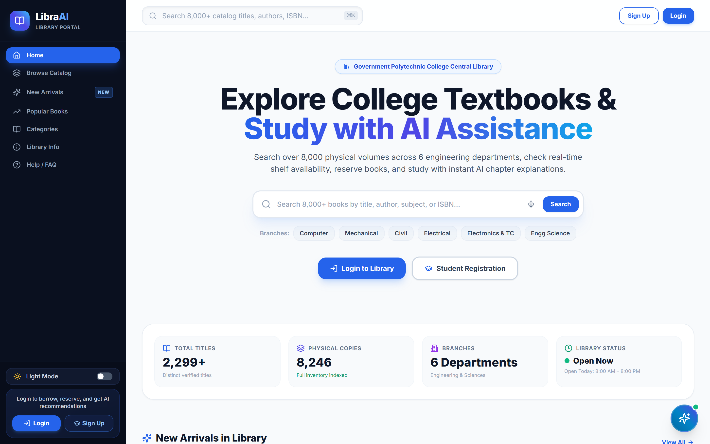
Figure 12.1: Guest Landing Page – Public discovery catalog with live database metrics, search bar, featured collections, and navigation.
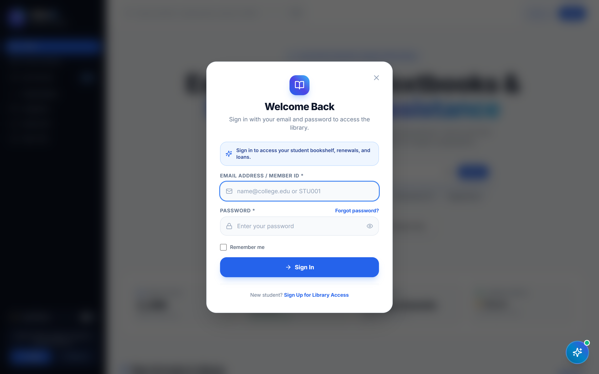
Figure 12.2: User Authentication – Interactive modal dialog for student, faculty, librarian, and admin credential sign-in.

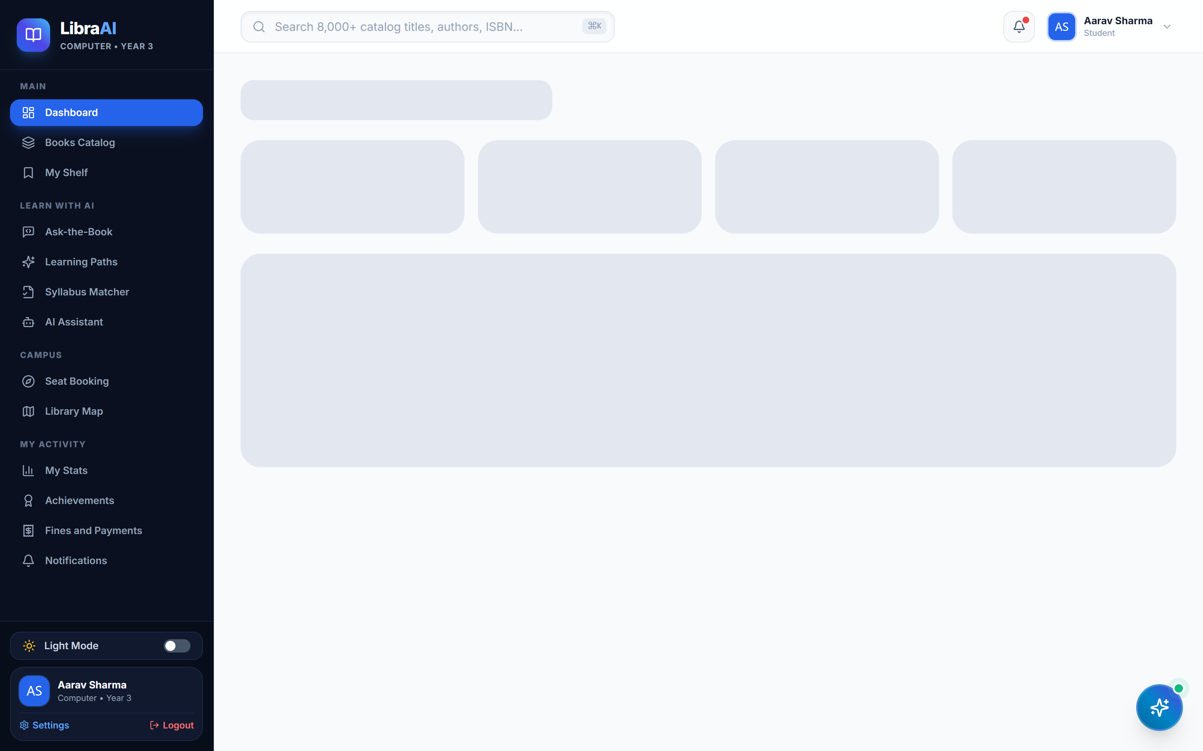
Figure 12.3: Student Dashboard – Active book loans with return due dates, instant renewal actions, and AI study cards.
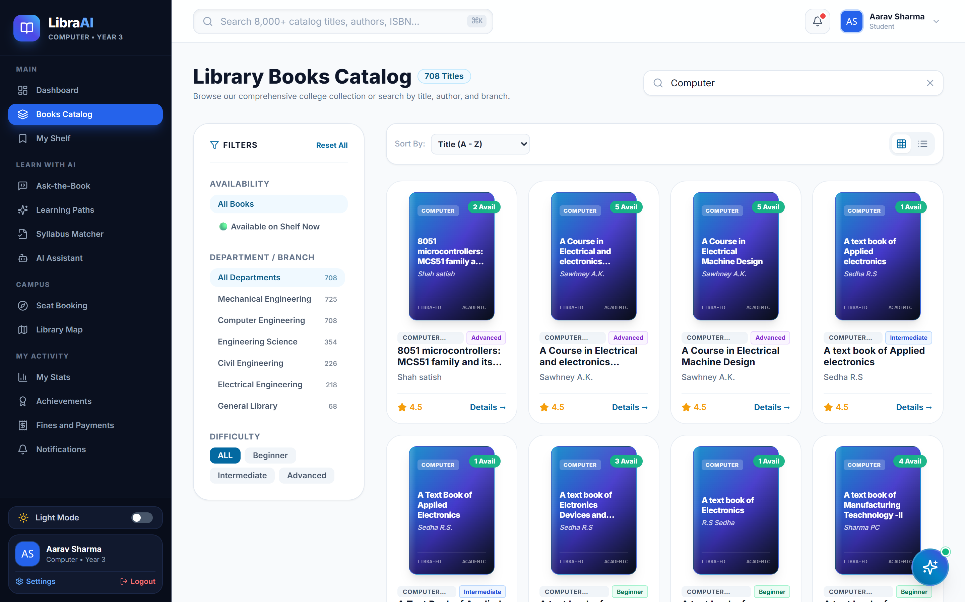
Figure 12.4: Books Catalog & Search – Real-time keyword filtering across 2,299 titles with rack location badges and availability counters.

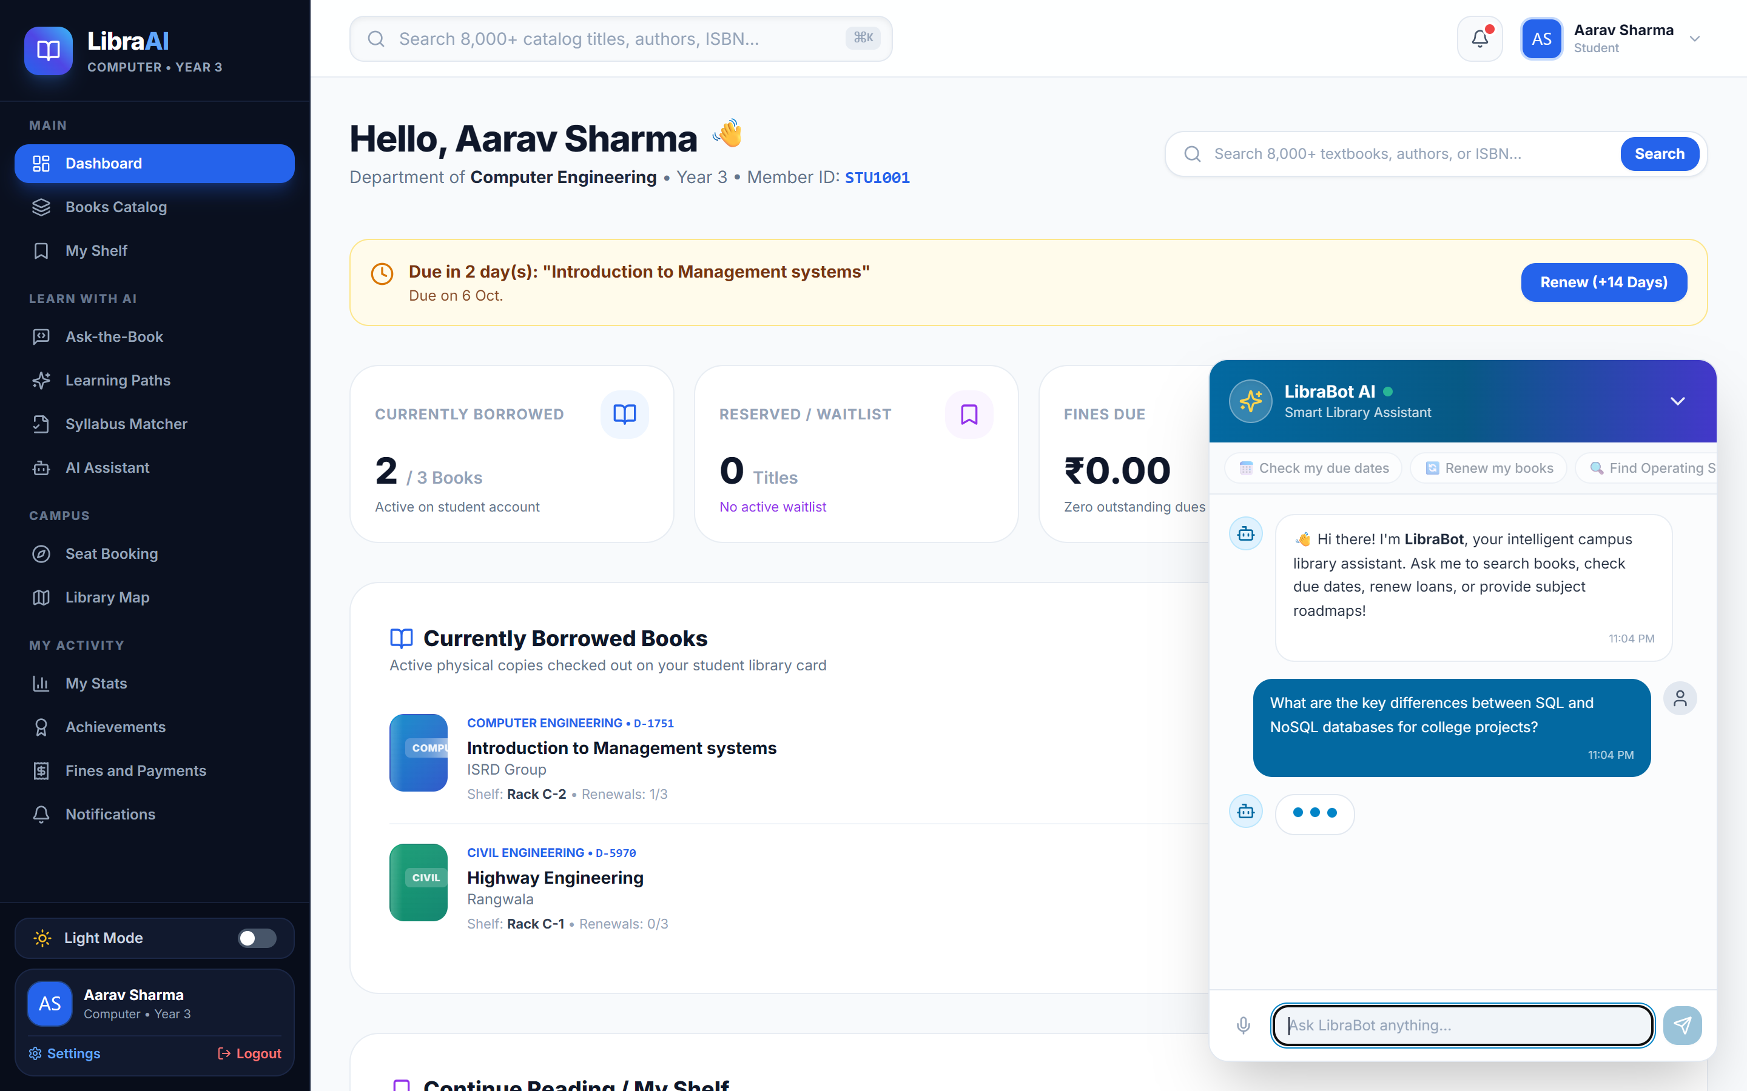
Figure 12.5: LibraBot AI Assistant – Domain-aware conversational assistant responding to technical queries with catalog references.
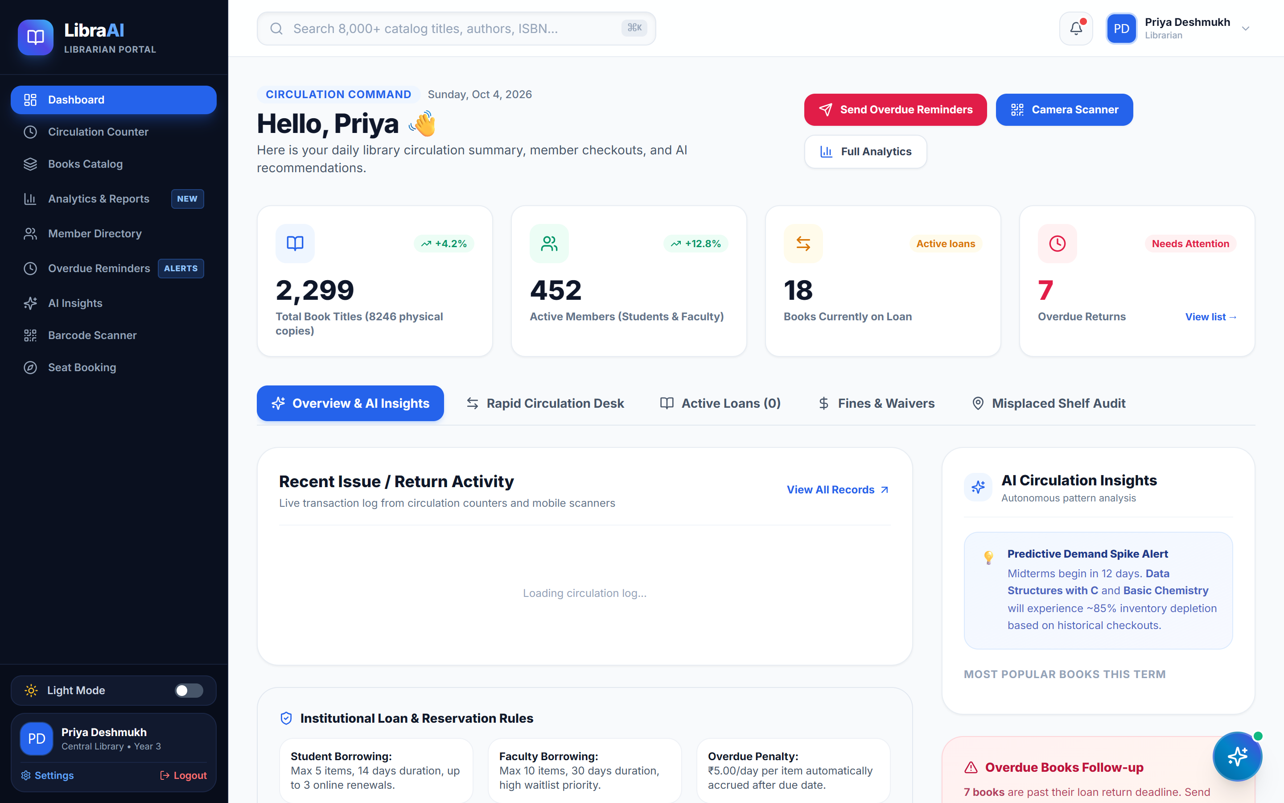
Figure 12.6: Librarian Dashboard – Daily circulation statistics, active loan monitors, pending returns, and rapid barcode actions.

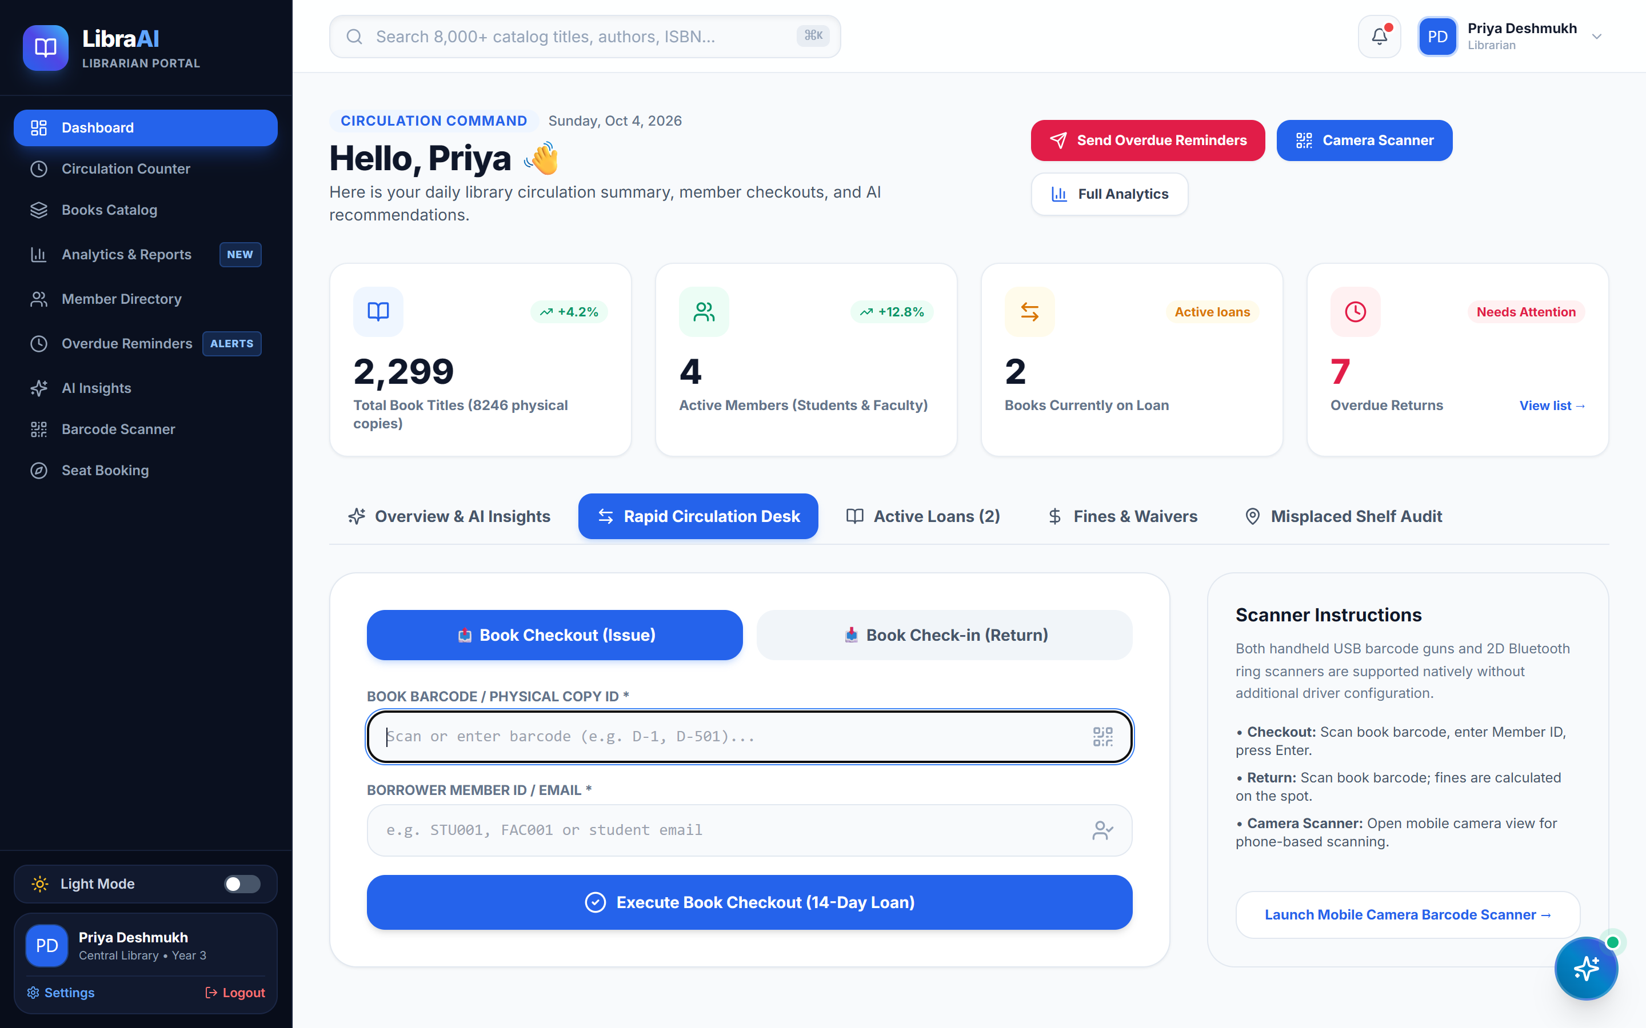
Figure 12.7: Rapid Circulation Desk – Barcode circulation console with instant book issuing, return validation, and fine calculation.
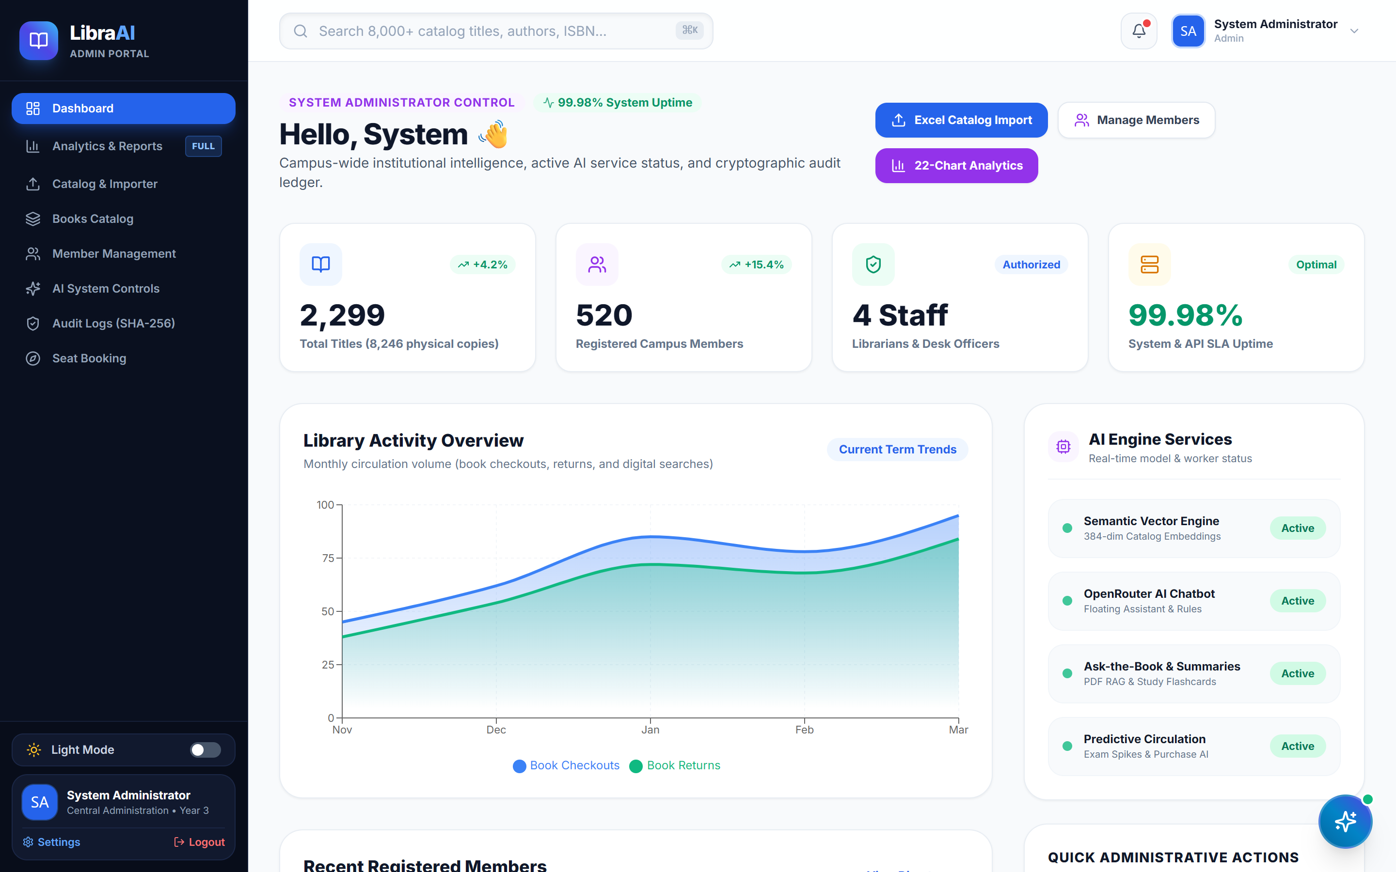
Figure 12.8: Admin Dashboard – Institutional KPI cards, 99.98% SLA monitoring, circulation activity curves, and AI telemetry.

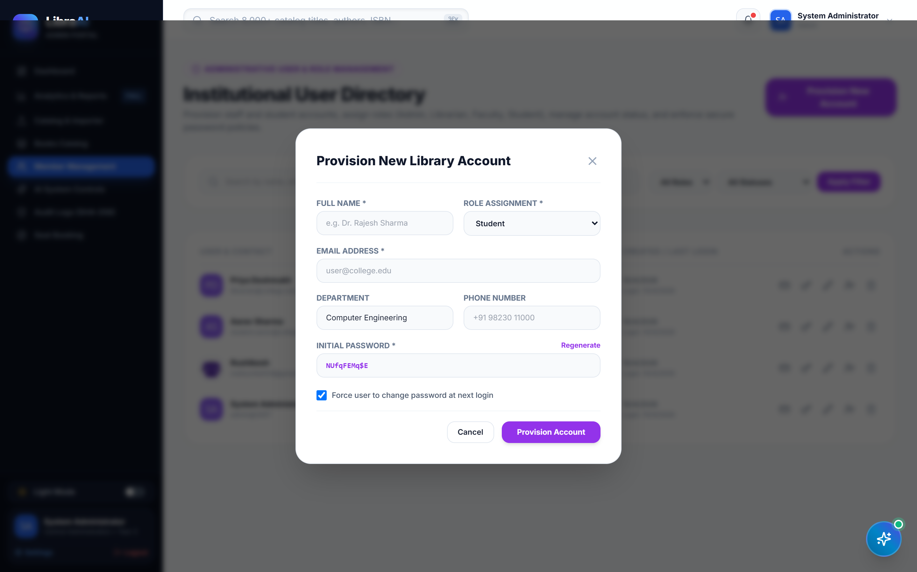
Figure 12.9: Admin User Management – Campus member directory with role-based access control and account provisioning modal.
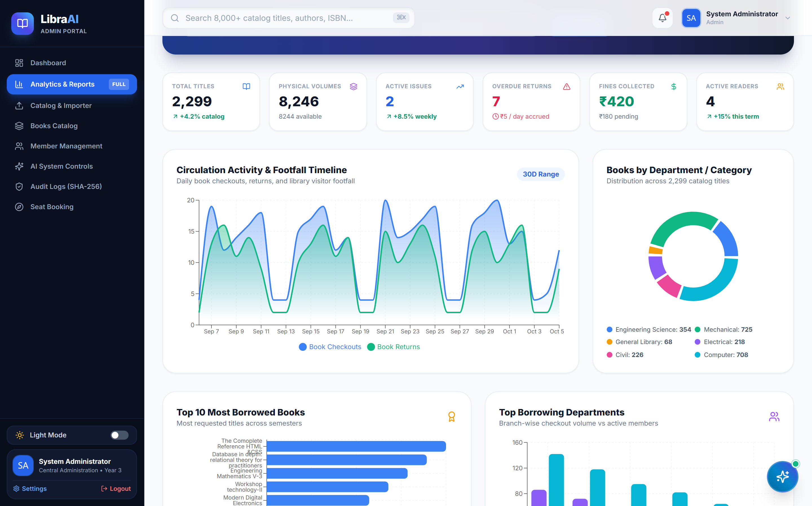
Figure 12.10: Analytics & Reports – Executive dashboard featuring circulation footfall timelines, category donuts, and top borrowed books.

