**PYTHON PROJECT PRE-SUBMITION REPORT**

**Project No: 24**

**To Design a GUI for Fitness Calculator using python.**



**Submitted By**

1. UTKARSH SINGH ( RK21RGA74 ) (11603042)
2. RUSHIK PATEL ( RK21RGB49 ) (12112228)
3. AVNEESH NARWAL ( RK21RGA24 ) (12107455)

# Table Of Contents

|  |  |  |
| --- | --- | --- |
| **Sr.no** | **Topics** | **Page. No** |
| **1** | Introduction | 3 |
| **2** | Modules | 4 - 7 |
| **3** | Role and Responsibility | 8 |
| **4** | Gantt chart | 8 |
| **5** | Outcome | 9 |

**Introduction**

* The project is GUI based Fitness Calculator and is Written using Python.
* It’s a basic fitness calculator. A user can enter his/her details (Age, Weight, BMI); at the end, a report will be generated showing the health details using a specifically calculated logic.
* GUI stands for Graphic User Interface and provides a Visual Link between the Python code and the user, making it easier for the user to enter his/her data even if they have no prior knowledge of coding.
* Python provides various options for developing graphical user interfaces (GUIs). The most important Of these and is “TKINTER” and we will be using it Primarily to build this Project

# Tkinter Programming

Tkinter is the standard GUI library for Python. Python when combined with Tkinter provides a fast and effortless way to create GUI applications. Tkinter provides a powerful object-oriented interface to the Tk GUI toolkit.

Tkinter Provides us with a total of 15 widgets out of which we will be using

* Text
* Scrollbar
* TkMessageBox
* Message
* Entry
* Button

## Modules And Description

#### This Project will have Three main working modules:

1. Welcome screen
2. Fitness calculator
3. Report generator

**Welcome screen**

* This Screen will be the first contact of the user with our program.
* The user will be greeted with a motivational message.
* The user can either choose to check his/her fitness or learn more about our team and program
* If the user chooses to learn more then a Prompt box created using Tkinter will popup displaying team member names and the aim of the project as mentioned earlier in the Introduction.
* If the user chooses to check their fitness, then an adjacent window will pop up with our next module layout i.e. Fitness Calculator

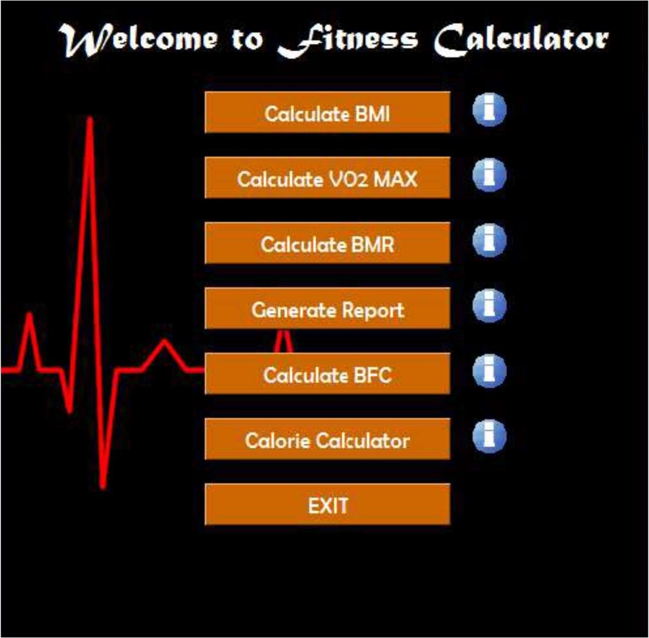

This is Just an Example of how the welcome screen might look and does not represent the final work.

### Fitness Calculator

#### In this module, our Primary Aim is to collect the related data from the users who will be prompted with a new PoP-up widow that will ask them to Enter Their

* + Age
  + Name
  + Gender
  + Weight
  + Height
  + BP low
  + BP High
  + Pulse Rate
  + RBC Count
  + WBC Count
  + Platelets
  + HB
  + Uric Acid Levels

Following is a Visual Representation of how the Fitness Calculator module will look, however, it does not represent the final product.

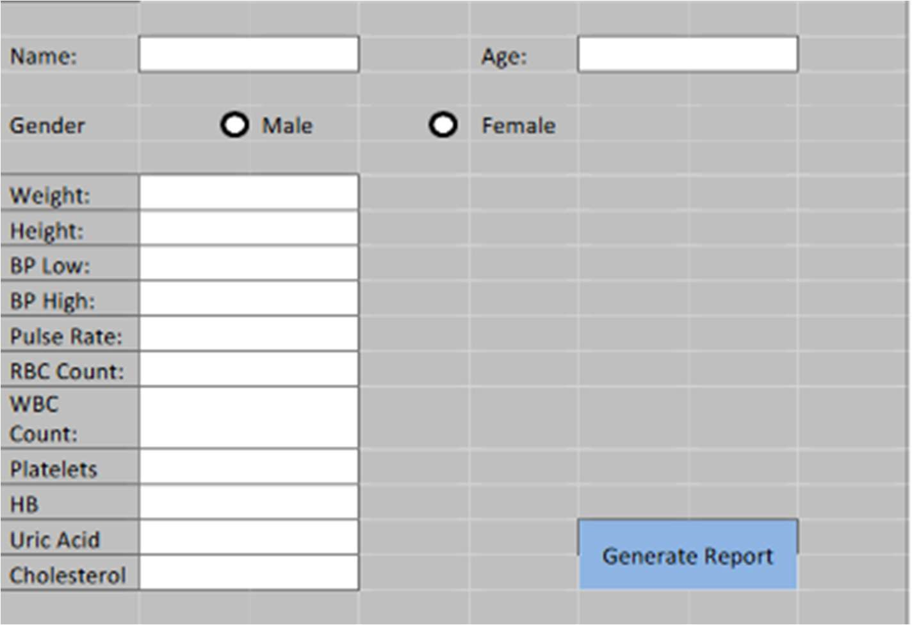

* After Entering their Data, the User will click on “Generate Report”
* A new Pop-up window will appear showing the final report of various Fitness Tests such as BMI, BMR, etc.
* All these results will be specific to each user’s entry and are calculated with correct and precise mathematical implementation

### Report Generator

In this module after Doing calculations according to the given Data the user will be prompted with the results of Various Fitness checks such as :

* BMI
* BP
* Pulse Rate
* RBC Count
* WBC Count
* Platelets
* HB
* Uric Acid
* Cholesterol

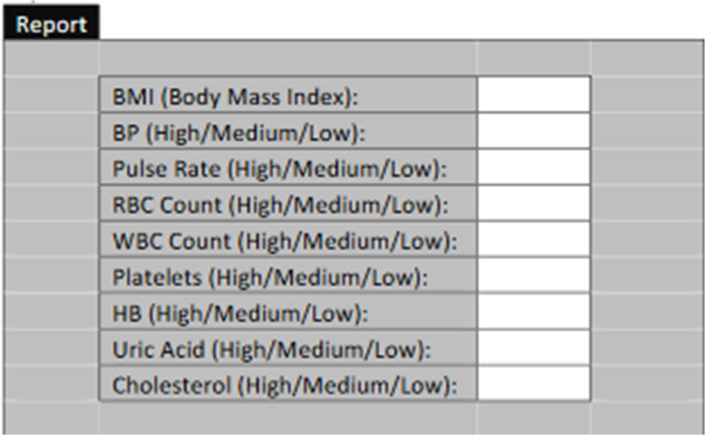

Above image is a Visual Representation of how the Fitness Calculator module will look, however, it does not represent the final product.

**Roles And Responsibilities**

|  |  |
| --- | --- |
| **NAME** | **ROLES** |
| **Utkarsh Singh** | Resource gathering, coding, Report making |
| **Rushik Patel** | coding, Debugging, testing |
| **Avneesh Narwal** | Designing, analysis and system testing |

# Gantt Chart

|  |  |  |  |  |  |  |  |  |  |  |  |  |
| --- | --- | --- | --- | --- | --- | --- | --- | --- | --- | --- | --- | --- |
| **Task Name** | **25/9** | | **5/10** | | **15/10** | | **25/10** | | **5/11** | | **15/11** | |
| **Planning** |  |  |  |  |  |  |  |  |  |  |  |  |
| **Research** |  |  |  |  |  |  |  |  |  |  |  |  |
| **Designing** |  |  |  |  |  |  |  |  |  |  |  |  |
| **Implementation** |  |  |  |  |  |  |  |  |  |  |  |  |
| **Improving** |  |  |  |  |  |  |  |  |  |  |  |  |

## Outcome

We finally got the end product as a ‘fitness calculator’ that includes all the mentioned modules. We will learn how to make a GUI using Tkinter in Python.

* + BFC will tell about the fat percentage in the body.
  + BMR will tell the amount of energy needed while resting in a temperate environment when the digestive system is inactive.