CHROMATOGRAPHY – HOMEWORK

Homework Exercise: Design a Purification Protocol
Scenario: A cell lysate contains a target enzyme with a molecular mass of 150 kDa. The enzyme is negatively charged at pH 7. The contaminants are smaller and positively charged.

Task 1 – Select Two Chromatography Methods
Selected methods: 1) Anion-Exchange Chromatography (IEX) and 2) Size-Exclusion Chromatography (SEC).
- Anion-exchange chromatography is selected because the target enzyme is negatively charged at pH 7. The positively charged stationary phase attracts and binds negatively charged proteins.
- Size-exclusion chromatography is selected because the target enzyme is large (150 kDa). SEC can separate the large target from smaller contaminants based on molecular size.

Task 2 – Order of the Purification Steps and Scientific Rationale
Step 1: Anion-Exchange Chromatography
The first step should be anion-exchange chromatography. At pH 7, the target enzyme has a net negative charge, so it binds to a positively charged anion-exchange matrix. The smaller positively charged contaminants do not bind to this matrix and can pass through in the flow-through. This gives an initial separation based on charge.
Step 2: Size-Exclusion Chromatography
The partially purified target fraction is then applied to a size-exclusion column. The 150 kDa enzyme is large and therefore cannot readily enter the pores of the stationary-phase beads. It bypasses the beads and elutes earlier than smaller contaminating molecules. This provides a second purification step based on molecular size.

Why This Order Is Logical
The two steps exploit different molecular properties—charge first and size second. The first step removes positively charged contaminants by charge-based separation, while the second step further separates the target from smaller molecules according to size. Using two different separation principles can improve purification because molecules that behave similarly in one separation property may differ in another.

3. Predicted Chromatogram for the First Purification Step
The first step is anion-exchange chromatography. During the initial flow-through, positively charged contaminants are expected to pass through without binding. The negatively charged target enzyme binds to the positively charged matrix and is expected to elute later when the conditions allow its release from the column. Protein detection can be monitored by UV absorbance at 280 nm, where proteins absorb primarily because of aromatic amino acids such as tryptophan and tyrosine.
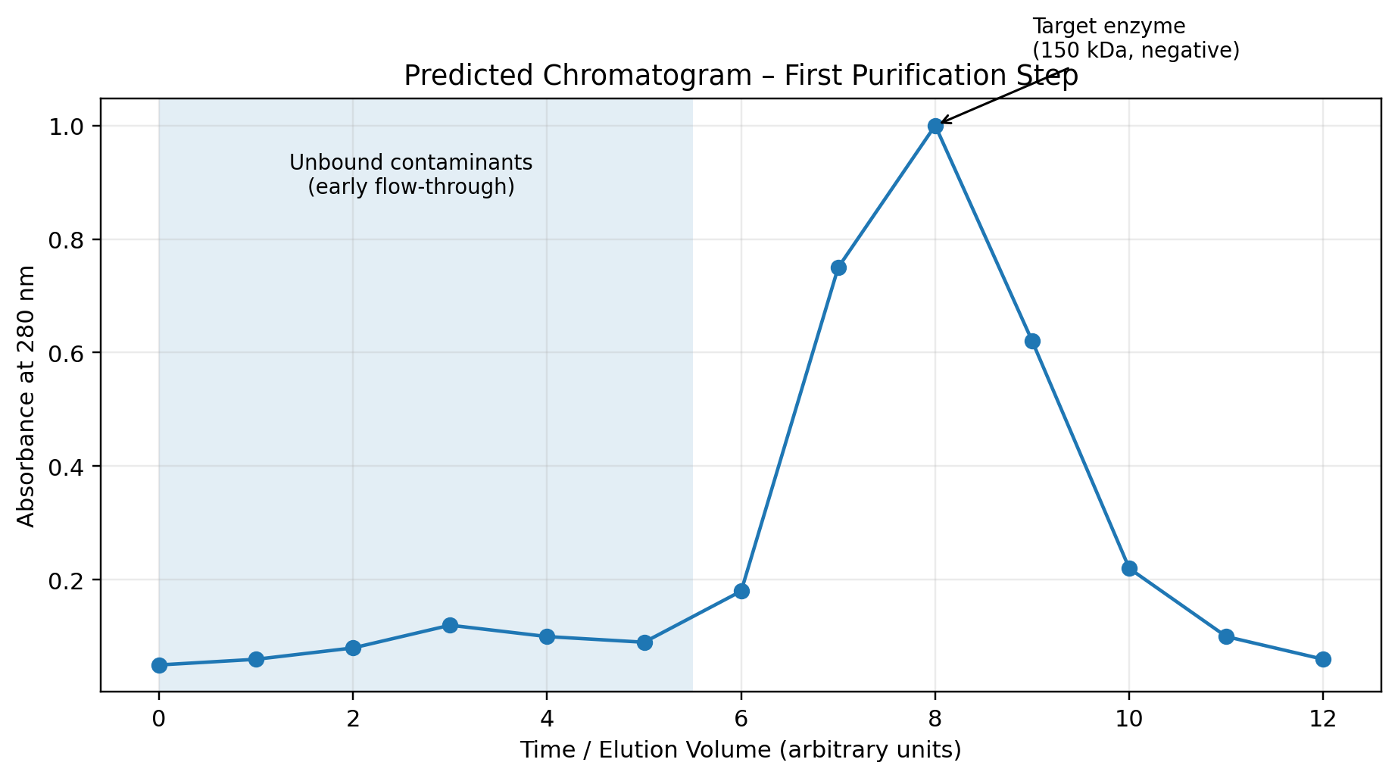
Figure 1. Predicted absorbance-versus-time chromatogram for the first purification step.

4. Expected Outcome
Component | Charge / Size | Expected Behavior in Step 1
Target enzyme | Negative; 150 kDa | Binds to anion-exchange matrix; elutes later
Contaminants | Positive; smaller | Do not bind to the positively charged matrix; elute in flow-through

5. Final Answer
For the given cell lysate, I would first use anion-exchange chromatography because the target enzyme is negatively charged at pH 7 and will bind to the positively charged matrix, whereas the positively charged contaminants will flow through. I would then use size-exclusion chromatography because the target enzyme is large (150 kDa) and will elute before smaller molecules. The first chromatographic step should show early peaks from unbound contaminants, followed by the target enzyme peak during elution.

