Air Pollution Analysis Of Dwarka-Sector (8)

Data Mining Assignment Report

SUBMITTED TO

DEPARTMENT OF COMPUTER SCIENCE AND ENGINEERING

RAMAIAH INSTITUTE OF TECHNOLOGY

(Autonomous Institute, Affiliated to VTU)

Bangalore – 54



**Submitted by**

Ajay Shastry 1MS16CS043

Abhishek 1MS16CS004

Appasaheb C 1MS16CS021

SUPERVISED BY

Faculty

**Prof. Chetan Shetty**

**Inferences**

**1. Presence of Aromatic pollutants and their effect on other pollutant :**

Aromatic compounds is an important class of hydrocarbons taking a significant part in the formation of tropospheric ozone and the secondary pollutants, including organic

aerosols, that can lead to photochemical smog. Being toxic and carcinogenic, these gases can be formed even without chemical transformation. The high level of pollutants can have worth effects on the blood system and central nervous system, such as, leukemia, bladder cancer, nervous system damage in the workers of industrial areas.

Aromatic hydrocarbons (Benzene, Toluene) were emitted in the highest amounts from air emissions from petroleum production industries (motor vehicle exhaust, incomplete combustion of fossil fuels, oil and gas service stations, and other industrial and human activities) that are similar to our results since Dwarka area is situated near other Industrial zones and Manufacturing unit.

During our statistical analysis found that Benzene did have significantly correlation with Toluene in the environmental sample like NOx, CO, O3 (Ozone). These chemicals are highly active and they react with each other to form new secondary pollutants even in low air temperature.

Dwarka has average temperature around 40-50 degree celcius, which is suitable for Aromatic reactions. Water (H2O) in atmosphere readily reacts with CO to form H30 positive molecule (Hydronium ion) and O negative molecule. Oxides of Nitrogen in air will be in unstable state and will readily react with O – molecule to form other NOx compounds.

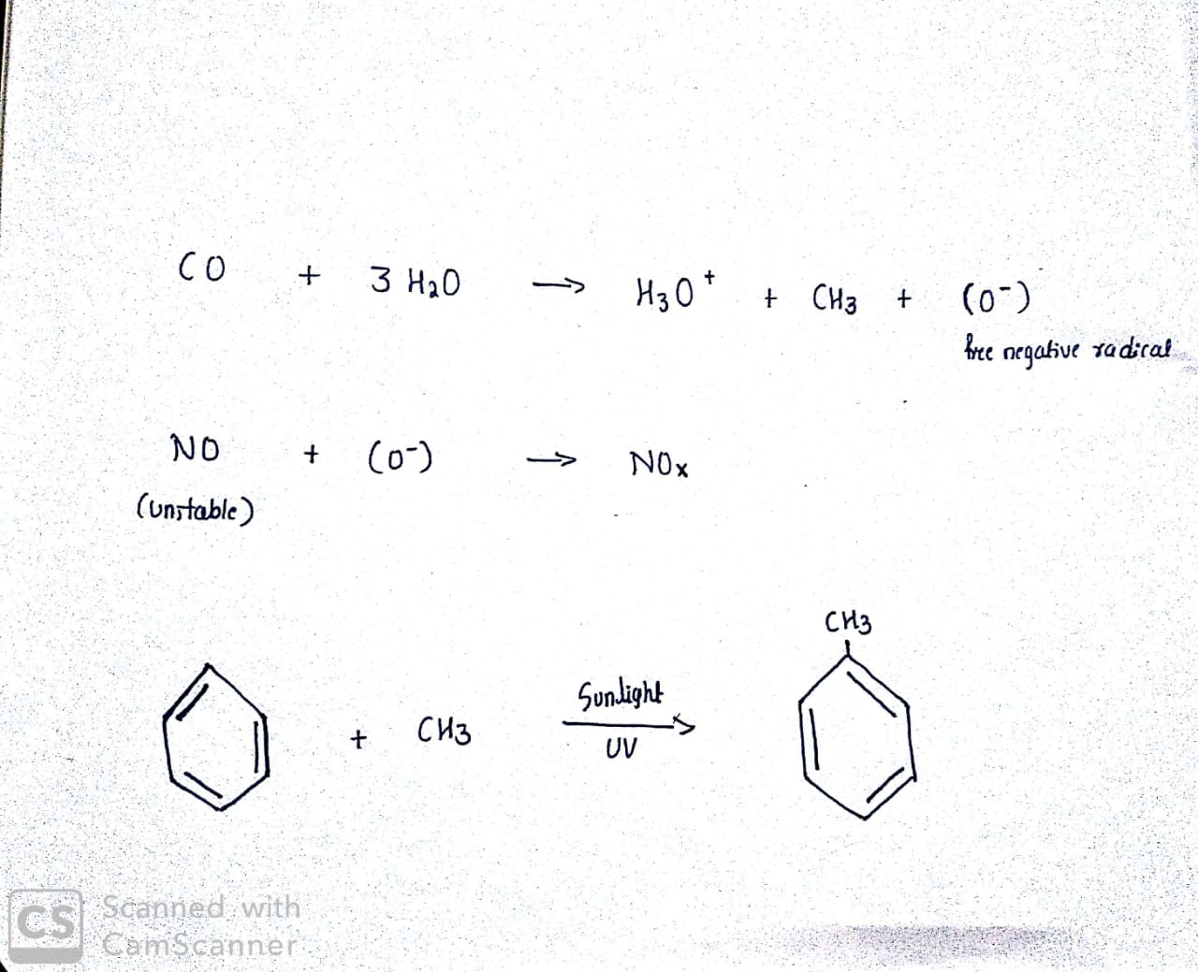

H3O + molecule and CO will react with Benzene to form Toluene under moderate temperature (40-50 degree C).

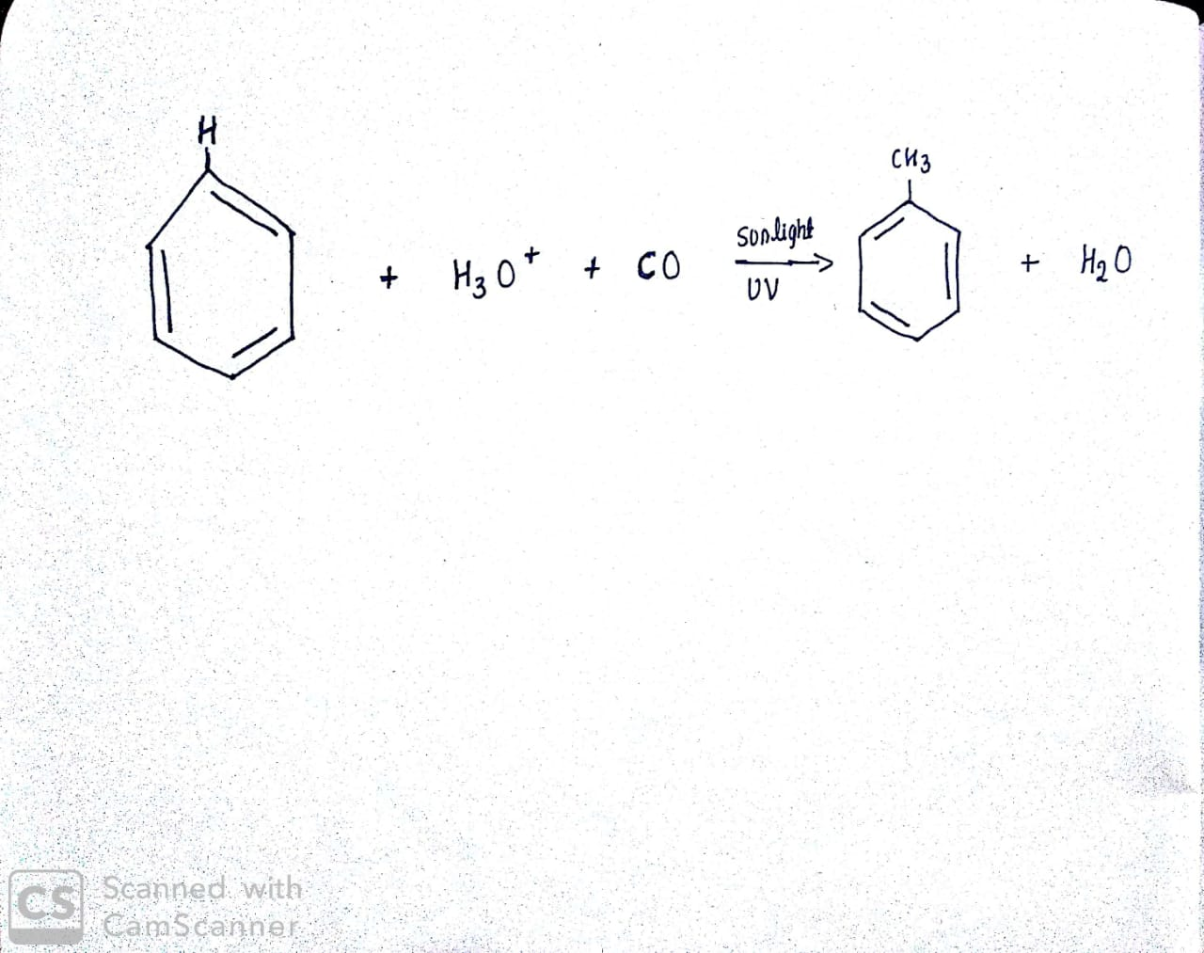

**Inferences**

**2. PM10 concentration on Diwali:**

Diwali being the festival of lights, people celebrate it in different ways. ”FIREWORKS” being an integral part of the festival is also a reason for air pollution. Bursting of crackers emits various compounds of nitrates and sulphates which is one of the main reasons for the formation of PM10. The below graph shows the same.

On the days of Diwali (5-10 November), the levels of PM10 was very high and the graph tells the same. A day after Diwali, Delhi’s air quality nosedived towards the "severe" category as people violated the supreme court’s time limit to burst firecrackers.

