1. 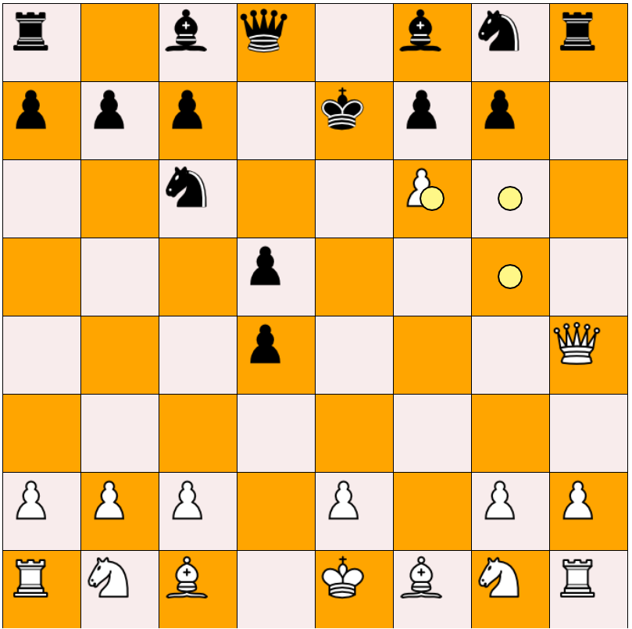Moves prediction for the pawn is not check if check is given by pawn. (Black to Move)
2. 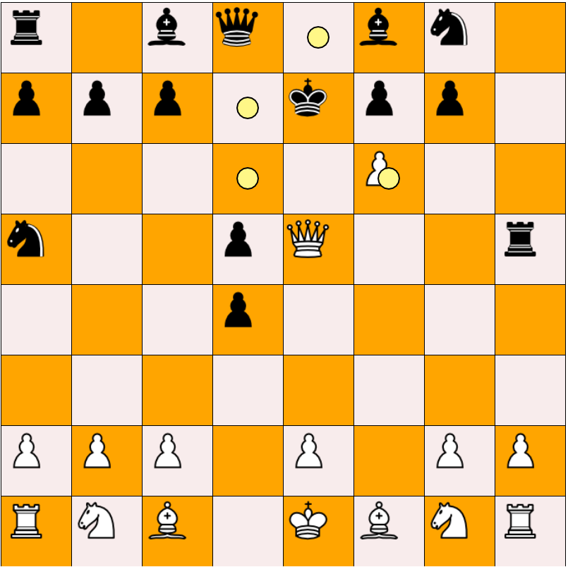King valid moves still shows in direction of attack, in check
3. 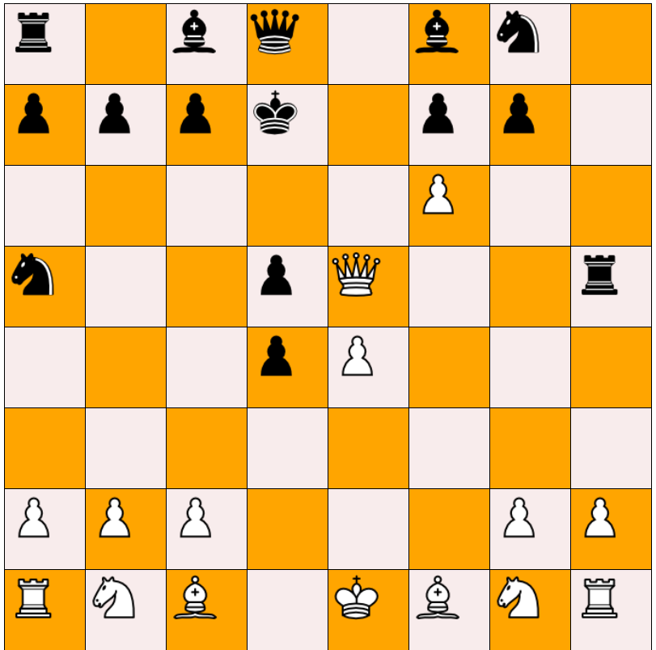King valid move in direction of attack, non-safe square,
4. Pieces moves are not shown but the the can be moved to their respective valid position

