Mission of the Department To nurture computer engineering professionals by offering:
- Dynamic learning environment that encourages problem-solving using emerging technology
- National Education Policy aligned evidence-based technical education, fostering innovation, research, and industry–institute collaboration ● Holistic, ethical and sustainable development for lifelong success.

Vision: After a few years in engineering, I see myself as a skilled and confident engineer working in a reputed organization where I can apply my technical knowledge to solve realworld problems. | Mission: 1 Build strong fundamentals in core engineering subjects.  2 Practice regularly through labs, miniprojects, and assignments.  - Learn new technologies and tools related to my field.  - Improve problem-solving skills by solving real-world problems.

Program Educational Objectives of the program (PEO): (broad statements that describe the professional and career accomplishments)
PEO1 | Preparation | P: Preparation | Pep-CL abbreviation pronounce as Pep-si-lL easy to recall
PEO2 | Core Competence | E: Environment  (Learning Environment) | Pep-CL abbreviation pronounce as Pep-si-lL easy to recall
PEO3 | Breadth | P: Professionalism | Pep-CL abbreviation pronounce as Pep-si-lL easy to recall
PEO4 | Professionalism | C: Core Competence | Pep-CL abbreviation pronounce as Pep-si-lL easy to recall
PEO5 | Learning  Environment | L: Breadth (Learning in diverse areas) | Pep-CL abbreviation pronounce as Pep-si-lL easy to recall

Program Outcomes (PO): (statements that describe what a student should be able to do and know by the end of a program)
Keywords of POs:
Engineering knowledge, Problem analysis, Design/development of solutions, Conduct Investigations of Complex Problems, Engineering Tool Usage, The Engineer and The World, Ethics, Individual and Collaborative Team work, Communication, Project Management and Finance, Life-Long Learning

PSO Keywords: Cutting edge technologies, Research

“I am an engineer, and I know how to apply engineering knowledge to investigate, analyse and design solutions to complex problems using tools for entire world following all ethics in a collaborative way with proper management skills throughout my life.” to contribute to the development of cutting-edge technologies and Research.
Mission of the Department To nurture computer engineering professionals by offering:
- Dynamic learning environment that encourages problem-solving using emerging technology
- National Education Policy aligned evidence-based technical education, fostering innovation, research, and industry–institute collaboration ● Holistic, ethical and sustainable development for lifelong success.

Integrity: I will adhere to the Laboratory Code of Conduct and ethics in its entirety.

Name and Signature of Student and Date
Rushikesh Bhondekar

Sr. No. | COs |  |  |  |  | POs |  |  |  |  |  |  |  | PSOs
Sr. No. | COs | Course Outcomes | 1 | 2 | 3 | 4 | 5 | 6 | 7 | 8 | 9 | 10 | 11 | PSO  1 | PSO  2
1 | CO1 | Demonstrate the ability to execute  Linux process management, memory  management,  and shell commands to manage system  resources efficiently. | 3 | 3 | 3 | - |  | - | - | - | - | - | 3 | 3
2 | CO2 | Develop programs utilizing system calls, thread programming,  and page  replacement algorithms to | 3 | 3 | 3 | - | - | - | - | - | - | - | 3 | 3
Mission of the Department To nurture computer engineering professionals by offering:
- Dynamic learning environment that encourages problem-solving using emerging technology
- National Education Policy aligned evidence-based technical education, fostering innovation, research, and industry–institute collaboration ● Holistic, ethical and sustainable development for lifelong success.

 |  | simulate and analyze operating system functionalities.
3 | CO3 | Design and  implement process scheduling, memory allocation, and  deadlock  detection  algorithms to address realworld operating system challenges. | 3 | 3 | 3 | - |  | - | - | - | - | - | 3 | 3
 |  | Avg |  | 3 | 3 | - |  | - | - | - | - | - | 3 | 3

Session | 2025-26 (EVEN) | Course Name | Operating Systems Lab
Semester | 4 | Course Code | 23CT1402
Roll No | 69 | Name of Student | Rushikesh Bhondekar

Practical Number | 2
Course Outcome | 1. Analyse operating system functionalities utilizing system calls, thread programming and process scheduling  algorithms (CO2)
Aim | Execute Linux process management system calls
Problem Definition | predict and verify the output of the program with conditional fork calls
Mission of the Department To nurture computer engineering professionals by offering:
- Dynamic learning environment that encourages problem-solving using emerging technology
- National Education Policy aligned evidence-based technical education, fostering innovation, research, and industry–institute collaboration ● Holistic, ethical and sustainable development for lifelong success.

Theory  (100 words) | Process management system calls are kernel functions  that let user programs create, control,  and terminate processes, with key examples in Unix/Linux being fork() (duplicate process),  exec() (load new program), exit() (terminate), and wait()  (parent waits for child). These  system calls act as an interface between user programs and the kernel for managing processes.  Key Process Management System Calls  fork(): Creates a new child process that's a nearly identical copy of the parent, each getting a unique Process ID (PID).  exec(): Replaces the current process's image with a new program, allowing execution of different code.  exit(): Terminates the calling process, releasing its resources.  wait(): Pauses the parent process until one of its child processes terminates, often used to get the child's exit status.  clone(): (Linux-specific) A more flexible version of fork, allowing shared resources like memory or file descriptors. getpid() / getppid(): Retrieve the current process's ID or its parent's ID, respectively, for
Mission of the Department To nurture computer engineering professionals by offering:
- Dynamic learning environment that encourages problem-solving using emerging technology
- National Education Policy aligned evidence-based technical education, fostering innovation, research, and industry–institute collaboration ● Holistic, ethical and sustainable development for lifelong success.

 | identification and management.
Procedure and Execution  (100 Words) | 1.Open the Linux Terminal.  Create a new C source file using a text editor (for example gedit or nano).  2.Type the given C program code in the editor.  Save the file with a .c extension (for example: fork.c).  3.Compile the program using the GCC compiler:  4.gcc fork.c -o fork  If there are no errors, the executable file fork will be created.  5.Execute the program using the following command:  Copy code  Observe the output displayed on the terminal.
Procedure and Execution  (100 Words) | Code:  #include <stdio.h>  #include <unistd.h>  int main()  {  pid_t ret_value;  printf("\nThe process id is %d\n", getpid());  ret_value = fork();  if (ret_value < 0)
Mission of the Department To nurture computer engineering professionals by offering:
- Dynamic learning environment that encourages problem-solving using emerging technology
- National Education Policy aligned evidence-based technical education, fostering innovation, research, and industry–institute collaboration ● Holistic, ethical and sustainable development for lifelong success.

{
// fork has failed
printf("\nFork Failure\n");
}
else if (ret_value == 0)
{
// child process
printf("\nChild Process\n");
printf("The process id is %d\n", getpid());
; } else
{
// parent process
// wait();
printf("Parent Process\n");
printf("The process id is %d\n", getpid());
}

return 0;
}
Output:
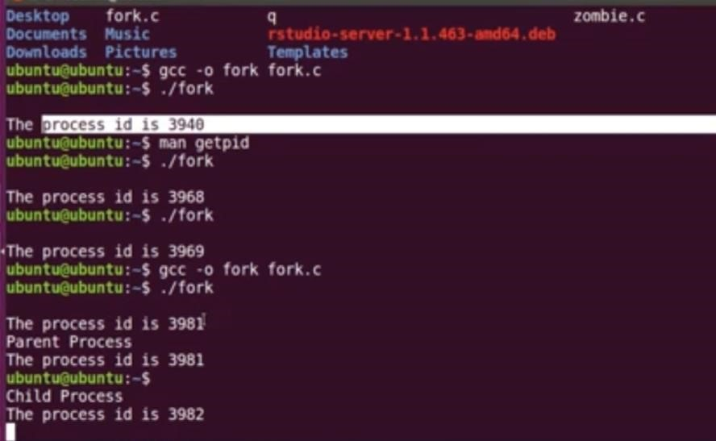
Mission of the Department To nurture computer engineering professionals by offering:
- Dynamic learning environment that encourages problem-solving using emerging technology
- National Education Policy aligned evidence-based technical education, fostering innovation, research, and industry–institute collaboration ● Holistic, ethical and sustainable development for lifelong success.

 | 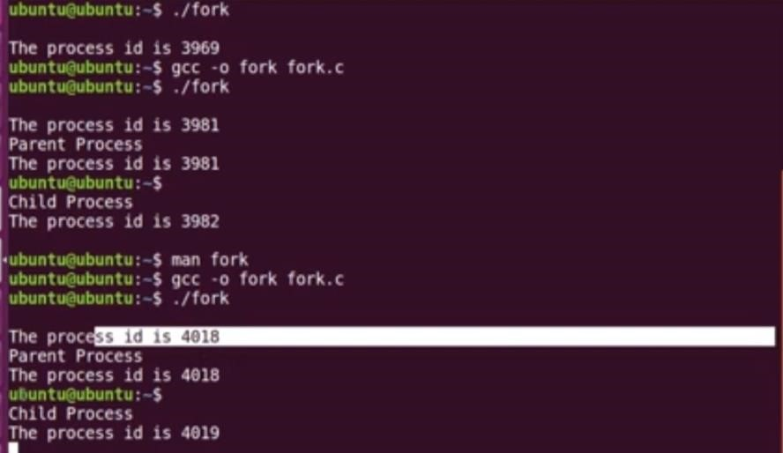
Output Analysis | When the program starts, only one process is running, and it first prints its own process ID using the getpid() function. After this, the fork() system call is executed, which creates a new child process. From this point onward, two processes exist and both continue execution independently. The return value of fork() is different for each process: in the parent process it returns a positive value (the child’s process ID), while in the child process it returns 0. Based on this return value, the parent process executes the else block and prints “Parent Process” along with its process ID, which remains the same as before the fork(). The child process executes the else if block and prints “Child Process” along with a new process ID assigned by the operating system. Since both processes run concurrently and there is no synchronization mechanism like wait(), the order in
Mission of the Department To nurture computer engineering professionals by offering:
- Dynamic learning environment that encourages problem-solving using emerging technology
- National Education Policy aligned evidence-based technical education, fostering innovation, research, and industry–institute collaboration ● Holistic, ethical and sustainable development for lifelong success.

 | which the parent and child outputs appear on the screen is not fixed and may vary each time the program is executed on Linux.
Link of student Github profile where lab assignment has been uploaded | https://github.com/rushikesh-bhondekar
Conclusion | The program prints the process ID before fork().  After fork(), two processes execute independently. The parent prints its PID again, while the child prints a new PID.  The order of execution depends on the Linux scheduler.
Plagiarism Report  (Similarity index <  12%) | 6 %< 12%
Date | 12/1/26

Mission of the Department To nurture computer engineering professionals by offering:
- Dynamic learning environment that encourages problem-solving using emerging technology
- National Education Policy aligned evidence-based technical education, fostering innovation, research, and industry–institute collaboration ● Holistic, ethical and sustainable development for lifelong success.

