Mission of the Department To nurture computer engineering professionals by offering:
- Dynamic learning environment that encourages problem-solving using emerging technology
- National Education Policy aligned evidence-based technical education, fostering innovation, research, and industry–institute collaboration
- Holistic, ethical and sustainable development for lifelong success.

Session 2025-2026

Vision: After a few years in engineering, I see myself as a skilled and confident engineer working in a reputed organization where I can apply my technical knowledge to solve real world problems. My goal is to gain strong practical experience and continuously improve my skills in my chosen field of engineering. | Mission: 1 Build strong fundamentals in core engineering subjects. 2 Practice regularly through labs, mini projects, and assignments. 3. Learn new technologies and  tools related to my field. 4. Improve problem-solving skills by solving realworld problems.

Program Educational Objectives of the program (PEO): (broad statements that describe the professional and career accomplishments)
PEO1 | Preparation | P: Preparation | Pep-CL abbreviation pronounce as Pep-si-lL easy to recall
PEO2 | Core Competence | E: Environment  (Learning Environment) | Pep-CL abbreviation pronounce as Pep-si-lL easy to recall
PEO3 | Breadth | P: Professionalism | Pep-CL abbreviation pronounce as Pep-si-lL easy to recall
PEO4 | Professionalism | C: Core Competence | Pep-CL abbreviation pronounce as Pep-si-lL easy to recall
PEO5 | Learning  Environment | L: Breadth (Learning in diverse areas) | Pep-CL abbreviation pronounce as Pep-si-lL easy to recall

Program Outcomes (PO): (statements that describe what a student should be able to do and know by the end of a program)
Keywords of POs:
Engineering knowledge, Problem analysis, Design/development of solutions, Conduct Investigations of Complex Problems, Engineering Tool Usage, The Engineer and The World, Ethics, Individual and Collaborative Team work, Communication, Project Management and Finance, Life-Long Learning

PSO Keywords: Cutting edge technologies, Research

“I am an engineer, and I know how to apply engineering knowledge to investigate, analyse and design solutions to complex problems using tools for entire world following all ethics in a collaborative way with proper management skills throughout my life.” to contribute to the development of cutting-edge technologies and Research.

Integrity: I will adhere to the Laboratory Code of Conduct and ethics in its entirety.

Mission of the Department To nurture computer engineering professionals by offering:
- Dynamic learning environment that encourages problem-solving using emerging technology
- National Education Policy aligned evidence-based technical education, fostering innovation, research, and industry–institute collaboration
- Holistic, ethical and sustainable development for lifelong success.

Name and Signature of Student and Date
Rushikesh Bhondekar 2/2/2026

  Sr. No. | COs |  |  |  |  | POs |  |  |  |  |  |  |  | PSOs
 | COs | Course Outcomes | 1 | 2 | 3 | 4 | 5 | 6 | 7 | 8 | 9 | 10 | 11 | PSO  1 | PSO  2
1 | CO1 | Demonstrate the ability to execute  Linux process management, memory  management,  and shell commands to manage system resources efficiently. | 3 | 3 | 3 | - |  | - | - | - | - | - | 3 | 3
2 | CO2 | Develop programs utilizing system calls, thread programming,  and page  replacement | 3 | 3 | 3 | - | - | - | - | - | - | - | 3 | 3
Mission of the Department To nurture computer engineering professionals by offering:
- Dynamic learning environment that encourages problem-solving using emerging technology
- National Education Policy aligned evidence-based technical education, fostering innovation, research, and industry–institute collaboration
- Holistic, ethical and sustainable development for lifelong success.

 |  | algorithms to simulate and analyze operating system functionalities.
3 | CO3 | Design and  implement process  scheduling, memory allocation, and  deadlock detection  algorithms to address realworld operating system challenges. | 3 | 3 | 3 | - |  | - | - | - | - | - | 3 | 3
 |  | Avg |  | 3 | 3 | - |  | - | - | - | - | - | 3 | 3

Session | 2025-26 (EVEN) | Course Name | Operating Systems Lab
Semester | 4 | Course Code | 23CT1402
Roll No | 69 | Name of Student | Rushikesh Bhondekar

Practical Number | 3
Course Outcome | 1. Understand Computer System Configuration and Simulate system resources efficiently using Linux Commands  (CO1)
Aim | Execute Linux memory management system calls and Device management system calls.
Mission of the Department To nurture computer engineering professionals by offering:
- Dynamic learning environment that encourages problem-solving using emerging technology
- National Education Policy aligned evidence-based technical education, fostering innovation, research, and industry–institute collaboration
- Holistic, ethical and sustainable development for lifelong success.

Problem Definition | Write a C program to lock and unlock the entire address space using mlockall().

Mission of the Department To nurture computer engineering professionals by offering:
- Dynamic learning environment that encourages problem-solving using emerging technology
- National Education Policy aligned evidence-based technical education, fostering innovation, research, and industry–institute collaboration
- Holistic, ethical and sustainable development for lifelong success.

Theory  (100 words) | These system calls allow a process to allocate, deallocate, and manage memory during  Key Memory Management System Callsbrk(addr) sets the end of the process’s heap (called the program break) to a specific memory address, thereby fixing how much heap memory the process can use.sbrk(increment) It is a simpler way to manage heap memory, as it increases or decreases the current program break by a specified amount. A positive increment allocates more memory,  while a negative increment releases memory back to the operating system.mmap(): It is a more flexible and powerful method for memory management. It creates anew mapping in the virtual address space of a process, allowing files or devices to be mapped directly into memory. This means the mapped data can be accessed like an array in RAM, which improves performance for large file operations and enables efficient shared memory communication between processes. In addition to file mapping, mmap() is also used  allocate large blocks of anonymous memory that are not backed by any file. For large memory allocations, mmap() is often preferred over brk() because it provides better efficiency, flexibility, and memory management.  munmap(): This removes a memory mapping from a process's address space, releasing the associated virtual memory regions.mlock() and munlock(): These system calls lock or unlock specified pages of memory into  RAM, preventing the Linux kernel from paging them out to swap space. This is particularly useful in real-time or highperformance applications where predictable memory access
Mission of the Department To nurture computer engineering professionals by offering:
- Dynamic learning environment that encourages problem-solving using emerging technology
- National Education Policy aligned evidence-based technical education, fostering innovation, research, and industry–institute collaboration
- Holistic, ethical and sustainable development for lifelong success.

 | timesare crucial.mlockall() and munlockall() lock or unlock the entire address space of the calling process.
Procedure and  Execution | 1.Write a C program using mlockall() to lock the entire process address space and munlockall() to unlock it.  2.Include the required header files:  stdio.h, stdlib.h, sys/mman.h, and unistd.h.  Use the flags MCL_CURRENT and MCL_FUTURE with mlockall() to lock all current and future memory pages. Display appropriate messages to indicate memory locking and unlocking.  3.Save the program with a .c extension (e.g., mlockall_demo.c). Compile the program using the GCC compiler.  Execute the program with superuser privileges, as memory locking requires special permissions.  4. Open the Linux terminal.  Navigate to the directory containing the program file.  5.Compile the program:  6.Observe the output showing successful memory locking, a short delay, and memory unlocking.  After execution, control returns to the terminal prompt, indicating normal program termination.
Mission of the Department To nurture computer engineering professionals by offering:
- Dynamic learning environment that encourages problem-solving using emerging technology
- National Education Policy aligned evidence-based technical education, fostering innovation, research, and industry–institute collaboration
- Holistic, ethical and sustainable development for lifelong success.

Code:
#include <stdio.h>
#include <stdlib.h>
#include <sys/mman.h>
#include <unistd.h>

int main() {

if (mlockall(MCL_CURRENT | MCL_FUTURE) == -1) { perror("mlockall failed");
return EXIT_FAILURE;
}

printf("Memory successfully locked into RAM.\n"); printf("Sleeping for 5 seconds...\n"); sleep(5);

if (munlockall() == -1) { perror("munlockall failed");
return EXIT_FAILURE;
}

printf("Memory successfully unlocked.\n");

return EXIT_SUCCESS; }
Output:

Mission of the Department To nurture computer engineering professionals by offering:
- Dynamic learning environment that encourages problem-solving using emerging technology
- National Education Policy aligned evidence-based technical education, fostering innovation, research, and industry–institute collaboration
- Holistic, ethical and sustainable development for lifelong success.

 | 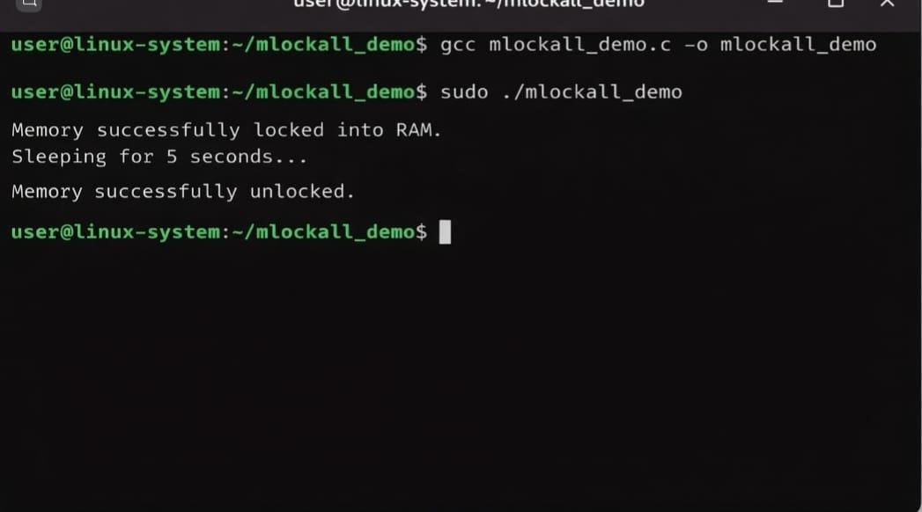
Output Analysis | When the program is executed on a Linux system with appropriate privileges, the following behavior is observed:  Successful Compilation:The program compiles without any errors using the GCC compiler.  This confirms that required headers (sys/mman.h, unistd.h, etc.) are correctly included and the syntax is valid.  Execution with Superuser Privileges  .The program is executed using sudo to grant permission for memory locking.  .This is necessary because locking memory requires sufficient system privileges.  Sleep Interval
Mission of the Department To nurture computer engineering professionals by offering:
- Dynamic learning environment that encourages problem-solving using emerging technology
- National Education Policy aligned evidence-based technical education, fostering innovation, research, and industry–institute collaboration
- Holistic, ethical and sustainable development for lifelong success.

.The program pauses for 5 seconds using the sleep() function.
.This delay demonstrates the time period during which the memory remains locked..
Link of student Github profile where lab assignment has been uploaded | https://github.com/rushikesh-bhondekar
Conclusion | The program successfully locks the entire process memory into RAM using mlockall() and later releases it using munlockall(). This prevents memory paging during execution and ensures predictable performance. Proper privileges are required, and normal memory management is restored after unlocking.
Plagiarism Report  (Similarity index <  12%) | 9%<12%
Date | 2/2/2026

