MACHINE LEARNING · CUSTOMER ANALYTICS
E-Commerce Customer Churn Prediction
An End-to-End, Leakage-Safe Classification & Explainable AI System

An end-to-end, leakage-safe binary classification system for estimating customer churn
risk — covering exploratory analysis, cost-sensitive imbalance handling, hyperparameter tuning,
probability calibration, and SHAP-based explainability.
▪ SUPERVISED LEARNING ▪ CLASS-IMBALANCE HANDLING ▪ PROBABILITY CALIBRATION ▪ EXPLAINABLE AI
PREPARED BY | Rushikesh Khamgaonkar
DATE | September 2026
DATASET | E-Commerce Customer Churn Dataset (51,706 records · 20 fields)
TARGET CLASSES | 2 — Retained · Churned
FINAL MODEL | Class-Weighted, Isotonic-Calibrated CatBoost Classifier

Leakage-Free Pipeline · Stratified Cross-Validation · Cost-Sensitive Class Weighting · SHAP Interpretability · Flask-Ready Deployment

CONTENTS
Table of Contents
1 Executive Summary
1.1 Headline Result
1.2 What This Project Demonstrates
2 Project & Business Understanding
2.1 Project Introduction
2.2 Business Objective
2.3 Machine Learning Objective & Problem Definition
2.4 Project Scope
3 Data Preparation & Cleaning
3.1 Dataset Loading & Overview
3.2 Raw Data Standardization
3.3 Duplicate Record Handling
4 Data Understanding
4.1 Dataset Structure & Initial Inspection
4.2 Missing-Value Assessment
4.3 Categorical Cardinality & Feature Profile
5 Exploratory Data Analysis
5.1 Target Variable Distribution
5.2 Numerical Feature Distributions
5.3 Churn Behaviour vs Numerical Features
5.4 Churn Rate Across Categorical Segments
5.5 Feature Relationship & Correlation Analysis
5.6 Churn Rate by Tenure Band
6 Feature Engineering
6.1 Digital Engagement per Device
6.2 Coupon Redemption Rate
7 Data Preprocessing & Train–Test Split
7.1 Feature–Target Separation and Stratified Split
7.2 Feature-Type Classification
7.3 Model-Specific Preprocessing Pipelines
7.4 Leakage-Safe Preprocessing Architecture
8 Model Development & Baseline Benchmarking
8.1 Candidate Models & Cross-Validation Strategy
8.2 Baseline Cross-Validation Results
8.3 Class-Imbalance Handling — Cost-Sensitive Weighting
9 Hyperparameter Tuning & Probability Calibration
9.1 CatBoost Randomized Search
9.2 Out-of-Fold Validation & Isotonic Calibration
9.3 Operating Threshold Selection
10 Final Model Evaluation
10.1 Held-Out Test Performance
10.2 Confusion Matrix Analysis
10.3 ROC-AUC and Precision–Recall Curves
11 Model Explainability (SHAP)
11.1 Global Feature Importance
11.2 Directional Feature Effects (Summary Plot)
12 Conclusion & Business Recommendations
12.1 Summary of Findings
12.2 Final Recommendation
12.3 Business Impact & Deployment Considerations
12.4 Skills & Techniques Demonstrated
Note: right-click this table and choose “Update Field” (or press F9) to refresh page numbers after opening in Word.

SECTION 1

Executive Summary
This report documents an end-to-end machine learning system that estimates the probability of customer
churn for an e-commerce platform, using behavioural, engagement, satisfaction, transactional, and profile
attributes recorded at the customer level. The system was built from a dataset of 51,706 raw customer records,
reduced to 50,000 unique customers after duplicate removal, and spans 20 original fields describing tenure,
access channel, spending, satisfaction, and order activity.
The workflow follows a leakage-aware, nine-phase pipeline covering project definition, data cleaning,
data understanding, exploratory data analysis, feature engineering, preprocessing, model development, model
interpretation, and final results. Four classification algorithms — Logistic Regression, XGBoost, LightGBM, and
CatBoost — were benchmarked with Stratified 5-Fold Cross-Validation, first as unweighted baselines and then
under cost-sensitive class weighting, since the target is imbalanced at roughly 82.25% retained customers
against 17.75% churned customers.

1.1 Headline Result
A hyperparameter-tuned CatBoost classifier, trained with cost-sensitive class weights and calibrated using
Isotonic Regression, was selected as the deployment candidate. On a completely unseen, held-out test set of
10,000 customers, the model reached a ROC-AUC of 0.90 and a PR-AUC of 0.71, confirming strong
discrimination between churners and retained customers despite the imbalance. At its selected operating
threshold of 0.30, the model achieved a Balanced Accuracy of 0.79 and a Macro F1-score of 0.78, correctly
identifying 1,187 of 1,775 churned customers in the test set.
Beyond raw predictive performance, the project prioritised probability reliability and clinical-style
interpretability appropriate for a customer-retention decision system. Isotonic calibration reduced the Brier
Score from 0.12 to 0.08 on held-out out-of-fold predictions, and SHAP (SHapley Additive exPlanations) analysis
confirmed that recency of activity, satisfaction, order frequency, and digital engagement are the dominant
behavioural signals driving the model's churn predictions.

1.2 What This Project Demonstrates
- End-to-end ML pipeline design — from raw Excel ingestion, through leakage-aware preprocessing, to a calibrated, deployable classifier.
- Imbalanced-classification discipline — unweighted baselines, cost-sensitive class weighting, out-of-fold calibration, and constrained threshold selection, compared empirically rather than assumed.
- Leakage-safe engineering — all imputation, scaling, and encoding steps are refit independently inside every cross-validation fold, and the test set is touched exactly once.
- Feature engineering for behavioural data — digital engagement per linked device and a normalised coupon-redemption rate, both derived without reference to the target.
- Breadth across model families — a linear baseline (Logistic Regression) alongside three gradient-boosted tree families (XGBoost, LightGBM, CatBoost).
- Probability calibration & threshold governance — Isotonic Regression calibration and a precision-constrained operating threshold, both selected exclusively from training-side data.
- Explainable AI (XAI) — global and directional SHAP analysis translating a gradient-boosted model into transparent, business-readable churn drivers.
SECTION 2

Project & Business Understanding
This phase establishes the business context, machine learning objective, prediction target, problem
formulation, and success criteria for the e-commerce customer churn prediction system. The objective is to
develop a reliable, leakage-free binary classification workflow using only customer information that is
legitimately available at prediction time.

2.1 Project Introduction
Customer churn is a material business problem in e-commerce, since the loss of existing customers reduces
future purchasing activity and long-run customer value. This project develops an end-to-end machine learning
system to estimate customer churn risk using customer-level behavioural, engagement, satisfaction,
transaction-related, and profile information. Throughout, the emphasis is on data quality, leakage prevention,
reproducibility, predictive performance, probability reliability, and model interpretability.

2.2 Business Objective
The business objective is to identify customers with elevated estimated churn risk so that retention
activities can be prioritised. The predictive system is intended to support targeted customer engagement,
prioritisation of retention effort, and more effective allocation of customer-retention resources across the
customer base.

2.3 Machine Learning Objective & Problem Definition
The machine learning objective is to predict the Churned outcome using
customer information available at prediction time, with the model estimating the probability that a customer
belongs to the churn class. Only information legitimately available at the point of prediction is used, which is
fundamental to the project's leakage-free modelling strategy.
The project is formulated as a Supervised Learning → Binary Classification problem. The target
variable is Churned, where 0 denotes a customer who does not churn and 1 denotes a
customer who churns. The model's primary output is the estimated probability of the positive (churn) class,
which is more informative than a bare binary label because it allows customers to be ranked by estimated risk
for prioritisation.

2.4 Project Scope
The project covers data understanding, exploratory data analysis, data-quality treatment, leakage-free
preprocessing, feature engineering, model development, cross-validation, hyperparameter tuning, probability
calibration, threshold optimisation, final evaluation, and explainability. Deployment of the finalised model
through a live prediction service is treated as a subsequent implementation stage beyond this report.
SECTION 3

Data Preparation & Cleaning
The raw dataset is loaded and standardised for consistent downstream analysis. This stage handles
deterministic data-quality corrections only; statistical transformations such as imputation, encoding, and
scaling are deliberately deferred until after the train–test split, so that no data-driven parameter is ever
learned from information outside the training fold.

3.1 Dataset Loading & Overview
The customer dataset was loaded from the source Excel workbook, with confirmed missing-value placeholders
(NA, N/A, -, --)
standardised to NaN during ingestion.
Raw records loaded | 51,706 rows × 20 columns
Target variable | Churned (0 = retained, 1 = churned)
Feature groups | Demographic / Profile, Access & Channel, Engagement, Transactional, Satisfaction
Source | E-Commerce Customer Churn Dataset (customer-level, synthetically generated)

3.2 Raw Data Standardization
The source dataset was standardised prior to Data Understanding and EDA, following a deterministic,
target-blind sequence:
- Preserve raw dataset — the original dataframe was retained as a reference before any modification.
- Blank and whitespace-only values — whitespace-only text entries were converted to NaN so they are not mistaken for a distinct category.
- Leading / trailing whitespace — stripped from all text columns to prevent visually identical categories being treated as different levels.
- Categorical review — unique values of every text column were inspected, surfacing inconsistent casing such as 'Female', 'FEMALE', and 'female' across Gender, Primary_Access_Device, Payment_Mode, Top_Category, and Marital_Status.
- Categorical text standardisation — Primary_Access_Device, Gender, Top_Category, and Marital_Status were normalised to consistent title-case labels, consolidating equivalent categories without discarding any meaningful business label.

3.3 Duplicate Record Handling
Confirmed duplicate observations were removed before Data Understanding and EDA, to prevent repeated
records from over-weighting subsequent statistics and model training.
Check | Result
Exact duplicate rows identified | 1,706
Records after de-duplication | 50,000
Duplicate customer codes remaining after cleaning | 0

OBSERVATION
Removing 1,706 exact duplicate rows (3.3% of the raw file) leaves a clean, uniquely-keyed
customer table of 50,000 records with zero remaining duplicate Customer_Code values —
confirming the dataset is now suitable for one-row-per-customer analysis.
SECTION 4

Data Understanding
This phase establishes the structure, composition, and quality of the standardised dataset before
exploratory analysis, covering variable types, the target variable, missingness, and categorical characteristics
that guide subsequent modelling decisions.

4.1 Dataset Structure & Initial Inspection
Observations | 50,000
Total features | 20 (14 numerical, 6 categorical — including the identifier and target)
Target variable | Churned (int64)
Identifier column | Customer_Code (dropped before modelling)

A concise sample of the standardised dataset and its descriptive statistics were reviewed to validate
structure and flag values requiring further investigation. Plausible ranges were confirmed across the numerical
fields — for example, Tenure_Months ranges from roughly 1 to 60+ months and CSAT_Score is bounded between 1
and 5 — with no impossible or out-of-range values detected.

4.2 Missing-Value Assessment
Missing-value patterns were assessed across the standardised dataset to identify variables requiring
treatment during the later leakage-free preprocessing stage. Twelve of the twenty features carry genuine
missingness, at rates between roughly 2.9% and 5.4% — consistent with real-world data collection gaps rather
than a systematic recording fault.
Feature | Missing Count | Missing %
Days_Since_Last_Order | 2,683 | 5.37%
Marital_Status | 2,651 | 5.30%
YoY_Spend_Growth_Pct | 2,493 | 4.99%
Payment_Mode | 2,399 | 4.80%
Monthly_Orders | 2,317 | 4.63%
Hub_To_Home_KM | 2,301 | 4.60%
Tenure_Months | 2,200 | 4.40%
Coupons_Redeemed | 2,191 | 4.38%
App_Engagement_Hrs | 2,188 | 4.38%
Top_Category | 2,051 | 4.10%
Primary_Access_Device | 1,800 | 3.60%
Gender | 1,447 | 2.89%

Post-cleaning validation confirmed that no complete duplicate records remain (0 duplicate rows, 0.00%),
verifying that the earlier de-duplication step was fully effective.

4.3 Categorical Cardinality & Feature Profile
The number of unique values in each categorical feature was reviewed to confirm category complexity ahead
of one-hot encoding, and a combined feature profile (data type, unique-value count, missing count) was compiled
for every column.
Categorical Feature | Unique Values
Customer_Code (identifier) | 50,000
Payment_Mode | 6
Top_Category | 6
Primary_Access_Device | 3
Marital_Status | 3
Gender | 2

DATA UNDERSTANDING SUMMARY
The cleaned dataset comprises 50,000 uniquely-keyed customers across 20
fields, with genuine (not systematic) missingness in 12 features at manageable rates, low-to-moderate
cardinality across all five nominal predictors, and zero remaining duplicate records — confirming the table is
analysis-ready ahead of exploratory analysis.
SECTION 5

Exploratory Data Analysis
Exploratory Data Analysis is performed to understand the distribution of customer behaviour, identify
meaningful relationships with churn, and detect patterns that may influence subsequent modelling decisions,
while avoiding unnecessary or redundant visualisations.

5.1 Target Variable Distribution
The distribution of the target variable was examined to quantify the proportion of churned and
non-churned customers and assess the degree of class imbalance.
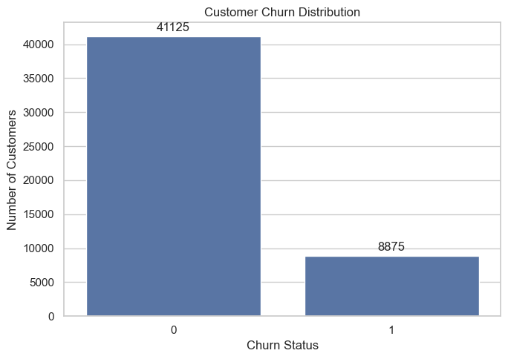
Figure 5.1 — Distribution of the Churned Target Variable
Churn Status | Customer Count | % of Dataset
0 — Retained | 41,125 | 82.25%
1 — Churned | 8,875 | 17.75%

OBSERVATION
The roughly 82% / 18% split confirms a meaningfully imbalanced target rather than a
merely skewed one, motivating the use of PR-AUC, Balanced Accuracy, and Macro F1 alongside raw accuracy, and the
cost-sensitive weighting strategy adopted in Section 8.

5.2 Numerical Feature Distributions
The distributions of thirteen numerical features (excluding the target) were examined to understand
central tendency, spread, skew, and potential extreme observations.
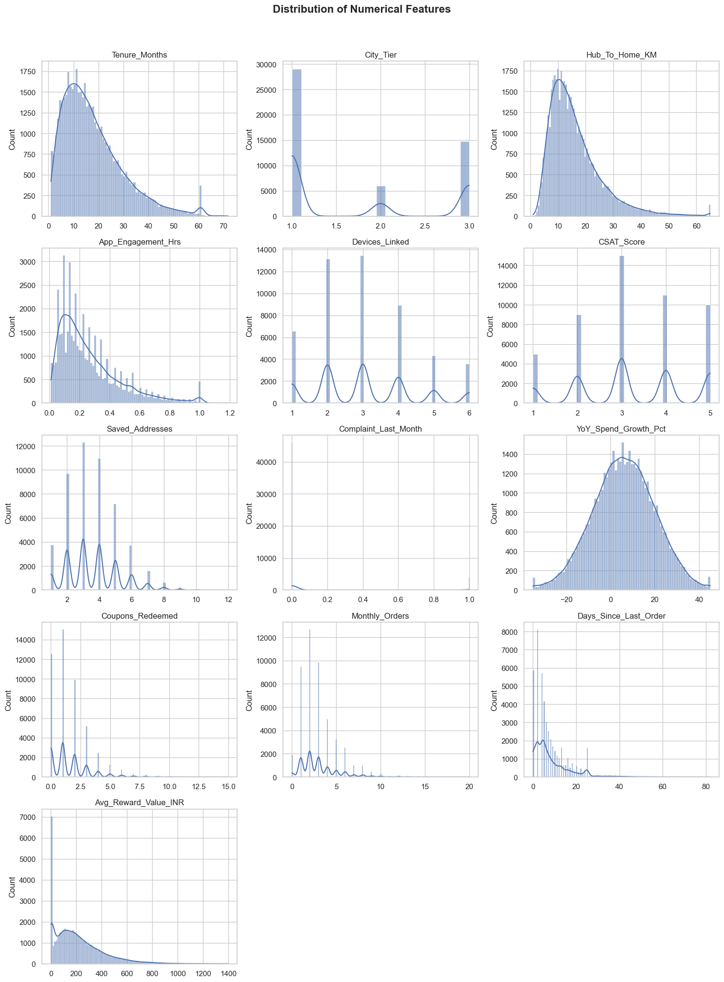
Figure 5.2 — Distribution of Numerical Features
KEY INSIGHTS
Tenure_Months, Hub_To_Home_KM, and App_Engagement_Hrs are positively skewed, concentrated
at lower values. Saved_Addresses, Coupons_Redeemed, Monthly_Orders, and Avg_Reward_Value_INR are right-skewed,
indicating a smaller group of highly active or higher-value customers. Days_Since_Last_Order shows a pronounced
right tail, with most customers recently active. City_Tier, Devices_Linked, and CSAT_Score are discrete/ordinal,
while Complaint_Last_Month is a sparse binary flag. YoY_Spend_Growth_Pct is comparatively balanced, spanning
both negative and positive growth. Overall, the feature set mixes continuous, discrete, ordinal, and binary
variables with varying shapes — a consideration carried into preprocessing in Section 7.

5.3 Churn Behaviour vs Numerical Features
Key numerical features were compared across churn classes using box plots to identify differences in
customer behaviour and potential predictive signal.
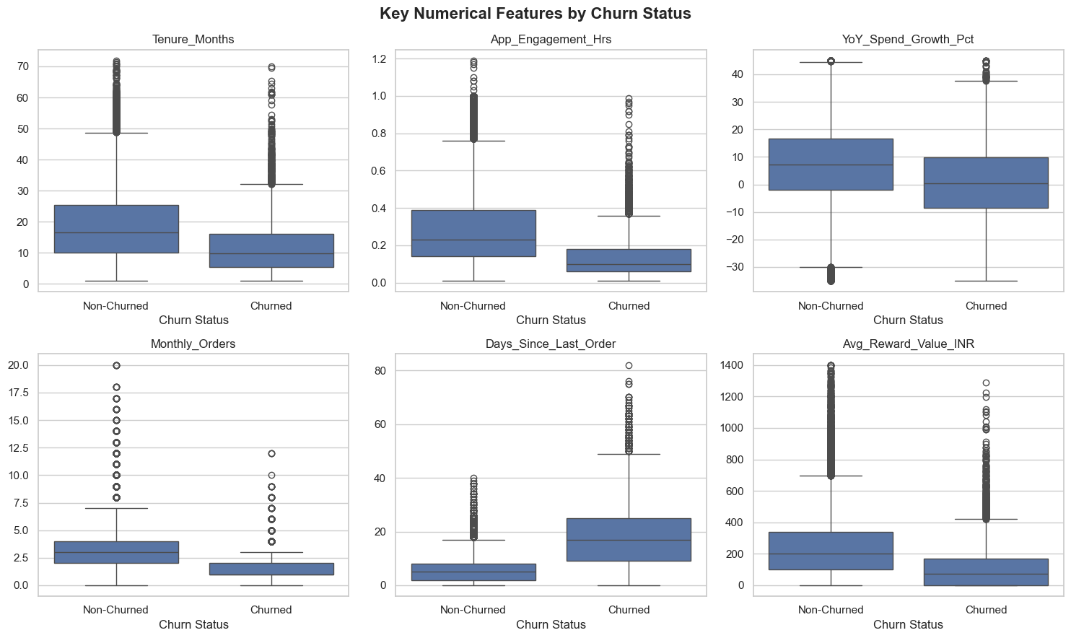
Figure 5.3 — Key Numerical Features by Churn Status
KEY INSIGHTS
Days_Since_Last_Order shows clear separation between churn classes, with churned
customers exhibiting substantially higher median inactivity. App_Engagement_Hrs and Monthly_Orders are
noticeably lower among churned customers, indicating reduced engagement and purchasing activity.
Avg_Reward_Value_INR is generally lower for churned customers, and Tenure_Months is lower for the churned
group, while YoY_Spend_Growth_Pct shows a lower central tendency and a broader negative range among churners.
Overall, recency, engagement, order activity, and reward value emerge as the strongest behavioural
candidates for churn prediction.

5.4 Churn Rate Across Categorical Segments
Churn rates were compared across key categorical segments to identify customer groups with noticeably
different churn behaviour and potential business relevance.
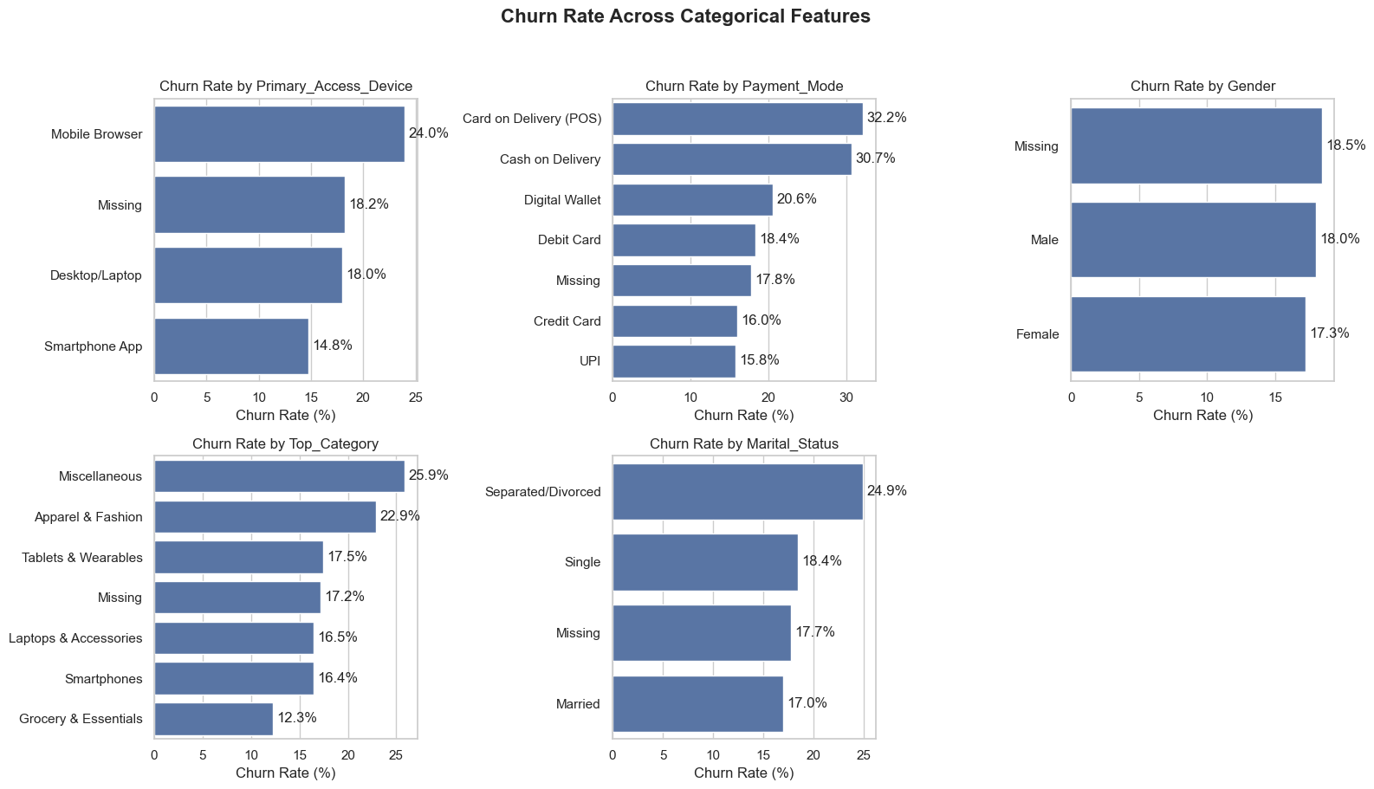
Figure 5.4 — Churn Rate Across Categorical Features
KEY INSIGHTS
Payment_Mode shows the strongest categorical variation, with Card on Delivery (POS) at
32.2% and Cash on Delivery at 30.7% recording notably higher churn than digital payment methods such as UPI
(15.8%). Marital_Status also varies meaningfully, with Separated/Divorced customers churning at 24.9% versus
17.0% for Married customers. Primary_Access_Device and Top_Category show moderate differences — Mobile
Browser users (24.0%) and the Miscellaneous category (25.9%) churn more than Smartphone App users (14.8%) and
the Grocery & Essentials category (12.3%). Gender shows limited variation (17.3%–18.0%) across its
categories.

5.5 Feature Relationship & Correlation Analysis
A Spearman correlation matrix of the numerical features was computed to surface monotonic relationships,
flag potential multicollinearity, and quantify each feature's association with the target ahead of model
training.
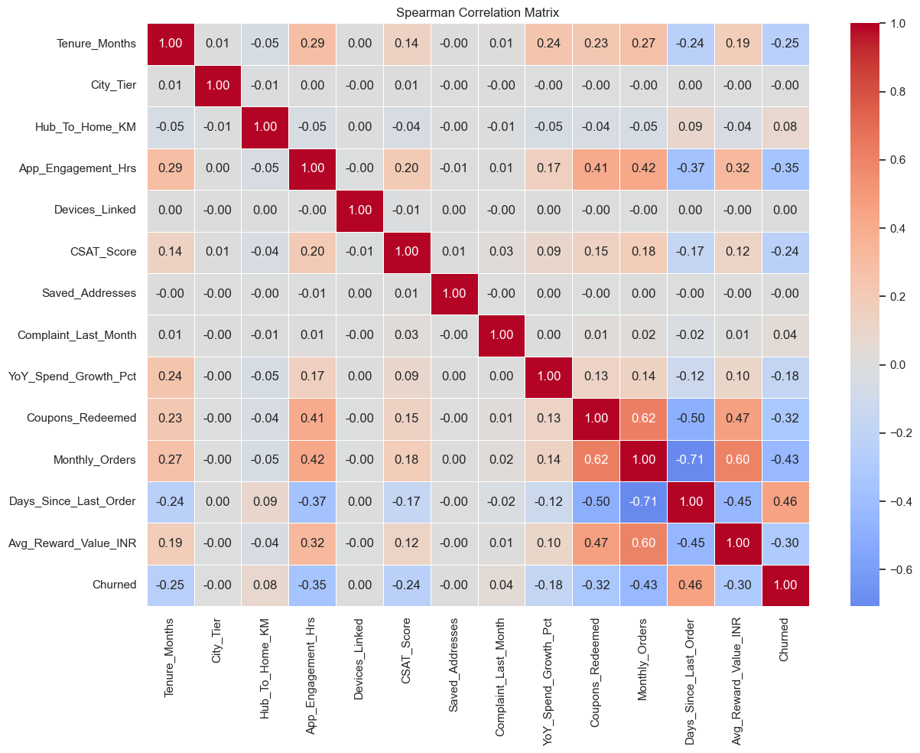
Figure 5.5 — Spearman Correlation Matrix of Numerical Features
KEY INSIGHTS
Days_Since_Last_Order shows the strongest positive correlation with churn
(ρ = 0.46), while Monthly_Orders shows a moderate negative correlation (ρ = −0.43). App_Engagement_Hrs
(−0.35) and Coupons_Redeemed (−0.32) also show moderate negative associations, and Tenure_Months
(−0.25) and CSAT_Score (−0.24) show weaker negative relationships with churn. Among the predictors
themselves, Monthly_Orders and Days_Since_Last_Order are strongly negatively correlated (−0.71), and
Coupons_Redeemed correlates positively with Monthly_Orders (0.62). Overall, customer recency, order
activity, engagement, and reward-related behaviour show the most notable associations with churn; no pair is
collinear enough to justify feature removal, so all predictors were retained for modelling.

5.6 Churn Rate by Tenure Band
Customer tenure was grouped into six lifecycle bands to examine how observed churn rates vary across
different stages of the customer relationship.
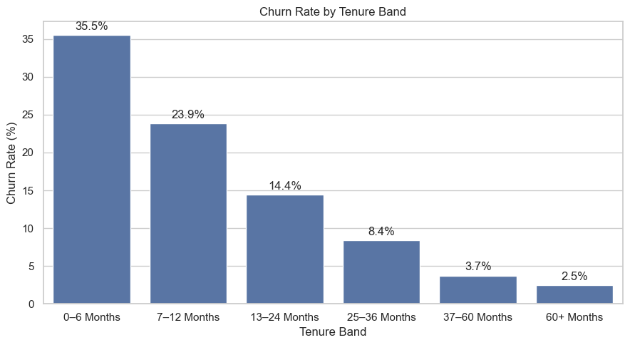
Figure 5.6 — Churn Rate by Tenure Band
KEY INSIGHTS
Churn is highest among newer customers, reaching 35.5% in the 0–6 month tenure band,
and declines consistently as tenure increases, falling to 2.5% among customers with 60+ months of tenure. The
largest reduction occurs during the early customer lifecycle (0–12 months), identifying new customers as the
highest-priority segment for churn-risk monitoring and retention investment.
EDA SUMMARY
The target is imbalanced (82.25% / 17.75%), motivating PR-AUC, Balanced Accuracy, and
class-weighted modelling. Churn is driven primarily by recency of activity, low engagement, low order frequency,
and lower reward value; Payment_Mode, Marital_Status, and Top_Category show the clearest categorical
associations, while Gender carries limited predictive value. No feature pair is collinear enough to warrant
removal, and newer customers (0–12 months' tenure) form the highest-risk lifecycle segment.
SECTION 6

Feature Engineering
New, domain-driven customer-behaviour indicators are derived from existing features to enhance the
representation of customer behaviour while preserving interpretability and strict separation from the target
variable. Both features below are computed entirely from customer-level attributes and use no target or future
information.

6.1 Digital Engagement per Device
Digital_Engagement_Per_Device measures the customer's app engagement intensity
relative to the number of linked devices, giving a more contextual view of digital engagement than raw app
usage alone:
Digital_Engagement_Per_Device = App_Engagement_Hrs / Devices_Linked
The feature is derived entirely from customer-level behavioural attributes; genuine missing values are
preserved for treatment at the preprocessing stage. Per the SHAP analysis in Section 11, this engineered ratio
contributes meaningful, measurable predictive information alongside the two raw features it is built from.

6.2 Coupon Redemption Rate
Coupon_Redemption_Rate measures the proportion of coupon redemptions relative to
the customer's monthly order activity — a more informative, normalised view of promotional purchasing
behaviour than a raw redemption count:
Coupon_Redemption_Rate = Coupons_Redeemed / Monthly_Orders (defined only where Monthly_Orders > 0)
The feature uses only observed customer-level variables; missing and undefined cases (zero monthly orders)
are intentionally preserved as NaN for the downstream preprocessing pipeline, rather
than being arbitrarily imputed at engineering time.
ENGINEERING NOTE
Both engineered features are computed before the train–test split but depend only
on already-observed customer attributes, not on the target — so their inclusion introduces no leakage. Their
missing values are handled by the same leakage-safe imputation pipeline described in Section 7.
SECTION 7

Data Preprocessing & Train–Test Split
The engineered dataset is transformed into a clean, model-ready representation while maintaining a strict
separation between training and unseen data. The workflow addresses missing values, numerical scaling, and
categorical encoding using transformations appropriate to each feature type, with the train–test split
performed before any data-driven preprocessing step.

7.1 Feature–Target Separation and Stratified Split
The target variable Churned was separated from the predictors before any
preprocessing, storing predictors in X and the target in y. The
identifier column and the EDA-only tenure band were dropped from X. The dataset was
then split into training and test subsets using stratified sampling, preserving the churn-class proportion in
both partitions; the test set remains completely unseen until final evaluation in Section 10.
Split | Rows × Columns | Churn Rate
Training Set | 40,000 × 20 | 17.75%
Test Set | 10,000 × 20 | 17.75%

7.2 Feature-Type Classification
Predictors are classified by their statistical and business meaning rather than raw data type, so that
each group receives an appropriate preprocessing strategy while preserving its original interpretation:
Feature Group | Members | Treatment
Ordinal | CSAT_Score, City_Tier | Natural order preserved; no imputation required (no missing values)
Binary | Complaint_Last_Month | Already a 0/1 indicator; passthrough, no encoding or scaling
Nominal | Primary_Access_Device, Payment_Mode, Gender, Top_Category, Marital_Status | Mode-imputed, then One-Hot Encoded
Numerical (missing) | Tenure_Months, Hub_To_Home_KM, App_Engagement_Hrs, YoY_Spend_Growth_Pct, Coupons_Redeemed, Monthly_Orders, Days_Since_Last_Order, Digital_Engagement_Per_Device, Coupon_Redemption_Rate | Median imputation (robust to skew and extreme values)
Numerical (complete) | Devices_Linked, Saved_Addresses, Avg_Reward_Value_INR | No imputation needed; legitimate zeros kept as valid observations

7.3 Model-Specific Preprocessing Pipelines
Separate pipelines were built for Logistic Regression and the tree-based models, since the two families
have different scaling requirements. Logistic Regression standardises numerical and ordinal features after
imputation (scale-sensitive linear model); XGBoost and LightGBM retain the original, unscaled values (scale-
invariant tree splits). CatBoost is handled with a dedicated data path that preserves its native categorical-
feature and missing-value handling, representing categorical gaps as an explicit "__MISSING__"
category rather than through mode imputation.
Model Family | Numerical Treatment | Categorical Treatment
Logistic Regression | Median-impute → StandardScaler | Mode-impute → One-Hot Encode
XGBoost / LightGBM | Median-impute, unscaled | Mode-impute → One-Hot Encode (handle_unknown = ignore)
CatBoost | Native missing-value handling, unscaled | Native categorical handling; missing as a dedicated category

7.4 Leakage-Safe Preprocessing Architecture
Preprocessing steps are never fitted separately before model evaluation. Instead, each preprocessor is
embedded directly inside its corresponding model pipeline (a scikit-learn ColumnTransformer
wrapped in a Pipeline), so that during cross-validation, imputation, scaling, and
encoding are fitted independently within each training fold and only then applied to that fold's validation
data. Preprocessing integrity is validated implicitly through this architecture: no transformation is ever
allowed to observe validation-fold or test-set information before it is used for prediction.
SECTION 8

Model Development & Baseline Benchmarking
This phase develops and evaluates multiple classification models for churn prediction. Logistic
Regression provides an interpretable linear baseline, while XGBoost, LightGBM, and CatBoost provide tree-based
approaches capable of capturing nonlinear relationships and feature interactions.

8.1 Candidate Models & Cross-Validation Strategy
Four complementary models were evaluated: Logistic Regression as an interpretable linear baseline;
XGBoost and LightGBM as gradient-boosted tree models; and CatBoost as a gradient-boosting model with native
categorical-feature support. All evaluation and tuning use Stratified 5-Fold Cross-Validation with a fixed random
seed, so that every candidate is compared on identical folds; any data-driven preprocessing is restricted to the
corresponding training folds to prevent leakage.

8.2 Baseline Cross-Validation Results
Each model was first evaluated in its unweighted, default configuration, recording ROC-AUC, PR-AUC, F1,
Recall, and Precision for a balanced view of discrimination and churn-class performance. The test set remained
untouched throughout.
Model | ROC-AUC | PR-AUC | F1 | Recall | Precision
Logistic Regression | 0.9003 ± 0.0035 | 0.7300 ± 0.0046 | 0.6211 ± 0.0016 | 0.5286 ± 0.0048 | 0.7531 ± 0.0094
XGBoost | 0.8909 ± 0.0026 | 0.7128 ± 0.0030 | 0.6089 ± 0.0050 | 0.5200 ± 0.0071 | 0.7347 ± 0.0070
LightGBM | 0.8992 ± 0.0033 | 0.7311 ± 0.0048 | 0.6184 ± 0.0024 | 0.5224 ± 0.0043 | 0.7578 ± 0.0053
CatBoost | 0.9033 ± 0.0034 | 0.7385 ± 0.0056 | 0.6222 ± 0.0036 | 0.5218 ± 0.0081 | 0.7707 ± 0.0094

CatBoost leads the unweighted baseline comparison on ROC-AUC, PR-AUC, F1, and Precision, with Logistic
Regression a close second on ROC-AUC. All four baselines recover only around half of churners (Recall ≈ 0.52)
at their default decision threshold — the expected consequence of an unweighted classifier facing an
82% / 18% imbalance, and the motivation for the cost-sensitive weighting introduced next.

8.3 Class-Imbalance Handling — Cost-Sensitive Weighting
Class imbalance is addressed through cost-sensitive learning rather than synthetic oversampling. During
cross-validation, class weights are calculated separately within each training fold (never from validation
data); for the final model, class weights are calculated from the full training set. The training-set churn
distribution mirrors the full dataset (32,900 retained / 7,100 churned, 17.75% churn rate), confirming the
stratified split preserved class balance.
Model (Class-Weighted) | ROC-AUC | PR-AUC | F1 | Recall | Precision
Logistic Regression | 0.9004 ± 0.0036 | 0.7290 ± 0.0047 | 0.6093 ± 0.0083 | 0.8139 ± 0.0065 | 0.4869 ± 0.0093
XGBoost | 0.8866 ± 0.0032 | 0.7068 ± 0.0043 | 0.6089 ± 0.0046 | 0.7190 ± 0.0054 | 0.5282 ± 0.0085
LightGBM | 0.8984 ± 0.0027 | 0.7277 ± 0.0048 | 0.6116 ± 0.0084 | 0.7876 ± 0.0059 | 0.5000 ± 0.0095

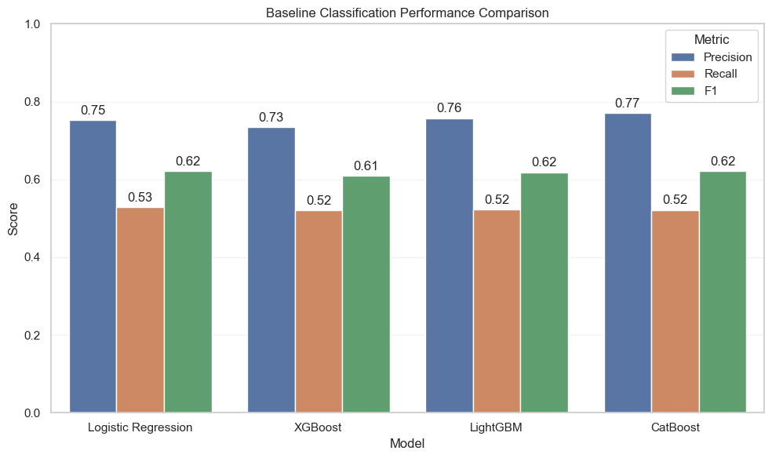
Figure 8.3 — Baseline Precision, Recall, and F1-score by Model
OBSERVATION
Class weighting more than doubles Recall for every model — e.g. Logistic Regression
rises from 0.53 to 0.81 — at the direct cost of Precision, illustrating the classic imbalance trade-off. Since
CatBoost led the unweighted baseline and natively supports categorical features and class weighting together, it
was carried forward — with class weighting — into hyperparameter optimisation in Section 9.
SECTION 9

Hyperparameter Tuning & Probability Calibration
A compact randomized search is used to identify a strong, class-weighted CatBoost configuration. Because
the final system produces a churn probability and the churn class is imbalanced, configurations are selected
primarily using PR-AUC, followed by ROC-AUC; threshold-dependent metrics (Precision, Recall, Balanced Accuracy,
Macro F1) are retained as supporting diagnostics rather than the primary selection criterion.

9.1 CatBoost Randomized Search
A compact search space was defined around CatBoost's most influential hyperparameters, balancing
exploration of model complexity and regularisation against computational cost. A fixed random seed reproducibly
sampled eight configurations from this space, each evaluated with 5-fold stratified cross-validation; categorical
preprocessing and class weights were computed separately within each fold to prevent validation-fold information
from influencing training.
iterations | 300 / 500 / 700
depth | 5 / 6 / 7
learning_rate | 0.03 / 0.05
l2_leaf_reg | 3 / 5 / 8

Rank | learning_rate | l2_leaf_reg | iterations | depth | PR-AUC | ROC-AUC | Macro F1
1 (selected) | 0.03 | 3 | 700 | 5 | 0.74 | 0.90 | 0.75
2 | 0.05 | 3 | 300 | 6 | 0.74 | 0.90 | 0.75
3 | 0.03 | 8 | 700 | 7 | 0.74 | 0.90 | 0.76
4 | 0.05 | 8 | 300 | 5 | 0.74 | 0.90 | 0.75
5 | 0.03 | 5 | 500 | 7 | 0.74 | 0.90 | 0.75

The top-ranked configuration — iterations = 700, depth = 5, learning_rate = 0.03,
l2_leaf_reg = 3 — was carried forward for out-of-fold prediction, probability calibration, and threshold
optimisation. Final class weights derived from the full training set were 0.608 for the retained class and 2.817
for the churned class.

9.2 Out-of-Fold Validation & Isotonic Calibration
The selected CatBoost configuration was evaluated with stratified cross-validation to generate
out-of-fold (OOF) probability predictions — produced only from validation folds — for calibration and
threshold optimisation without ever touching the test set. Isotonic Regression was then used to calibrate the
CatBoost churn probabilities: the calibrator was fitted on 70% of the training-side OOF predictions and evaluated
on the remaining, held-out 30% OOF portion.
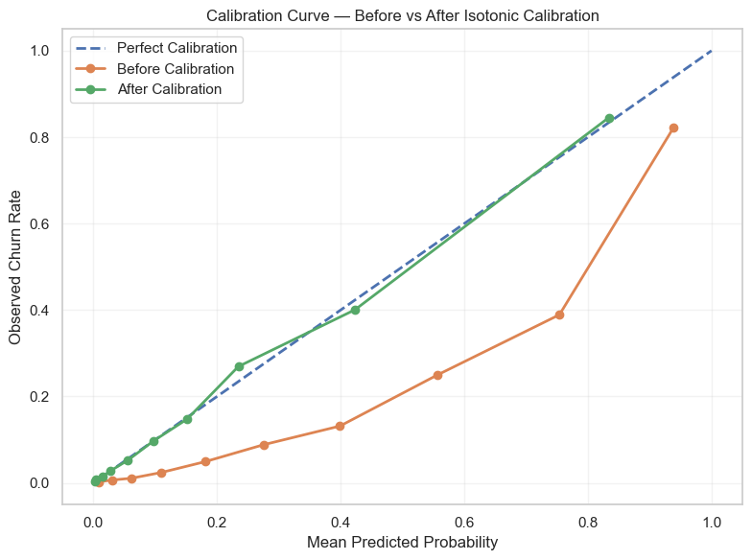
Figure 9.2 — Calibration Curve, Before vs. After Isotonic Calibration
Metric | Before Calibration | After Calibration
Brier Score | 0.12 | 0.08

KEY INSIGHT
Before calibration, the raw CatBoost probabilities are systematically overconfident in
the upper probability range (the orange curve sits well below the diagonal). After Isotonic calibration, the
curve tracks the perfect-calibration reference far more closely, and the Brier Score improves from 0.12 to 0.08
— confirming the calibrated probabilities are meaningfully more reliable for risk-based prioritisation.

9.3 Operating Threshold Selection
The classification threshold was optimised using the calibrated OOF probabilities. A minimum Precision
constraint of 0.60 was applied — ensuring at least 60% of flagged high-risk customers are expected to be
genuine churners — and among thresholds satisfying that constraint, the threshold with the highest Recall was
selected, using Precision as the tie-breaker. The test set remained untouched throughout threshold selection.
Threshold | Recall | Precision | F1 | Balanced Acc. | Macro F1
0.20 | 0.82 | 0.50 | 0.62 | 0.82 | 0.75
0.25 | 0.72 | 0.58 | 0.64 | 0.80 | 0.78
0.30 (selected) | 0.66 | 0.62 | 0.64 | 0.79 | 0.78
0.35 | 0.60 | 0.68 | 0.64 | 0.77 | 0.78
0.40 | 0.58 | 0.72 | 0.64 | 0.77 | 0.79
0.50 | 0.52 | 0.77 | 0.62 | 0.74 | 0.78
0.70 | 0.37 | 0.90 | 0.52 | 0.68 | 0.73

SELECTED OPERATING THRESHOLD
Threshold = 0.30 is the lowest threshold satisfying the 0.60
minimum-Precision constraint, and among qualifying thresholds it delivers the highest Recall (0.66) — the
best available balance between catching genuine churners and avoiding excessive false alarms for this
constraint.
SECTION 10

Final Model Evaluation
The selected CatBoost configuration was retrained on the full training set and evaluated once on the
10,000-record held-out test set, using the calibrated probabilities and the operating threshold selected
exclusively from training-side out-of-fold predictions — giving a realistic, single-shot estimate of
production performance.

10.1 Held-Out Test Performance
Metric | Score
ROC-AUC | 0.90
PR-AUC | 0.71
Brier Score | 0.08
Recall | 0.67
Precision | 0.62
F1 | 0.64
Balanced Accuracy | 0.79
Macro F1 | 0.78

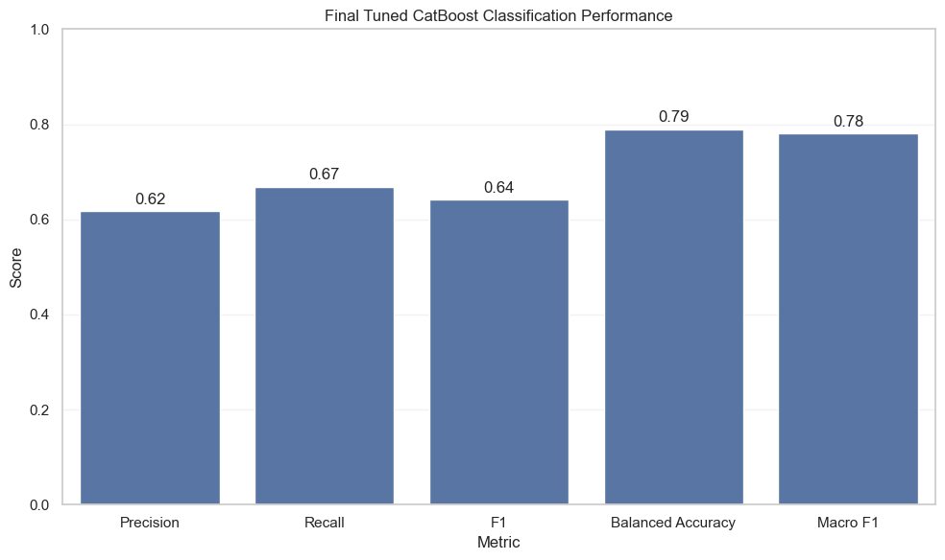
Figure 10.1 — Final Tuned CatBoost Classification Performance (Test Set)
The test-set discrimination (ROC-AUC 0.90) matches the cross-validated average closely, and the
Balanced Accuracy of 0.79 comfortably exceeds the 50% no-skill baseline for a binary task — evidence of
genuine generalisation from cross-validation and calibration to a completely unseen customer set.

10.2 Confusion Matrix Analysis
The confusion matrix breaks down prediction outcomes by true class at the selected 0.30 operating
threshold, revealing exactly where the model succeeds and where it is confused.
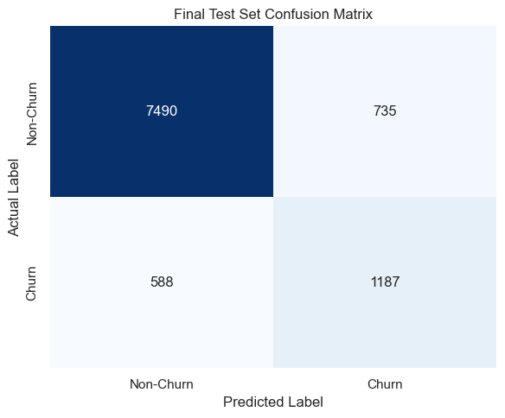
Figure 10.2 — Final Test-Set Confusion Matrix
KEY INSIGHTS
The model correctly identifies 1,187 of 1,775 churned customers (Recall 0.67) while
missing 588 genuine churn cases. It generates 735 false churn alerts among 8,225 genuinely retained customers,
meaning a small share of retained customers may receive unnecessary retention outreach. Overall, the confusion
matrix reflects a deliberately Recall-leaning balance, appropriate for a screening system where missing a true
churner is costlier than an unnecessary retention touchpoint.

10.3 ROC-AUC and Precision–Recall Curves
ROC-AUC and Precision–Recall curves evaluate the final CatBoost model across every possible
classification threshold, independent of the single operating point chosen in Section 9.3.
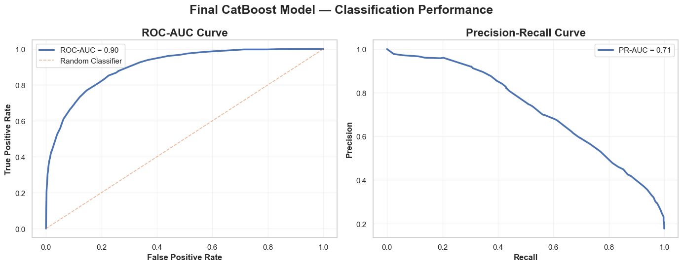
Figure 10.3 — Final CatBoost Model — ROC-AUC and Precision–Recall Curves
INTERPRETATION
The model achieves strong discrimination with a ROC-AUC of 0.90, indicating effective
separation between churn and non-churn customers across thresholds. The PR-AUC of 0.71 reflects useful
precision–recall performance despite the imbalanced churn distribution — well above the 0.18 PR-AUC a
no-skill classifier would achieve on this class balance. Precision decreases as Recall increases, illustrating
the expected trade-off between catching more churners and generating more false-positive alerts.
SECTION 11

Model Explainability (SHAP)
SHAP (SHapley Additive exPlanations) is used to interpret the final CatBoost model by identifying the
features that contribute most strongly to churn predictions, providing model transparency and translating
predictions into actionable customer-risk drivers for retention teams.

11.1 Global Feature Importance
Global SHAP importance was computed via TreeExplainer on a representative
2,000-customer training sample (to keep computation efficient), identifying the features with the greatest
overall influence on the model's churn predictions.
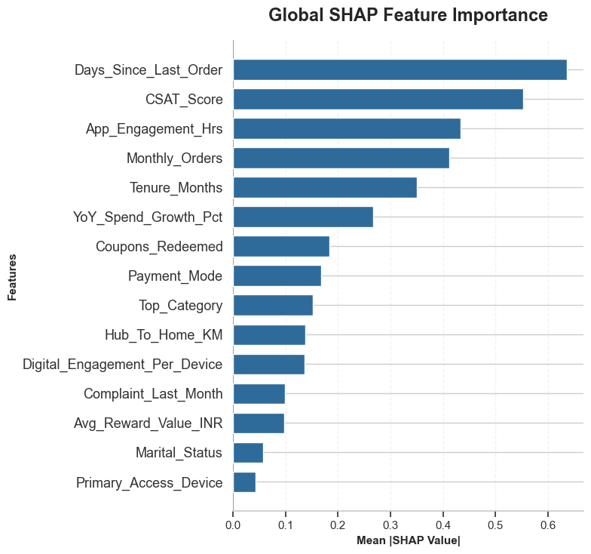
Figure 11.1 — Global SHAP Feature Importance
KEY HIGHLIGHTS
Days_Since_Last_Order is the most influential feature, showing that customer recency
has the strongest overall contribution to the model's predictions. CSAT_Score and Monthly_Orders are the next
most influential, highlighting the importance of satisfaction and purchasing behaviour. App_Engagement_Hrs and
Tenure_Months also make substantial contributions, while YoY_Spend_Growth_Pct and Coupons_Redeemed provide
moderate signal. The engineered Digital_Engagement_Per_Device feature contributes meaningful, measurable
predictive information. Payment_Mode, Top_Category, Hub_To_Home_KM, Complaint_Last_Month, and
Avg_Reward_Value_INR have smaller but measurable contributions, while Marital_Status and Primary_Access_Device
rank lowest among the displayed features. These results describe model behaviour, not causal relationships.

11.2 Directional Feature Effects (Summary Plot)
The SHAP summary plot shows how individual feature values influence churn predictions, capturing both the
magnitude and the direction of each feature's contribution across the sampled customers.
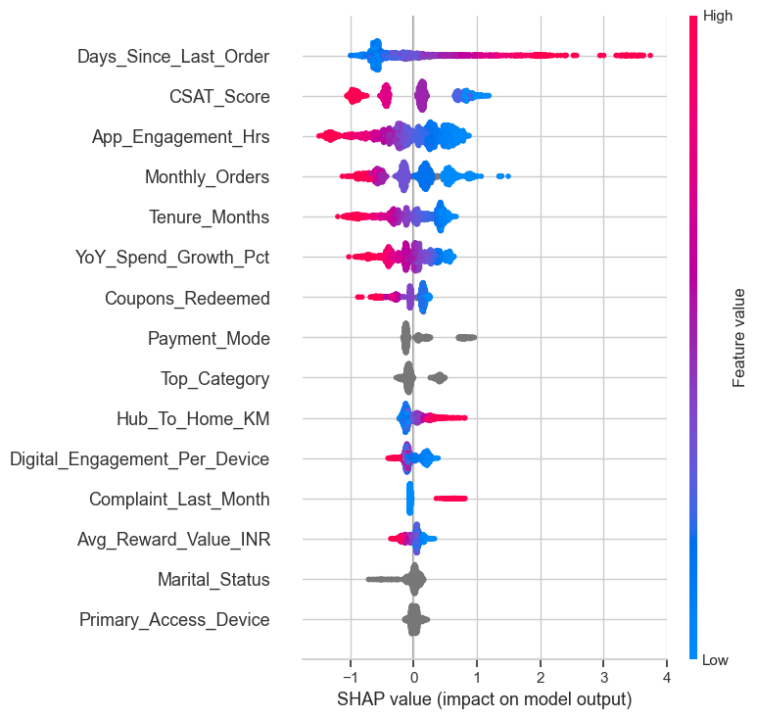
Figure 11.2 — SHAP Summary Plot — Direction and Magnitude of Feature Effects
KEY INSIGHTS
Customer recency is the strongest directional signal: higher Days_Since_Last_Order
values generally push predictions toward higher churn risk. Customer satisfaction matters strongly: lower
CSAT_Score values tend to increase predicted churn risk, while higher scores reduce it. Purchasing behaviour is
important: lower Monthly_Orders values push predictions toward churn, while higher order frequency reduces it.
Digital engagement shows a clear pattern, with lower App_Engagement_Hrs values contributing toward higher churn
predictions, and shorter Tenure_Months similarly pushes predictions toward higher risk. Lower YoY_Spend_Growth_Pct
values, recent complaints, and lower reward values also push predictions toward higher churn risk. Payment_Mode,
Top_Category, Marital_Status, and Primary_Access_Device show comparatively lower and more varied influence.
These patterns represent model behaviour, not causal relationships, and should be read as predictive
associations rather than direct business causation.
SECTION 12

Conclusion & Business Recommendations

12.1 Summary of Findings
- CatBoost achieved the strongest and most consistent baseline performance among all four algorithms tested, leading on ROC-AUC, PR-AUC, F1, and Precision.
- Cost-sensitive class weighting more than doubled Recall relative to unweighted baselines across every model, at an expected cost to Precision — the correct trade-off for a churn-screening use case.
- Isotonic Regression calibration reduced the Brier Score from 0.12 to 0.08 on held-out out-of-fold predictions, materially improving the reliability of the churn probability output.
- A precision-constrained operating threshold of 0.30 delivers a Recall of 0.67 and Precision of 0.62 on the untouched test set, correctly identifying 1,187 of 1,775 churned customers.
- Days_Since_Last_Order, CSAT_Score, Monthly_Orders, and App_Engagement_Hrs are the strongest predictors of churn, confirmed independently by both the correlation analysis and SHAP-based explainability.
- Newer customers (0–6 months' tenure) churn at 35.5%, versus 2.5% for customers with 60+ months' tenure — identifying early tenure as the highest-risk lifecycle stage.

12.2 Final Recommendation
The tuned, class-weighted, and Isotonic-calibrated CatBoost model is recommended as the deployment
candidate for this churn-screening task, combining solid held-out test performance (ROC-AUC 0.90, PR-AUC 0.71,
Balanced Accuracy 0.79, Macro F1 0.78) with calibrated probabilities and full SHAP-based interpretability — a
combination essential for a model intended to inform customer-retention decisions and resource allocation.

12.3 Business Impact & Deployment Considerations
- Position the model as a retention-prioritisation aid, ranking customers by calibrated churn probability rather than issuing an unqualified automated action.
- Prioritise outreach toward customers in the 0–12 month tenure band, given their substantially elevated observed and predicted churn risk.
- Monitor customers on Card on Delivery (POS) and Cash on Delivery payment modes, and those with declining App_Engagement_Hrs or rising Days_Since_Last_Order, as leading indicators worth proactive engagement.
- Use the SHAP-based explanations to give retention teams a transparent, feature-level rationale alongside every flagged customer, not just a probability score.
- Re-calibrate and re-threshold the model periodically as customer behaviour and channel mix evolve, since both were selected on a specific historical training distribution.

12.4 Skills & Techniques Demonstrated
- Data cleaning, validation, and exploratory data analysis (pandas, seaborn, matplotlib).
- Imbalanced-classification methodology: stratified splitting and cost-sensitive class weighting, benchmarked empirically against an unweighted baseline.
- Feature engineering for behavioural e-commerce data: digital engagement per device and a normalised coupon-redemption rate.
- Leakage-safe pipeline design using scikit-learn's ColumnTransformer and Pipeline, with all learned parameters refit inside every cross-validation fold.
- Model development across a linear baseline (Logistic Regression) and three gradient-boosted tree families (XGBoost, LightGBM, CatBoost), including CatBoost's native categorical-feature handling.
- Hyperparameter optimisation via randomized search with Stratified K-Fold cross-validation, selected on PR-AUC for an imbalanced target.
- Out-of-fold probability calibration (Isotonic Regression) and precision-constrained operating-threshold selection, both derived exclusively from training-side data.
- Explainable AI (XAI) using SHAP TreeExplainer — global feature importance and directional summary analysis.
- Clear, structured technical communication — translating model internals into business-relevant conclusions for non-technical stakeholders.

