PROJECT REPORT
Multiclass Sleep Health Risk Classification & Explainable AI System
An End-to-End Machine Learning Pipeline for Predicting Insomnia and Sleep Apnea from Lifestyle and Physiological Health Data
Supervised Learning • Class-Imbalance Handling • Explainable AI (XAI)
Prepared by Rushikesh Khamgaonkar | September 2026

Dataset: Sleep Health & Lifestyle Records (10,000 individuals, 13 features) • 3 Target Classes: No Sleep Disorder · Insomnia · Sleep Apnea
Leakage-Free Pipeline • Stratified Cross-Validation • SHAP-Based Model Interpretability • Flask Deployment

Table of Contents

1. Executive Summary 3
1.1 What This Project Demonstrates 3
2. Project Overview 3
2.1 Project Objective 3
2.2 Business Objective 3
2.3 Problem Statement 4
2.4 Dataset Description 4
3. Data Preparation & Understanding 4
3.1 Initial Data Preparation 4
3.2 Data Quality & Validation Checks 5
3.3 Descriptive & Target Distribution Summary 5
4. Exploratory Data Analysis (EDA) 5
4.1 Target Variable Distribution 6
4.2 Numerical Feature Distribution 6
4.3 Categorical Feature Distribution 7
4.4 Feature Relationships with the Target 8
4.5 Correlation Analysis 10
4.6 Multivariate Relationship Analysis 10
4.7 Outlier Analysis 11
5. Feature Engineering 12
5.1 Engineered Features 12
5.2 Engineered Feature Validation 13
6. Data Preprocessing & Train-Test Split 13
6.1 Preprocessing Pipeline 13
6.2 Stratified Train-Test Split 13
7. Model Development & Selection 13
7.1 Modeling Approach 13
7.2 Baseline Cross-Validation Results 14
7.3 Class Weight vs. SMOTE Comparison 14
7.4 Hyperparameter Tuning 15
8. Final Model Evaluation 16
8.1 Held-Out Test Set Performance 16
8.2 Confusion Matrix 16
8.3 Multiclass ROC-AUC 17
8.4 Precision–Recall Curves & PR-AUC 18
8.5 Class-wise Performance 19
9. Probability Calibration Analysis 20
9.1 Probability Calibration Curves 20
9.2 Calibration Metrics 21
9.3 Platt Scaling (Sigmoid) Calibration 21
9.4 Platt Scaling Calibration Results 22
9.5 Isotonic Regression Calibration 22
9.6 Isotonic Regression Calibration Results 22
9.7 Calibration Method Comparison 22
10. Model Explainability (XAI) 23
10.1 SHAP Global Feature Importance 23
10.2 SHAP Feature Interaction Analysis 24
10.3 Explainability Summary 25
11. Conclusion & Key Takeaways 25
11.1 Summary of Findings 25
11.2 Final Recommendation 26
11.3 Business Impact & Recommendations 26
11.4 Skills & Techniques Demonstrated 26

1. Executive Summary
This report documents an end-to-end machine learning project that classifies an individual's sleep health status using demographic, lifestyle, and physiological data. The system distinguishes between three outcomes — No Sleep Disorder, Insomnia, and Sleep Apnea — from a dataset of 10,000 patient records spanning occupation, activity, stress, sleep quality, and cardiovascular indicators.
The project follows a leakage-aware, ten-phase pipeline: project definition, initial data preparation, data understanding, exploratory data analysis, feature engineering, preprocessing, model development, final evaluation, probability calibration, and explainability. Five classification algorithms — Logistic Regression, Decision Tree, Random Forest, Support Vector Machine, and XGBoost — were each benchmarked under two class-imbalance strategies (class weighting and SMOTE) using Stratified 5-Fold Cross-Validation, since the target is imbalanced at roughly 78% / 12% / 10% across its three classes.
Headline Result
A tuned XGBoost classifier was the best-performing model, achieving 90.95% accuracy and a Macro F1-score of 83.41% on a completely unseen, held-out test set — outperforming Logistic Regression, Decision Tree, Random Forest, and SVM under both imbalance-handling strategies tested. The model also reached a balanced accuracy of 81.38% and a ROC-AUC of 96.77%, confirming strong overall multiclass discrimination.
Beyond raw predictive accuracy, the project prioritised clinical interpretability. SHAP (SHapley Additive exPlanations) was applied to the final XGBoost model to quantify which features drive each prediction, confirming that Heart Rate, Sleep Duration, and Systolic BP are the dominant physiological and behavioural signals, while demographic and occupational attributes contribute comparatively little.

1.1 What This Project Demonstrates
- End-to-end ML pipeline design — from raw Excel ingestion to a deployable, explainable classifier.
- Imbalanced-classification discipline — stratified splitting, class weighting, and SMOTE, compared side-by-side rather than assumed.
- Leakage-safe engineering — preprocessing and resampling refit independently inside every cross-validation fold.
- Feature engineering for health data — pulse pressure and a composite sleep-quality index, each derived without touching the target.
- Breadth across model families — linear, tree-based, kernel-based, and gradient-boosted classifiers.
- Explainable AI (XAI) — global and interaction-level SHAP analysis, turning a 'black-box' gradient-boosted model into a transparent, stakeholder-readable decision system.

2. Project Overview

2.1 Project Objective
Develop an explainable multiclass classification system that predicts an individual's sleep-disorder status — No Sleep Disorder, Insomnia, or Sleep Apnea — from demographic, occupational, lifestyle, and physiological attributes, while benchmarking multiple algorithms and imbalance-handling strategies to identify the most reliable, generalisable model.

2.2 Business Objective
- Flag individuals at risk of a sleep disorder from routinely available health and lifestyle data.
- Benchmark class-imbalance strategies and select the strongest model on class-aware metrics, not raw accuracy alone.
- Explain predictions with SHAP to support clinical trust and stakeholder transparency.
- Package the final model as a deployable Flask web application for real-time inference.

2.3 Problem Statement
Sleep disorders such as Insomnia and Sleep Apnea are frequently under-diagnosed despite measurable ties to lifestyle and physiological signals — stress, activity level, blood pressure, and heart rate. Given an individual's demographic, lifestyle, and physiological attributes, this project predicts sleep-disorder status as one of three classes, using a dataset that is naturally imbalanced (78% / 12% / 10%), which makes naïve accuracy an unreliable evaluation metric and motivates the model-selection strategy used throughout this report.

2.4 Dataset Description
The dataset consists of synthetically generated patient-level sleep, lifestyle, and cardiovascular records.
Attribute | Value
Raw Records | 10,182 rows (182 exact duplicates removed)
Modelling Records | 10,000 records × 13 features
Target Variable | Sleep Disorder (No Sleep Disorder · Insomnia · Sleep Apnea)
Feature Groups | Demographic, Occupational, Lifestyle, Physiological, Cardiovascular
Missing Values | 12 of 13 features affected (up to ~5.40% per feature)
Duplicate Records | 182 identified and removed
Source | Sleep Health and Lifestyle Dataset (Kaggle, synthetically generated)

Data cleaning note: the combined “Blood Pressure” field (e.g. "126/83") was split into separate Systolic BP and Diastolic BP columns to enable numerical analysis. The literal string “None” in the target column was explicitly preserved as a valid category during ingestion (rather than parsed as a missing value) and relabelled to “No Sleep Disorder”, and inconsistent categorical entries (e.g. "FEMALE", "female", "Female ") were standardised prior to encoding.

3. Data Preparation & Understanding
Before analysis, the raw dataset was cleaned and validated to ensure every downstream statistic and model is computed on a trustworthy, consistent table.

3.1 Initial Data Preparation
- Identifier removal: non-predictive identifier columns (e.g. Person ID) were dropped before analysis.
- Duplicate handling: 182 exact duplicate records were identified and removed, leaving 10,000 unique rows.
- Categorical standardisation: inconsistent casing and stray whitespace in Gender, Occupation, and BMI Category were normalised to a single canonical spelling per category.
- Missing-value standardisation: blank strings were explicitly converted to NaN so that numerical and categorical imputers could detect them consistently.
- Blood Pressure decomposition: the combined "Systolic/Diastolic" text field was split into two numeric columns, Systolic BP and Diastolic BP.

3.2 Data Quality & Validation Checks
Following the initial preparation steps, the dataset was re-validated to confirm the cleaning stage produced a leakage-free, analysis-ready table.
Check | Result
Duplicate records remaining | 0
Features with missing values | 12 of 13 (imputed later inside the pipeline, not dropped)
Maximum missing-value rate | ~5.40% (Physical Activity Level)
Target class integrity | “None” correctly preserved and relabelled — not read as null
Categorical consistency | Standardised (no duplicate-meaning categories remain)

3.3 Descriptive & Target Distribution Summary
Descriptive statistics confirmed plausible physiological ranges across the dataset (e.g. Heart Rate roughly 44–126 bpm, Sleep Duration roughly 4.5–9.4 hours), with no impossible or out-of-range values detected. The target variable, however, is meaningfully imbalanced — a fact that shapes the modelling strategy for the remainder of this report.
Class | Count | % of Dataset
No Sleep Disorder | 7,813 | 78.13%
Insomnia | 1,237 | 12.37%
Sleep Apnea | 950 | 9.50%

Key takeaway: a model that always predicts “No Sleep Disorder” would already score ~78% accuracy while never identifying a single at-risk patient. This motivated Macro F1 as the primary model-selection metric, alongside class weighting and SMOTE as imbalance-handling strategies.

4. Exploratory Data Analysis (EDA)
Before modelling, the cleaned dataset was explored visually and statistically to understand the shape of the target, feature distributions, categorical breakdowns, correlations, and outliers.

4.1 Target Variable Distribution
The target variable shows a clear three-way class imbalance: healthy individuals dominate the dataset, while Insomnia and Sleep Apnea together make up roughly one in five records.
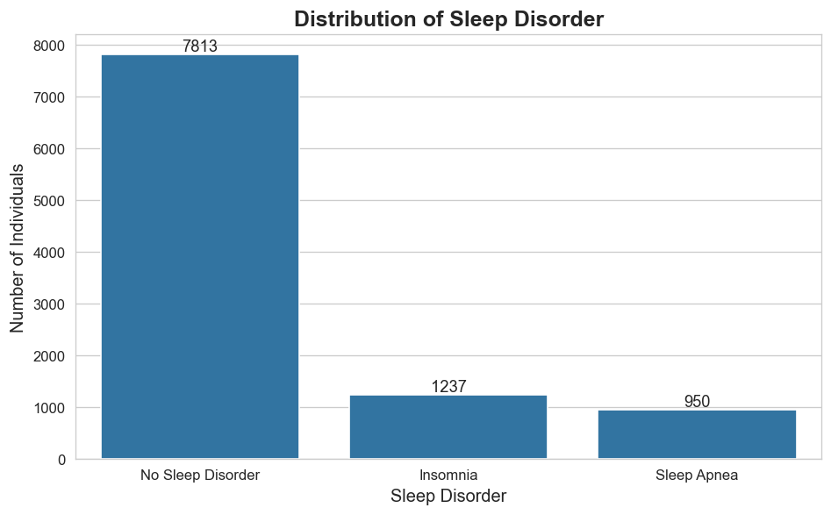
Figure 4.1 — Distribution of the Sleep Disorder Target Variable
Observation: the 78% / 12% / 10% split confirms the dataset is imbalanced rather than merely skewed, reinforcing the decision to evaluate models on Macro F1 and Balanced Accuracy rather than accuracy alone.

4.2 Numerical Feature Distribution
Histograms with kernel-density overlays were plotted for all nine original numerical features to inspect shape, skew, and multimodality ahead of modelling.
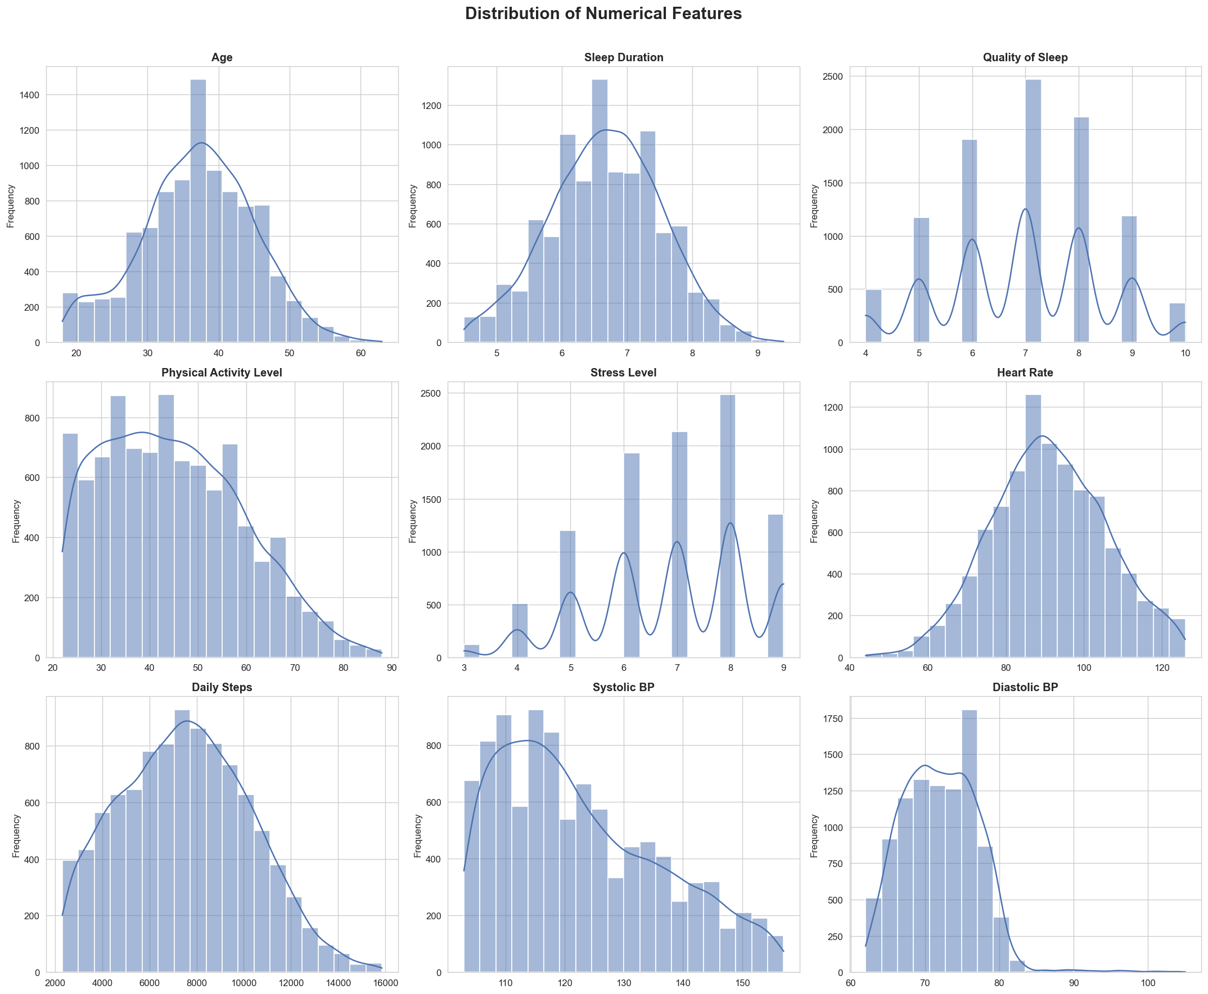
Figure 4.2 — Distribution of Numerical Features
Insights: Age is concentrated around 30–45 years with a mild right tail toward older ages; Sleep Duration is primarily distributed between 6–8 hours. Quality of Sleep and Stress Level are discrete, multi-modal ordinal scales rather than continuous measures, with observations concentrated around 7–8 and 6–8 respectively. Heart Rate is approximately bell-shaped, centred between 85–100 bpm, while Daily Steps and Systolic BP show mild right-skew consistent with a smaller, more sedentary, higher-risk subgroup. Diastolic BP is primarily concentrated between 65–80 mmHg.

4.3 Categorical Feature Distribution
Gender, Occupation, and BMI Category were profiled to understand demographic composition and category cardinality ahead of one-hot encoding.
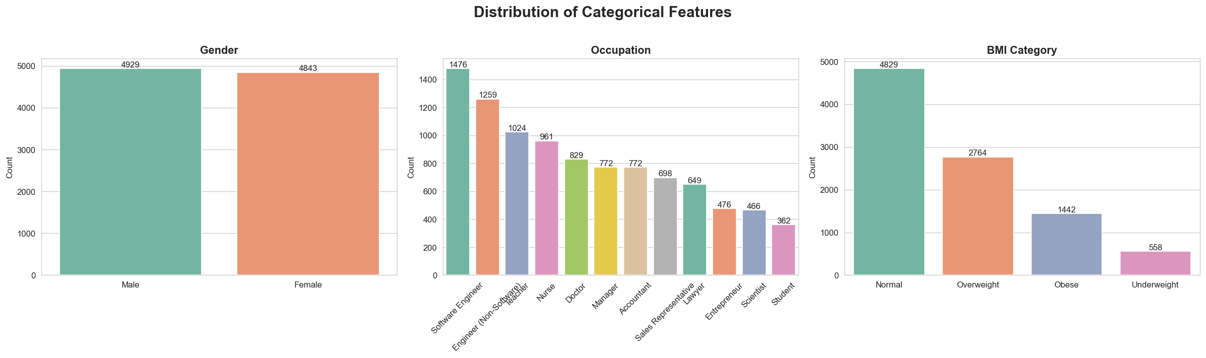
Figure 4.3 — Distribution of Categorical Features
Insights: Gender is close to evenly split, with Male (4,929) and Female (4,843) observations. Occupation spans 13 categories, with Software Engineer (1,476) and Lawyer (1,259) among the most represented groups, while Student (362) has the lowest representation. Just under half of individuals fall in the Normal BMI category (4,829), followed by Overweight (2,764) and Obese (1,442), while Underweight (558) is comparatively less represented.

4.4 Feature Relationships with the Target
Each numerical feature was compared across the three target classes using box plots to identify which signals separate healthy individuals from those with a disorder.
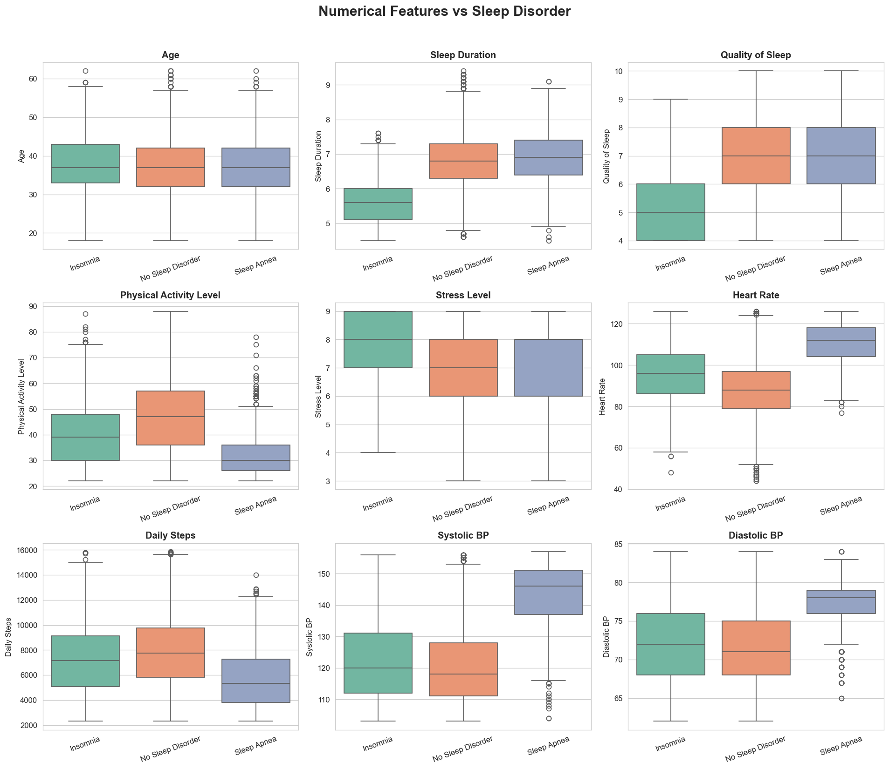
Figure 4.4a — Numerical Features vs. Sleep Disorder
Insights: Sleep Apnea patients show markedly higher Systolic BP, Diastolic BP, and Heart Rate than the other two classes, alongside lower Physical Activity Level and Daily Steps. Insomnia is strongly associated with shorter Sleep Duration, lower Quality of Sleep, and elevated Stress Level. Age distributions largely overlap across all three classes, offering limited standalone separation.
The same comparison was repeated for the three categorical features to test for demographic or occupational association with the target.
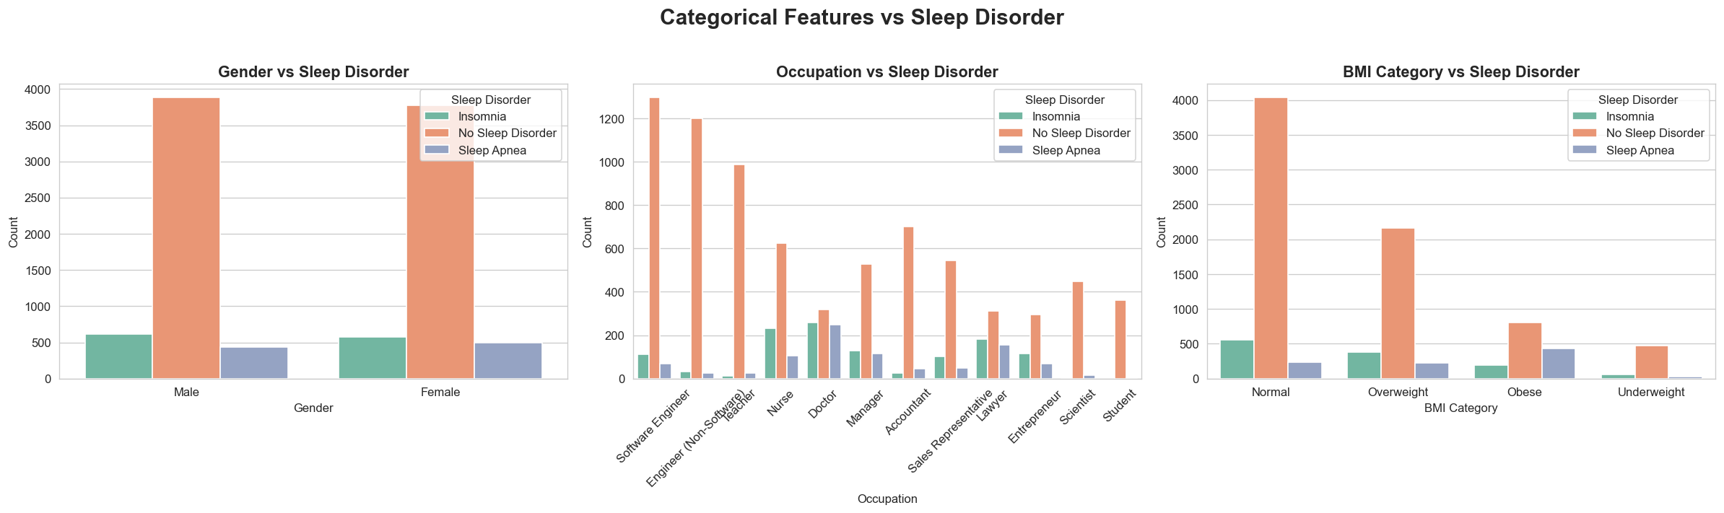
Figure 4.4b — Categorical Features vs. Sleep Disorder
Insights: No Sleep Disorder dominates both genders with similar class distributions, indicating limited target association for Gender. Class distributions vary noticeably across Occupation, suggesting it may provide useful predictive information. BMI Category shows the clearest visual association — No Sleep Disorder dominates the Normal BMI group, while Sleep Apnea is relatively more prominent among Obese individuals.

4.5 Correlation Analysis
A Pearson correlation matrix of the numerical features was computed to surface linear relationships and flag potential multicollinearity ahead of model training.
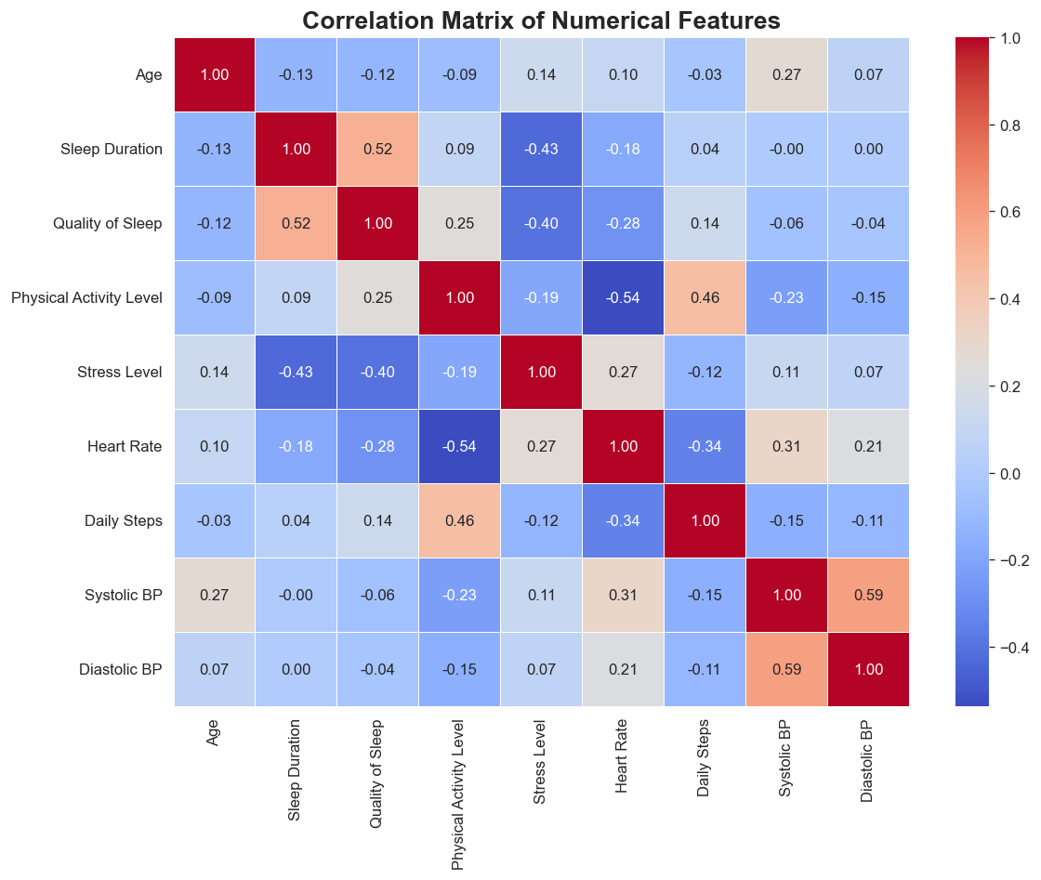
Figure 4.5 — Correlation Matrix of Numerical Features
Insights: Sleep Duration and Quality of Sleep show a moderate positive correlation (r = 0.52), as expected for two related sleep metrics. Sleep Duration is also moderately negatively correlated with Stress Level (r = −0.43), and Quality of Sleep follows a similar pattern (r = −0.40). Physical Activity Level and Heart Rate are moderately negatively correlated (r = −0.54), while Physical Activity Level and Daily Steps are moderately positively correlated (r = 0.46). Systolic BP and Diastolic BP are moderately-to-strongly positively correlated (r = 0.59), confirming these are related but non-redundant cardiovascular signals. No pair reaches the near-perfect correlation that would force feature removal, so all numerical predictors were retained for modelling.

4.6 Multivariate Relationship Analysis
A pair-plot of the most target-relevant numerical features (Sleep Duration, Quality of Sleep, Stress Level, Heart Rate) was generated, coloured by class, to visually inspect how well these signals separate the three sleep-disorder categories in combination.
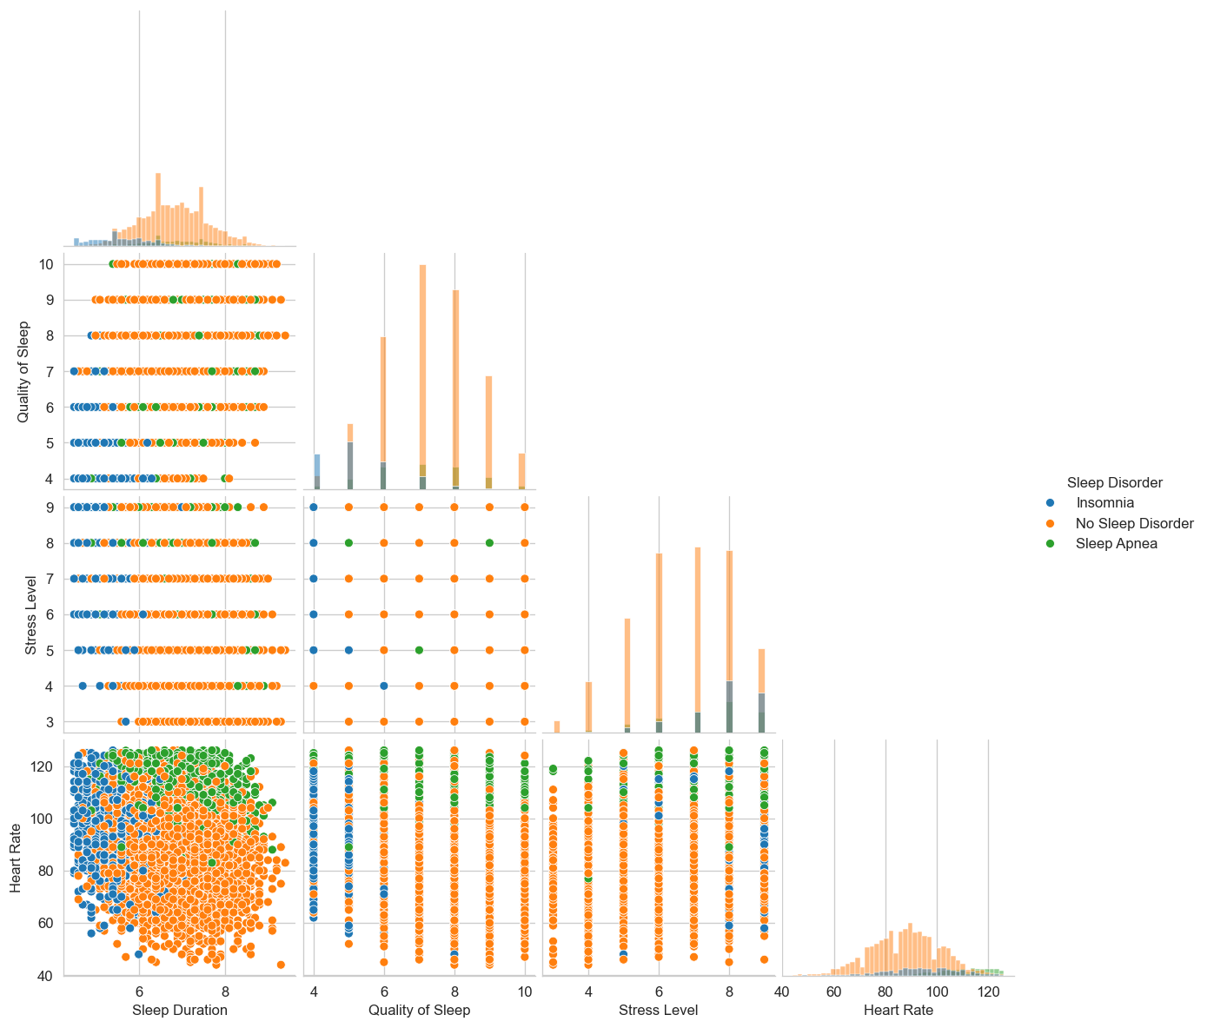
Figure 4.6 — Pair Plot of Key Features by Sleep Disorder Class
Insights: Insomnia (blue) clusters toward shorter Sleep Duration, lower Quality of Sleep, and higher Stress Level, while Sleep Apnea (green) spreads toward higher Heart Rate values, and No Sleep Disorder (orange) dominates the moderate-stress, moderate-heart-rate region — evidence that even simple, partially-separable structure exists in the feature space ahead of formal modelling.

4.7 Outlier Analysis
Outliers in the nine original numerical features were assessed using the Interquartile Range (IQR) method and visualised with box plots.
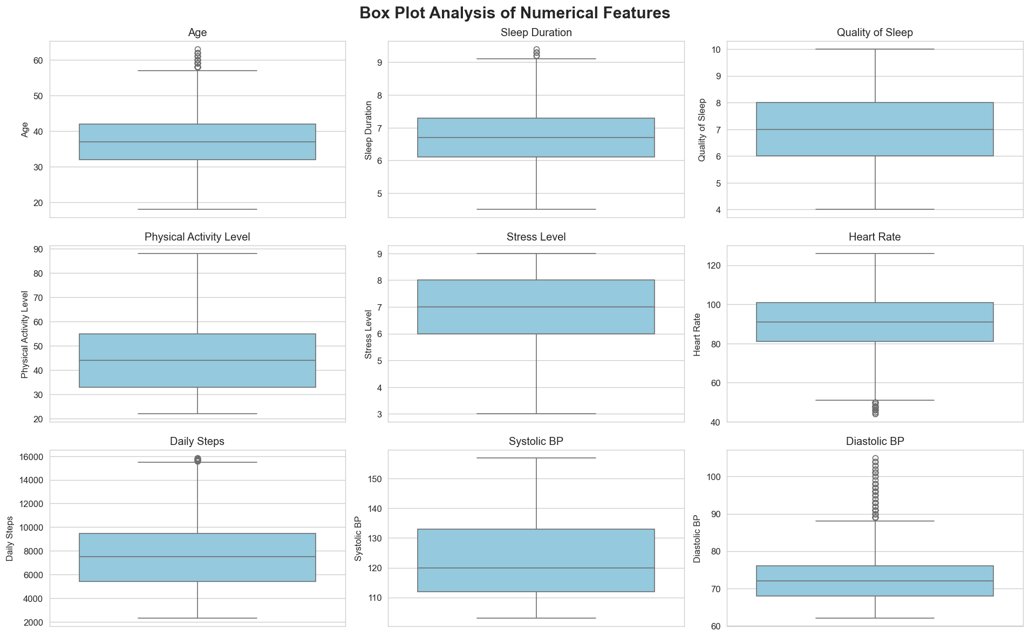
Figure 4.7 — Box Plot Analysis of Numerical Features (Outlier Detection)
Key Insights: Diastolic BP shows the highest proportion of statistical outliers at 0.72% of observations, followed by Age (0.41%), Heart Rate (0.27%), Daily Steps (0.14%), and Sleep Duration (0.07%); the remaining numerical features show no IQR-flagged outliers. These points correspond to physiologically plausible individuals (e.g. very low resting heart rate, unusually high blood pressure) rather than data-entry errors, so they were retained rather than removed — consistent with the objective of modelling real-world variation, including at-risk edge cases.

EDA Summary — Target is imbalanced (78% / 12% / 10%) → Macro F1 and class weighting/SMOTE required. Sleep Apnea is driven by elevated blood pressure and heart rate; Insomnia by lower sleep quality, shorter duration, and higher stress. BMI Category shows the clearest categorical association with the target; Gender carries little predictive value. No feature pair is collinear enough to warrant removal → all predictors retained. Outliers are limited to genuine physiological variation (under 1% of rows per feature) and were kept, not removed.

5. Feature Engineering
Two domain-informed features were derived from existing predictors to give the models additional, clinically meaningful signal without introducing any dependency on the target variable.

5.1 Engineered Features
Feature | Formula | Rationale
Pulse Pressure | Systolic BP − Diastolic BP | Additional cardiovascular signal beyond raw BP
Sleep Quality Index | ((Sleep Duration / 24) + (Quality of Sleep / 10)) / 2 | Consolidated, standardised sleep-profile score

5.2 Engineered Feature Validation
Each engineered feature was checked for missing values (none were introduced) and validated by comparing its group-wise mean across the three target classes.
- Pulse Pressure shows strong separation for Sleep Apnea — mean 65.61 vs. 50.05 for Insomnia and 48.97 for No Sleep Disorder — directly reflecting the elevated blood pressure observed during EDA.
- Sleep Quality Index is lowest for Insomnia (0.378) compared to 0.505 for No Sleep Disorder and 0.495 for Sleep Apnea, consolidating two related sleep metrics into a single, standardised signal.
Both engineered features separate the target classes meaningfully and were retained for modelling.

6. Data Preprocessing & Train-Test Split

6.1 Preprocessing Pipeline
All preprocessing was implemented as a single scikit-learn `ColumnTransformer`, fit exclusively on the training fold in every cross-validation split to prevent information leakage from the test set.
Feature Type | Pipeline
Numerical (11 features) | Median imputation → StandardScaler
Categorical (3 features) | Mode imputation → OneHotEncoder

The numerical group includes the nine original physiological/lifestyle measures plus the two engineered features (Pulse Pressure, Sleep Quality Index). Combining the numerical and one-hot-encoded categorical outputs expands the processed feature matrix from 13 raw columns to 29 model-ready features.

6.2 Stratified Train-Test Split
Given the 78% / 12% / 10% class imbalance, a random split risks under-representing Insomnia or Sleep Apnea in either partition. A stratified 80/20 split was therefore used to preserve the original class proportions in both the training and test sets.
Split | Samples | Class Proportions Preserved
Training Set | 8,000 | Yes (stratified) — 6,250 / 990 / 760
Test Set | 2,000 | Yes (stratified) — 1,563 / 247 / 190

The test set remained completely untouched until the final evaluation stage in Section 8.

7. Model Development & Selection

7.1 Modeling Approach
Five classification algorithms — Logistic Regression, Decision Tree, Random Forest, Support Vector Machine, and XGBoost — were each benchmarked under two imbalance-handling strategies, class weighting and SMOTE (Synthetic Minority Over-sampling), using Stratified 5-Fold Cross-Validation. Preprocessing and SMOTE (where applicable) were refit independently inside every fold to guarantee a leakage-safe comparison.
Primary metric: Macro F1, which weights every class equally regardless of size — the appropriate choice for a 78/12/10 imbalanced target. Balanced Accuracy, Macro Precision/Recall, and ROC-AUC were tracked as supporting evidence.

7.2 Baseline Cross-Validation Results
Class-Weighting Strategy
Model | Accuracy | Balanced Acc. | F1 Macro | ROC-AUC
XGBoost | 89.96% | 76.25% | 78.81% | 95.17%
Random Forest | 88.24% | 70.60% | 75.95% | —
Logistic Regression | 83.31% | 85.09% | 75.33% | —
SVM | 83.38% | 83.73% | 75.06% | —
Decision Tree | 82.59% | 68.45% | 68.42% | —

SMOTE Strategy
Model | Accuracy | Balanced Acc. | F1 Macro
Random Forest + SMOTE | 88.55% | 78.04% | 78.82%
XGBoost + SMOTE | 88.40% | 77.15% | 78.29%
SVM + SMOTE | 85.28% | 82.33% | 76.65%
Logistic Regression + SMOTE | 84.36% | 84.81% | 76.43%
Decision Tree + SMOTE | 81.65% | 69.77% | 67.89%

XGBoost led the class-weighting strategy outright (78.81% Macro F1), while Random Forest and XGBoost were near-identical under SMOTE (78.82% vs. 78.29%). XGBoost — alongside Random Forest, its closest competitor — was carried forward into hyperparameter tuning.

7.3 Class Weight vs. SMOTE Comparison
The two imbalance-handling strategies were compared directly across all five candidate models on cross-validated Macro F1.
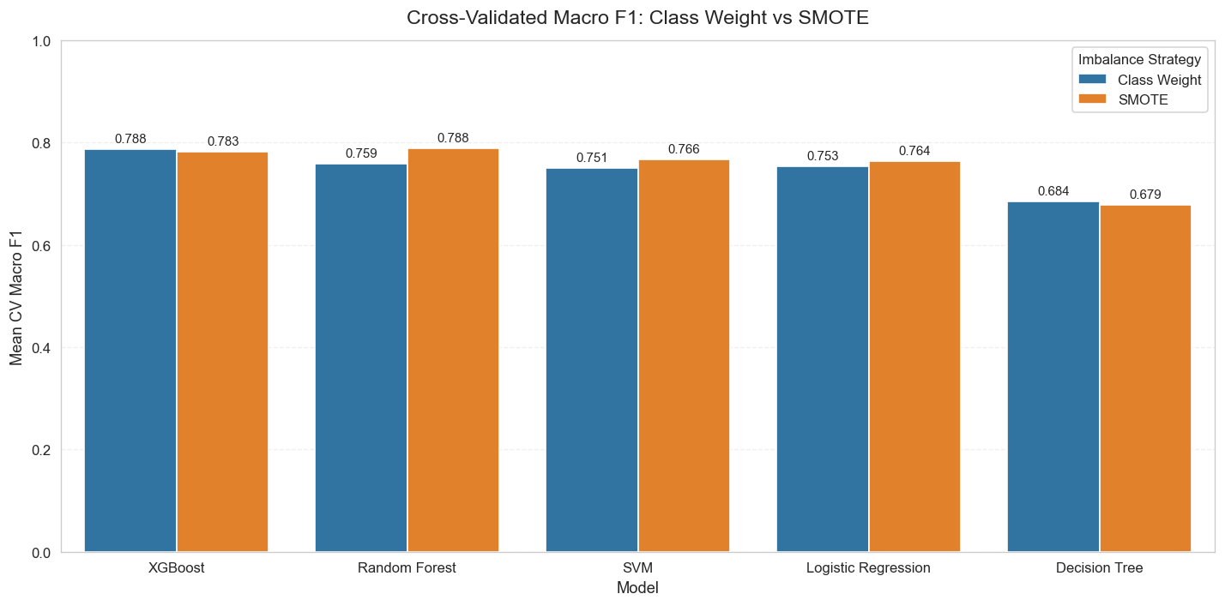
Figure 7.3 — Cross-Validated Macro F1: Class Weight vs. SMOTE
Observation: SMOTE holds a consistent edge for Random Forest, SVM, and Logistic Regression, while class weighting is marginally stronger for XGBoost and Decision Tree. Given the near-parity in performance and XGBoost's lead under class weighting, class weighting was preferred going forward — it avoids generating synthetic samples and is simpler to reproduce consistently at inference time.

7.4 Hyperparameter Tuning
The strongest candidates from the baseline comparison — XGBoost (both strategies) and Random Forest — were tuned using `RandomizedSearchCV` with Stratified 5-Fold cross-validation, optimising for Macro F1. The test set remained untouched throughout this stage.
Candidate | Best CV Macro F1
XGBoost — Class Weight (selected) | 80.41%
XGBoost — SMOTE | 80.01%
Random Forest — Tuned | 78.33%

Selected Configuration — XGBoost (Class Weight)
Hyperparameter | Tuned Value
n_estimators | 200
max_depth | 3
learning_rate | 0.10
subsample | 0.70
colsample_bytree | 1.0
min_child_weight | 1

SELECTED — XGBoost (Class Weight, tuned) selected as the final model — highest cross-validated Macro F1 (80.41%) among all candidates tested.

8. Final Model Evaluation
The tuned XGBoost model was evaluated once, on the 2,000-record held-out test set that had not been used during training, tuning, or cross-validation — giving a realistic estimate of production performance.

8.1 Held-Out Test Set Performance
Metric | Score
Accuracy | 90.95%
Balanced Accuracy | 81.38%
F1 Macro | 83.41%
F1 Weighted | 90.74%
Precision Macro | 85.78%
Recall Macro | 81.38%
ROC-AUC (One-vs-Rest) | 96.77%
PR-AUC (Macro Avg., One-vs-Rest) | 90.02%

The test Macro F1 (83.41%) exceeds the cross-validated average (80.41%), and overall accuracy (90.95%) comfortably clears the 78% no-skill baseline of always predicting the majority class — evidence of genuine generalisation from cross-validation to an unseen test set.

8.2 Confusion Matrix
The confusion matrix breaks down prediction outcomes by true class to reveal exactly where the model succeeds and where it confuses classes.
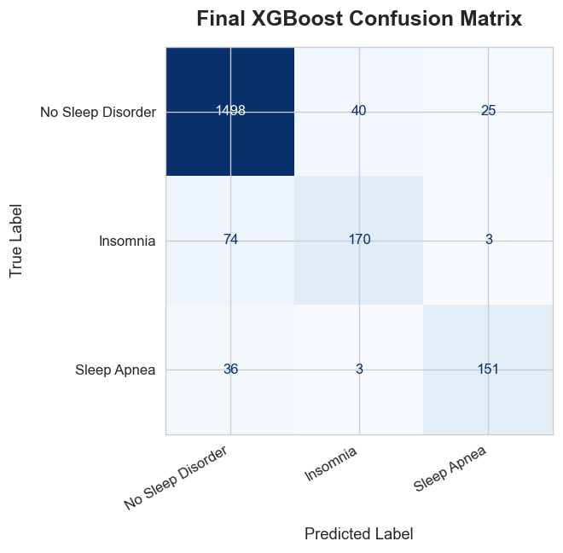
Figure 8.2 — Final XGBoost Confusion Matrix (Test Set)
Key Insights: the model correctly classifies 1,498 of 1,563 No Sleep Disorder cases and 151 of 190 Sleep Apnea cases. Insomnia is the hardest class to isolate — 74 of 247 true Insomnia cases are misclassified as No Sleep Disorder, while confusion between Insomnia and Sleep Apnea is minimal (at most 3 records each direction), showing the model rarely confuses the two disorder types with each other — only with the healthy baseline.

8.3 Multiclass ROC-AUC
One-vs-Rest ROC curves were plotted for each class to evaluate ranking quality independent of the classification threshold.
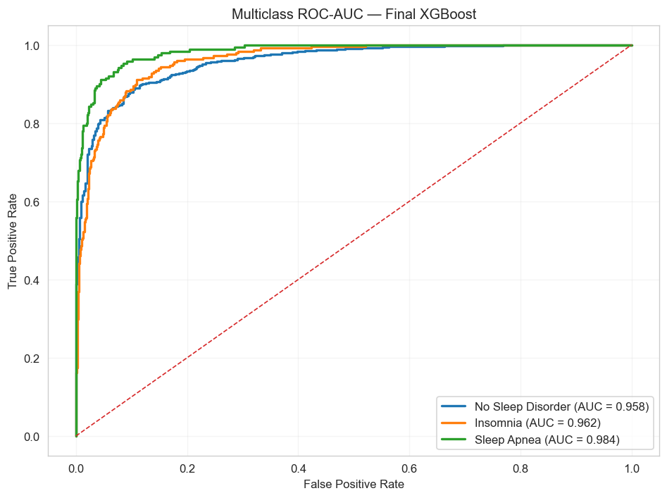
Figure 8.3 — Multiclass ROC-AUC Curve, Final XGBoost Model
Insights: all three classes achieve AUC at or above 0.958 — No Sleep Disorder 0.958, Insomnia 0.962, and Sleep Apnea 0.984 — indicating strong discrimination across every decision threshold, not just the default 50% cut-off used for the confusion matrix above.

8.4 Precision–Recall Curves & PR-AUC
Because the target is imbalanced, Precision–Recall analysis was used alongside ROC-AUC to give a second, threshold-independent view of class-specific performance. One-vs-Rest PR curves were plotted for each class using the final XGBoost model, with particular attention to the more difficult, less-separated classes.
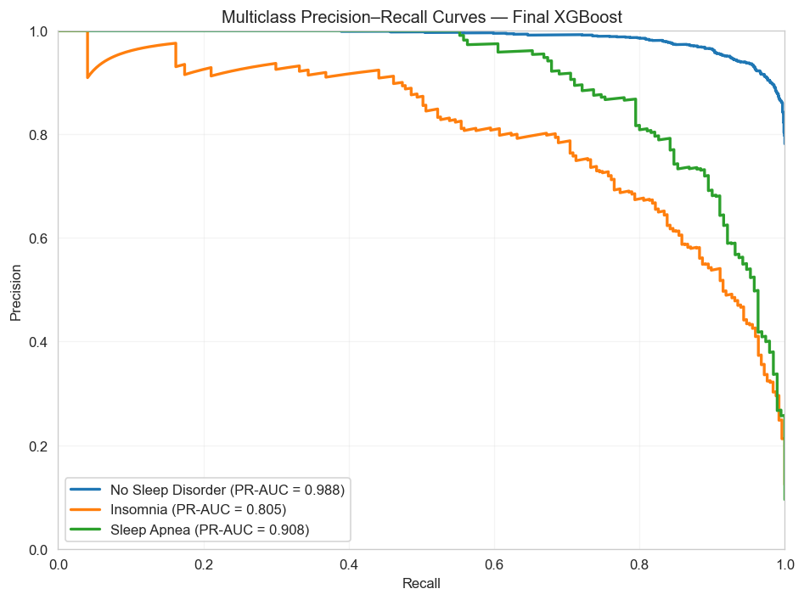
Figure 8.4 — Multiclass Precision–Recall Curves, Final XGBoost Model
Insights: PR-AUC is 0.988 for No Sleep Disorder and 0.908 for Sleep Apnea — both comfortably above 0.90 — while Insomnia trails at 0.805. Because PR-AUC is more sensitive than ROC-AUC to performance on the minority classes, this gap reinforces the confusion-matrix finding that Insomnia is the model's hardest class to separate from a healthy profile, even though its ROC-AUC alone (0.962) looks strong.

8.5 Class-wise Performance
Precision, Recall, and F1-score were computed independently for each class to identify which disorder is hardest for the model to detect.
Class | Precision | Recall | F1-Score
No Sleep Disorder | 93.16% | 95.84% | 94.48%
Sleep Apnea | 84.36% | 79.47% | 81.84%
Insomnia | 79.81% | 68.83% | 73.91%

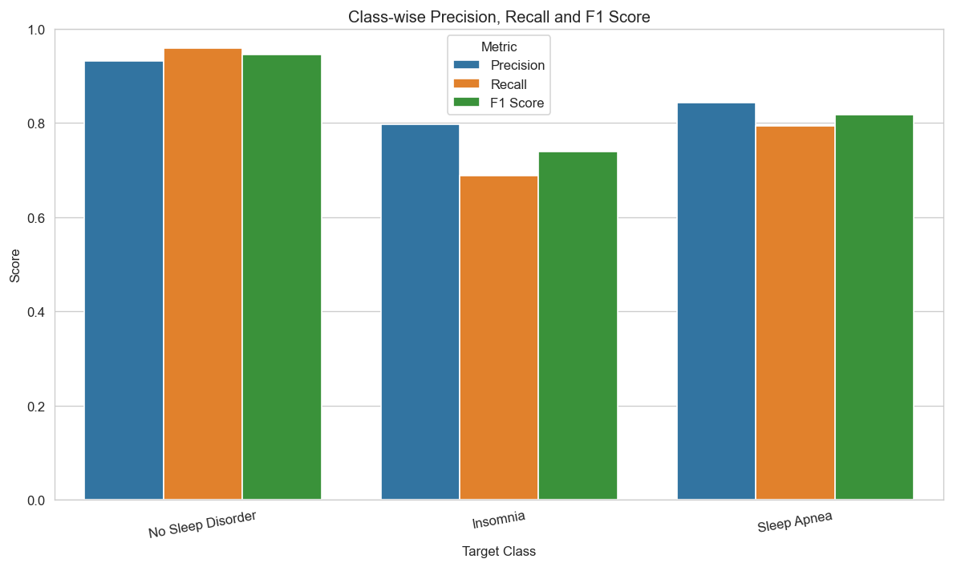
Figure 8.5 — Class-wise Precision, Recall, and F1-Score
Reading the results: No Sleep Disorder is detected very reliably (F1 = 94.48%), Sleep Apnea remains solidly detected (F1 = 81.84%), while Insomnia is the hardest class (F1 = 73.91%) and is most often confused with a healthy profile — consistent with the EDA finding that Insomnia's physiological signals overlap more with No Sleep Disorder than Sleep Apnea's more distinctive cardiovascular profile does.

9. Probability Calibration Analysis
Beyond raw classification accuracy, the reliability of the final XGBoost model's predicted probabilities was examined as a separate post-training validation experiment. Probability calibration evaluates whether the predicted probabilities correspond to the observed frequency of each sleep-disorder class — a well-calibrated classifier assigns probabilities that reflect the actual likelihood of the corresponding outcome. Calibration is evaluated separately for No Sleep Disorder, Insomnia, and Sleep Apnea using a one-vs-rest approach, combining calibration curves, quantitative probability metrics, and a comparison against sigmoid-calibrated (Platt Scaling) and isotonic-calibrated versions of the model.

9.1 Probability Calibration Curves
Calibration curves compare the mean predicted probability within ten uniform probability bins against the observed frequency of each class, evaluated separately for No Sleep Disorder, Insomnia, and Sleep Apnea using a one-vs-rest approach. A perfectly calibrated model would fall exactly on the diagonal reference line.
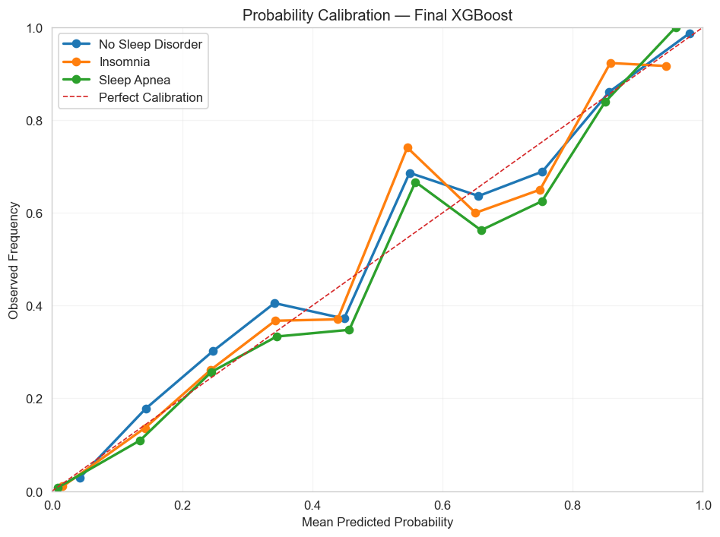
Figure 9.1 — Probability Calibration Curves, Final XGBoost Model
The calibration curves compare the predicted probabilities with the observed class frequencies for No Sleep Disorder, Insomnia, and Sleep Apnea. The curves broadly track the perfect-calibration reference line at the extremes, although a visible dip appears in the mid-probability range (roughly 0.55–0.75) across all three classes.
The results suggest that the original XGBoost probabilities provide a reasonable level of probability agreement, while also indicating that some calibration error remains across intermediate probability ranges. Quantitative probability metrics are therefore considered alongside the calibration curves.

9.2 Calibration Metrics
To complement the calibration curves, Log Loss and the multiclass Brier Score were calculated on the held-out test set to quantify the quality of the predicted probability distributions. Lower values indicate better probability performance.
Metric | Score
Multiclass Log Loss | 0.2386
Multiclass Brier Score | 0.1366

The final XGBoost model achieved a multiclass Log Loss of 0.2386 and a multiclass Brier Score of 0.1366 on the test set. Combined with the calibration curves, the results indicate that the model's predicted probabilities show a reasonable level of agreement with the observed class frequencies, although some deviation from the perfect calibration line remains, particularly across the mid-probability range.
These results provide evidence that the model probabilities are informative; however, calibration performance should be interpreted alongside the reliability curves and the model's overall classification performance.

9.3 Platt Scaling (Sigmoid) Calibration
To determine whether probability calibration improves the reliability of the final XGBoost model, a calibrated version was trained using `CalibratedClassifierCV` with 5-fold cross-validation on the training set. The sigmoid (Platt scaling) method was used as a post-training calibration approach for the multiclass probability estimates. The test set was not used to fit the calibration model — it was used only to evaluate and compare the original and sigmoid-calibrated probability estimates.

9.4 Platt Scaling Calibration Results
The sigmoid-calibrated XGBoost model was evaluated using Multiclass Log Loss and Multiclass Brier Score on the held-out test set. These metrics assess the quality of the calibrated probability estimates across the three sleep-disorder classes. Lower values indicate better probability performance.
Metric | Score
Multiclass Log Loss | 0.2677
Multiclass Brier Score | 0.1417

The sigmoid-calibrated model achieved a higher Log Loss and Brier Score than the original, uncalibrated XGBoost model — indicating that Platt Scaling did not improve the reliability of the predicted probabilities on this held-out test set.

9.5 Isotonic Regression Calibration
Since sigmoid (Platt scaling) calibration did not improve the probability performance of the final XGBoost model, Isotonic Regression was evaluated as an alternative, non-parametric post-training calibration approach. As with Platt scaling, a calibrated version of the model was trained using `CalibratedClassifierCV` with 5-fold cross-validation on the training set, this time specifying the isotonic method — a separate isotonic calibrator is fitted for each sleep-disorder class using a one-vs-rest formulation, learning a monotonic mapping between the original XGBoost probabilities and the observed class outcomes.
As with the sigmoid experiment, the test set was not used to fit the isotonic calibrators — it was used only to evaluate the resulting calibrated probability estimates against the original, uncalibrated XGBoost probabilities.

9.6 Isotonic Regression Calibration Results
The isotonic-calibrated XGBoost model was evaluated using Multiclass Log Loss and Multiclass Brier Score on the held-out test set. These metrics assess whether isotonic calibration improves the quality of the predicted probabilities compared with the original XGBoost estimates. Lower values indicate better probability performance.
Metric | Score
Multiclass Log Loss | 0.2375
Multiclass Brier Score | 0.1362

Isotonic Regression achieved a marginally lower Log Loss and Brier Score than the original, uncalibrated XGBoost model — the only one of the two calibration methods tested to edge out the baseline on this held-out test set.

9.7 Calibration Method Comparison
The uncalibrated, sigmoid-calibrated, and isotonic-calibrated XGBoost models were compared using Log Loss and the multiclass Brier Score, all evaluated on the same untouched test set. Lower values indicate better probability estimation; this three-way comparison determines whether either calibration method provides a meaningful improvement in the reliability of the predicted probabilities.
Metric | Uncalibrated | Platt Scaling | Isotonic
Multiclass Log Loss | 0.2386 | 0.2677 | 0.2375
Multiclass Brier Score | 0.1366 | 0.1417 | 0.1362

Calibration Comparison and Deployment Decision — The original XGBoost model was compared against Platt Scaling (sigmoid) and Isotonic Regression on the held-out test set. The uncalibrated model achieved a multiclass Log Loss of 0.2386 and a Brier Score of 0.1366; Platt Scaling achieved 0.2677 and 0.1417 (clearly worse); and Isotonic Regression achieved 0.2375 and 0.1362 — a marginal improvement over the uncalibrated model on both metrics. Since the improvement from Isotonic Regression is small and Platt Scaling degrades performance, neither calibration method provides a substantial, decisive benefit, and the original, uncalibrated XGBoost model is retained for deployment for simplicity and consistency. The Platt Scaling and Isotonic Regression experiments are documented as post-training validation analyses, while the production prediction pipeline remains unchanged.

10. Model Explainability (XAI)
To ensure the final XGBoost model is not a 'black box', SHAP (SHapley Additive exPlanations) was applied via `TreeExplainer` on the transformed test set to quantify how much each feature contributes to every prediction, both globally and by feature interaction.

10.1 SHAP Global Feature Importance
Aggregating SHAP values across all test observations, split by target class, produces a global importance ranking for every feature in the model.
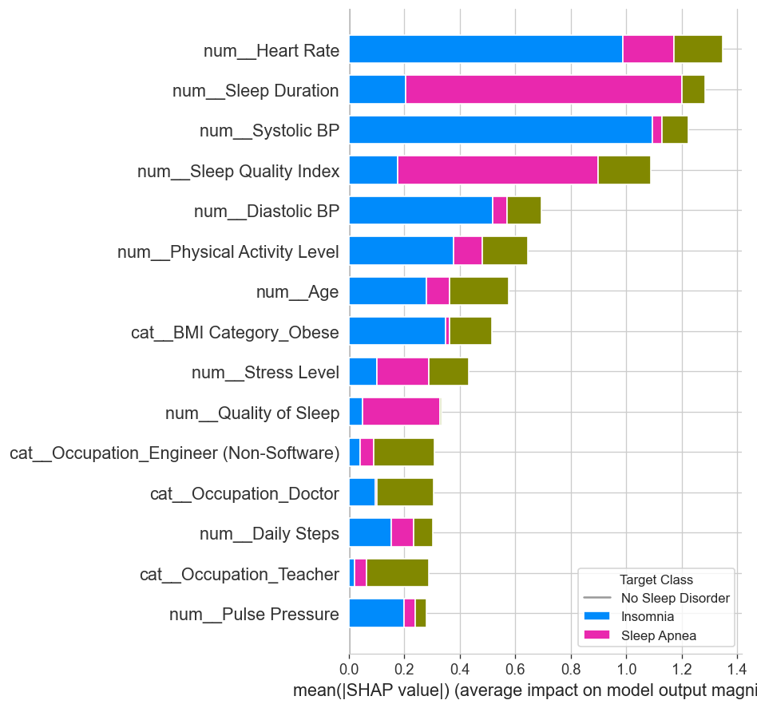
Figure 10.1 — SHAP Global Feature Importance by Target Class
Insights: Heart Rate is the single strongest predictor across all classes, followed by Sleep Duration and Systolic BP. The engineered Sleep Quality Index and Diastolic BP contribute substantially, while Physical Activity Level and Age provide meaningful supporting signal. BMI Category (Obese) is the strongest categorical contributor, ahead of Stress Level and Quality of Sleep. Demographic and occupational one-hot features (e.g. Occupation_Doctor, Occupation_Teacher) and the engineered Pulse Pressure feature rank lowest overall — the model relies primarily on physiological and sleep-related signals rather than demographic proxies.

10.2 SHAP Feature Interaction Analysis
An interaction summary was generated for the model's top continuous predictors to examine whether pairs of features jointly influence predictions beyond their individual, additive effects.
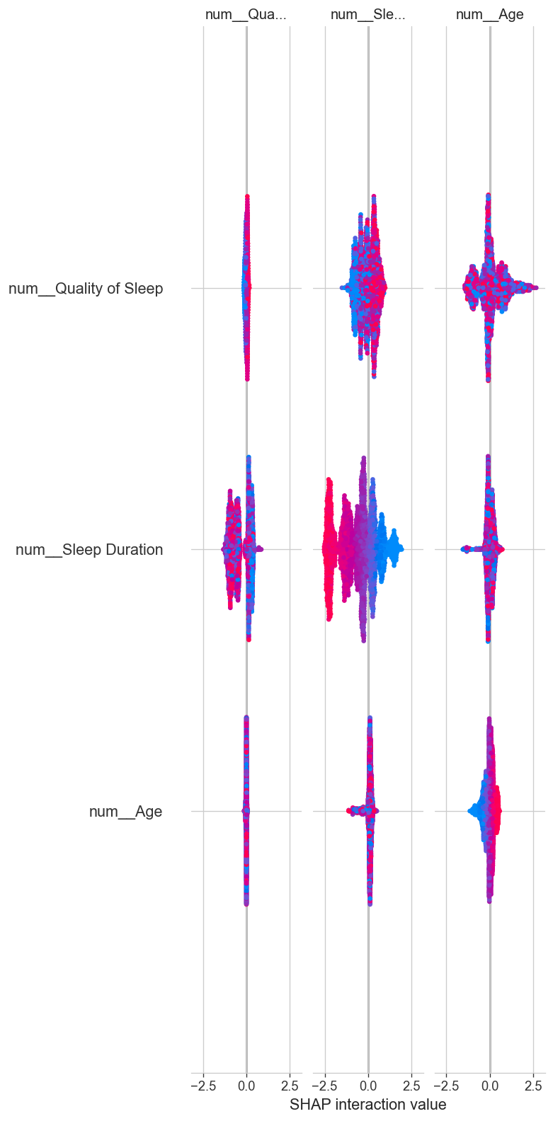
Figure 10.2 — SHAP Feature Interaction Summary (Quality of Sleep, Sleep Duration, Age)
Key Insight: Sleep Duration shows the strongest interaction effect with Quality of Sleep — the impact of one depends visibly on the level of the other, reflecting their real-world relationship as two facets of the same underlying sleep-health construct rather than fully independent signals.

10.3 Explainability Summary
Key Insight — Heart Rate, Sleep Duration, and Systolic BP dominate the model's predictions across both the global SHAP ranking and the interaction analysis. The engineered Sleep Quality Index provides strong secondary signal alongside Diastolic BP, while demographic and occupational features contribute comparatively little. This consistent, human-readable explanation is exactly what makes the model suitable for a real-world screening context, where 'why' matters as much as 'what'.

11. Conclusion & Key Takeaways

11.1 Summary of Findings
- XGBoost achieved the strongest and most consistent performance among all five algorithms tested, under both class-weighting and SMOTE imbalance strategies.
- Class weighting and SMOTE performed comparably across most models, with SMOTE giving Random Forest, SVM, and Logistic Regression a modest edge — class weighting was preferred for the final model for its simplicity at inference time.
- Heart Rate, Sleep Duration, and Systolic BP are the strongest predictors of sleep-disorder status, confirmed independently by both the correlation analysis and SHAP-based explainability.
- Sleep Apnea is driven primarily by elevated blood pressure and heart rate; Insomnia by lower sleep quality and duration combined with higher stress.
- Insomnia remains the hardest class to separate from a healthy sleep profile — the clearest target for future feature or data improvements.

11.2 Final Recommendation
The tuned XGBoost (Class Weight) model is recommended as the deployment candidate for this classification task, combining solid held-out test performance (90.95% accuracy, 83.41% Macro F1, 96.77% ROC-AUC) with full interpretability via SHAP — a combination essential for any model intended to support health-related screening decisions.

11.3 Business Impact & Recommendations
- Position the model as a screening / triage aid, not a diagnostic system — flagged cases should be routed to a qualified healthcare provider for confirmation.
- Prioritise Insomnia recall in future iterations, given it is the class most often confused with a healthy profile and therefore the highest-risk false negative.
- Use the SHAP-based explanations to give end users (clinicians or individuals) a transparent, feature-level rationale alongside every prediction, not just a class label.
- Validate the pipeline on real clinical data before any production use, since the current dataset is synthetically generated.

11.4 Skills & Techniques Demonstrated
- Data cleaning, validation, and exploratory data analysis (pandas, seaborn, matplotlib).
- Imbalanced-classification methodology: stratified splitting, class weighting, and SMOTE, compared empirically rather than assumed.
- Feature engineering for health and lifestyle data: pulse pressure and a composite sleep-quality index.
- Leakage-safe pipeline design using scikit-learn's ColumnTransformer and Pipeline, with resampling refit inside every cross-validation fold.
- Model development across linear (Logistic Regression), tree-based (Decision Tree, Random Forest), kernel-based (SVM), and gradient-boosted (XGBoost) paradigms.
- Hyperparameter optimisation using RandomizedSearchCV with Stratified K-Fold cross-validation.
- Explainable AI (XAI) using SHAP TreeExplainer — global feature importance and feature-interaction analysis.
- Clear, structured technical communication — translating model internals into business-relevant conclusions for non-technical stakeholders.
— End of Report —

