PROJECT REPORT
Fake News Detection Using Machine Learning
A text classifier for news articles, tested on its own data and on data it has never seen
Author: Rushikesh Kulkarni
Date: October 2026
Origin: Rebuild of a January 2021 class project for a Neural Networks and Fuzzy Control course
Code: github.com/rushikesh-rk08/Fake-News-Dectation-System-using-Python

Summary
This project builds a system that labels a news article as real or fake from its text. It reaches 92.5% accuracy on a held-out portion of its own dataset. When the same model is tested on a second dataset from different publishers, accuracy falls to about 60%.
That gap is the main finding. The model learns how the publishers in its training data write, which is enough to sort articles from the same collection and not enough to recognise fake news in general. The project therefore positions the system as an explainable screening aid that shows the words behind every decision, and not as an automatic judge of truth.

1. Introduction
False and misleading news is now a routine part of the information people see online. It travels through the same channels as real reporting and is designed to look like it, and readers have little time to check what they read before sharing it.
Research on Twitter data from 2006 to 2017 found that false news stories were 70% more likely to be retweeted than true ones, and that true stories took about six times as long to reach 1,500 people [1]. The same study found that people, not automated accounts, were responsible for most of that spread. The World Economic Forum’s Global Risks Report 2025, based on a survey of more than 900 experts, ranked misinformation and disinformation as the top short-term global risk for the second year running [2].
Machine learning is an obvious candidate for this problem because the volume of content is far beyond what human reviewers can read. This project began in January 2021 as a class exercise in applying a text classifier to labelled news articles. It was rebuilt in 2026 with a wider aim: to measure how well such a classifier really works, and to say clearly where it does not.

2. Objective
The project has four objectives.
- Build a working classifier. Label a news article as REAL or FAKE from its text alone, using methods light enough to train on a laptop in minutes.
- Compare approaches fairly. Test a linear baseline against logistic regression, naive Bayes and a small neural network on identical data, and check whether the differences are statistically meaningful.
- Measure honestly. Report accuracy on articles from the training collection and on a second, independent dataset, so the result is not overstated.
- Make decisions explainable. Show which words pushed each prediction, so a user can judge whether the reasoning is sensible.

3. Problem Statement
Given the text of a news article, decide whether it is more likely to be genuine reporting or fabricated news, and show the evidence for that decision.
Three things make this harder than it first appears.
- The label is about truth, but the input is only text. A classifier cannot check facts. It can only learn patterns in wording that happen to go with each label in its training data.
- Datasets carry shortcuts. Fake and real articles are usually collected from different websites at different times. A model can score well by recognising the website’s style, dates or page layout text rather than anything about reliability.
- A single accuracy figure hides this. Testing on a random slice of the same dataset rewards those shortcuts. Many published results near or above 90% come from this kind of test.
The project therefore treats two questions as equally important: how accurate is the classifier, and does that accuracy survive a change of data source?

4. Market Research

4.1 Size of the problem
Public concern is high and trust is low. The Reuters Institute Digital News Report 2025, covering 48 markets, found that 58% of respondents worry about telling true from false online, rising to 73% in the United States and in Africa. Overall trust in news stood at 40%. Online influencers and national politicians were each named by 47% as major sources of false or misleading information [3].
The same report shows how people try to verify a doubtful story: 38% turn first to a news outlet they trust, 35% to official sources, 33% to a search engine and 25% to a fact-checker [3]. Verification is something readers do themselves, with general tools, and only a minority use a dedicated service.

4.2 Market problems and current solutions
The table below sets out the main problems in this market, how each is addressed today, and what remains unsolved.
Market problem | Current solution | Remaining gap
False news spreads faster than corrections. False stories are 70% more likely to be shared and reach people about six times sooner [1]. | Platform moderation systems that detect and down-rank content automatically, supported by human reviewers. | Detection is tuned to each platform’s own data and is not open to outside scrutiny. Meta said that one to two in ten of its enforcement actions in December 2024 may have been mistakes [5].
Professional fact-checking cannot keep up with volume. There were 443 active projects worldwide in 2025, in 116 countries, down 2% on 2024, and their output fell about 6% [4]. | Independent fact-checking organisations that research individual claims and publish verdicts. | Each check takes skilled staff hours or days. Coverage is a small fraction of what circulates.
Fact-checkers depend on platform funding. About 160 projects, roughly a third of the total, took part in Meta’s programme, and participating organisations drew about 45% of revenue from it [4]. | Platform partnerships that pay fact-checkers to review flagged posts. | Meta ended its third-party fact-checking programme in the United States in January 2025 in favour of Community Notes [5], removing a main source of income.
Crowd-sourced correction is slow and patchy. Of 1.76 million Community Notes written on X from 2021 to March 2025, over 90% were never published, and published notes took 14 days on average in 2025 [6]. | Community Notes on X, now being adopted by Meta: users write and rate corrections, shown only when raters who usually disagree both find a note helpful. | Most notes never appear, and those that do arrive after a post has already had most of its audience.
Readers have to verify stories themselves. Only 25% use a fact-checker when unsure [3]. | Media literacy programmes, source-rating browser tools and search engines. | These need effort and time from the reader at the moment of reading, when attention is lowest.
Automated detectors are hard to trust. Reported accuracy is usually measured on the detector’s own dataset, and most tools give a label with no reasons. | Research classifiers and commercial detection services. | Performance on new sources is rarely reported. This project measured it: 92.5% on its own data, 60.4% on an outside dataset (Section 5).
Table 1. Market problems, current solutions and remaining gaps.

4.3 What the market needs
The gaps point to the same need from different directions. Human checking is accurate and slow. Platform automation is fast and closed. Crowd correction is open and late. There is room for tools that are fast, inexpensive to run, open about how they decide, and honest about how often they are wrong, used to help people prioritise what to check, not to replace the check.

5. Our Solution

5.1 Approach
The system converts each article into numerical features and trains a classifier on labelled examples.
- Data. The main dataset holds 6,335 news articles labelled REAL or FAKE, almost evenly balanced. After removing 36 empty and 241 duplicate articles, 6,058 remain: 4,846 for training and 1,212 held back for testing.
- Cleaning. Dates, numbers, web links, wire-service datelines and page boilerplate such as “share” and “advertisement” are removed, because they reveal where an article came from and are not part of what it says.
- Features. TF-IDF weighting, which scores each word by how often it appears in an article and how rare it is across all articles.
- Models. A Passive-Aggressive linear classifier as the baseline, compared with logistic regression, multinomial naive Bayes and a neural network with one hidden layer of 64 units.
- Tuning. A search over 24 combinations of settings, scored by five-fold cross-validation on the training set only.
- Outside test. Every trained model is also scored on the ISOT Fake News Dataset, 38,639 articles from different publishers, without any retraining.

5.2 Results
Model | Own test set | Cross-validation | Outside dataset (ISOT)
Passive-Aggressive, no cleaning | 93.1% | 92.9% | 63.9%
Passive-Aggressive (baseline) | 92.1% | 91.9% | 63.3%
Logistic regression | 91.3% | 91.8% | 63.8%
Multinomial naive Bayes | 88.8% | 88.5% | 53.6%
Neural network | 92.5% | 91.0% | 61.1%
Passive-Aggressive, tuned (final model) | 92.5% | 92.6% | 60.4%
Table 2. Accuracy of each model. The outside dataset is 55% real articles, so always answering “real” would score 54.8% there.
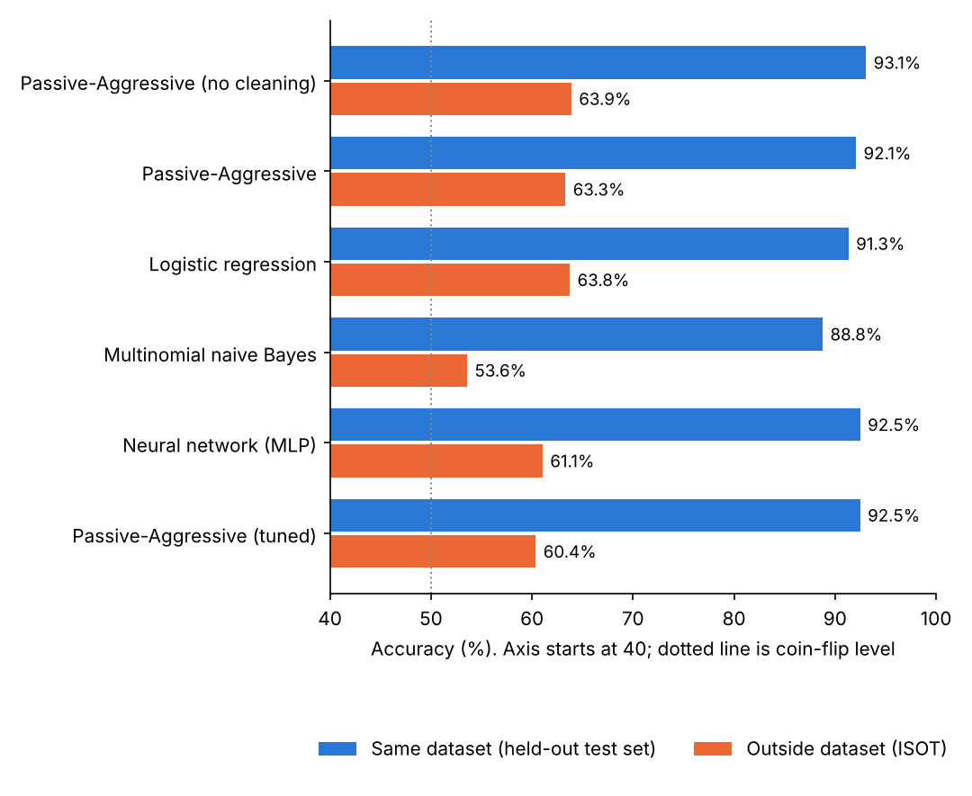
Figure 1. Accuracy on the model’s own test set (blue) and on the outside dataset (orange).
Four findings follow from these numbers.
- The models are effective on their own data. The final model classifies 1,121 of 1,212 unseen test articles correctly.
- The choice of model matters little. A significance test (McNemar) shows that only naive Bayes differs clearly from the baseline. The neural network and the tuned model are statistically indistinguishable from it.
- Accuracy does not transfer. Every model falls to between 54% and 64% on the outside dataset. The reverse holds too: a model trained on ISOT scores 97.1% on ISOT and 55.6% on the main dataset.
- Cleaning is not enough to fix this. Removing the obvious shortcuts cost about one point at home and did not improve the outside score. The deeper cause is that each dataset’s publishers cover different subjects in different styles.

5.3 Explaining each decision
Because the final model is linear, each prediction can be broken down exactly into the contribution of each word. The command-line tool and the web demo both list the words that pushed a decision towards FAKE and towards REAL, with their weights. A user can see at once when a label rests on a topic word, such as a politician’s name, and discount it.
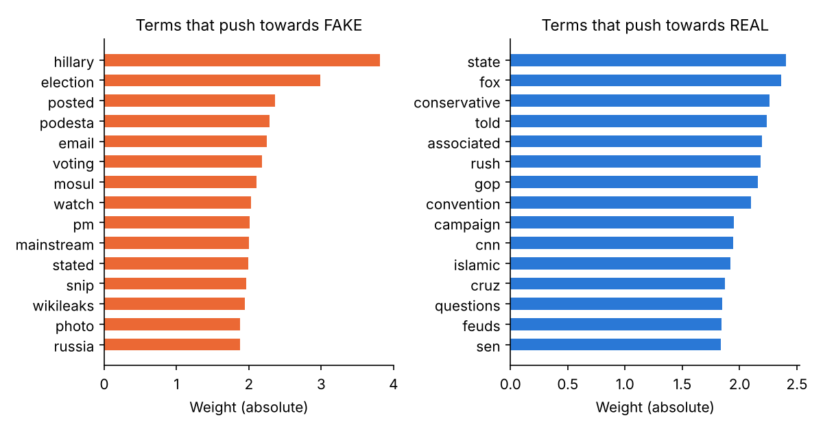
Figure 2. The words the final model weights most heavily in each direction.
Figure 2 shows what the model has learned overall. The strongest FAKE terms are subjects from the 2016 United States election and words typical of blog pages. The strongest REAL terms are the vocabulary of conventional reporting. The model separates two groups of publishers; it does not assess whether a claim is true.

5.4 What was delivered
- A training script that cleans the data, trains and compares all models, runs the outside test and writes the metrics and charts.
- A command-line predictor that returns a label, a confidence margin and the words behind the decision.
- A web demo, built with Streamlit, for pasting in an article. This has been written but not yet run end to end.
- Twelve automated tests, run on every code change through GitHub Actions.
- Open source code and full results in a public repository.

5.5 How it addresses the market gaps
Gap | How this project responds
Checking cannot keep up with volume | The model trains in seconds on a laptop and classifies an article instantly, so it can screen large numbers of articles for a human to review.
Detectors give labels without reasons | Every prediction comes with the words that drove it and a margin that shows how confident the model is.
Performance on new sources goes unreported | The outside-dataset result is reported next to the headline figure, and the test can be re-run by anyone.
Closed systems cannot be examined | Code, method, metrics and tests are public.
Table 3. Market gaps and the project’s response.

5.6 Limitations
- The system recognises writing style and subject matter. It does not verify facts and should not be used alone to judge an article.
- The training data is United States political news from 2015 and 2016. Accuracy on other subjects, countries or years should be expected to be nearer 60% than 92%.
- Both datasets are in English.
- A false story written in a newswire style can be labelled REAL, and a true story in an informal style can be labelled FAKE.

6. Conclusion
The project met its objectives. It delivers a working classifier at 92.5% accuracy on its own test data, a fair comparison of four model types, an independent test on a second dataset, and an explanation for every prediction.
Its most useful result is the one that looks least impressive. Accuracy of about 60% on unfamiliar sources shows that a text classifier of this kind learns who published an article more than whether it is true. That matches the gap found in the market research: automated detection is fast, but its reliability outside its own data is rarely measured or disclosed.
The practical conclusion is that this system is suited to screening and to teaching, where its explanations help a person decide what deserves a proper check, and is not suited to issuing verdicts. Three steps would take it further: training on several datasets from different periods and publishers, replacing word counts with a pretrained language model that captures meaning, and adding calibrated confidence so the tool can decline to answer when it is unsure.

References
[1] S. Vosoughi, D. Roy and S. Aral, “The spread of true and false news online”, Science, March 2018. Summary by MIT News: news.mit.edu
[2] World Economic Forum, Global Risks Report 2025, press release, January 2025: weforum.org
[3] Reuters Institute for the Study of Journalism, Digital News Report 2025, overview and key findings: reutersinstitute.politics.ox.ac.uk
[4] Duke Reporters’ Lab, “2025 census: Fact-checkers persevere as politicians, platforms turn up heat”, June 2025: reporterslab.org
[5] Meta, “More Speech and Fewer Mistakes”, January 2025: about.fb.com
[6] Digital Democracy Institute of the Americas, “A Deep Dive into X’s Community Notes”, July 2025: ddia.org
Project results are taken from results/metrics.json and results/tuning.json in the project repository.

