If you want to **dive deeper into the CLI** and learn more about its usage, have a look at its official **documentation**: <https://github.com/angular/angular-cli/wiki>

**You encountered issues during the installation of the CLI or setup of a new Angular project?**

A lot of problems are solved by making sure you're using the latest version of NodeJS, npm and the CLI itself.

**Updating NodeJS:**

Go to nodejs.org and download the latest version - uninstall (all) installed versions on your machine first.

**Updating npm:**

Run [sudo] npm install -g npm  (sudo  is only required on Mac/ Linux)

**Updating the CLI**

[sudo] npm uninstall -g angular-cli @angular/cli

npm cache clean

[sudo] npm install -g @angular/cli

**Here are some common issues & solutions:**

1. **Creation of a new project takes forever (longer than 3 minutes)**  
   That happens on Windows from time to time => Try running the command line as administrator
2. **You get an EADDR error (Address already in use)**  
   You might already have another ng serve process running - make sure to quit that or use ng serve --port ANOTHERPORT  to serve your project on a new port
3. **My changes are not reflected in the browser (App is not compiling)**  
   Check if the window running ng serve  displays an error. If that's not the case, make sure you're using the latest CLI version and try restarting your CLI

To create a new angular project

$ ng new my-first-app

Recommended editor Microsoft visual Code

<https://code.visualstudio.com/>

To use forms directive in angular html pages one needs to import modules in app.module.ts

import { BrowserModule } from '@angular/platform-browser';

import { NgModule } from '@angular/core';

import { FormsModule } from '@angular/forms';

import { AppComponent } from './app.component';

@NgModule({

declarations: [

AppComponent

],

imports: [

BrowserModule,

FormsModule

],

providers: [],

bootstrap: [AppComponent]

})

export class AppModule { }

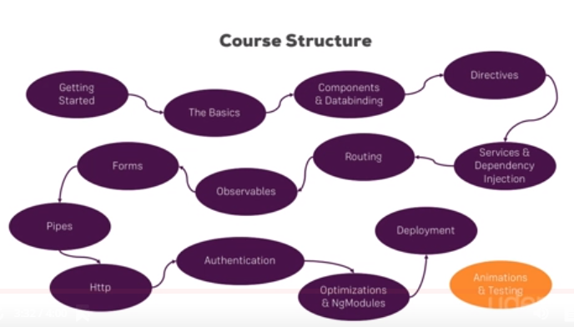

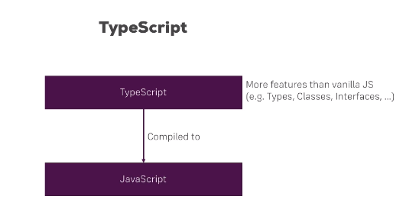

Install bootstrap with angular detailed article

<https://medium.com/codingthesmartway-com-blog/using-bootstrap-with-angular-c83c3cee3f4a>

Install bootstrap using

npm install bootstrap jquery --save

Then update angular.json to add bootstrap style dependency in styles and scripts array:

"styles": [

"styles.css",

"../node_modules/bootstrap/dist/css/bootstrap.min.css"

],

"scripts": [

"../node_modules/jquery/dist/jquery.min.js",

"../node_modules/bootstrap/dist/js/bootstrap.min.js"

],

View source of html document and one should see bootstrap css loaded under <head> section.

