**Opening a New Bike Store in Tempe, AZ**

**Rushikesh Hayatnagarkar**

**June 15th, 2020**

1. **Introduction**
   1. **Background:**

Biking is on the rise in the United States. In order to reduce pollution, cities are making roads more bike friendly. Cities like Chicago, San Francisco, Tempe have dedicated bike lanes throughout the city to encourage residents to bike. Companies like Google have bike racks in the office to support employees who bike to work. Tempe is ranked 11th most bike friendly city in the United States. With a huge student population and new students coming in every year, the demand for bikes is going up in Tempe. To benefit from this increasing demand, analyzing the bike stores in Tempe would be helpful for potential investors in the business.

* 1. **Problem:**

Analyze the Bike Store market in Tempe, Arizona and determine if building an additional store near the University would be beneficial.

1. **Data acquisition and cleaning:**

* The data for all the venues in a 100 KM radius for Tempe, can be found using the FourSquare API.
* Set a maximum limit of 10,000 for the result.
* This will provide substantial data for the analysis.
* Venue Name, Venue ID, Venue Category, Venue Latitude and Venue Longitude are the features that will be used for the analysis.

1. **Methodology/Exploratory Data Analysis:**

* Using the data pulled from FourSquare API, identify the bike stores that operate in the Tempe Area.
* Once, all the bike stores are determined, plot the stores on the map of Tempe using the Folium package in Python.
* Using the bike store id feature, get the ratings for these stores.
* This will help us determine how well these stores are run.

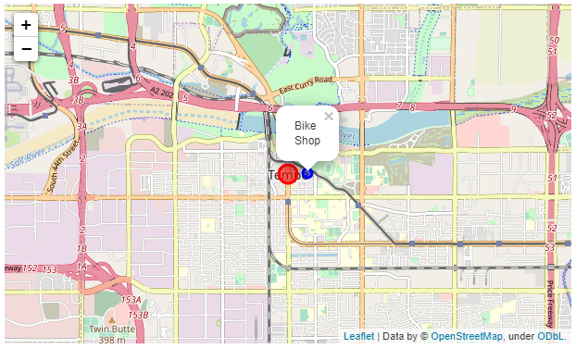

There is a single store in a 100 KM radius from Tempe, AZ. It has a rating of 8.7.

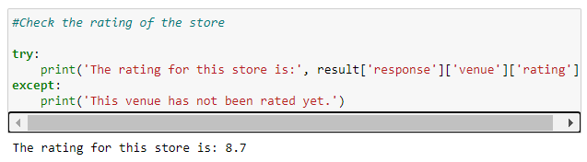

1. **Results:**

* This study showed that in a 100KM radius in Tempe, there is a single bike store albeit with a good rating.

1. **Discussion Section:**

* This store would not be able to support the growing demand for bikes in Tempe.
* The above analysis clearly demonstrates that there is a need for a new bike store in Tempe, AZ
* Even though stores like Walmart sell bikes, the range of bikes sold at these stores is limited
* A bike store provides the customer to buy either a new or used bike and repair their own bike in the store using the tools provided by the store

1. **Conclusion/Recommendation**

* A bike store would help the customers purchase different types of bikes.
* It would provide students who are on a tight budget to maintain their own bikes in the store using the store provided equipment
* Hence, I would recommend opening another store in Tempe, AZ to reap the benefits of growing bike demand.