CREATING A LINUX INSTANCE ON AWS SERVERS AND CREATING A CONNECTION

Selecting The Linux Image :

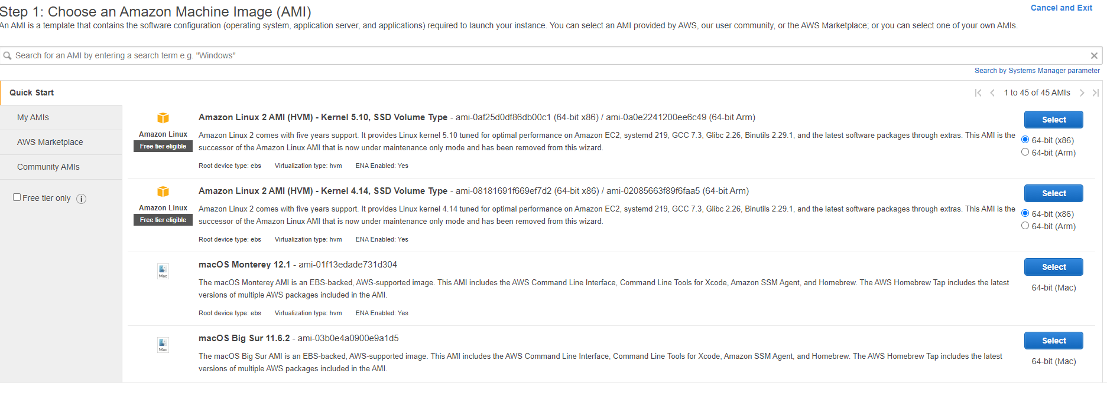

Choosing An Instance Type :

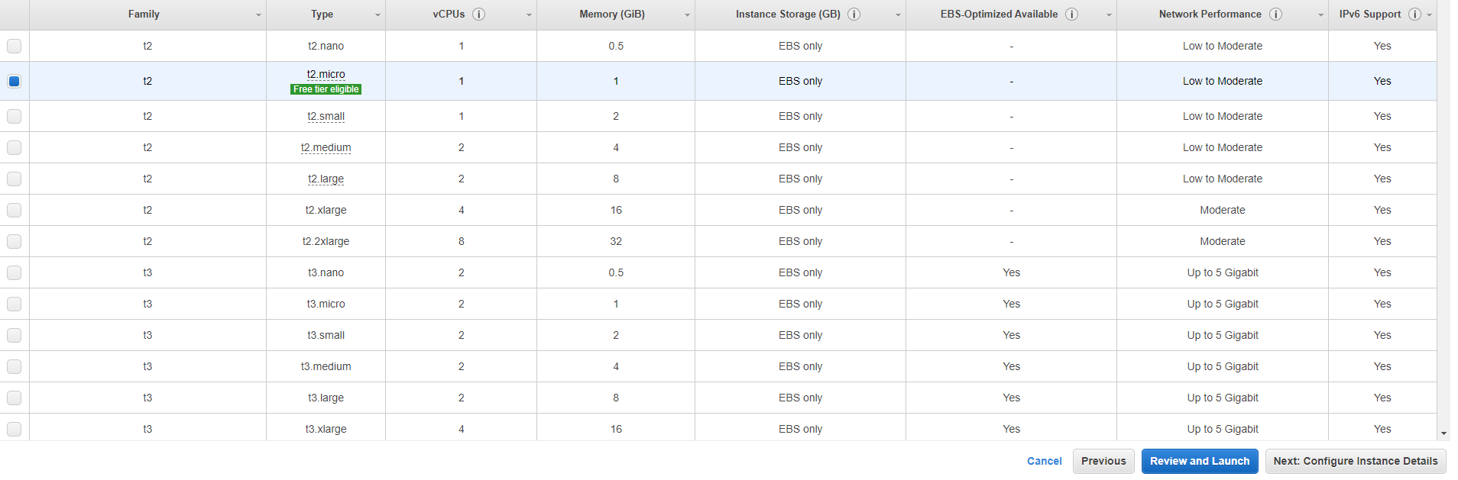

Configuring Instance Details :

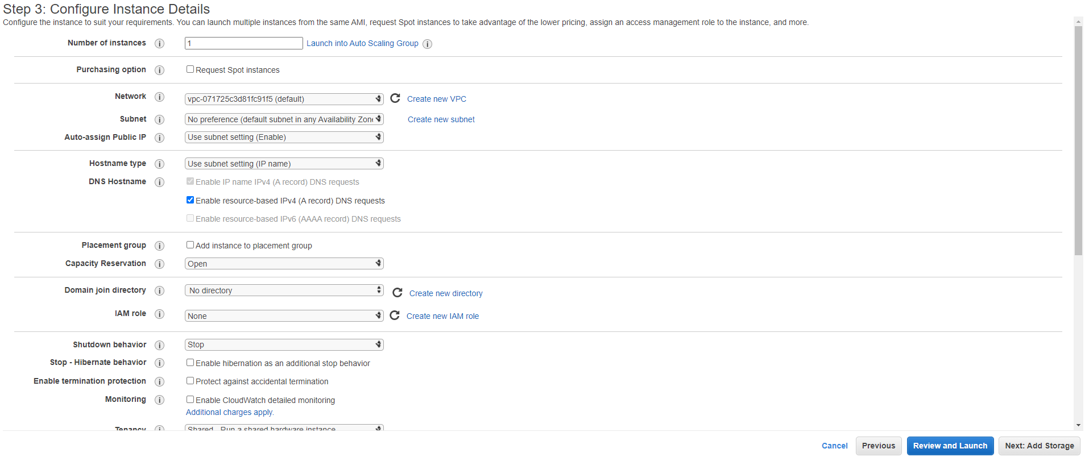

Adding Storage:

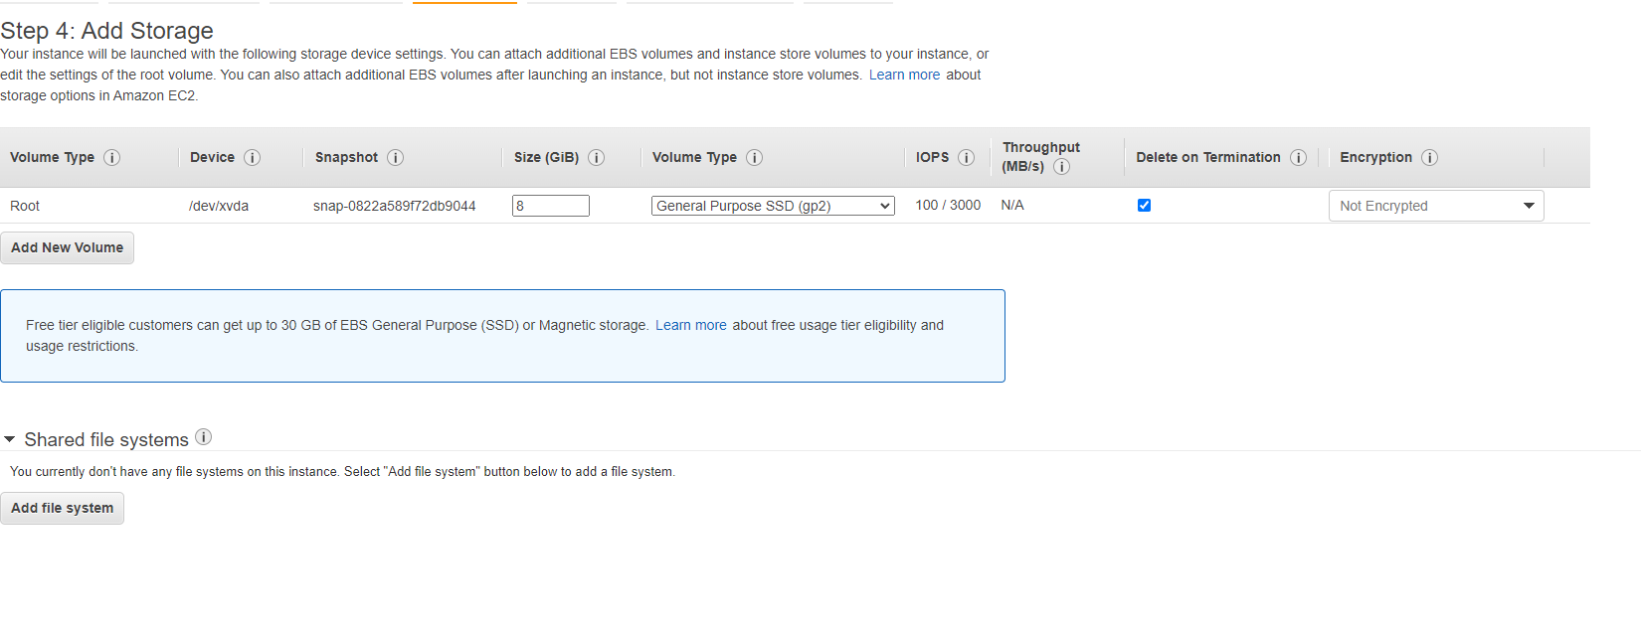

Configuring Security Groups :

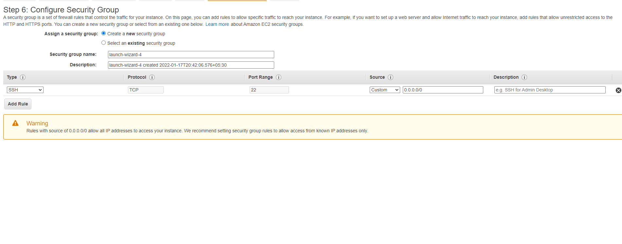

For Linux Instance we Used The SSH protocol

Creating A key Pair Before Launch :

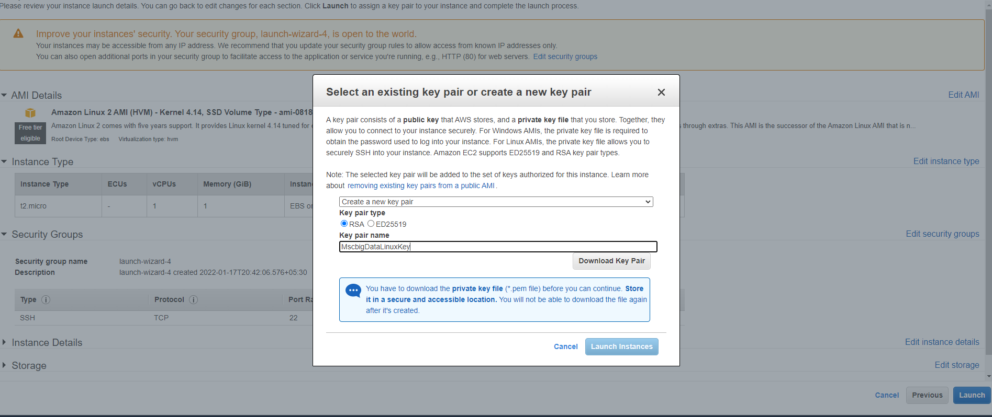

Instance Status Running :

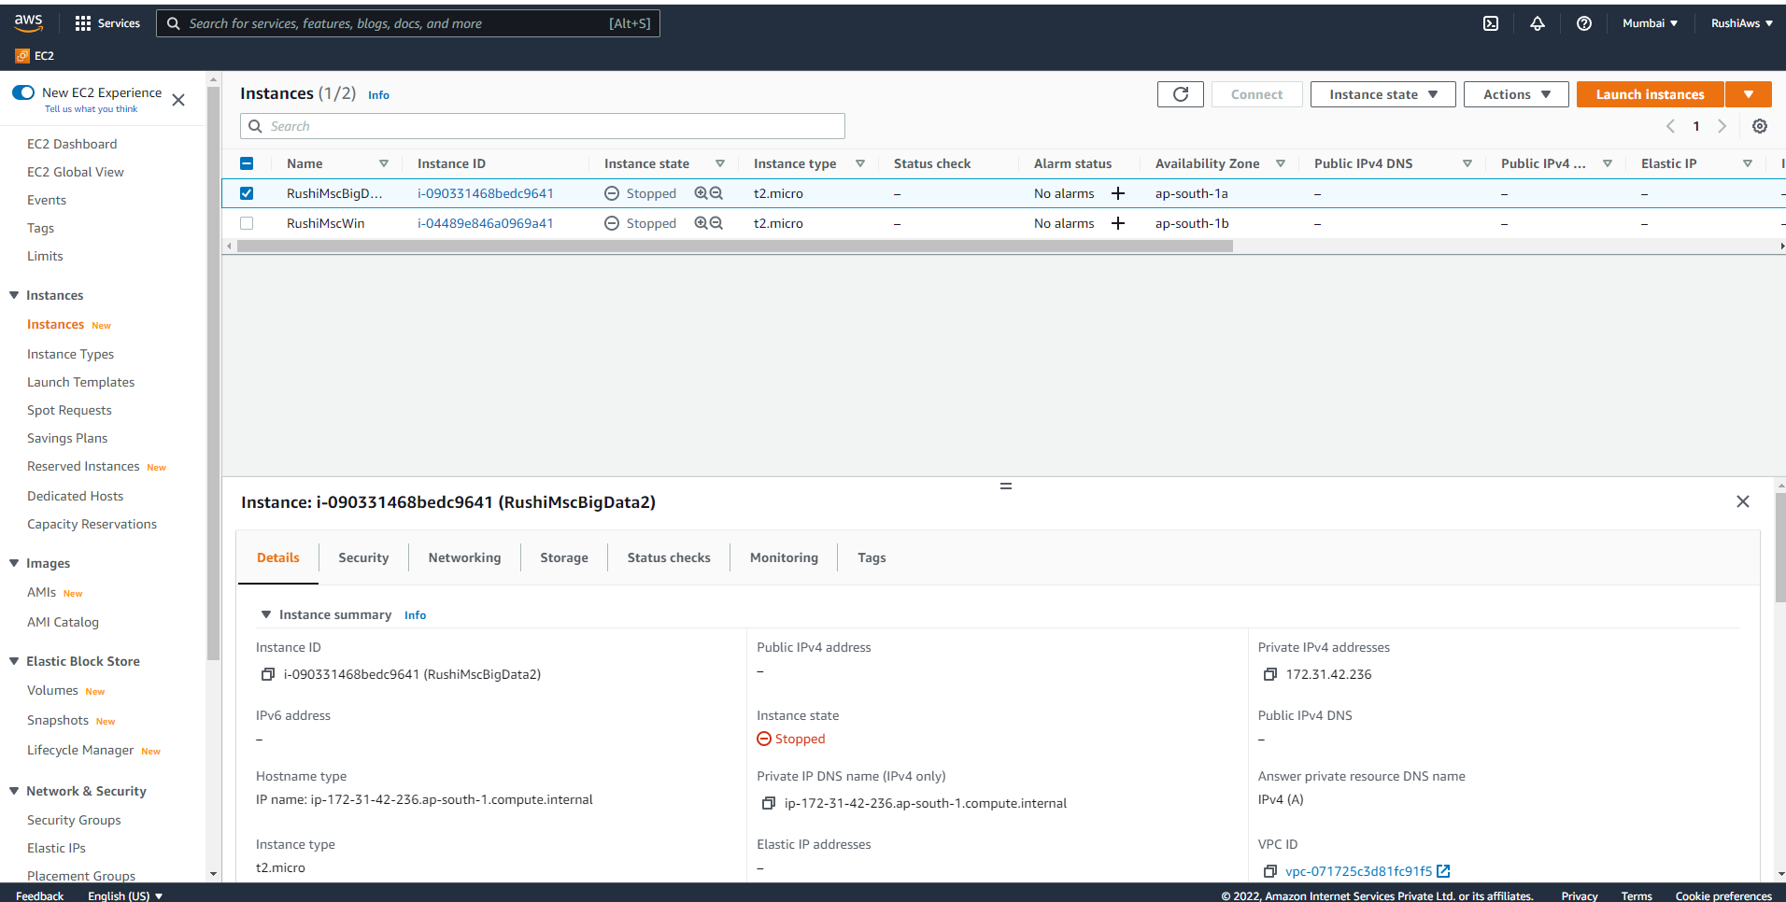

Connecting To The Linux Instance Using Putty:

1)Generating A Putty Compatible Key pair using Putty Key Gen using The insance Key Pair

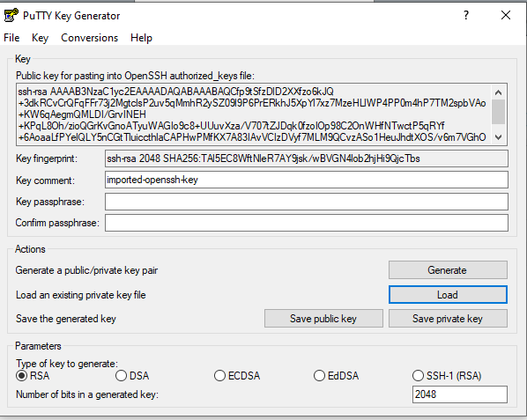

2)Inputting Ip Adress of the Linux Instance :

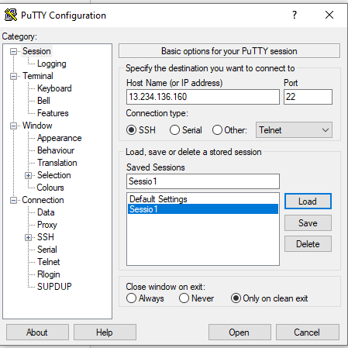

Connection Made :

CREATING A WINDOWS INSTANCE ON AWS SERVER AND CONNECTING TO IT :

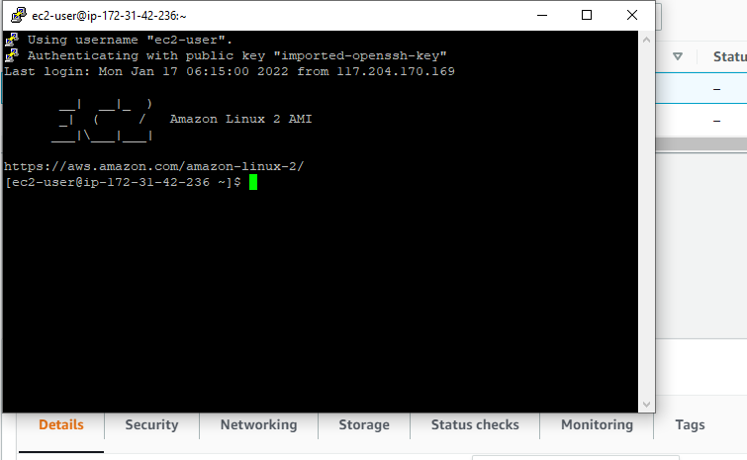

Creating Windows Server :

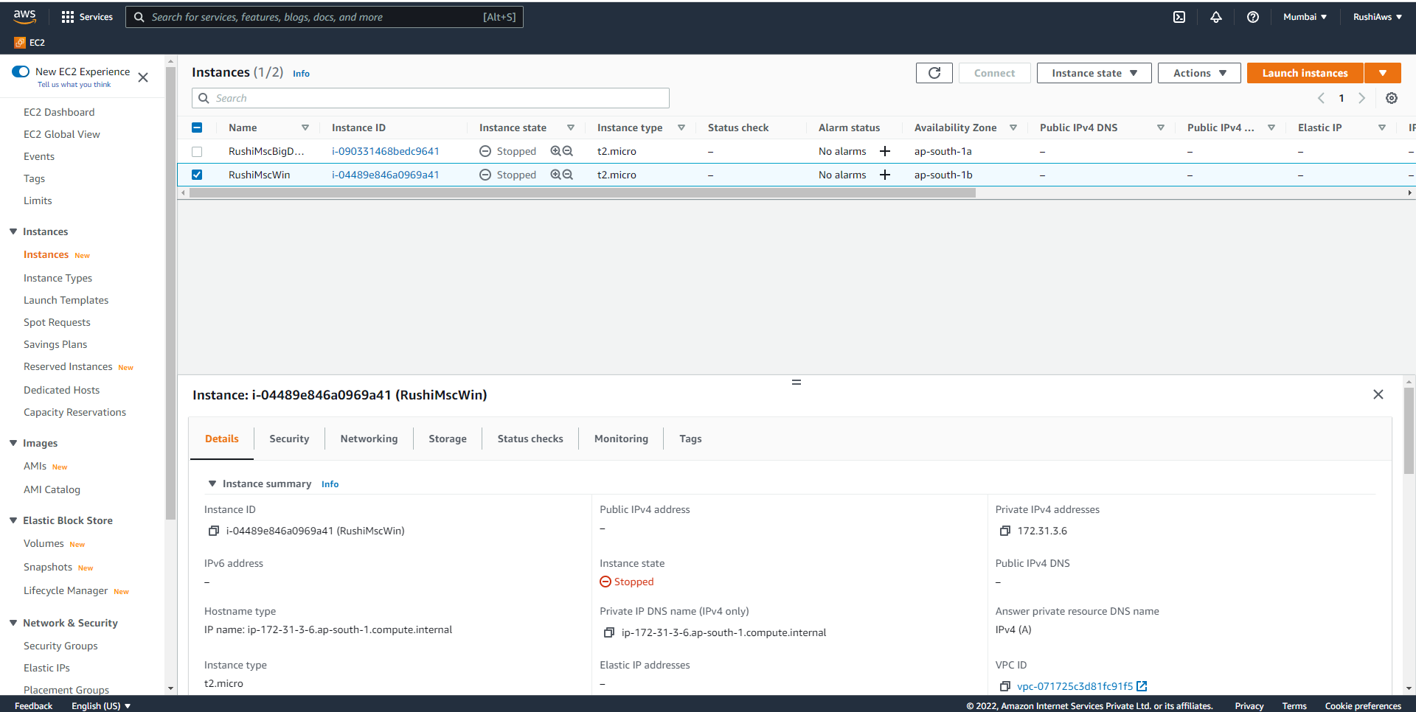

Connecting To the Windows Server Using Remote Desktop Connection :

a)Getting the password :

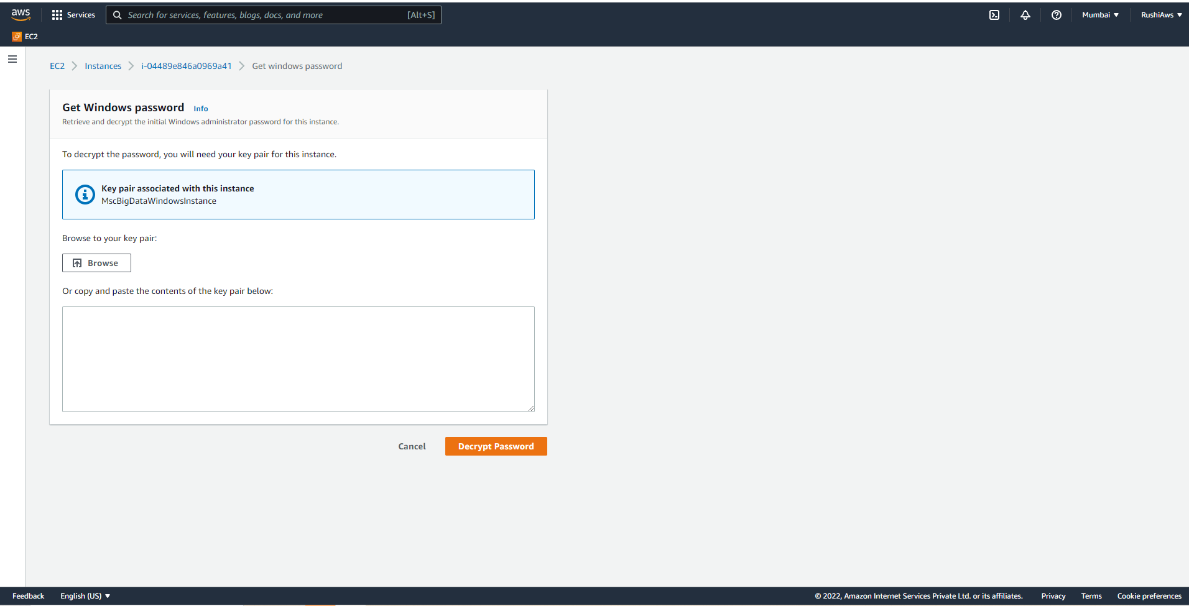

b)Connecting With RDC :

