CONNECTING A RDS MYSQL DATABASE AND CONNECTING TO IT WITH MYSQL WORKBENCH

1)Selecting MySQL

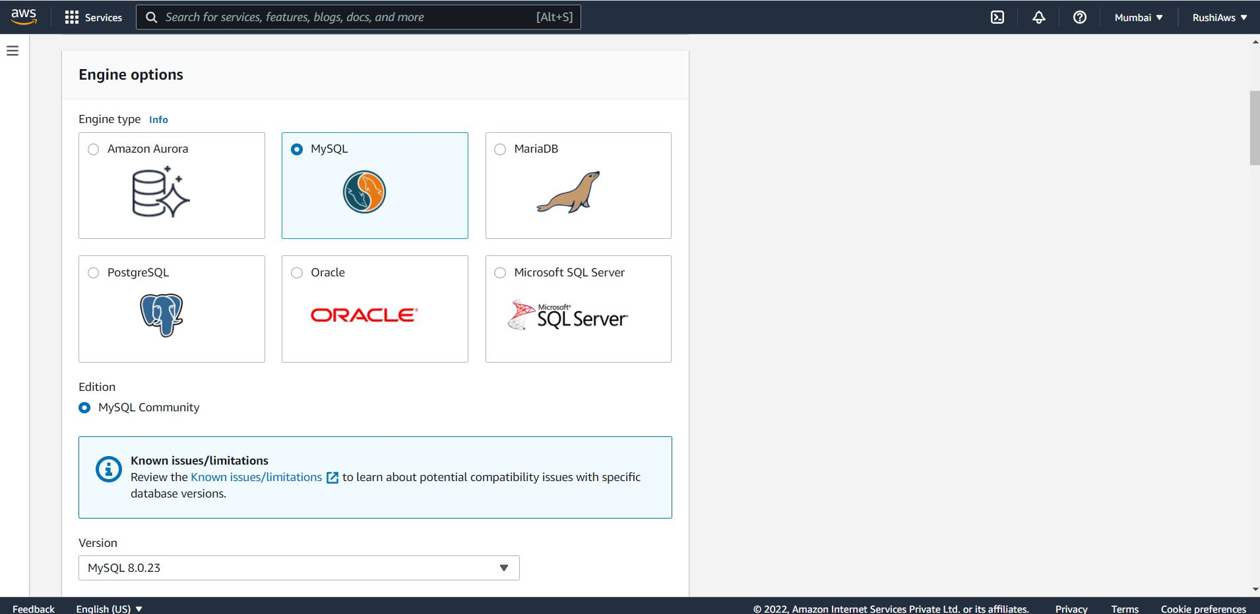

2)Dev or Production Options

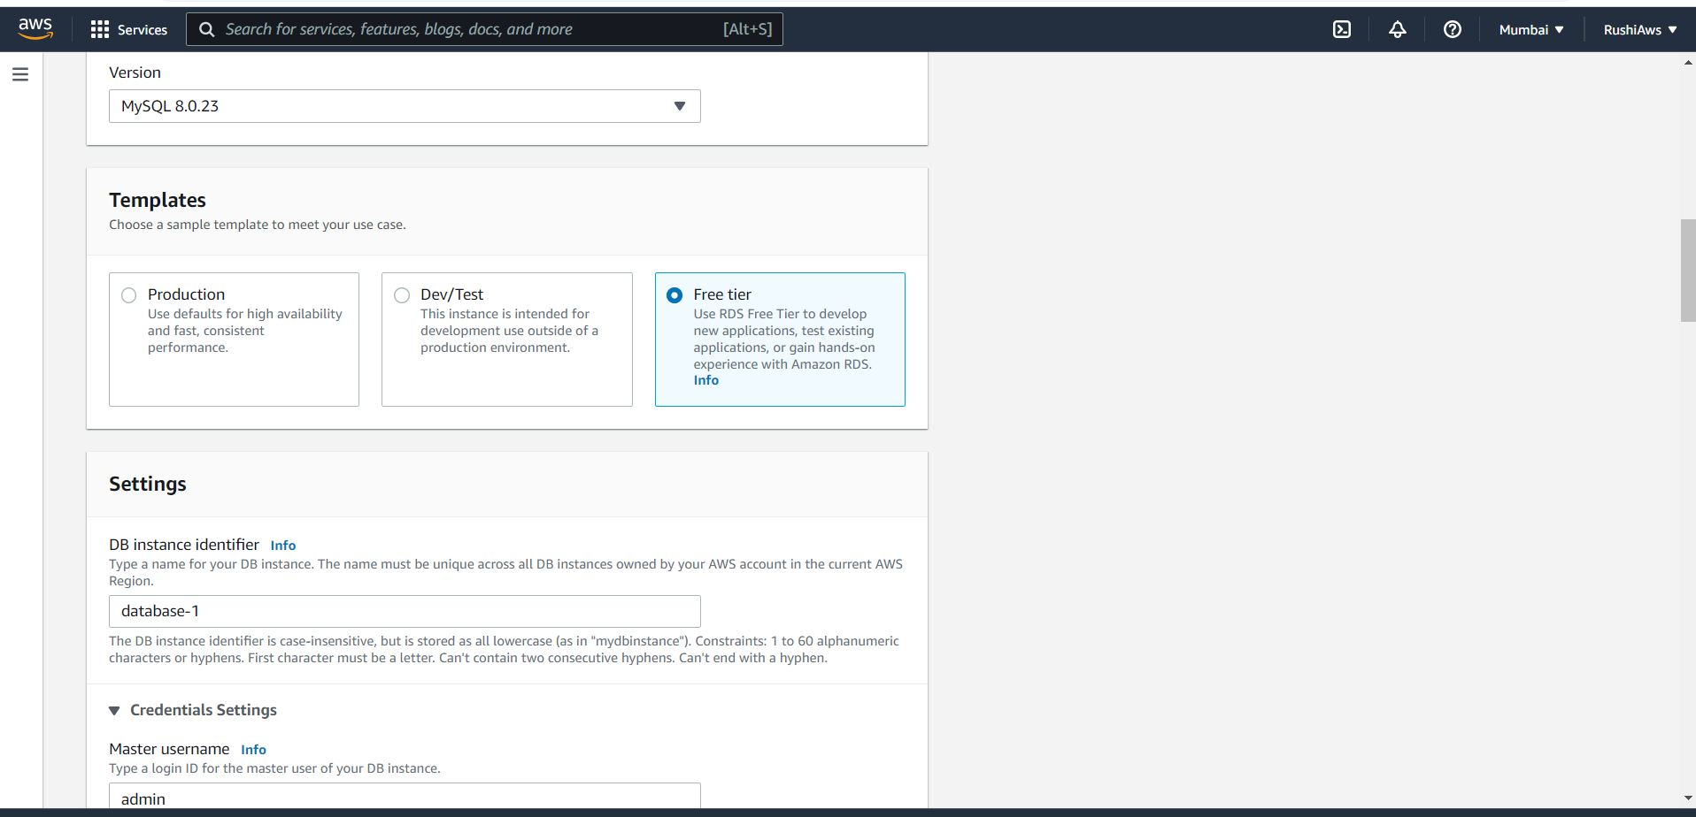

Credentials Setting

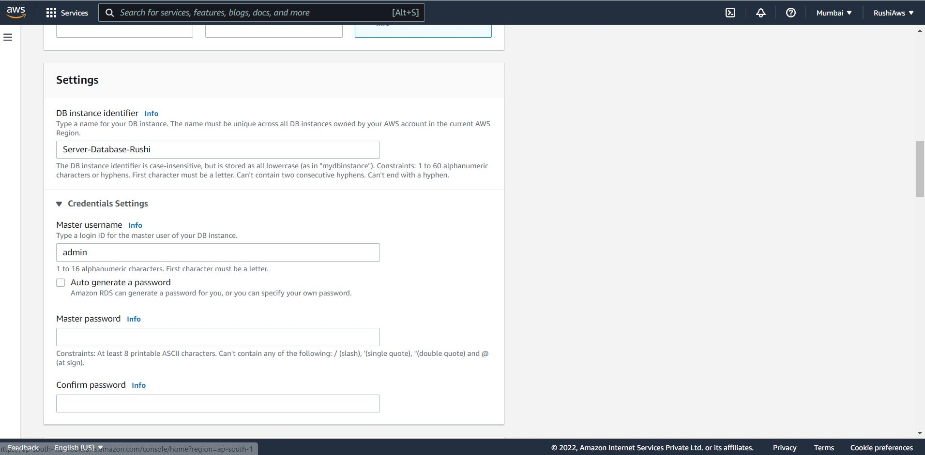

Storage Info :

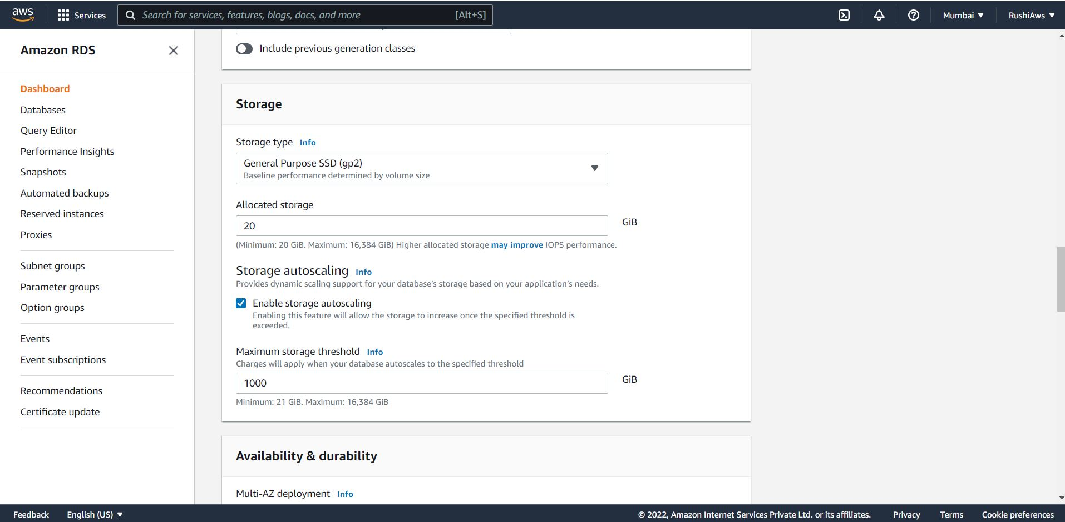

BackUp Options :

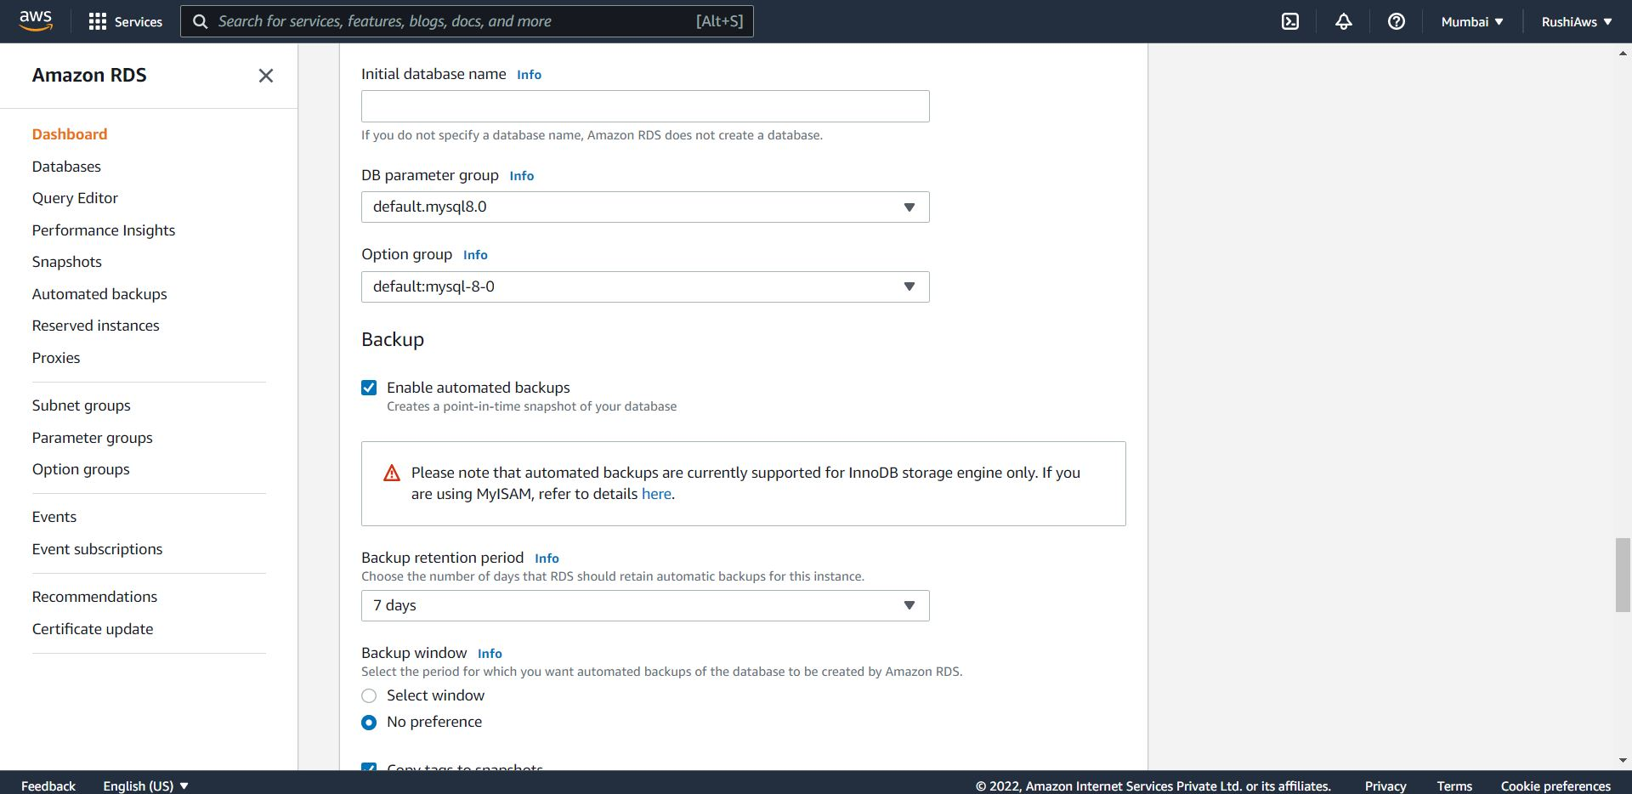

Security Settings:

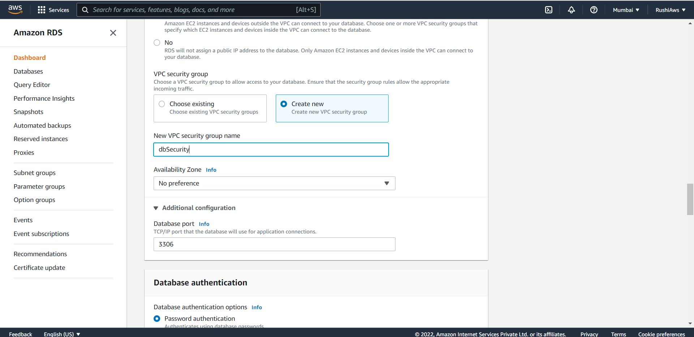

Database Created:

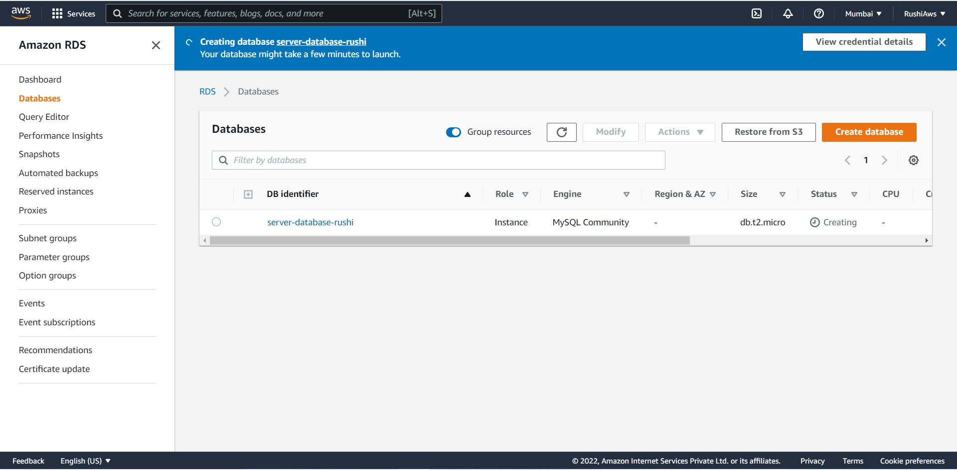

Connecting Using MySQL WorkBench :

