Name : Rushikesh Wakhare

**Capital Asset Pricing Model (CAPM)**

**Introduction :**

We take a look at the Capital Asset Pricing Model . We analyze weather the expected return we get from our investment beat the required return. For us to undertake the investment the CAPM says the expected return of a security or a portfolio equals the rate on a risk free security plus a risk premium .

We take a look at Four Companies : Asian Paint, Cipla , Dmart , Tiindia

and Compare it with BSE 500

**Calculating The Dialy log return:**

R Code :

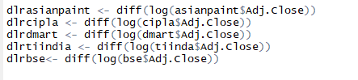

Calculating the Daily Returns of the Four Companies :

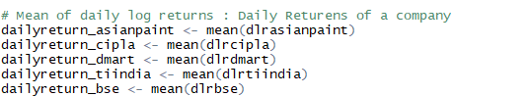

Calculating The Annualised Return :

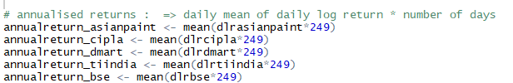

Calculating the Daily std dev : Historical daily std [Daily Risk]



Calculating the Annual Risk :

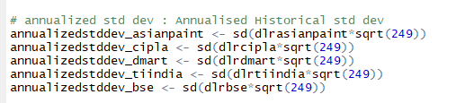

Building our regression Models :

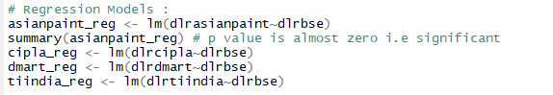

Calculating the beta for each companies :

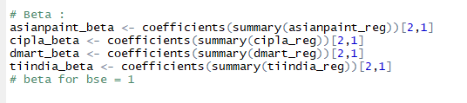

The India 10 Years Government Bond has a 7.362% yield

Rf = Risk free rate of return , Rf = 0.07362

# Rm - bse 500 annualised mean i.e annualised historical returns

Annualised Expected Return :

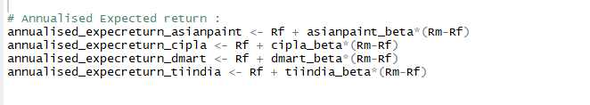

Sharpe’s Ratio :

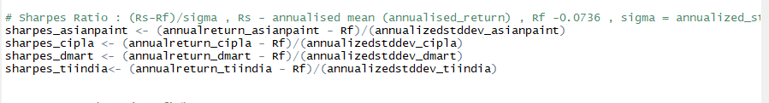

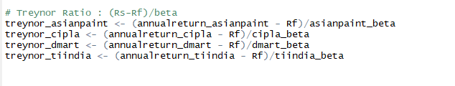

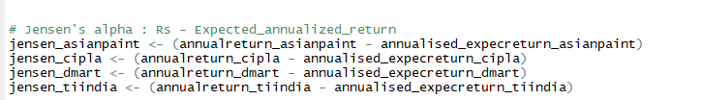

Scatter plots and Regression Lines :



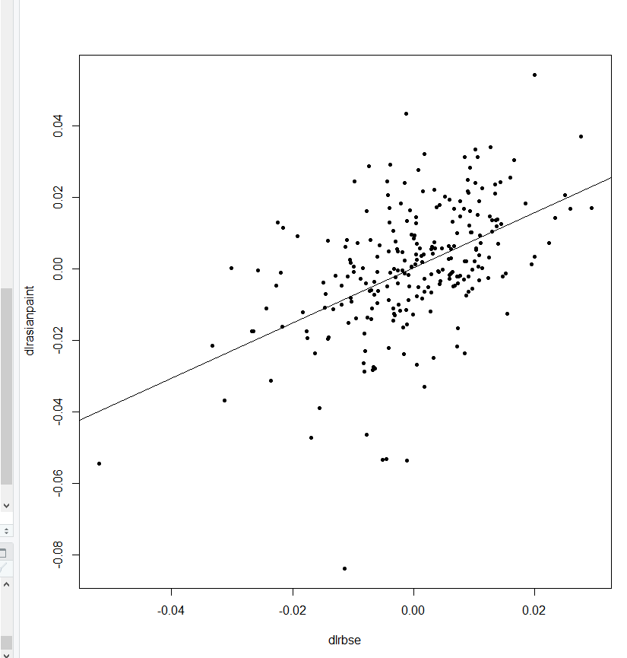



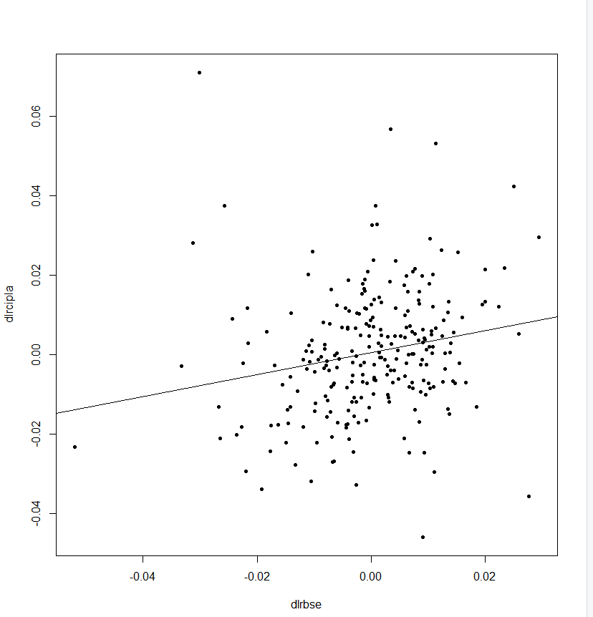



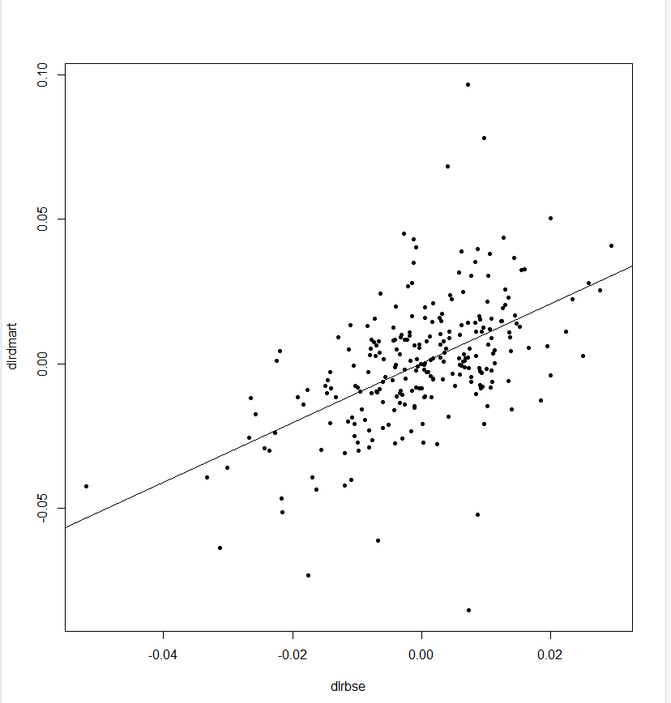



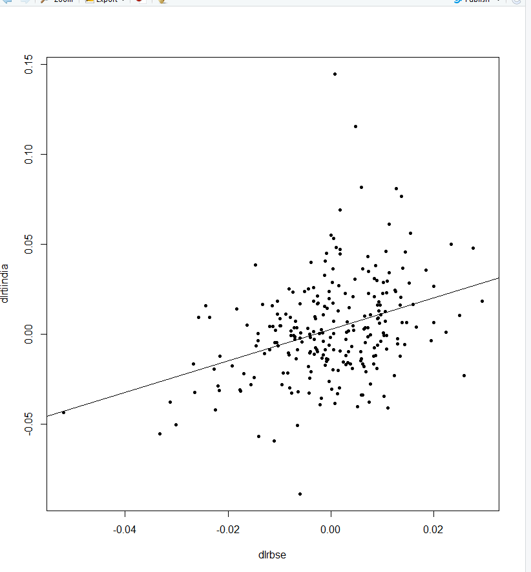

Creating A dataframe of all the values we calculated :

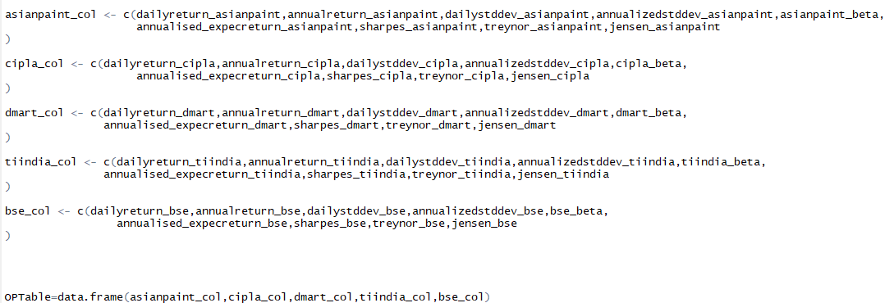

All the values in a table :

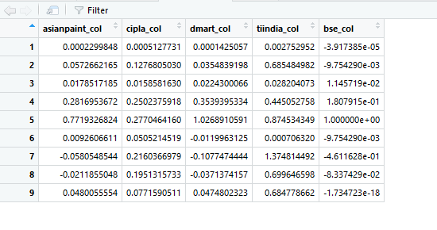

Conclusion :

We saw if our expected return of our portfolio equals the risk on a risk – free security plus a premium . This could be seen with all the ratio’s we calculated .