Name : Rushikesh Wakhare

**Portfolio Analysis**

Introduction:

We take a look at the daily stock price of three companies, specifically the adjusted closing price of the stock of the companies and we will see the

Return of the companies against the risk .

The companies are : Sapphire , Nazara , Nureca , Rossari

**Calculating The Dialy log return:**

R Code :

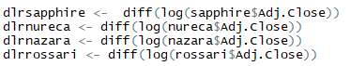

Calculating Daily Return, Annual Return , Daily Risk , Annual Risk For Nazzara :

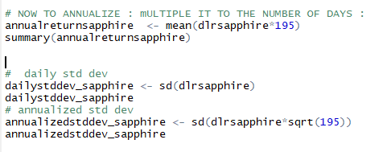

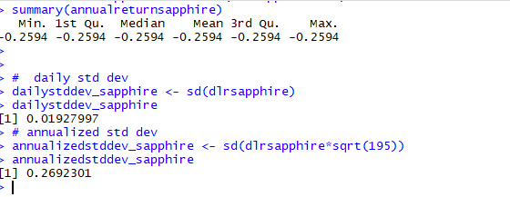

Calculating Daily Return, Annual Return , Daily Risk , Annual Risk For Nureca :

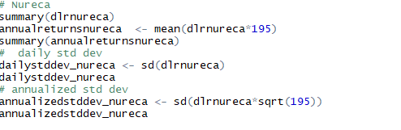

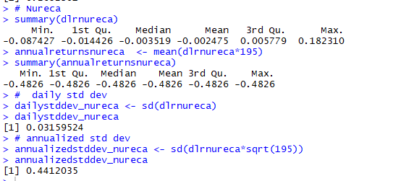

Calculating Daily Return, Annual Return , Daily Risk , Annual Risk For Nazzara :

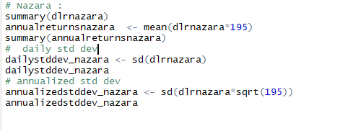

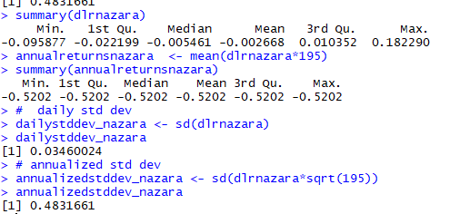

Calculating Daily Return, Annual Return , Daily Risk , Annual Risk For Rossari:

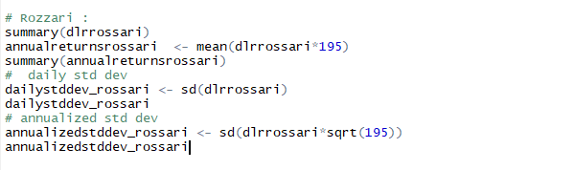

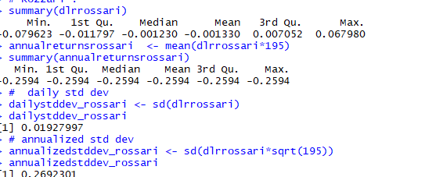

Creating a dataframe of our daily log returns of the four companies :



**To calculate the pairwise correlation of the companies with each other :**



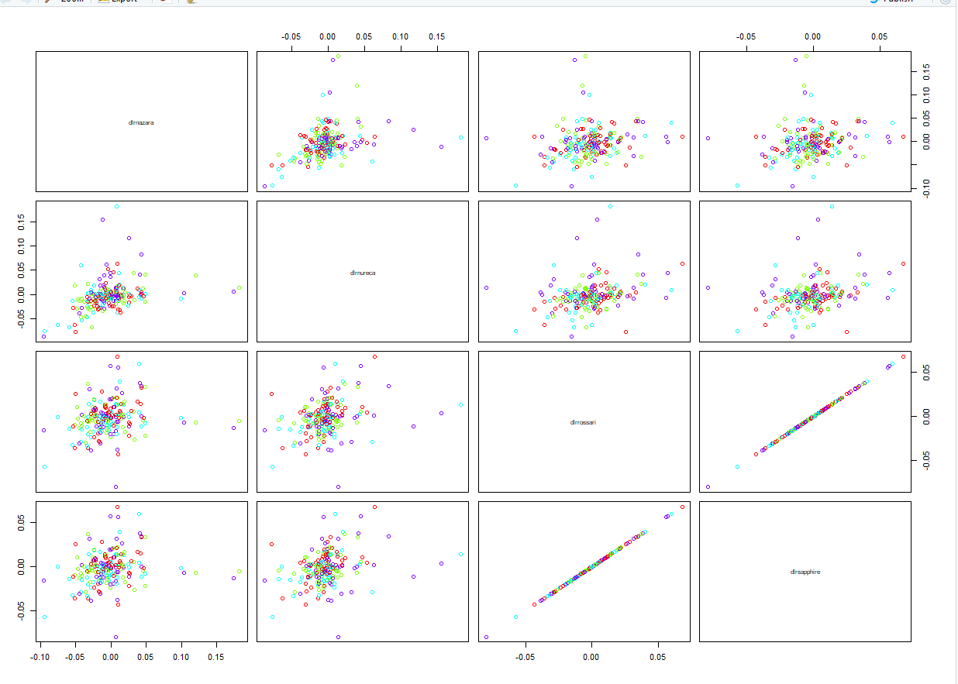

Variance Covariance Matrix :



Defining our weight matrix :

The weight matrix has the values according to the proportion of money invested in the respective stocks



Portfolio Variance :



Annualised portfolio Risk :



Portfolio Return :

