OrderFill allows sending one-way orders to Shoonya Desktop App, can be used with any program that supports writing .ini files and allows executables (Excel, Ami Broker, Python, C#, etc)

**File Structure**

OrderFill reads data from config.ini and processes it into order automation.

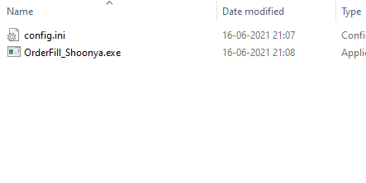

You can use any software that allows to write data into config file, the format for the config file should match with the parameters in image.

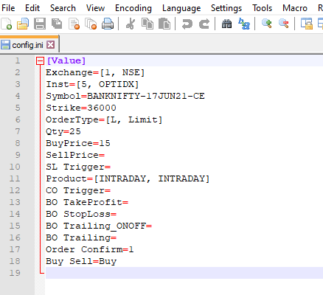

Such type of error is common when one or more parameter for order is incorrect/mismatch,

check for spaces, symbol name, etc. to avoid the same.

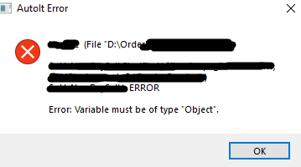

**User Guide Excel:**

In Excel create a new sheet named “OrderFill” without quotes and paste the given format in cell as shown in image below.

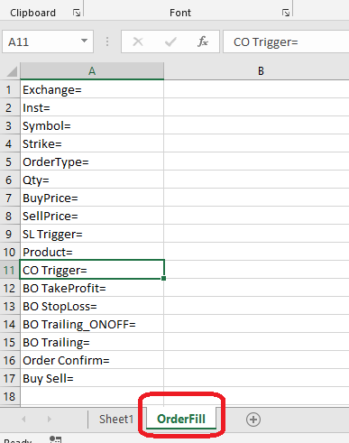

Exchange=

Inst=

Symbol=

Strike=

OrderType=

Qty=

BuyPrice=

SellPrice=

SL Trigger=

Product=

CO Trigger=

BO TakeProfit=

BO StopLoss=

BO Trailing_ONOFF=

BO Trailing=

Order Confirm=

Buy Sell=

OrderFill Sheet should match with Order-Box window in Shoonya

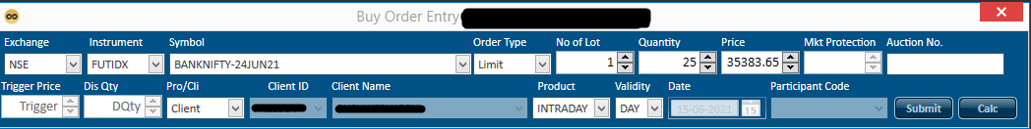

Use the codes given below for order parameters.

**Instrument=**

[1, EQUITY]

[2, FUTIDX]

[3, FUTSTK]

[4, FUTIVX]

[5, OPTIDX]

[6, OPTSTK]

[7, FUTCUR]

[8, OPTCUR]

**(For BSE)**

[9, EQUITY]

[24, FUTCUR]

[25, OPTCUR]

**(For MCX)**

[17, FUTCOM]

[18, OPTFUT]

[30, OPTCOM]

[32, FUTIDX]

**Exchange=**

[1, NSE]

[2, BSE]

[3, MCX]

**OrderType=**

[L, Limit]

[MKT, Market]

[SL, SL]

[SL-M, SL-M]

**Product=**

[MARGIN, MARGIN]

[INTRADAY, INTRADAY]

[CO, CO]

[BO, BO]

**Format**

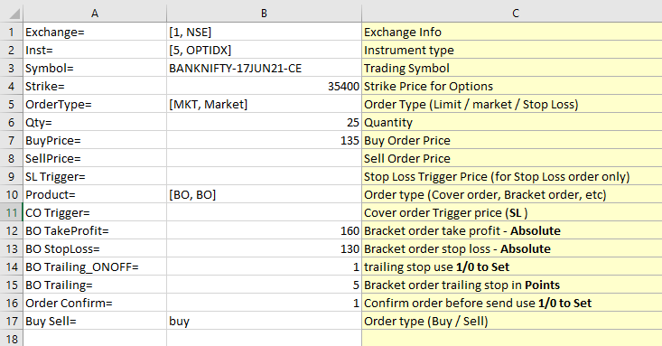

**Examples**

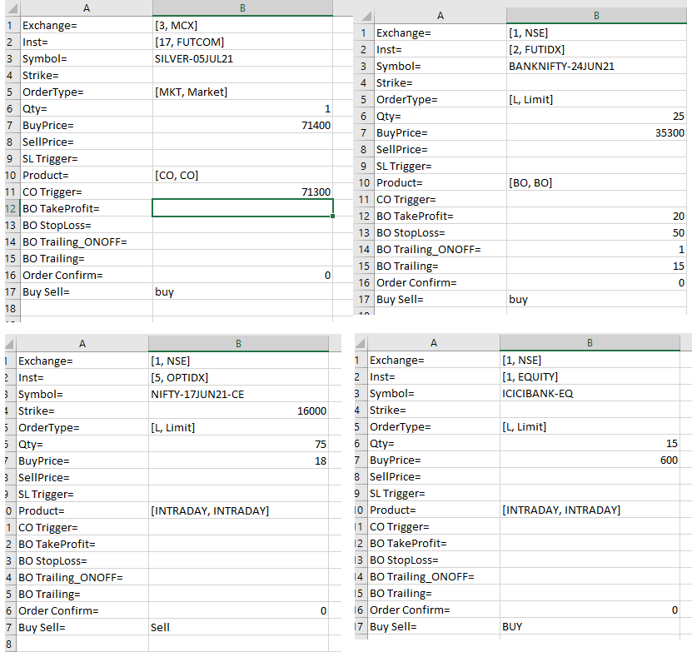

Enable Developer tab in excel by going to File > Options > Customize Ribbon 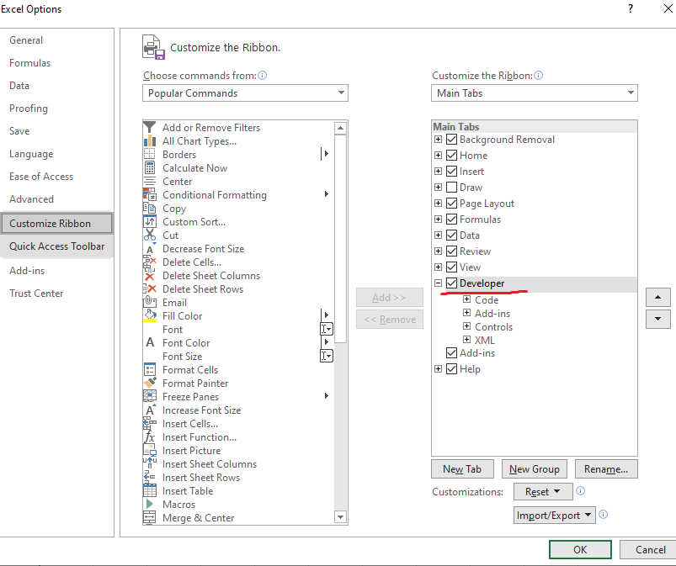

Create a Button or use your own excel VBA code to execute strategy.

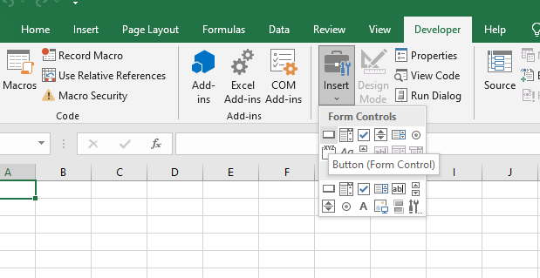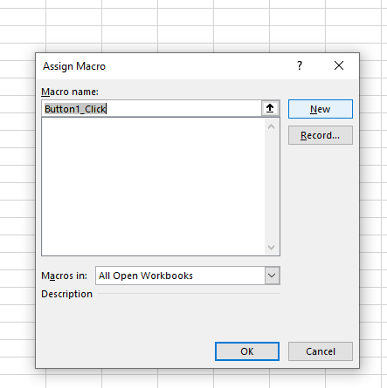

Button Code

Sub Button1_Click()

Dim oFile As String: oFile = "D:\OrderFill\config.ini"

Dim intFF As Integer: intFF = FreeFile()

Dim c As Range, r As Range

Dim output As String

For Each r In Range("A1:B17").Rows

For Each c In r.Cells

output = output & c.Value

Next c

output = output & vbNewLine

Next r

Open oFile For Output As #intFF

Print #intFF, "[Value]"; vbNewLine; output;

Close #intFF

Pid = Shell("D:\OrderFill\OrderFill_Shoonya.exe", vbNormalFocus)

[OrderFill!A20] = "Order Placed"

End Sub