Introduction

This web app allows all users to browse Ghumat aarti track details as well as group/club as well as album details. There are 2 types of users- public users and group/club user . The public users can only view the data. Where as club member can view as well ad add, edit or delete data that belongs to only he’s organization. An Admin can view, edit, delete, data.

Registration: When registering, default role is public, If user wants to register as club, it requires admin permission. Login is common for both users. The group user can fill all details that belongs to that particular group/club.

The aarti tracks belong to a particular ghumat aati group. The tracks are further categorised into published CD, competition live performances, and invitational performances. A group /club can have album that contains ghumat aarti tracks. Also a group can have tracks that are not yet released in an album.

Every track consist of track name, group name, last updated date, main singer. In case of published CD it consist of CD name, published date. In case of live and invitational performances it consist of performed date, organisation name, ..etc.

A user can access details of tracks on basis of the categories and can filter on basis of tack details.

Objectives

Objective is to provide all public users the ghumat aarti library details. That is all the club details, members belongs to the clubs, all the tracks belonging to the clubs, and also the composers of the tracks.

Also it gives platform to all the clubs to showcase their library of tracks and albums virtually.

ERD

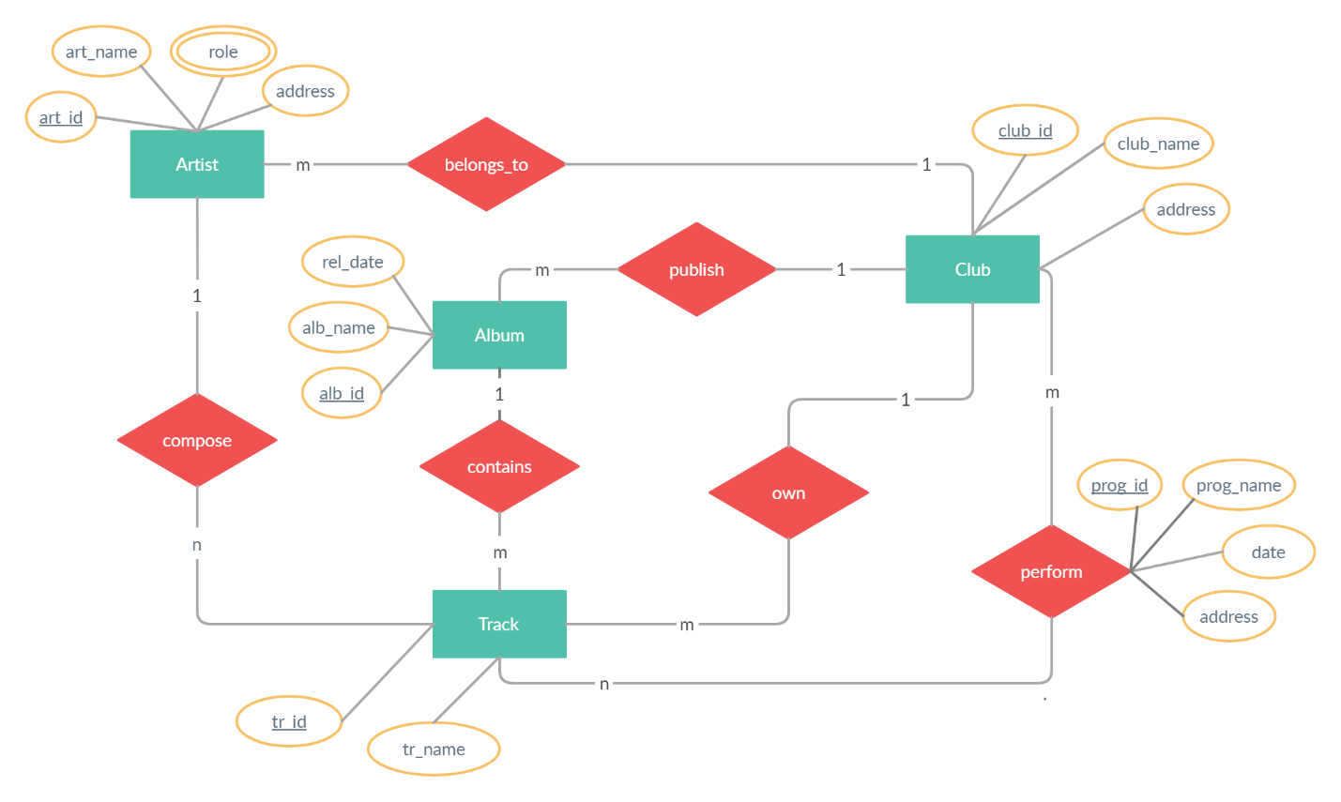

UML - Use Case Diagram

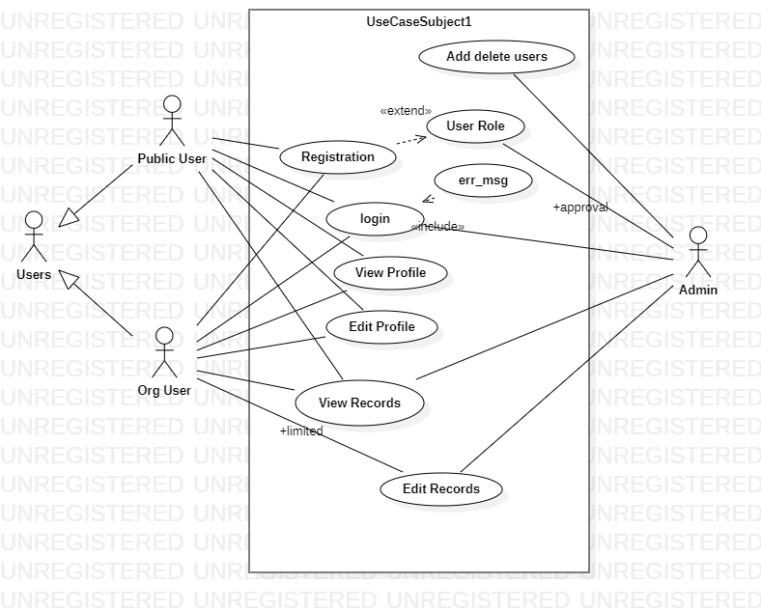

Database Tables

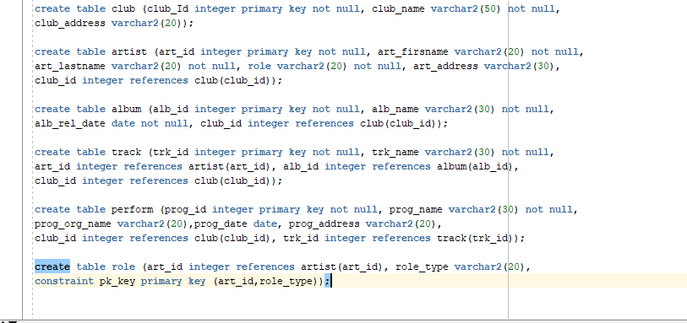

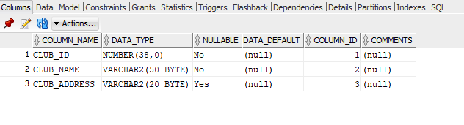

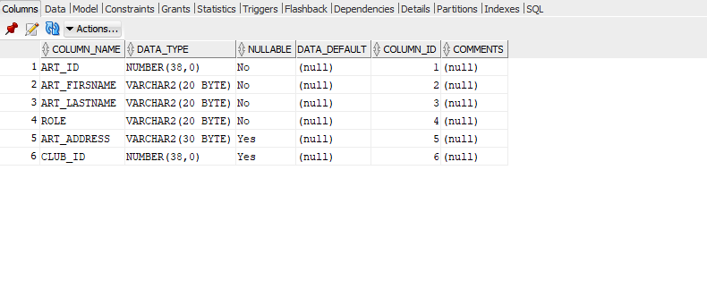

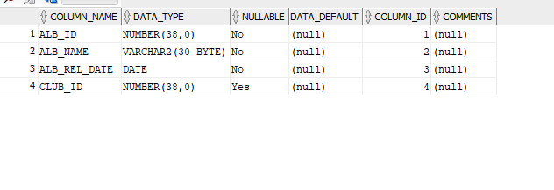

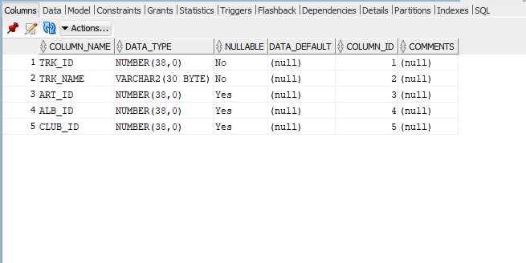

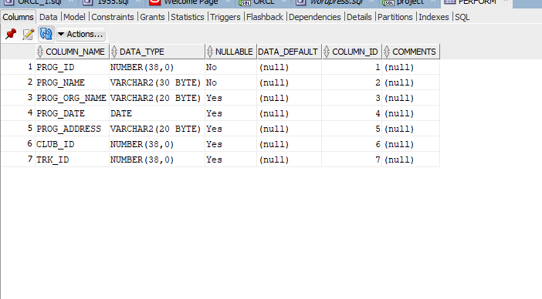

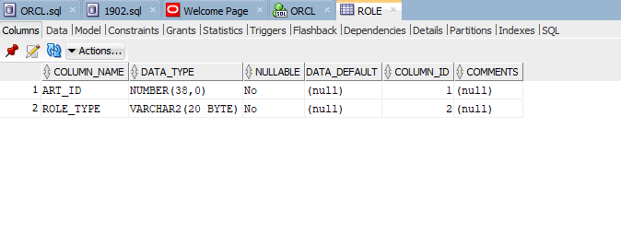

UI

