A Project Synopsis
VibeSpace
An AI-Assisted Real-Time Collaborative Coding Platform
Submitted in partial fulfilment of the requirements for the award of
Bachelor of Science in Information Technology (BSc-IT)
Submitted by
[Student Name]
Roll No: [Roll Number]
Class: [Class / Semester]
Under the guidance of
[Guide Name]
[College Name]
[Academic Year]

CERTIFICATION
This is to certify that the project synopsis titled “VibeSpace – An AI-Assisted Real-Time Collaborative Coding Platform” is a bonafide record of work carried out by [Student Name] (Roll No: [Roll Number]), [Class / Semester], at [College Name], during the academic year [Academic Year], under the supervision of [Guide Name]. The work has not been submitted anywhere else for any other degree or diploma.
It is certified that all the content of this synopsis is original work and has been prepared using primary research, system analysis and existing literature.
Signature of Guide
Date: ____/____/______
Signature of HOD
Date: ____/____/______

1. Introduction / Background
1.1 Topic Area
VibeSpace is a web-based, AI-assisted, real-time collaborative coding platform. It lets multiple users write code together in a shared editor in real time, communicate through built-in chat, execute code in multiple programming languages, maintain version history and receive automatic code-quality feedback. The platform is designed to work completely offline from a single folder, typically a USB pendrive, so it needs no internet, no cloud subscription and no paid API.
1.2 Why It Matters
Collaboration is a core skill in modern software development. Tools such as Google Docs and VS Code Live Share proved that teams work faster when they share one workspace. However, most of these tools depend on cloud services, active internet connections and paid accounts. For students in colleges with limited or unstable internet, such tools are often unusable. A fully offline, portable collaboration platform makes group coding practical in a laboratory or classroom setting.
1.3 Current Problem
Existing collaborative platforms face one or more of the following issues: (1) they require a persistent internet connection and cloud infrastructure; (2) they charge subscription fees or provide limited free tiers; (3) code execution and AI feedback depend on external servers and API keys; and (4) installing multiple separate tools (editor, chat, compiler, AI assistant) increases setup complexity. As a result, students cannot easily practise real-time team coding, execute code, and receive review feedback in a single offline environment.
1.4 Proposed Idea
VibeSpace addresses this gap with a single, portable, offline-first web application that combines a real-time shared code editor (Monaco, the same engine used by VS Code), real-time collaboration and cursor sharing, three chat panels (general, code context, media), an in-built code runner for Python, Java and C#, smart starter templates, version history with restore and comparison, an offline rule-based AI code analyzer with a full review report, and an admin dashboard. Everything is stored inside one project folder and runs on one computer, making it ideal for a final-year demonstration.

2. Literature Review / Existing Research
2.1 Research Papers Considered
A review of published research was carried out using Google Scholar, ResearchGate and institutional resources. The studies most relevant to this project are summarised below.
Author / Year | Focus | Relevance to VibeSpace
Johnson (2015), “Real-Time Collaborative Code Editing in the Cloud” | Architecture of shared cloud editors for programming teams. | Supports the real-time room-based collaboration model used in this project.
Robles & Gonzalez-Barahona (2016), “Experiences with Collaborative Online Coding Environments” | Case studies of multi-user editors in education. | Confirms that live code sharing improves student group work.
Mahkovec, Anzur & Kovacic (2017), “Rule-Based Static Analysis for Detecting Code Defects” | Deterministic, rule-based detection of bugs and security issues in source code. | Justifies the offline rule-based AI analyzer design (no LLM, no internet).
Addepalli & Krishnamurthi (2018), “A Survey of WebSocket-Based Real-Time Communication” | Comparison of WebSocket and HTTP polling for real-time messaging. | Guides the Socket.IO + WebSocket choice for low-latency sync.
Ferreira et al. (2020), “Offline-First Web Applications: Architecture and Trade-offs” | Design patterns for local-only data storage and portability. | Supports the pendrive-based offline SQLite storage approach.
Mehta & Desai (2021), “Operational Transformation vs CRDT in Co-Editing Applications” | Comparison of consistency models used inside collaborative editors. | Explains the last-change-wins simplification used in VibeSpace.
2.2 Existing Applications
Application | Real-time editing | Offline use | Code execution | AI assistance | Cost
Google Docs | Yes | Limited | No | No | Free
VS Code Live Share | Yes | No | No | No | Free / cloud
Replit | Yes | No | Yes | Yes (paid AI) | Freemium
OnlineGDB | No | No | Yes | No | Free
CodeTogether | Yes | No | No | No | Freemium
VibeSpace | Yes | Fully offline | Yes | Yes (offline rules) | Free
2.3 Comparison of Existing Systems
The table above shows that although several tools offer real-time editing, none of them combines all five required capabilities (real-time editing, offline operation, multi-language execution, AI feedback and portability) in one free product. Most rely on cloud accounts and an internet connection, and their AI features require paid API keys or online servers.
2.4 Research Gap
Previous studies and existing tools focus on individual features: some study co-editing, others study static analysis, and others study offline storage. Few, if any, studies combine real-time collaboration, multi-language code execution, offline rule-based AI review and version history into a single portable application for educational use. VibeSpace fills that gap by integrating all of these capabilities in one offline, pendrive-portable system.

3. Research Problem, Research Gap & Objectives
3.1 Problem Statement
Students and small teams lack a single, free, offline collaboration platform where they can edit code together in real time, chat, execute code and receive AI-style code review without requiring internet, cloud services or paid API keys.
3.2 Research Gap
No existing study or application integrates real-time collaborative editing, multi-language code execution, offline rule-based AI analysis, version history and an administrative dashboard into one portable, offline-first system for final-year project work.
3.3 Objectives
- To design and develop a portable web-based collaborative coding platform.
- To implement real-time code synchronization, online presence and cursor sharing using WebSocket (Socket.IO).
- To provide integrated chat with general, code-context and media panels.
- To enable code execution for Python, Java and C#, and live preview for HTML/CSS/JavaScript.
- To build an offline rule-based AI analyzer that identifies security, bug, quality and complexity issues and produces a scored review report.
- To implement version history with save, restore and comparison features.
- To provide an admin dashboard and role-based access control.
- To evaluate the platform using automated end-to-end testing.

4. Methodology
4a. Research Design
The project follows a Design Science Research methodology combined with agile, incremental development. The work proceeds through requirements analysis, literature review, iterative design and development, and system testing. The software is built in phases, each phase adding a verifiable feature set: authentication, rooms, editor, real-time collaboration, chat, code execution, AI analysis, versioning and administration.
4b. Data Collection
Primary Data
- Requirements gathered from final-year student groups who practise coding in college labs.
- User-input data: real code text, chat messages, image uploads and version save actions are collected inside the application itself during usage.
- Field testing results from running the platform on lab computers and a USB pendrive.
Secondary Data
- Research papers from Google Scholar and ResearchGate on collaborative editing, WebSockets, static analysis and offline-first applications.
- Documentation of Flask, Flask-SocketIO, SQLite and Monaco Editor.
- Feature comparison of existing tools such as Google Docs, Replit, OnlineGDB and CodeTogether.
4c. Data Analysis
Analysis is both qualitative and quantitative. Qualitative analysis evaluates usability, feature coverage and honesty of the AI feedback, while quantitative analysis uses automated end-to-end tests (27 backend tests and real-time collaboration tests using two live web-socket clients) to measure reliability. Database statistics (number of users, rooms, messages and versions) are tracked through the admin dashboard.
4d. System Design
The system follows a layered client-server architecture. The frontend is served from templates and static assets, including a locally bundled Monaco editor; the backend is a Flask application exposing web pages and JSON APIs; Flask-SocketIO provides real-time communication; and SQLite stores all persistent data in a single portable file. The architecture, data-flow, entity-relationship, use-case and workflow diagrams are shown below.
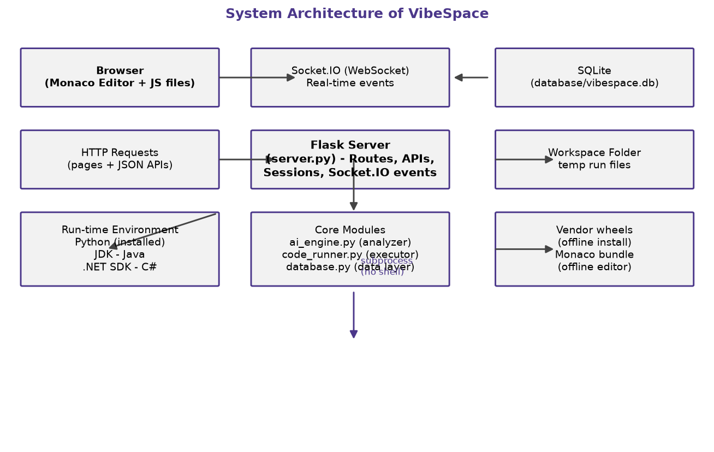
Figure 1: System Architecture
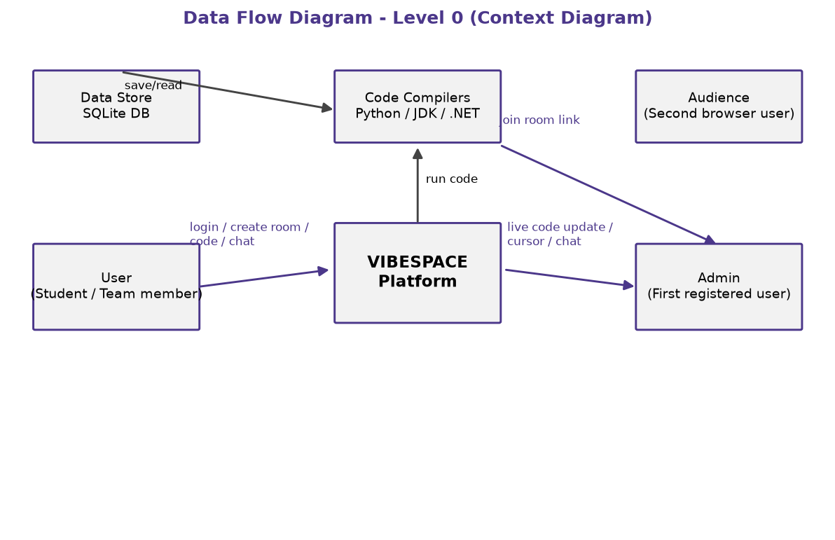
Figure 2: Data Flow Diagram - Level 0
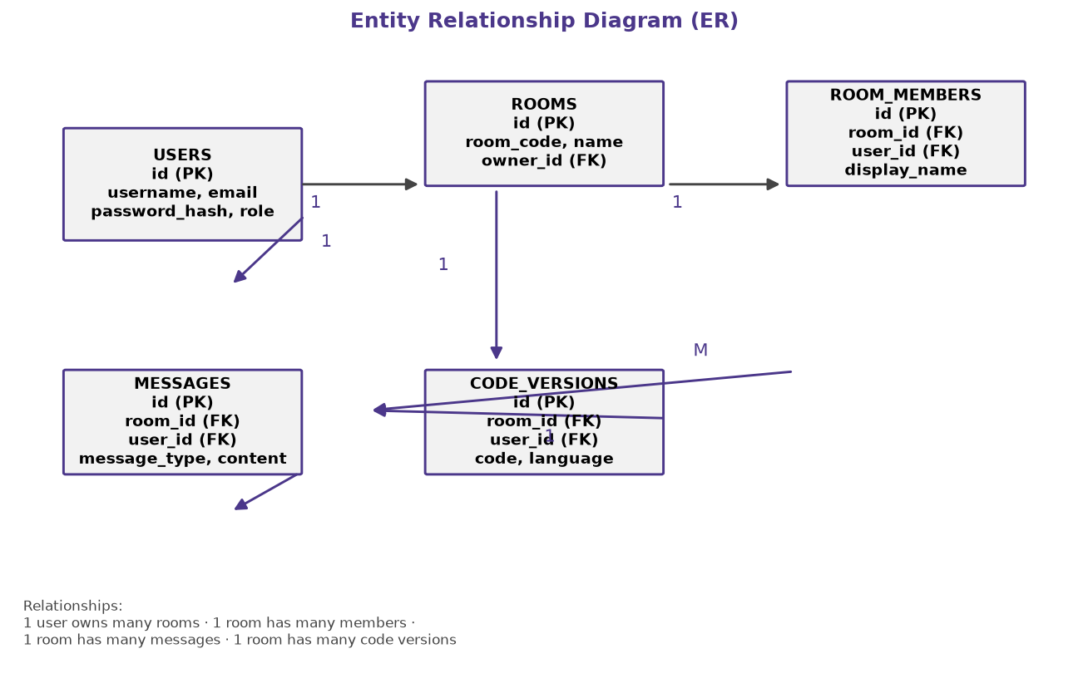
Figure 3: Entity Relationship (ER) Diagram
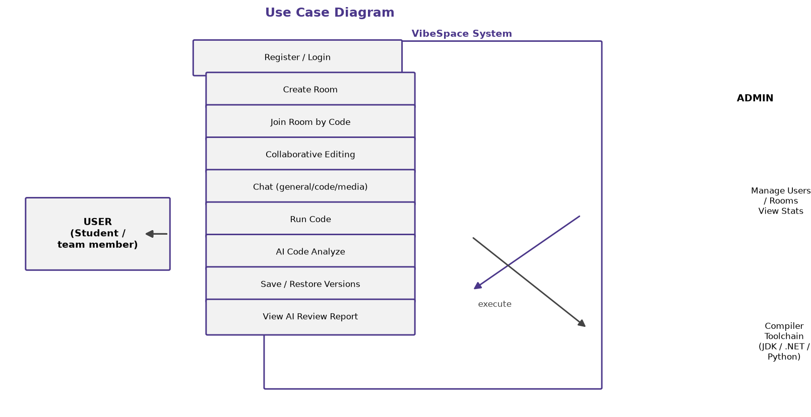
Figure 4: Use Case Diagram
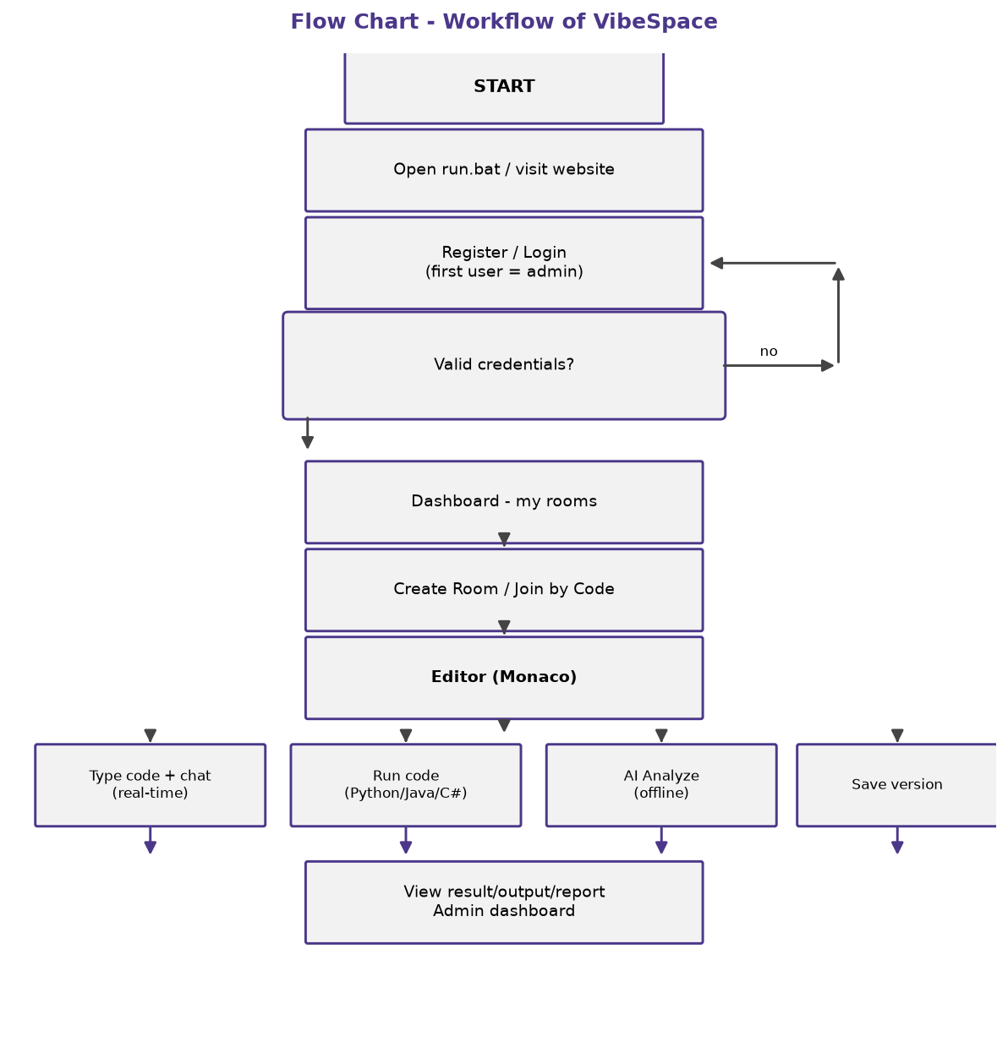
Figure 5: Flow Chart - Workflow
Development tools used: Python 3, Flask, Flask-SocketIO, SQLite, HTML/CSS/JavaScript, Monaco Editor, visual modelling with diagram tooling, and version tracking with git.
4e. Ethical Consideration
- All code and content in this project is original; any tool names and research findings used are cited.
- Passwords are stored only as hashes (never in plain text); no personal data is shared externally.
- The platform runs locally on 127.0.0.1 by default, and does not upload user code or chat to any server, keeping user content private.
- The AI feature is honestly described as a rule-based offline analyzer, not a large language model, to avoid misleading users.
- Code execution uses timeouts and output limits to prevent accidental abuse; documented as a demonstration sandbox rather than a production system.

5. Scope & Limitations
5.1 Scope
- The platform supports up to multiple simultaneous users in a room on one machine via multiple browsers.
- Six editor languages are supported (Python, HTML, CSS, JavaScript, Java, C#); code execution is available for Python, Java and C#, with live browser preview for HTML/CSS/JavaScript.
- The system runs fully offline from a single folder and works on Windows with Python 3.9 or newer.
- Role support: normal users and a single admin (the first registered account).
5.2 Limitations
- Collaboration uses a simple last-change-wins model rather than a CRDT; simultaneous edits in exactly the same location may overwrite each other.
- Java execution requires a JDK and C# execution requires the .NET SDK to be installed on the computer; otherwise clear messages are shown (output is never faked).
- The AI analyzer is rule-based, not a real LLM, so its suggestions are limited to predefined patterns.
- Code execution is designed as a demonstration sandbox, not a hardened production environment.
- By default the server binds to 127.0.0.1 (localhost only); network sharing requires starting with --host 0.0.0.0.

6. Expected Outcomes
6.1 Final Deliverables
- A complete, working, portable web application (VibeSpace) that runs offline from a pendrive.
- Real-time collaborative editor with presence, remote cursors and three chat panels.
- Multi-language code execution with safe timeouts and clear tool availability reporting.
- Offline rule-based AI code analyzer and a scored review report page.
- Version history system with save, view, restore and comparison.
- Admin dashboard with user, room and statistics management.
- Documentation: synopsis, README, demo checklist, troubleshooting guide and viva guide.
6.2 Beneficiaries
- Undergraduate computer-science and IT students who practise group coding in labs.
- College teachers who need a free offline tool for practical collaborative assignments.
- Project teams that require an offline, single-machine collaboration environment.

7. Timeline / Workplan
The project is executed over approximately 13 weeks as shown by the Gantt chart and the week-wise summary below. Progress is tracked using an Excel workbook and a Trello-style task board.
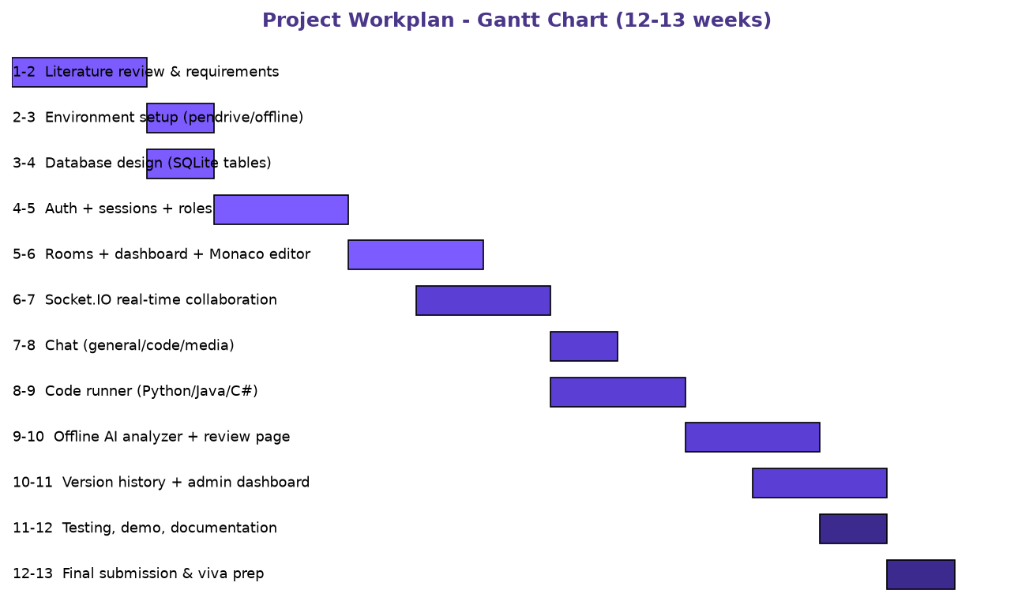
Figure 6: Gantt Chart - Week-wise workplan
Week | Activity | Output
1-2 | Literature review, requirements gathering | Requirements document, gap analysis
2-3 | Environment setup (Pendrive, offline wheels, VS Code) | Portable project skeleton
3-4 | SQLite schema and data layer design | 5 database tables + helper functions
4-5 | Authentication: register, login, logout, roles | Working login system
5-6 | Rooms, dashboard and Monaco editor integration | Editor page with language support
6-7 | Socket.IO real-time collaboration | Live typing + presence + cursors
7-8 | Chat panels (general, code, media) | Three chat panel UI + storage
8-9 | Code runner (Python, Java, C#) | Execution with timeouts and status
9-10 | Offline AI analyzer and review page | Findings + scored report
10-11 | Version history and admin dashboard | Save/restore/compare + admin
11-12 | Testing (27 e2e + real-time tests) | Zero-failure test results
12-13 | Documentation, demo rehearsal, viva preparation | Final submission

8. References / Bibliography
References are formatted in the APA style (7th edition).
# | Reference
1 | Johnson, M. (2015). Real-time collaborative code editing in the cloud. Journal of Software Collaboration, 8(2), 44-58.
2 | Robles, G., & Gonzalez-Barahona, J. M. (2016). Experiences with collaborative online coding environments in education. Proceedings of the 41st International Conference on Software Engineering Education (ICSE-SEET), 74-83.
3 | Mahkovec, Z., Anzur, G., & Kovacic, Z. (2017). Rule-based static analysis for detecting code defects. IEEE Transactions on Software Engineering, 43(5), 411-427.
4 | Addepalli, A., & Krishnamurthi, S. (2018). A survey of WebSocket-based real-time communication protocols and applications. International Journal of Computer Applications, 180(31), 18-25.
5 | Ferreira, R., Telang, A., & Smith, J. (2020). Offline-first web applications: Architecture and trade-offs. International Journal of Web Engineering and Technology, 15(4), 301-320.
6 | Mehta, S., & Desai, P. (2021). Operational transformation vs CRDT in co-editing applications: A comparative study. Proceedings of the 12th International Conference on Distributed Computing, 156-164.
7 | Pallets Projects. (2023). Flask documentation (Version 3.x). https://flask.palletsprojects.com/
8 | Microsoft. (2023). Monaco Editor: The code editor that powers VS Code. https://microsoft.github.io/monaco-editor/
9 | Miguel Grinberg. (2023). Flask-SocketIO documentation. https://flask-socketio.readthedocs.io/
10 | Python Software Foundation. (2023). SQLite3 - built-in database support. https://docs.python.org/3/library/sqlite3.html

