Creting database on AWS

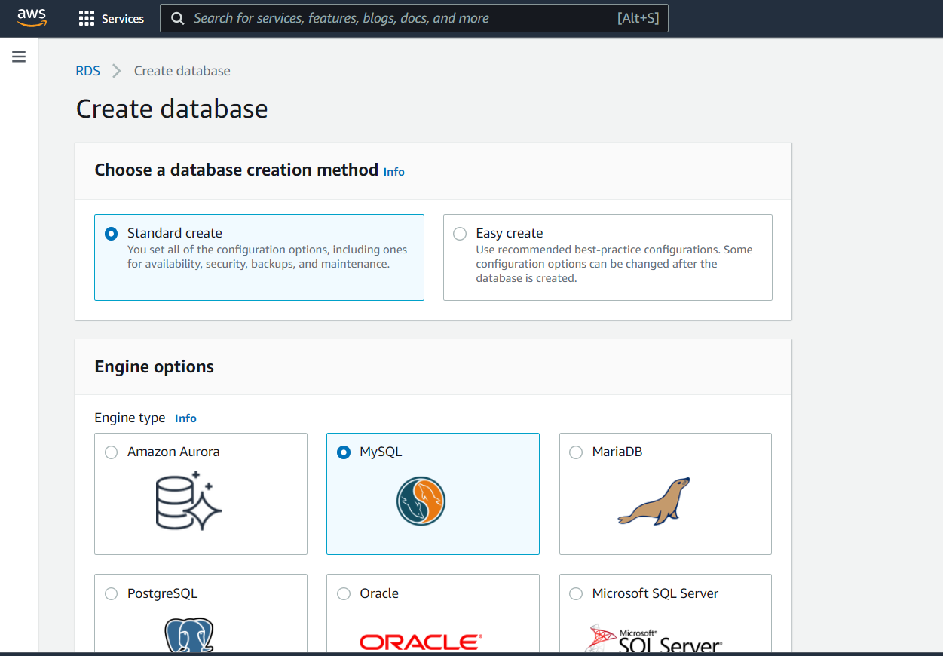

Creating the cloud storage using service AWS s3

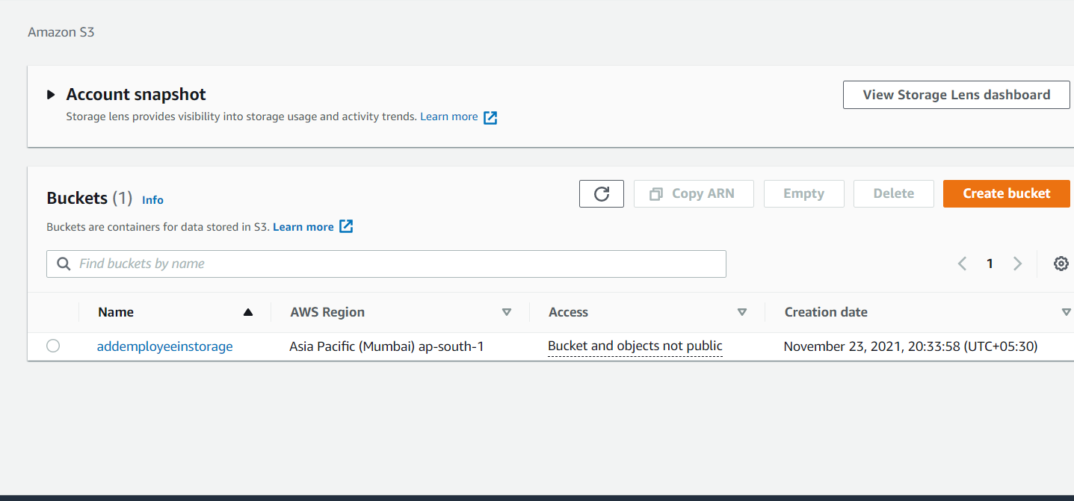

Creating the cloud server using AWs services EC2

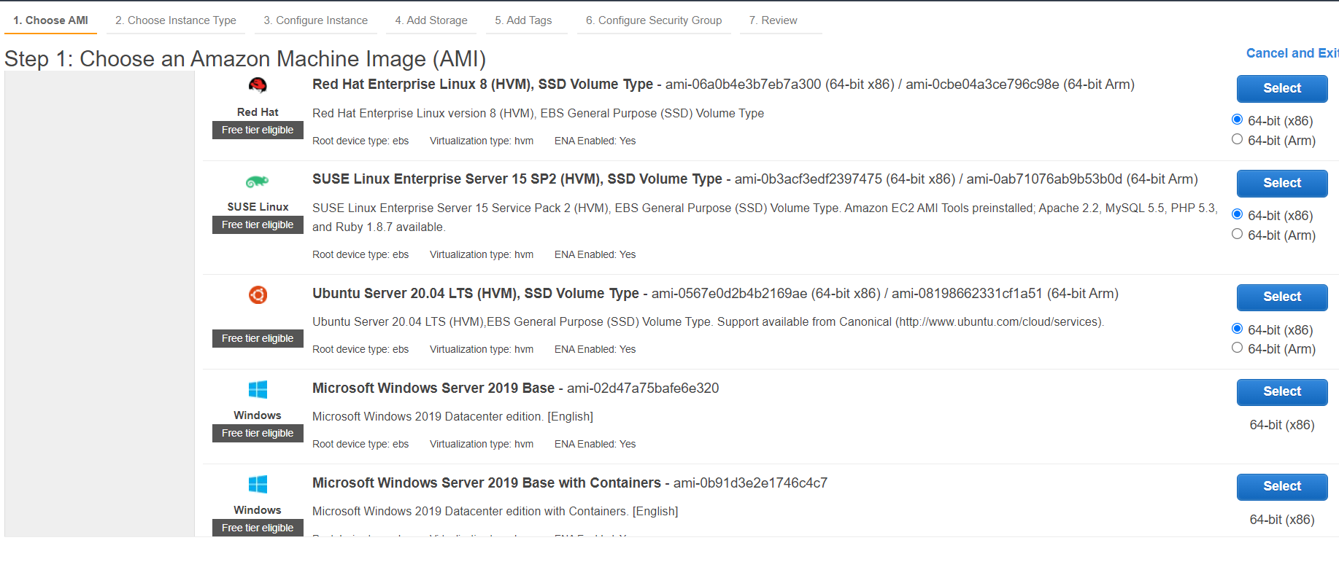

Connecting server with cmd and updating it

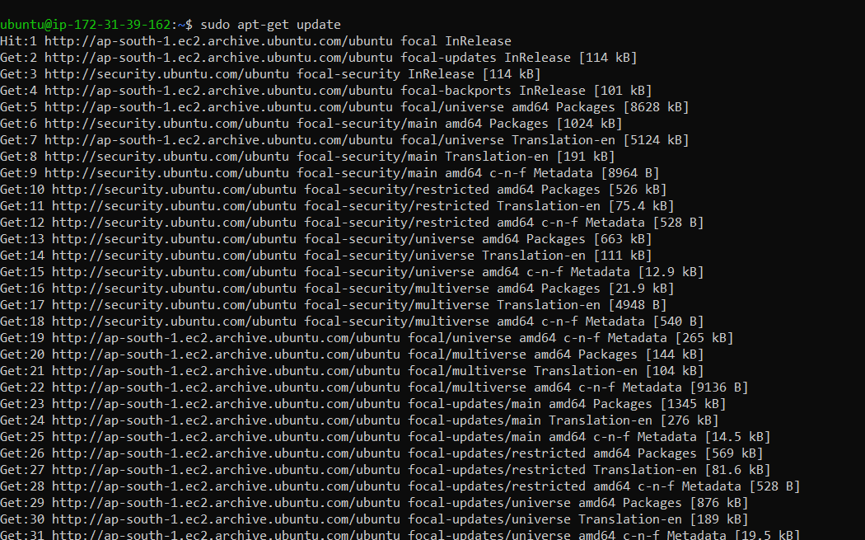

Installing mysql client on server  
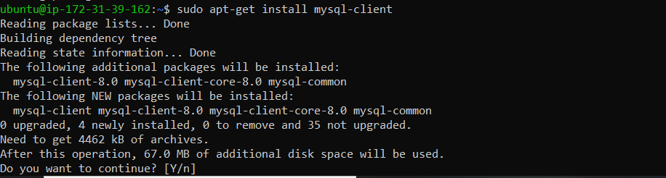

Connecting to my Sql client on server.