# Deploying End to

# End Website on

# AWS

Flow :- User-website-AWS

Aws contain route53(optional),EC2 instance,RDS,S3 and IAM

Creating database on AWS

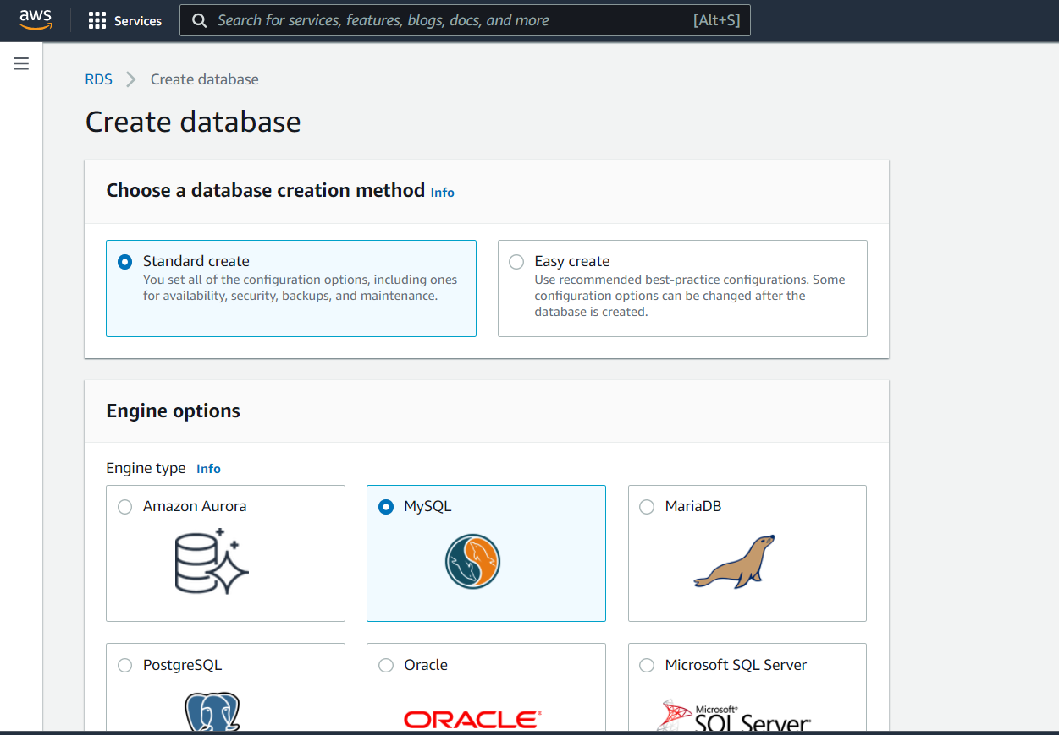

Creating the cloud storage using service AWS s3

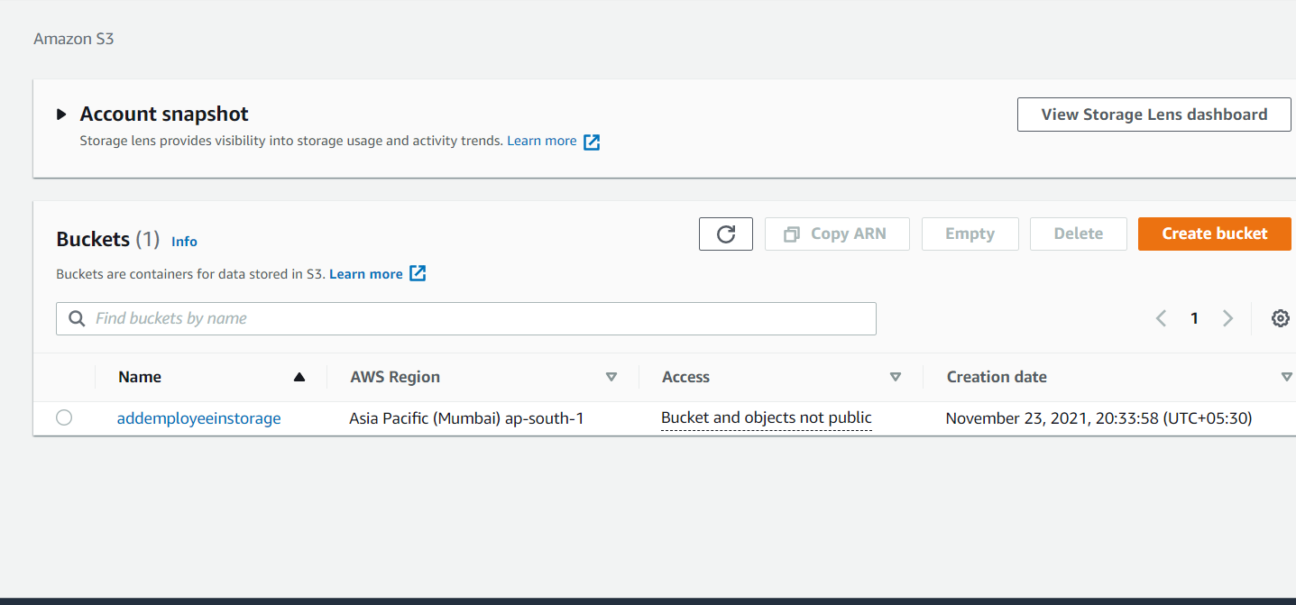

Creating the cloud server using AWs services EC2

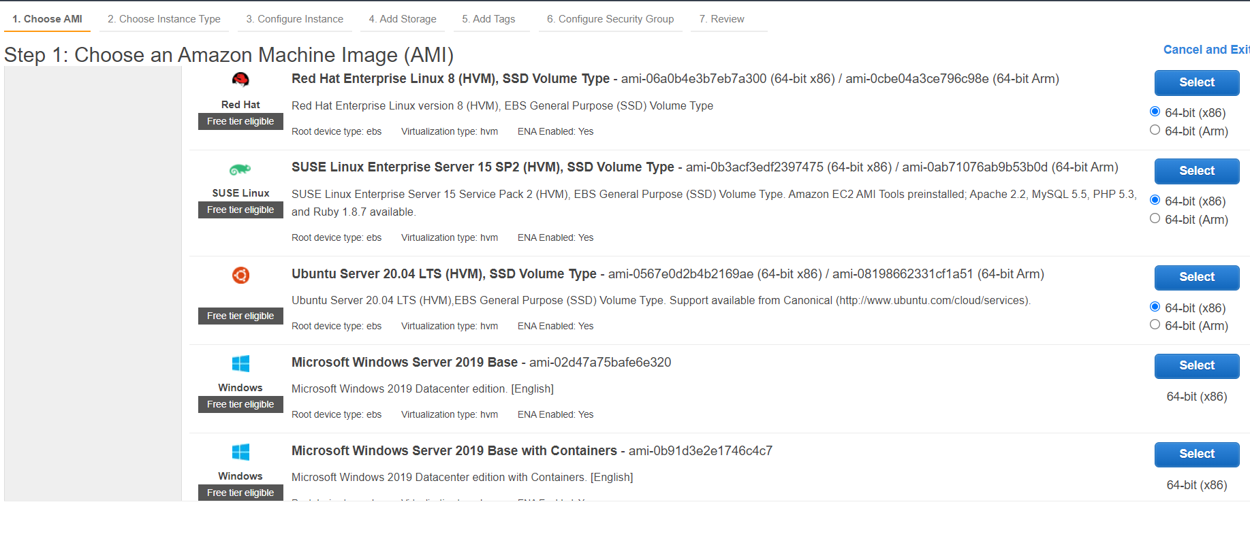

Connecting server with cmd and updating it

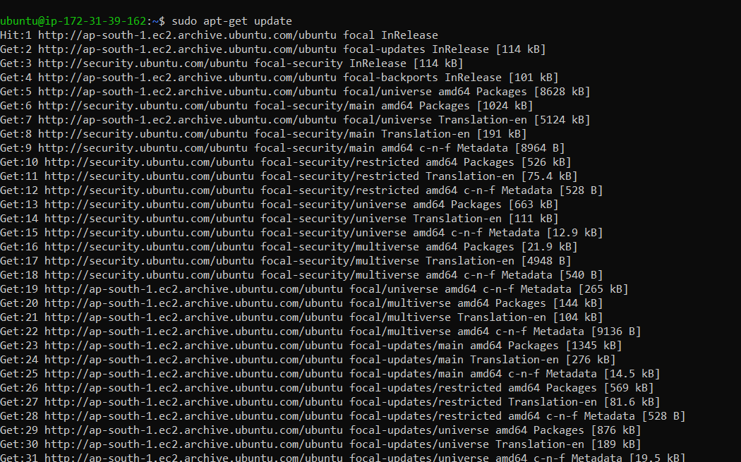

Installing mysql client on server  
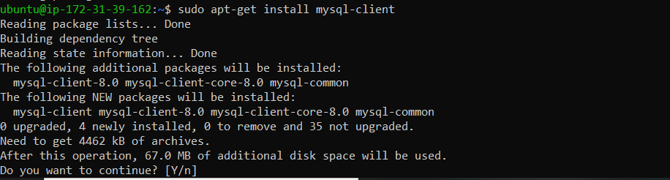

Connecting to my Sql client on server.

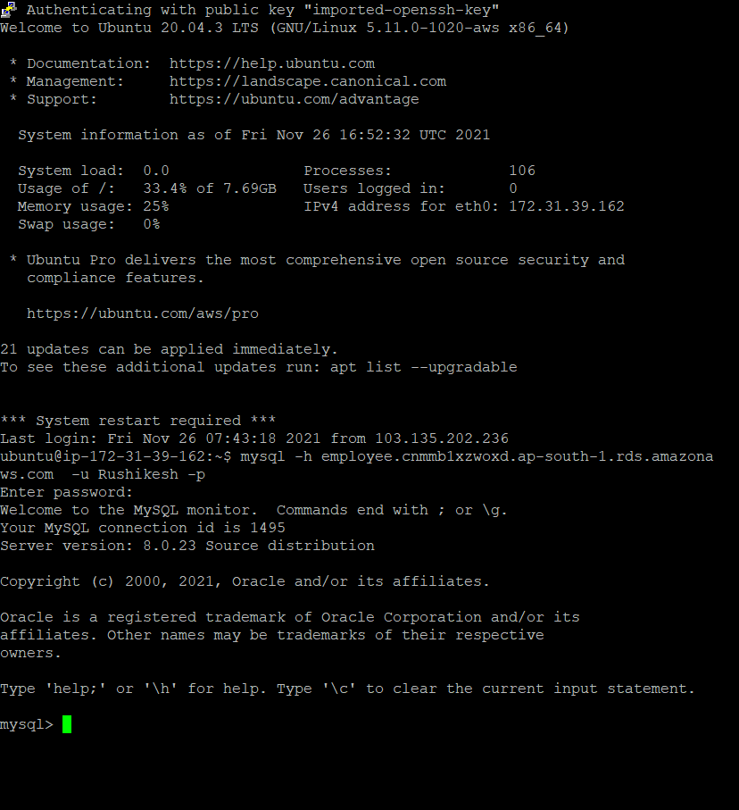

Installing python on AWS ec2 host   
  
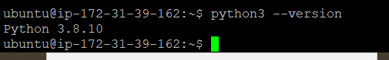

Please install git on your son your system like window so we can we can upload our our files Git Hub

And please also open account on github.com

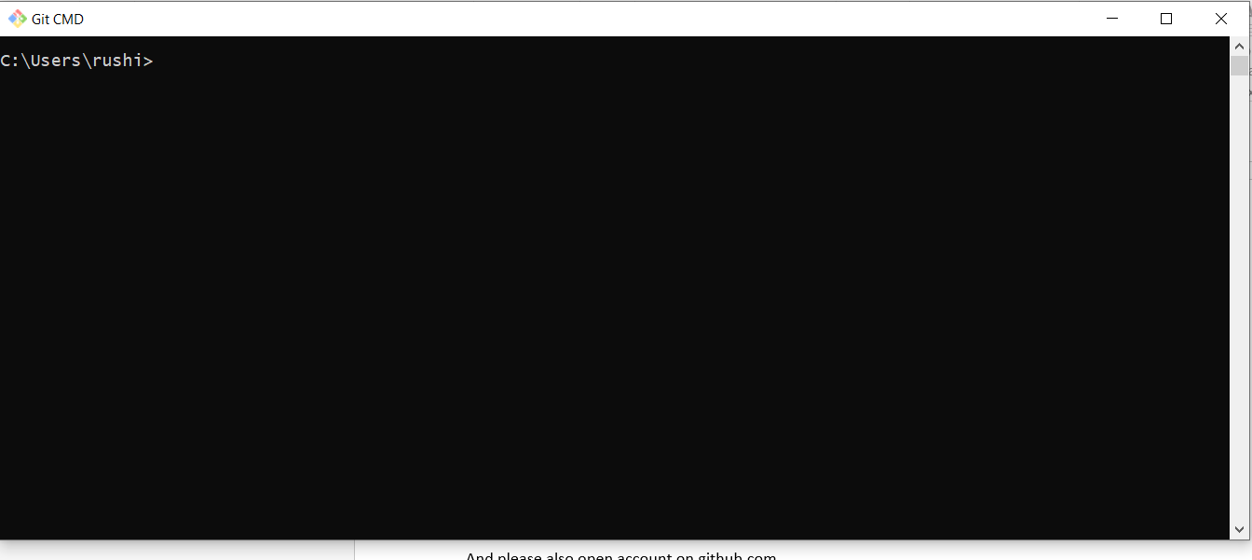

Commands for uploading document on Git on window

git add .

git commit –m “adding files”

git remote add origin repository url

git push –u origin master