AI-Assisted Regulatory Affairs

eCTD Module 3 Gap Analyzer
Simulated Validation Report - pre-submission CMC audit against ICH Q1A, Q2(R2), Q3A/B/C/D, Q6A and M7
Item | Detail
Author | Rushikesh Mohan Kumbhar, M.Pharm (Regulatory Affairs) candidate, Savitribai Phule Pune University
Report date | 3 November 2026
Project type | Portfolio / academic simulation
Data | 10 synthetic Module 3 draft sections (fictional drug names, invented data); 11 health authorities; 110 audit runs
Status | Simulation only. No real dossier, client data or live regulatory submission was used.

1. Executive summary
The eCTD Module 3 Gap Analyzer is a browser-based tool that audits draft CMC sections (3.2.S.2, S.3, S.4, S.7, P.2, P.5, P.8) against ICH quality guidelines and flags gaps a reviewer would likely raise. It combines a deterministic rule engine, which applies fixed threshold arithmetic and keyword/pattern checks, with a prompt-ready AI review layer (switched off in the audited build, so every result in this report is fully deterministic and reproducible) and an auto-generated Module 2.3 QOS draft.
For this report the rule engine was run on ten synthetic drafts: three written to be compliant and seven seeded with realistic defects (one of them the tool's built-in demo case). Key results:
Metric | Result
Documents audited | 10
Checks executed | 96
Missing findings | 35
Partial findings | 15
Documents passing the 90% gate (zero Missing) | 3 of 10
Verdict agreement with expected outcome | 10 of 10
Seeded defects detected / false positives | 39 of 39 / 0
Verdict distribution | 3 Ready to File, 2 Minor Revision Required, 5 Major RTF Risk

The seeded-defect result is a regression test, not independent accuracy evidence: the defects were written to exercise the tool's own rules. Section 8 sets out the limitations.

2. Project background and scope
Module 3 (Quality) is the part of the eCTD dossier most often cited in information requests and refuse-to-file decisions. Typical causes are vague acceptance criteria, missing validation characteristics, impurity limits above ICH thresholds, absent solvent and elemental-impurity control, thin stability packages and unreferenced master files. The analyzer automates a first-pass check for these issues.

2.1 Guidelines covered
- ICH M4Q(R1): CTD quality structure, batch analyses, specification justification, reference standards
- ICH Q6A: universal and specific tests, objective acceptance criteria
- ICH Q2(R2): validation characteristics (specificity, range, accuracy, repeatability, intermediate precision, QL, robustness)
- ICH Q3A(R2) / Q3B(R2): reporting, identification and qualification thresholds scaled to maximum daily dose
- ICH Q3C(R8): residual solvent classes and limits; ICH Q3D(R2): elemental impurity PDEs
- ICH M7(R2): mutagenic impurity and nitrosamine risk statements
- ICH Q1A(R2), Q1B, Q1E: stability conditions, batches, timepoints, photostability, shelf-life extrapolation

2.2 Authorities and sections
Eleven authorities are supported: US FDA, EMA, MHRA, PMDA, Health Canada, TGA, Swissmedic, CDSCO, NMPA, ANVISA and WHO Prequalification. Seven Module 3 sections can be audited: 3.2.S.2, S.3, S.4, S.7, P.2, P.5 and P.8. Regional notes in the tool are flagged "verify against current agency text".

3. Methodology

3.1 Test dataset
Ten synthetic drafts were used. Drug names (Treliban HCl, Lumapril, Zentravastatin Calcium) are fictional and all data are invented. Three drafts are compliant positives, six are negatives with specific defects seeded, and the tool's built-in demo draft (D10) completes the set.
ID | Case | Authority | Section | MDD (mg) | Expected
D01 | S.4 compliant (FDA) | US FDA | 3.2.S.4 | 40 | Ready to File
D02 | P.8 compliant (EMA) | EMA | 3.2.P.8 | 25 | Ready to File
D03 | P.5 compliant (Health Canada) | Health Canada | 3.2.P.5 | 25 | Ready to File
D04 | S.4 seeded defects (FDA) | US FDA | 3.2.S.4 | 80 | Major RTF Risk
D05 | P.8 weak stability (FDA) | US FDA | 3.2.P.8 | 10 | Major RTF Risk
D06 | P.5 vague/threshold errors (EMA) | EMA | 3.2.P.5 | 500 | Major RTF Risk
D07 | S.2 solvents/Pd/MF (PMDA) | PMDA | 3.2.S.2 | 50 | Major RTF Risk
D08 | S.4 DMF without LOA (FDA) | US FDA | 3.2.S.4 | 40 | Minor Revision Required
D09 | S.4 limits above Q3C/Q3D (FDA) | US FDA | 3.2.S.4 | 40 | Minor Revision Required
D10 | Zentravastatin S.4 (built-in demo) | US FDA | 3.2.S.4 | 80 | Major RTF Risk

3.2 Audit logic
- Each draft is checked by the deterministic rule engine, which returns a matrix of Compliant, Partial and Missing rows.
- Impurity thresholds are computed from the maximum daily dose (for example, at 80 mg/day a drug-substance unspecified-impurity limit above 0.10% is flagged).
- Score = (Compliant + 0.5 x Partial) / total checks. The gate passes only if Score is at or above the threshold (default 90%) and there are zero Missing items.
- Verdict: four or more Missing = Major RTF Risk; any Missing or three or more Partial = Minor Revision Required; otherwise Ready to File.
- Every draft was also re-run against all 11 authorities to measure regional sensitivity.

4. Results

4.1 Document-level outcomes
ID | Compliant | Partial | Missing | Score | Verdict | Gate
D01 | 10 | 0 | 0 | 100.0% | Ready to File | PASS
D02 | 7 | 0 | 0 | 100.0% | Ready to File | PASS
D03 | 8 | 0 | 0 | 100.0% | Ready to File | PASS
D04 | 1 | 3 | 8 | 20.8% | Major RTF Risk | FAIL
D05 | 1 | 3 | 4 | 31.3% | Major RTF Risk | FAIL
D06 | 1 | 2 | 7 | 20.0% | Major RTF Risk | FAIL
D07 | 0 | 0 | 4 | 0.0% | Major RTF Risk | FAIL
D08 | 7 | 4 | 2 | 69.2% | Minor Revision Required | FAIL
D09 | 10 | 0 | 2 | 83.3% | Minor Revision Required | FAIL
D10 | 1 | 3 | 8 | 20.8% | Major RTF Risk | FAIL

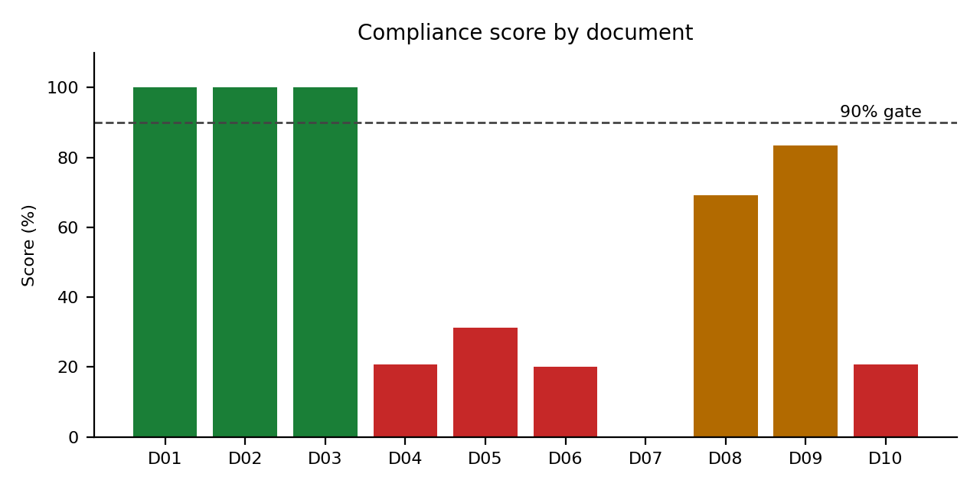

4.2 Findings by guideline
Guideline | Missing | Partial | Compliant | Gap rate
ICH M4Q(R1) | 6 | 4 | 9 | 53%
ICH Q2(R2) | 2 | 7 | 5 | 64%
ICH Q3D | 5 | 0 | 4 | 56%
ICH M7 | 5 | 0 | 3 | 63%
ICH Q1A(R2) | 3 | 2 | 6 | 45%
ICH Q3C | 4 | 0 | 3 | 57%
ICH Q3A/Q3B | 4 | 0 | 10 | 29%
ICH Q6A | 3 | 0 | 4 | 43%
Regional DMF/ASMF | 2 | 1 | 0 | 100%
ICH Q1E | 1 | 0 | 1 | 50%
ICH Q1B | 0 | 1 | 1 | 50%

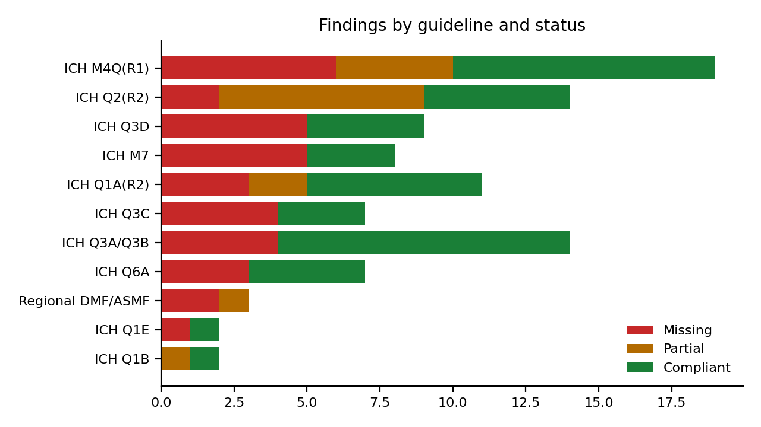
Q2(R2) validation gaps (mostly Partial: robustness and system suitability) and ICH M4Q(R1) content gaps (batch data, specification justification, reference standards) account for the largest number of open items. M7/nitrosamine statements and Q3C/Q3D control were each absent in more than half of the drafts in which they were checked.

5. Case study: built-in demo draft (D10)
D10 is a 3.2.S.4 draft for the fictional Zentravastatin Calcium, audited for US FDA at a maximum daily dose of 80 mg. The tool returned Major RTF Risk with 8 Missing, 3 Partial and 1 Compliant checks (score 20.8%).
Element | Status | Reviewer risk | Corrective action
Acceptance criteria specificity | Missing | Non-quantitative criteria: "Identification (IR): Conforms to reference standard"; "Identification (HPLC): Conforms"; "Polymorphic form (XRPD): Conforms to Form I"; "Pa... | Replace with objective criteria (e.g. IR spectrum matches reference standard, correlation NLT x; particle size D90 NMT x um).
Residual solvents | Missing | Solvents not controlled with named limits (generic compendial reference is insufficient). | List each solvent with Q3C class and limit (e.g. methanol NMT 3000 ppm).
Elemental impurities | Missing | Legacy heavy-metals limit test used; no Q3D risk assessment. | Add Q3D risk assessment (classes 1, 2A, intentionally added catalysts) and control strategy with PDE-based limits.
Mutagenic impurity / nitrosamine risk statement | Missing | No mutagenic impurity or nitrosamine assessment statement. | Add M7 and nitrosamine risk assessment conclusion with report reference.
Validation: Intermediate precision | Missing | Intermediate precision not demonstrated in validation summary. | Add Intermediate precision data with acceptance criteria and results.
Validation: Robustness | Partial | Robustness not demonstrated in validation summary. | Add Robustness data with acceptance criteria and results.
Validation: System suitability | Partial | System suitability not demonstrated in validation summary. | Add System suitability data with acceptance criteria and results.
Unspecified impurity limit | Missing | Limit 0.20% exceeds identification threshold 0.10% at MDD 80 mg/day. | Tighten to NMT 0.10% or identify/qualify.
Batch analyses | Missing | Batch results not provided. | Include tabulated results and CoAs.
Justification of specification | Missing | No scientific, data-based justification. | Justify each limit with batch/stability data, ICH thresholds and clinical/toxicological basis.
Reference standards (3.2.S.5) | Partial | Reference standard characterisation not described. | Add S.5 characterisation.
QL within reporting threshold | Compliant | No deficiency detected. | None

Auto-generated Module 2.3 QOS excerpt. Gaps are marked rather than filled, which keeps the draft honest about what the source text supports:
3.2.S.4 Control of Drug Substance is presented for review by US FDA. The section reports three pilot-scale batches. A specification is presented. Analytical procedures are supported by validation data. [DATA GAP: Q3D assessment] [DATA GAP: residual solvent limits] [DATA GAP: M7/nitrosamine assessment] Impurity thresholds were evaluated for a maximum daily dose of 80 mg.

6. Regional sensitivity
ID | Section | Verdict across 11 authorities | Missing count range
D01 | 3.2.S.4 | Ready to File | 0
D02 | 3.2.P.8 | Ready to File | 0
D03 | 3.2.P.5 | Ready to File | 0
D04 | 3.2.S.4 | Major RTF Risk | 8
D05 | 3.2.P.8 | Major RTF Risk | 4
D06 | 3.2.P.5 | Major RTF Risk | 7
D07 | 3.2.S.2 | Varies by authority | 3 to 4
D08 | 3.2.S.4 | Minor Revision Required | 1 to 2
D09 | 3.2.S.4 | Minor Revision Required | 2
D10 | 3.2.S.4 | Major RTF Risk | 8

The rule engine is mostly authority-neutral. Authority changes the result in two places: master-file checks (an FDA letter of authorisation, a Health Canada letter of access or a PMDA registration number is required, whereas other authorities accept an ASMF/CEP/registration reference) and the climatic zone IVb check (30C/75%RH long-term data) for CDSCO, ANVISA and WHO PQ. Only D07 changed verdict: Major RTF Risk for FDA, PMDA and Health Canada, Minor Revision Required for the rest. The remaining regional alerts are narrative notes from the tool's knowledge base and do not change the score.

7. Conclusions and next steps
- The tool separates compliant from deficient drafts on the synthetic set with specific corrective actions; its threshold arithmetic (Q3A/Q3B, Q3C, Q3D) is deterministic and reproducible.
- Next steps: test on de-identified or publicly available dossier text, add independent defect sets written by a second reviewer, add authority-specific rule checks beyond DMF and stability zone, and version the benchmark text against current agency guidance.

8. Limitations and disclaimers
- All test documents are synthetic and this is academic, training-level work, not live regulatory submission experience. Results do not demonstrate performance on real submissions.
- Seeded defects were authored to match the tool's own rules, so 100% detection is a regression-test outcome rather than independent accuracy evidence.
- The tool is a screening aid. A qualified regulatory affairs professional must review any output before it informs a filing decision.
- Benchmark values and regional notes are condensed summaries and must be verified against current ICH and agency documents.

Appendix A. Open findings by document (excluding D10)
Doc | Element | Guideline | Status | Reviewer risk | Corrective action
D04 | Acceptance criteria specificity | ICH Q6A | Missing | Non-quantitative criteria: "Identification (IR): Conforms to reference standard"; "Identification (HPLC): Conforms"; "Polymorphic form (XRPD): Conforms to Form I"; "Particle size: Conforms". Review... | Replace with objective criteria (e.g. IR spectrum matches reference standard, correlation NLT x; particle size D90 NMT x um).
D04 | Residual solvents | ICH Q3C | Missing | Solvents not controlled with named limits (generic compendial reference is insufficient). | List each solvent with Q3C class and limit (e.g. methanol NMT 3000 ppm).
D04 | Elemental impurities | ICH Q3D | Missing | Legacy heavy-metals limit test used; no Q3D risk assessment. | Add Q3D risk assessment (classes 1, 2A, intentionally added catalysts) and control strategy with PDE-based limits.
D04 | Mutagenic impurity / nitrosamine risk statement | ICH M7 | Missing | No mutagenic impurity or nitrosamine assessment statement. | Add M7 and nitrosamine risk assessment conclusion with report reference.
D04 | Validation: Intermediate precision | ICH Q2(R2) | Missing | Intermediate precision not demonstrated in validation summary. | Add Intermediate precision data with acceptance criteria and results.
D04 | Validation: Robustness | ICH Q2(R2) | Partial | Robustness not demonstrated in validation summary. | Add Robustness data with acceptance criteria and results.
D04 | Validation: System suitability | ICH Q2(R2) | Partial | System suitability not demonstrated in validation summary. | Add System suitability data with acceptance criteria and results.
D04 | Unspecified impurity limit | ICH Q3A/Q3B | Missing | Limit 0.20% exceeds identification threshold 0.10% at MDD 80 mg/day. | Tighten to NMT 0.10% or identify/qualify.
D04 | Batch analyses | ICH M4Q(R1) | Missing | Batch results not provided. | Include tabulated results and CoAs.
D04 | Justification of specification | ICH M4Q(R1) | Missing | No scientific, data-based justification. | Justify each limit with batch/stability data, ICH thresholds and clinical/toxicological basis.
D04 | Reference standards (3.2.S.5) | ICH M4Q(R1) | Partial | Reference standard characterisation not described. | Add S.5 characterisation.
D05 | Number of batches | ICH Q1A(R2) | Missing | 1 batch(es) only. | Provide data on at least three primary batches.
D05 | Accelerated condition | ICH Q1A(R2) | Missing | No accelerated 40C/75%RH data. | Add 6-month accelerated data.
D05 | Long-term duration | ICH Q1A(R2) | Missing | Longest timepoint 6 months. | Provide >=12 months long-term data.
D05 | Shelf-life extrapolation | ICH Q1E | Missing | 36-month claim vs 6 months of data. | Reduce claim or add data.
D05 | Photostability | ICH Q1B | Partial | Photostability absent or waived without data. | Provide Q1B data or justification.
D05 | Dissolution on stability | ICH Q1A(R2) | Partial | Dissolution not tested. | Include dissolution.
D05 | Post-approval protocol/commitment | ICH Q1A(R2) | Partial | No defined protocol/commitment. | Add protocol with batches, conditions, frequency.
D06 | Acceptance criteria specificity | ICH Q6A | Missing | Non-quantitative criteria: "Identification (HPLC, UV): Conforms"; "Microbial limits: Complies". Reviewers raise information requests. | Replace with objective criteria (e.g. IR spectrum matches reference standard, correlation NLT x; particle size D90 NMT x um).
D06 | Elemental impurities | ICH Q3D | Missing | No Q3D elemental impurity assessment found. | Add Q3D risk assessment (classes 1, 2A, intentionally added catalysts) and control strategy with PDE-based limits.
D06 | Mutagenic impurity / nitrosamine risk statement | ICH M7 | Missing | No mutagenic impurity or nitrosamine assessment statement. | Add M7 and nitrosamine risk assessment conclusion with report reference.
D06 | Validation: Robustness | ICH Q2(R2) | Partial | Robustness not demonstrated in validation summary. | Add Robustness data with acceptance criteria and results.
D06 | Validation: System suitability | ICH Q2(R2) | Partial | System suitability not demonstrated in validation summary. | Add System suitability data with acceptance criteria and results.
D06 | Unspecified impurity limit | ICH Q3A/Q3B | Missing | Limit 0.5% exceeds identification threshold 0.20% at MDD 500 mg/day. | Tighten to NMT 0.20% or identify/qualify.
D06 | Quantitation limit vs reporting threshold | ICH Q3A/Q3B | Missing | QL 0.15% exceeds reporting threshold 0.1%. | Demonstrate QL <= 0.1%.
D06 | Batch analyses | ICH M4Q(R1) | Missing | Batch results not provided. | Include tabulated results and CoAs.
D06 | Justification of specification | ICH M4Q(R1) | Missing | No scientific, data-based justification. | Justify each limit with batch/stability data, ICH thresholds and clinical/toxicological basis.
D07 | Residual solvents | ICH Q3C | Missing | Solvents not controlled with named limits (generic compendial reference is insufficient). | List each solvent with Q3C class and limit (e.g. methanol NMT 3000 ppm).
D07 | Elemental impurities | ICH Q3D | Missing | No Q3D elemental impurity assessment found. | Add Q3D risk assessment (classes 1, 2A, intentionally added catalysts) and control strategy with PDE-based limits.
D07 | Mutagenic impurity / nitrosamine risk statement | ICH M7 | Missing | No mutagenic impurity or nitrosamine assessment statement. | Add M7 and nitrosamine risk assessment conclusion with report reference.
D07 | DMF/MF cross-reference | Regional DMF/ASMF | Missing | Master file referenced without the required authorisation or registration identifier. | Cite the MF registration number and holder details.
D08 | Mutagenic impurity / nitrosamine risk statement | ICH M7 | Missing | No mutagenic impurity or nitrosamine assessment statement. | Add M7 and nitrosamine risk assessment conclusion with report reference.
D08 | Validation summary | ICH Q2(R2) | Partial | Validation only cross-referenced to a master file; no applicant verification data. | Summarise validation and provide applicant-site verification.
D08 | Batch analyses | ICH M4Q(R1) | Partial | Batches mentioned without numerical results. | Add numerical results per batch.
D08 | Reference standards (3.2.S.5) | ICH M4Q(R1) | Partial | Reference standard characterisation not described. | Add S.5 characterisation.
D08 | DMF/MF cross-reference | Regional DMF/ASMF | Missing | Master file referenced without the required authorisation or registration identifier. | Cite the current LOA for DMF (21 CFR 314.420) and holder details.
D08 | Applicant-side method verification | Regional DMF/ASMF | Partial | No applicant-site verification of DMF methods. | Add verification/transfer data.
D09 | Residual solvent limits vs Q3C | ICH Q3C | Missing | Limit exceeds Q3C: methanol 5000 ppm > 3000. | Tighten to the Q3C limit or justify (Option 2 / PDE).
D09 | Elemental impurity limits vs oral PDE | ICH Q3D | Missing | Pb 500 ug/g x 40 mg/day = 20.00 ug/day > oral PDE 5. | Reduce the limit or justify per Q3D.

The full untruncated matrix (96 rows) is in the accompanying Excel workbook, sheet "Findings".

