# TaskBuddy

**Project Name:** TaskBuddy (Task management system).

**Date:** 04-09-2024

**Author:** Rushikesh Gajanan Suryawanshi

**Introduction:** TaskBuddy is easy-to-use web application for managing daily task. This user guide helps you understand how TaskBuddy works.

* **Features:** 
  + **Easy Registration & Login**: Quickly sign up and securely log in to your account.
  + **Task Management:** Create, update and manage your daily tasks.
  + **Secure Access:** Your task information is safely stored and accessible.
* 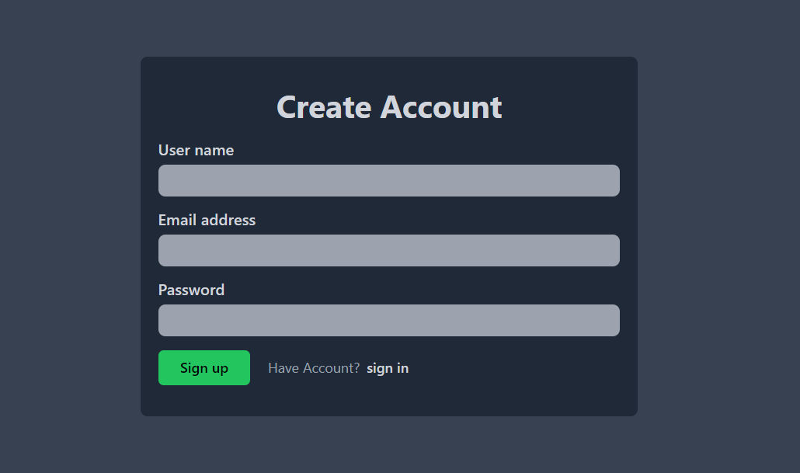**Sign-Up Process:**

* **Access the Sign-Up Page:**
* Navigate to the sign-up page by clicking on the "Create Account" button located below the "Login" button.
* **Enter Your Details:**
* **User Name:** Input your full name in the provided field.
* **Email Address:** Enter a valid email address. This will be used for account verification and login.
* **Password:** Choose a strong password that is at least 4 characters long. The password should ideally include a mix of letters, numbers, and special characters for better security.
* **Submit the Form:**
* Once all fields are filled out, click the "Sign up" button to submit your information.
* If your account is successfully created, you will automatically be redirected to the login page.
* **Login Process:**

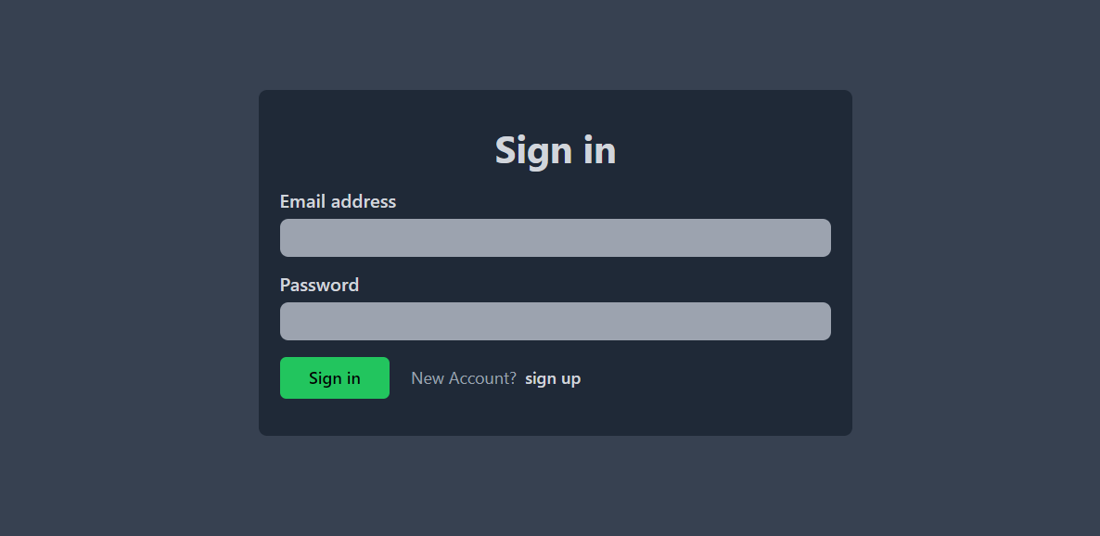

* **Access the Login Page:**
* If you’re not already on the login page, navigate to it by clicking on the "Sign in" button on the sign-up confirmation page or by visiting the login URL directly.
* **Enter Login Credentials:**
* **Email Address:** Enter the email address you used during the sign-up process.
* **Password:** Enter the password you created.
* **Login to Your Account:**
* Click the "Login" button to access your account. If your credentials are correct, you will be logged in and redirected to the home page.
* **Error Handling:**
* If you enter an incorrect email or password, an alert message will be displayed.

No record exit or password incorrect

**Main Page (Home Page):**

After logging in, you will land on the home page. By default, you see All task page

* **Side Bar:**

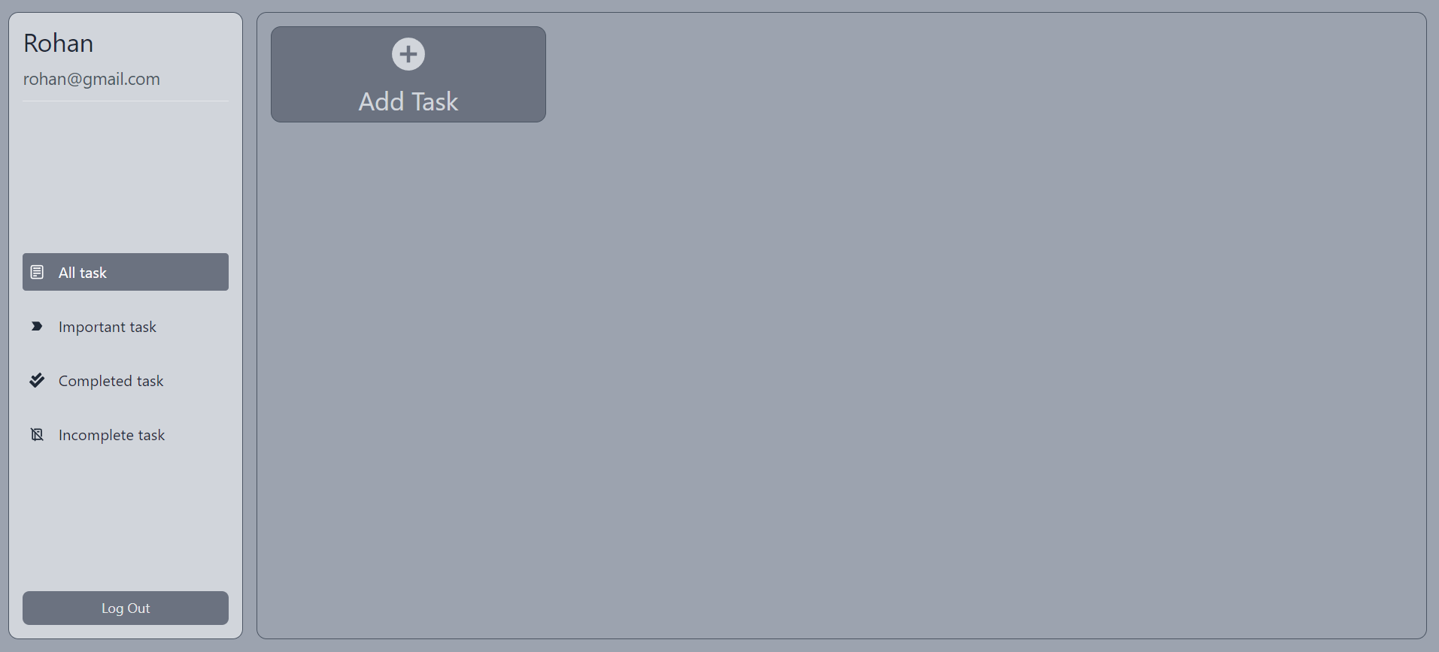

* + - **User Info**: On the top left of the sidebar, your usernname and email are displayed.
    - **Navigation:**
    - **All task:** Return to this main page.
    - **Important task:** Navigate to the Important task page.
    - **Complete task:** Navigate to the Complete task page**.**
    - **Incomplete task:** Navigate to the Incomplete task page**.**
  + **Logout:** On the bottom left of the sidebar, Logout button is shown.
* 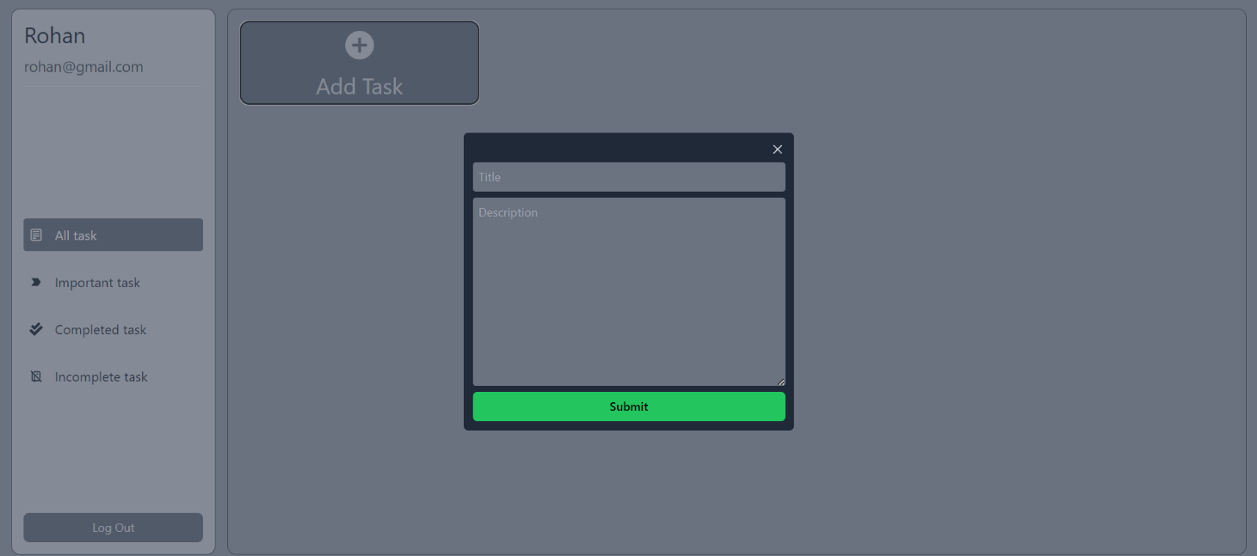**All task Section**:
* **Enter task Details:**
  + **Task Title:**  Enter title of your task.
  + **Task Description:** Give description about your task.
* **Submit the Form:**
* Once all fields are filled out, click the "submit" button to submit your task.
* 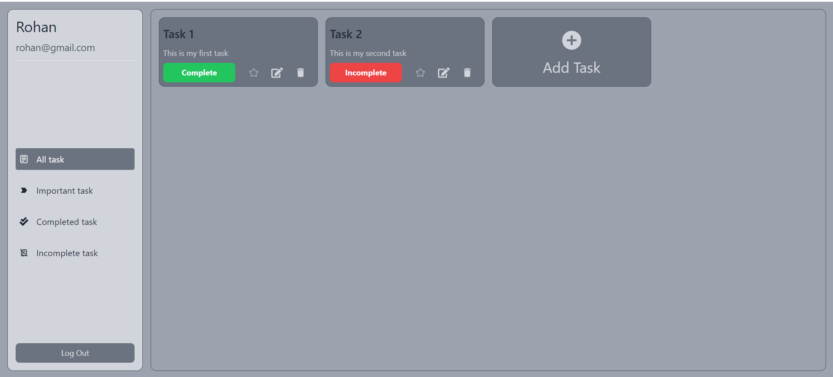After submitting, task will be added to your all task page.
* 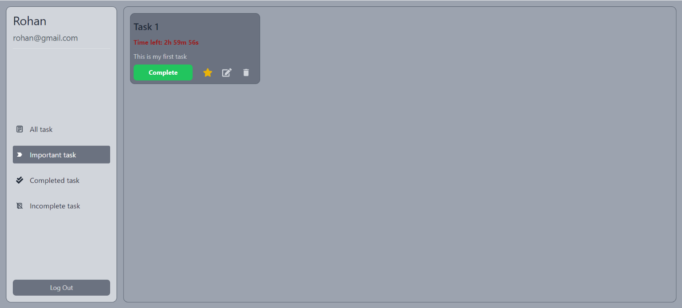**Important task Section**:
* All task which are made important by clicking “STAR” icon, are displayed here.
* When a task is made as Important, a timer of 3 hours will be started for that task.
* You can deselect task importance at any time.
* **Complete task Section**:

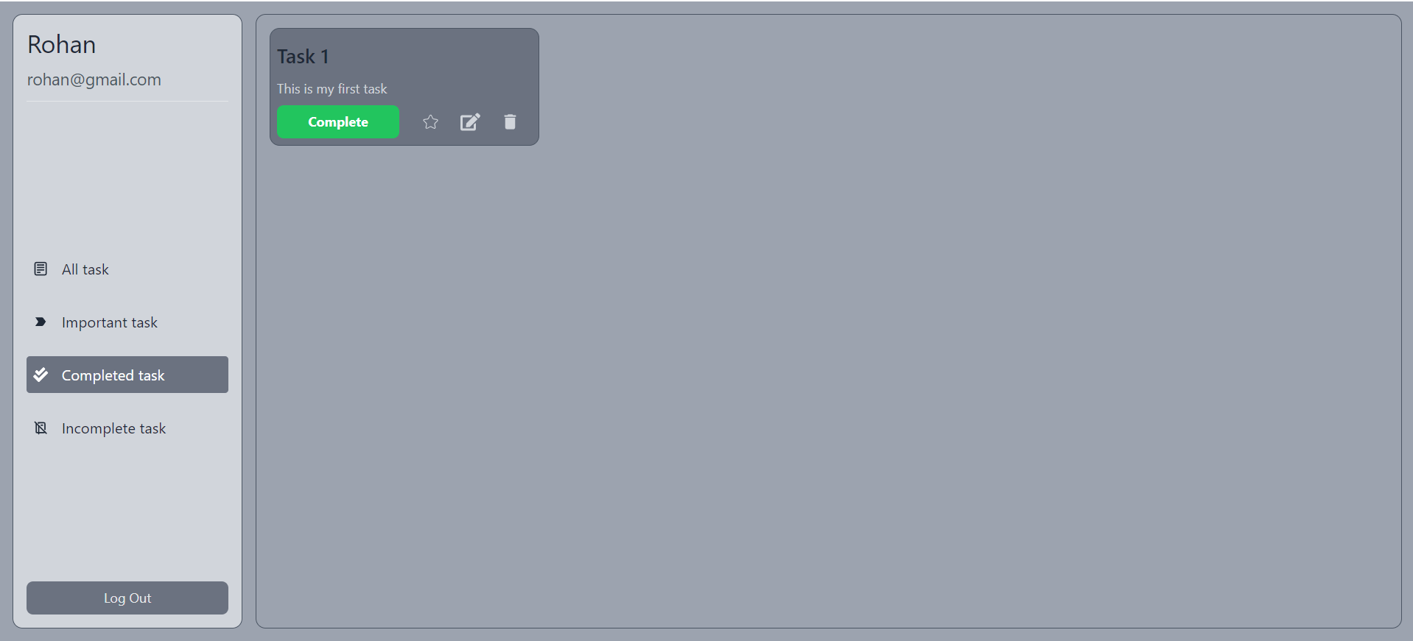

* All task which are completed, are displayed here.
* **Incomplete task Section**:

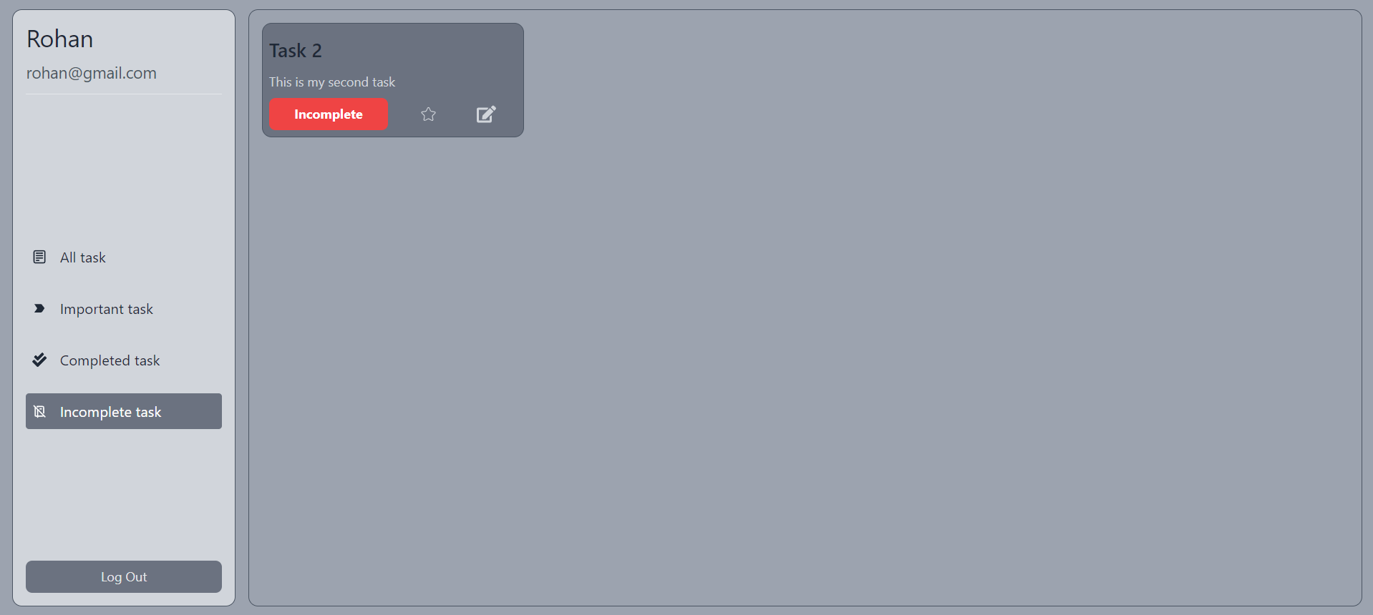

* All task which are incomplete, are displayed here.
* **Task Card**:

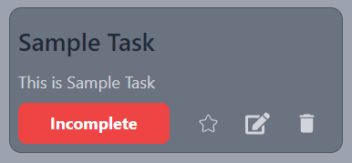

* Task card contain task “Title” and its “Description”.
* From this card user can change task status from incomplete to complete and vice versa.
* User can make task important by clicking star icon.
* User can update task title and description using update button.
* Can delete task by clicking delete button.
* **Summary**:

This user guide provides a comprehensive overview of "TaskBuddy," a web application designed to simplify daily task management. It covers essential features like secure registration and login, task creation, and management. The guide explains the user interface, including sidebar navigation and task cards, which allow users to update, delete, and prioritize tasks. Additionally, it highlights the "Important Task" feature, which includes a timer to track high-priority tasks. This guide serves as a helpful resource for understanding and effectively using TaskBuddy.